Table of Contents

STEPS TO SETUP A PLATFORM: 6

WELCOME PAGE: 7

DASHBOARD/HOME TOGGLE BUTTON : 8

PROFILE PAGE : 9

LIST PAGE : 10

NAVIGATION PAGE: 11

Mifos x manage code functions : 14

Mifos X Loan Fees & Charges v15.03: 17

Mifos x Savings Products 22

Now Select Create Fixed Deposit Product : 23

Details : 23

Currency : 24

Terms : 24

Settings: 25

Interest Rate chart : 27

Charges : 30

Accounting : 30

Mifos X Accounting : 33

How to Create GL Account? 36

How to Create Tag? 38

How to Create Sub-ledger Account? 40

Overview of General Ledger Accounts : 42

42

View Chart of Accounts (Tree View): 42

43

Edit, Disable or Delete an Existing Account: 44

Accounts linked to Financial Activities: 45

Defining new mapping 46

Defining new mapping 46

Migrate opening balances (Office-wise) : 47

48

Accounting Rules: 53

Create accounting rule : 53

Multiple entries: 54

To tag an account to be debited, do the following: 54

To tag an account to be credited, do the following: 58

Accounting Rule 60

To set the Debit rules: 64

To set the Credit rules: 65

View Accounting rule: 65

Edit or Delete Accounting rule: 65

Provisioning Entries 66

Create Provisioning Entries : 66

View provisioning entry : 67

Print General Ledger Listing: 68

How to Print? 70

How To Enter GL Opening Balance 72

Configure Notifications: 78

Summary : 80

Mifos X ,how to create clients,groups and centers: 82

Create a Client : 82

To create group : 86

To create center: 88

Mifos x manage data tables: 91

Mifos x currency configuration : 94

Mifos x Manage Office : 95

Mifos x Charges(savings and deposit fees) : 97

Select Charges: 97

97

Creating a Charge : 98

Loan charge : 98

Savings & deposit charge : 99

Client charge : 99

Share charge : 100

Editing charge: 100

100

Viewing charges : 101

Charge Fields : 102

Mifos x Windows Installation : 104

Mifos x Low Bandwidth cloud access 120

Mifos x installation on cloud: 120

121

Mifos X Training Request Feature & Report Bug : 123

Mifos x data Import tool: 125

Installing Data Import Tool: 125

2 - Setting up environment variables for gradle. 126

3 - Cloning URL 127

5 - Starting Data import tool: 129

6 - Start Using - Data Import tool from web browser, by going to: 129

Get started with data import tool 130

**Getting started** 130

Using Data Import Tool : 130

**Re-Uploading unsuccessful import sheet** 131

Import Centers: 133

Import Groups: 133

Import Loans: 133

Import Loan repayments: 134

Import Savings: 134

Import fixed deposit: 135

Import recurring deposit: 135

Importing RD account transaction’s: 135

Importing closing of savings account: 136

Importing/Adding – Journal entries: 136

Mifos x Building Custom Reports: 136

METADATA TABLES: 137

1) Stretchy Reports 137

2) Pentaho Reports 137

Creating Stretchy Reports: 138

Modify existing Stretchy Reports: 141

Create and Upload Custom Pentaho Reports: 142

Creating Simple Pentaho Report and Embedding it to Mifos X : 143

Embedding Pentaho Report in MifosX: 157

Generating created Pentaho Report : 158

Mifoxs x Payment type 159

Adding a Payment Type : 159

**Adding a Payment Type** 160

Edit Payment Type : 161

Delete Payment Type: 162

Mifos x Account number Preferences: 162

Step 1: Beginning at the main screen, select Admin, then System from the drop-down menu. This will launch the System menu**.** 162

**Step 4:** 164

Creating Preferences for Loan Account Number 166

Creating Preferences for Savings Account Number 166

Mifos x Training manage funds : 167

Add Funds 167

View Funds 167

Edit Funds 168

Training Audit Trail 169

Advanced Search for a User 170

How to view an Audit Entry : 171

How to Export CSV : 171

MIFOS X CONFIGURATIONS : 173

Mifox creating Templates 174

Mifos x Teller Cash Management 176

Mifos x Password preferences 178

Setting Up the Password Preferences 179

Mifos x Standing Instructions : 180

About Standing Instructions 180

MIFOS X REPORTS : 185

Mifos x loan process : 187

Mifos x Loan Loss Provisioning : 193

Mifos x Manage Holidays : 194

Add Holidays 195

View Holidays 196

Edit/Delete Holiday : 197

Loan Overview 198

Loan Products : 198

Personal Loans: 198

Business Loans: 198

Equal Credit Opportunity 198

Definition of Applicant 199

Truth-in-Lending 199

Cross-Collateralization Clause 199

Notification of Adverse Action 199

Loan Application Process 200

**Loan Application** 200

Proof of Income 201

Photo Identification 201

Guarantor 201

Loan Guidelines 201

Credit Builder Loans 202

Mifos x Training Product Mix 203

Product Mix 203

Creating a new Product Mix 204

Edit or Delete Product Mix 205

Mifos x Training funding mapping 206

Searching by Loan Status 208

Searching by Product 208

Searching by Office 209

Searching by Approval/Creation/Disbursement-Date 209

Searching by Loan Outstanding Percentage : 209

Searching by Loan Outstanding Amount : 210

Mifos X Entity to entity mapping 211

The features provided by a banking platform are :

* Banking operations
* Loan origination
* Management ,savings and deposit products
* Client management
* Accounting and reporting
* Digital financial services like mobile banking and payment gateway

## STEPS TO SETUP A PLATFORM:

1. Open a new window in any internet browser (e.g., Firefox, Chrome, Internet Explorer)
2. Enter the URL in the address bar
3. The Sign in page will be displayed, as shown in the picture above.
4. Enter your username in the username field (Default user name - mifos)
5. Enter your password in the password field (Default password - password)

6. Click Sign In as shown in fig below

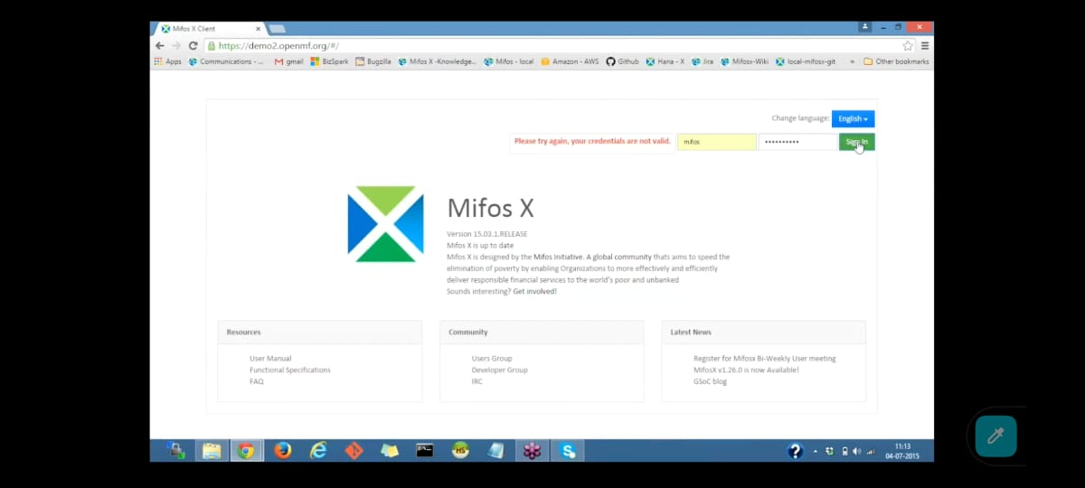

1. Once you sign in, the Welcome page is displayed as shown below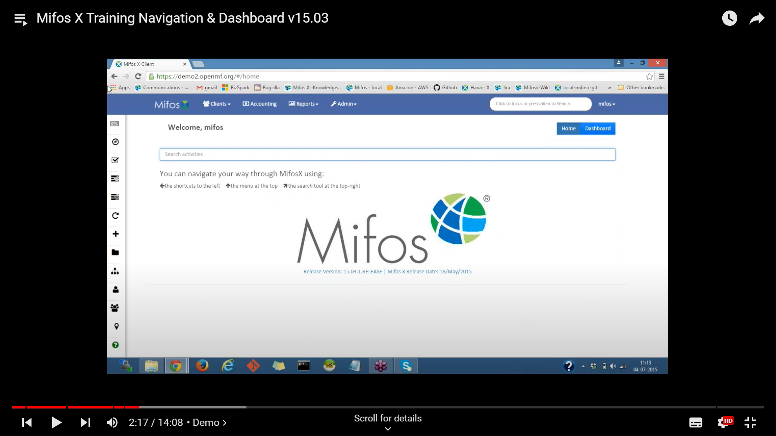

## WELCOME PAGE:

* **logo**  
  Access the Welcome Page from anywhere in the Mifos X platform
* **Clients** menu  
  Access [Clients](https://mifosforge.jira.com/wiki/spaces/docs/pages/67895338/Manage+Clients), [Groups](https://mifosforge.jira.com/wiki/spaces/docs/pages/67895334/Manage+Groups), and [Centers](https://mifosforge.jira.com/wiki/spaces/docs/pages/67895340/Manage+Centers)
* **Accounting** menu  
  Access the [Accounting](https://mifosforge.jira.com/wiki/spaces/docs/pages/101384453/Accounting) activities pages
* **Reports** menu  
  Access Clients, Loans, Savings, Funds, Accounting, and XBRL Reports
* **Admin** menu  
  Access the [Administration](https://mifosforge.jira.com/wiki/spaces/docs/pages/52592736/Administration) menu
* **Search** tool  
  System-wide [Search Tool](https://mifosforge.jira.com/wiki/spaces/docs/pages/107020338/Global+Search)—use the search tool to search for clients, groups, and centers
* **menu**   
  Access to **Help** (*redirects to the User Manual*), **Profile** (*your user profile, including an option to change your password*), **Settings** (*to change user language and date format*), and **Log Out** button.

## DASHBOARD/HOME TOGGLE BUTTON :

* The **Home**/**Dashboard** toggle button on the top right switches between this page (Welcome page) and the [Dashboard page](https://mifosforge.jira.com/wiki/spaces/docs/pages/81166372/Dashboard+Page).
* Your username will appear beside the word **Welcome**. If your username is not displayed correctly, contact your administrator.
* The **activity search** tool is a quick method to find and navigate to activities/pages in the platform. You can write keywords in the given textbox and search for related activities. For example, if you want to access an activity related to loans, type "loan" into the activity search field. Loan-related activities will be listed (i.e create loan product, loan products, bulk loan reassignment). You can then click on the desired loan activity. Similarly, you can access activities related to clients, savings products, groups, and more.
* The **navigation hints** point out navigation methods that are available to you wherever you are in , including:
* Shortcut menu (sidebar)
* menu bar
* Search tool (located on the menu bar)
* The [**Shortcut**](https://mifosforge.jira.com/wiki/spaces/docs/pages/112296004/Side+Bar+-+Features) menu is a sidebar menu of your favorite/most frequently used activities. You can personalize the Shortcut sidebar to suit your work style. The Shortcut sidebar will pop out when you hover the mouse over the menu area. The Shortcut sidebar is available on every page in the app.

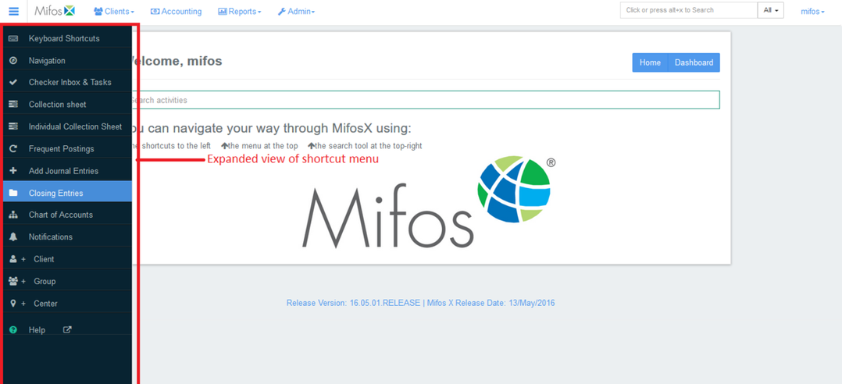

* The Dashboard contents will be unique to each user. The page displays recent activities ,frequent activities ,amount disbursed for today,amount collected for today and client trends for head office with the help of graphs.

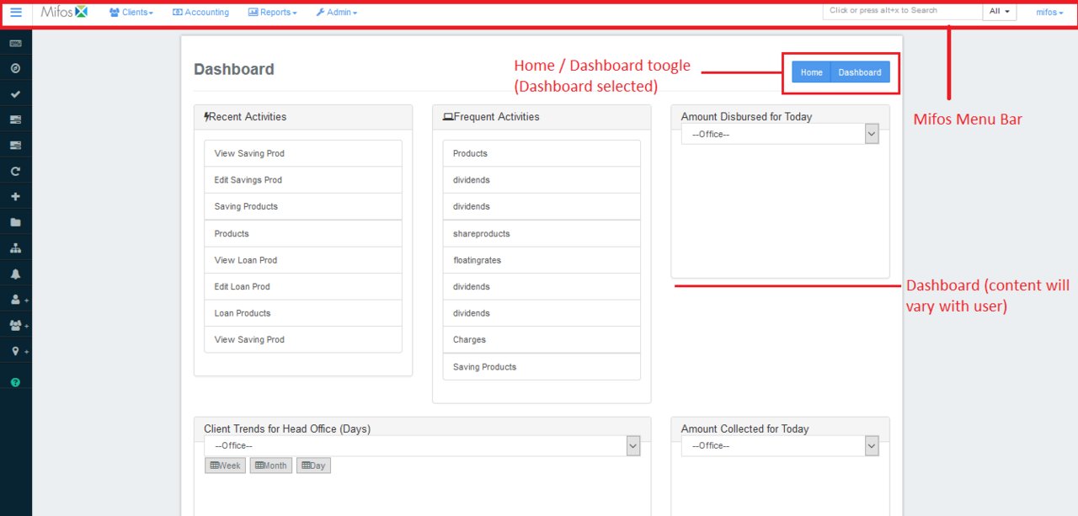

## PROFILE PAGE :

* Click on mifos a drop a down list will be displayed in that select profile option a profile page will be displayed

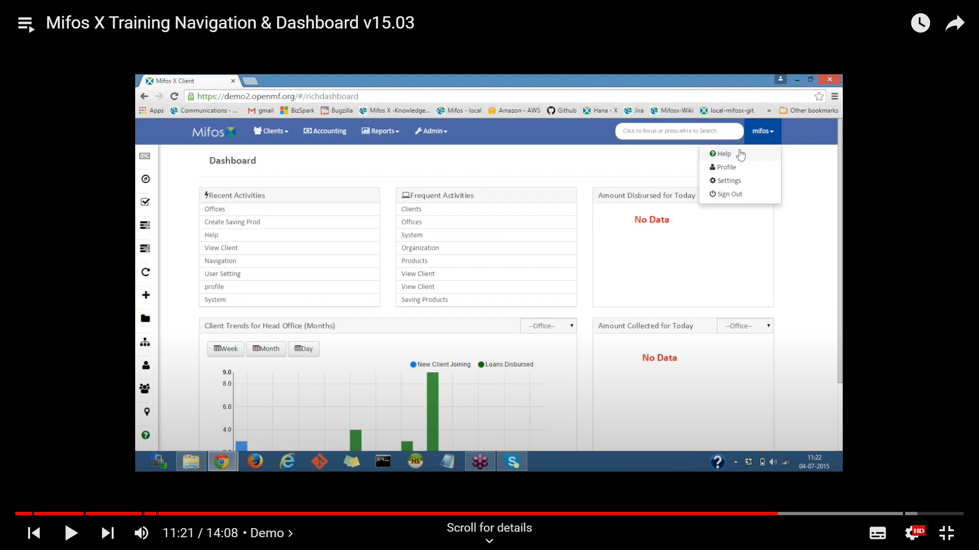

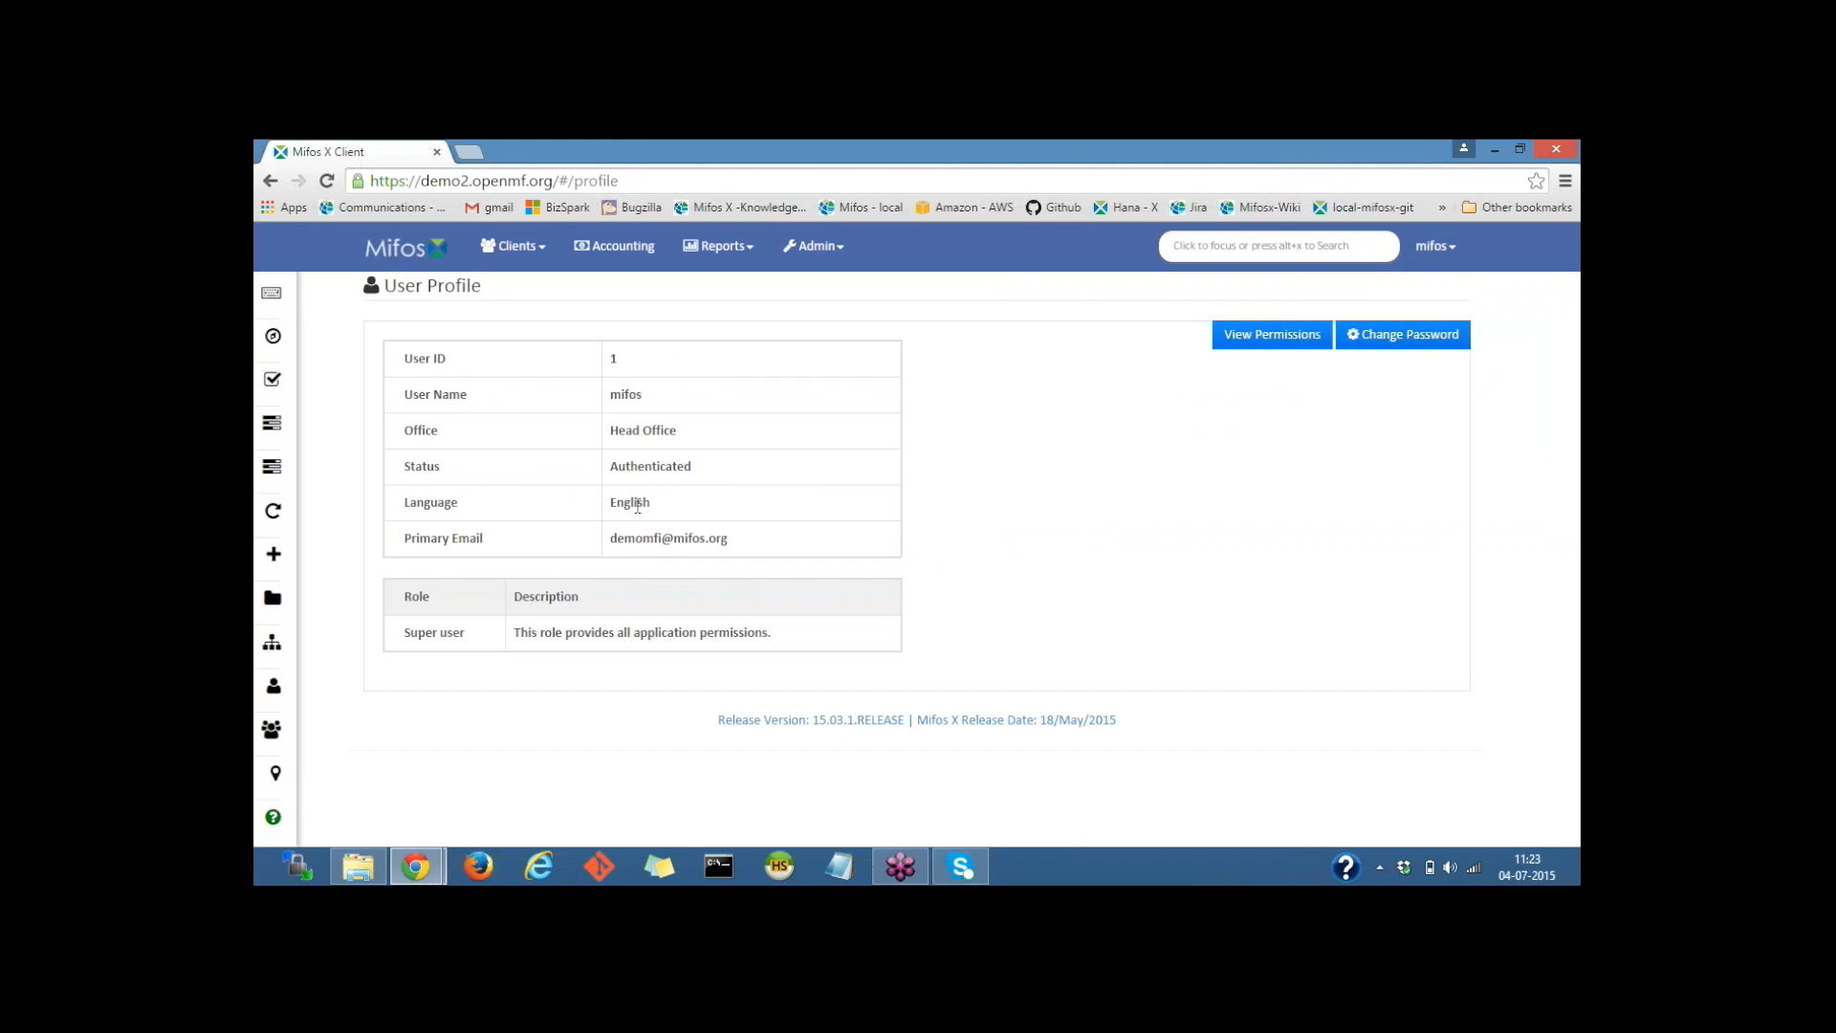

## LIST PAGE :

* The List page layout is used throughout Mifos X and is a method to view and access information.
* The Mifos menu bar and the Shortcut sidebar menu are available on list pages.The grey bar under the Mifos menu bar identifies the type of information presented in the list.One or more bright blue Activity buttons may be present below the grey bar.
* The label on the button tells you the activity that will be launched when you click it.
* The Filters allow you to narrow the listed information on the page. The text in the filter field informs you which fields will be filtered when you enter a filter.Page navigation buttons (<–Prev, Next –>) at the bottom of the page are used to scroll forward and backward through the list.

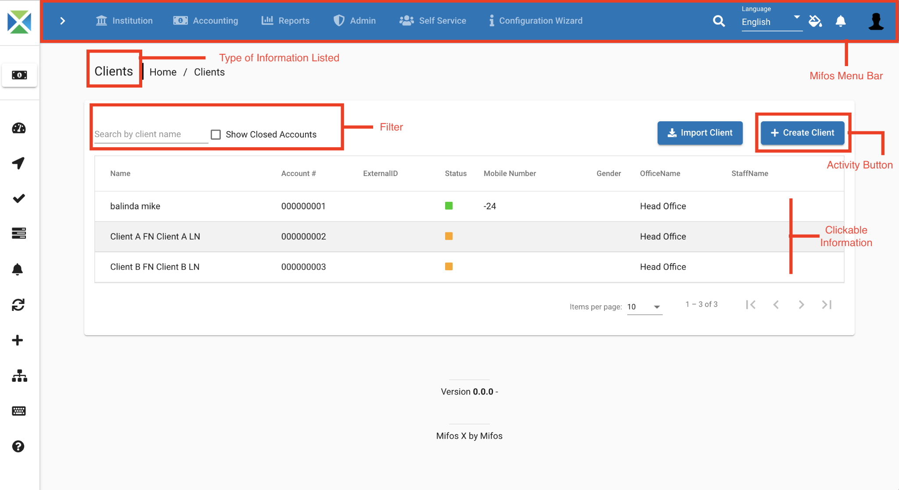

## NAVIGATION PAGE:

The **Navigation Tool** enables you to quickly navigate through Offices, Loan Officers, Centers, Groups and Clients within Mifos X. It provides a very efficient mechanism that allows you to quickly filter through and navigate to particular groups or clients under a specific office.

How to use navigation tool?

1. Click on the **Navigation** option in the Side Bar Menu.

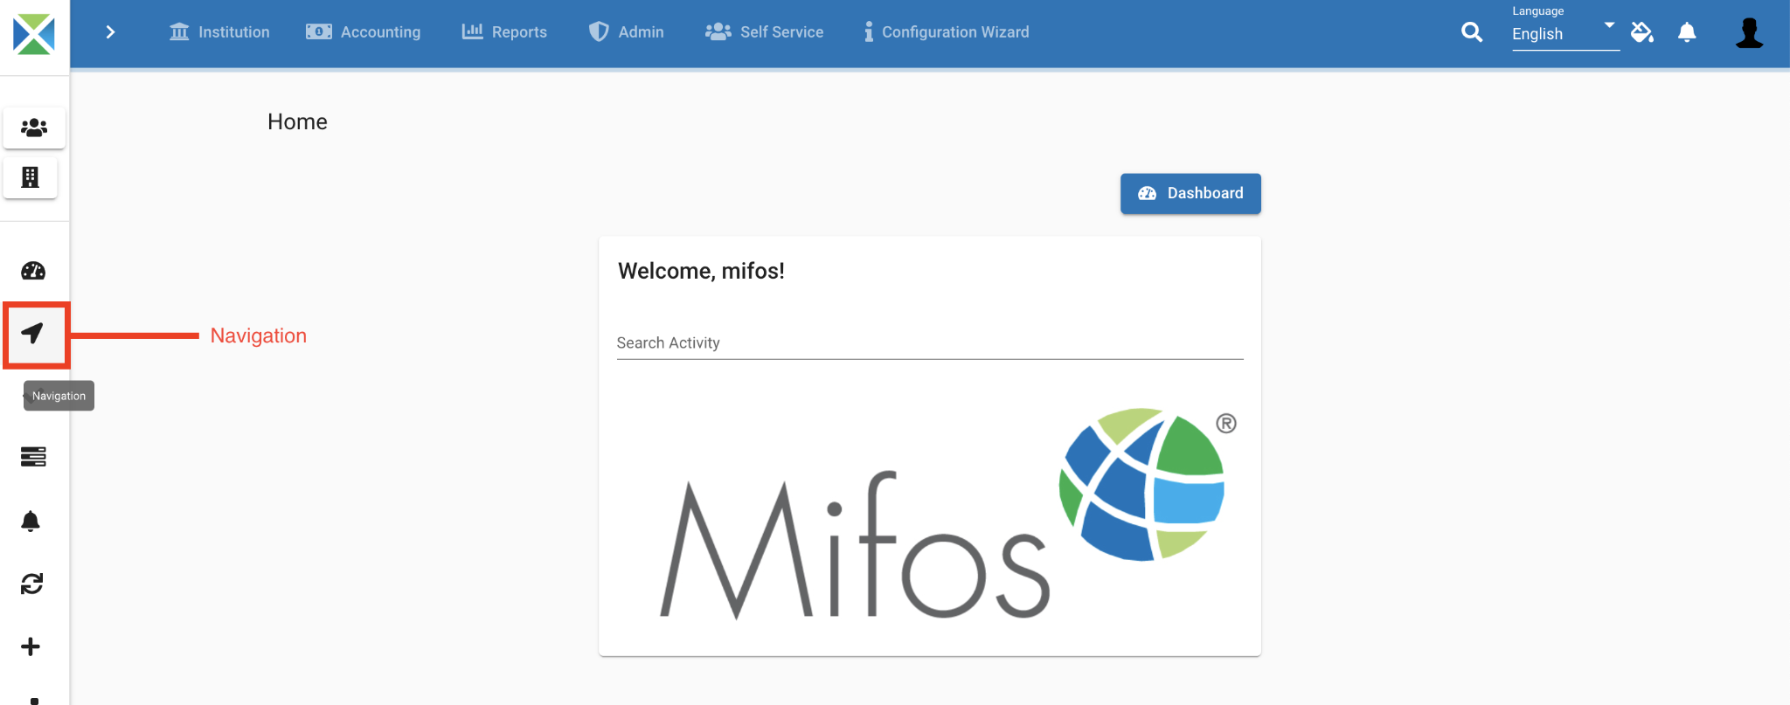

Once you click on the **Navigation** panel, the following window appears. This window has buttons that allow you to navigate through offices, loan officers, center, groups and clients.

Click on '**Offices (Head Office)**' to see the list of branch offices.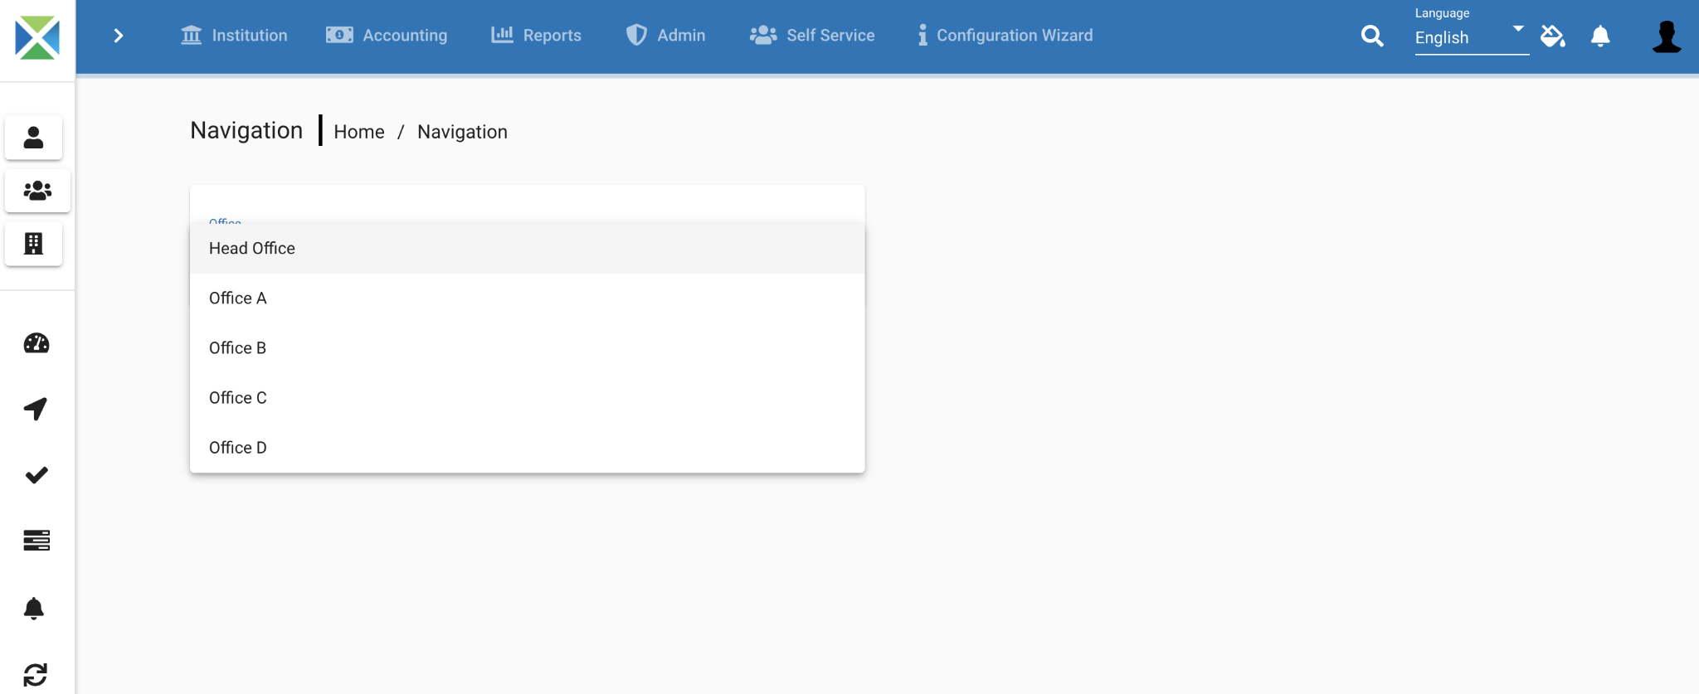

Here, click on any office (*for example: Head Office*) to see the list of loan officers.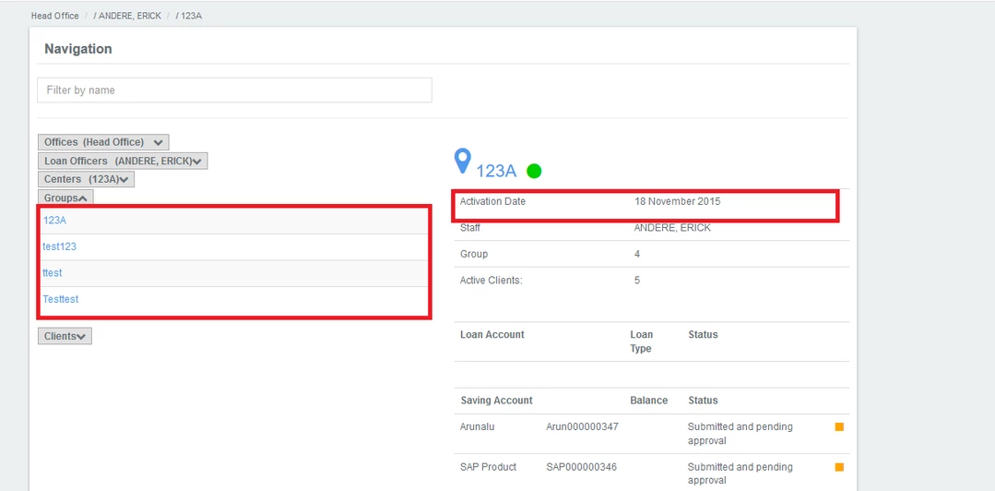

In this example, there is one loan officer (*Andere, Erick*) under our selected branch office (*Head Office*). Click on the loan officer's name (*Andere, Erick, in this example*) to see the list of centers managed by them.

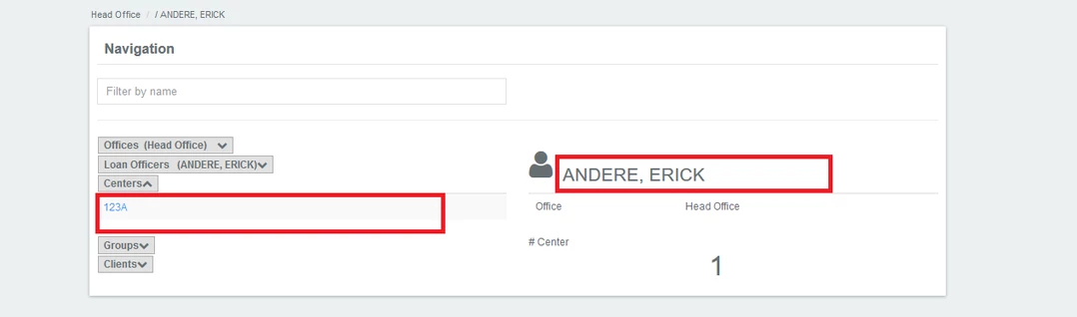

As shown in the screenshot below, there is one center which is managed by our selected loan officer *(Andere, Erick).* Click on any specific center to see the list of groups under that center.

You can now see that there are four groups and can also view the center activation date. Click on any group to see the list of clients under that group.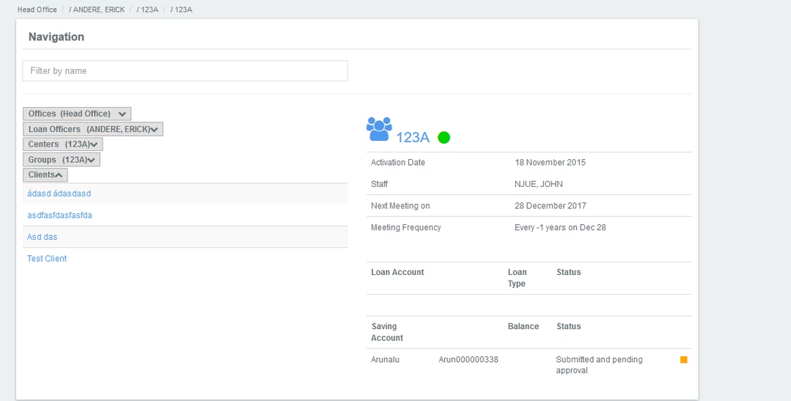

There are four clients under the group 123A. In order to see the overview of any particular client, click on the client's name.

In this example, the client 'Test Client' has been selected. The following is displayed: 1. Client's personal profile 2. List of loan accounts held by the client (and their overview) 3. List of savings accounts held by the client (and their overview)

If you click on the Client's name (*Test Client, in this example*), it redirects you to the client's profile.

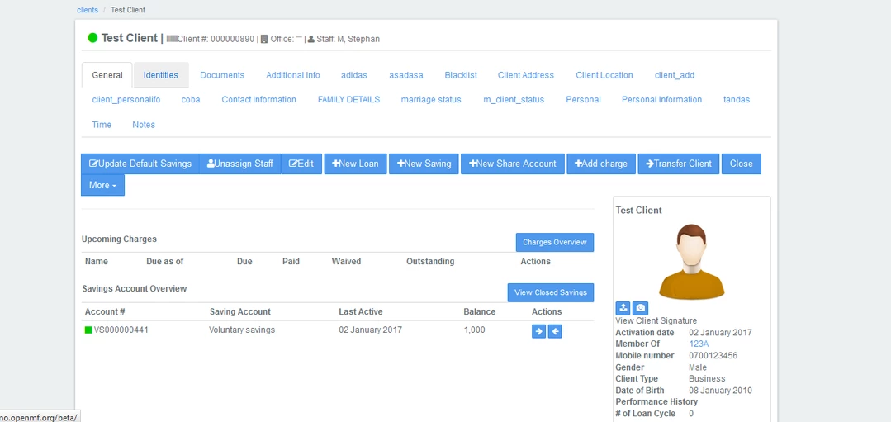

## Mifos x manage code functions :

To find drop down fields and drop down values.

Goto Admin,click on system-select managa codes.

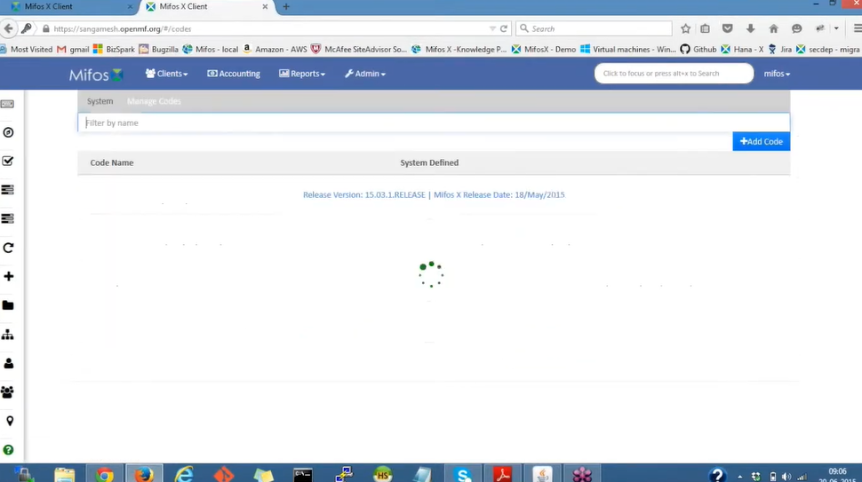

Click on +Add code and select the Add code value and below snapsort page will appear

And provide the Name and Position.

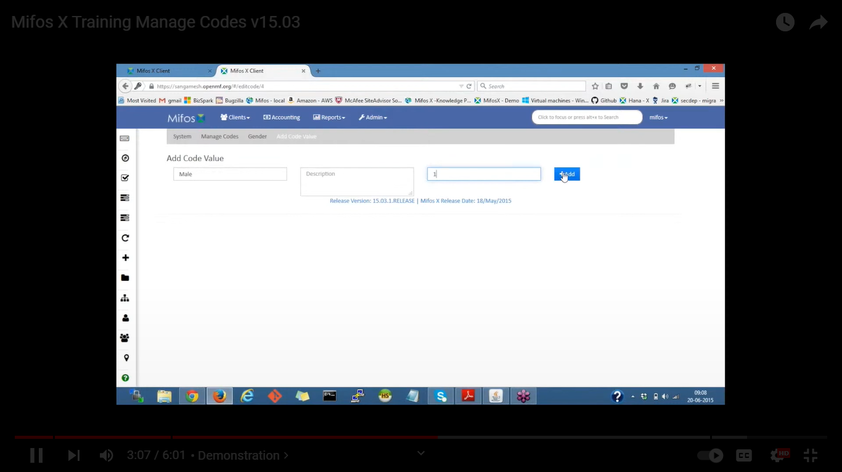

We have to define code values by create client and client type,Goto the home page-click on create client and select gender,client type then submit.

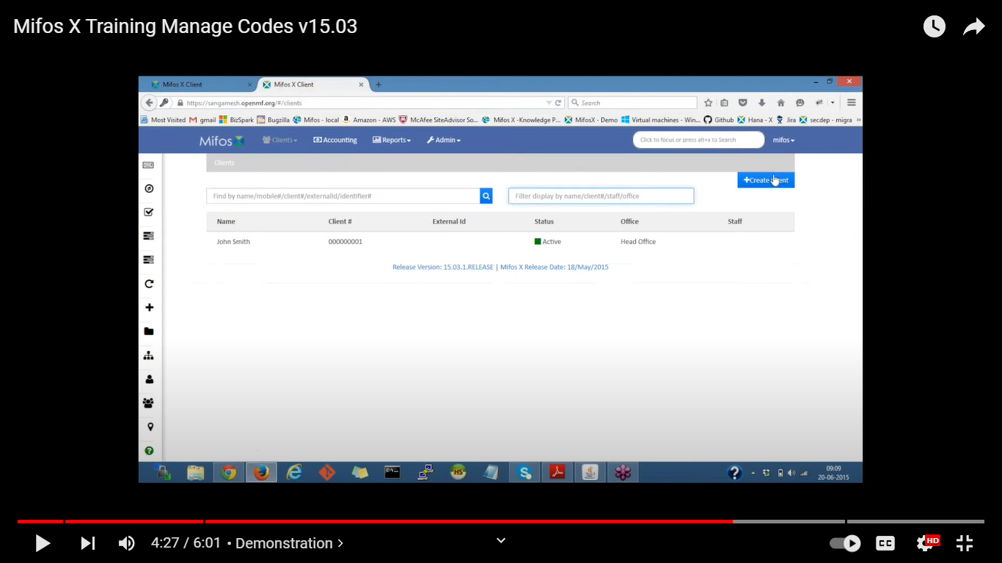

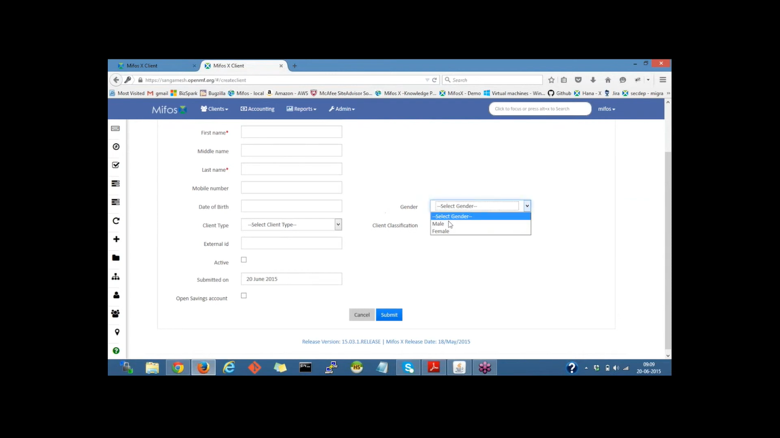

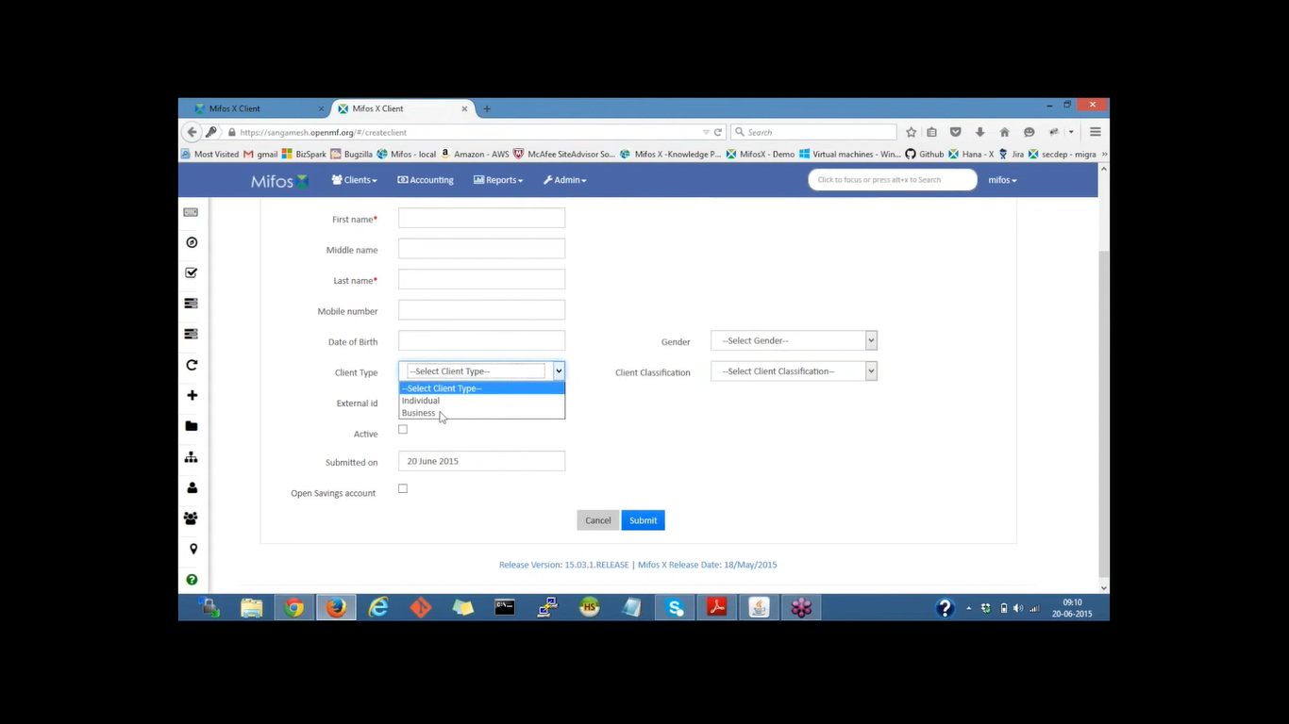

## Mifos X Loan Fees & Charges v15.03:

About Charges:

Mifos support 2 types of charges:

* Fees
* Penalties

Fees are charged for services for example, membership fees, loan disbursement fees, withdrawal fees. Penalties are charged to discourage clients from deviating from the terms of a product-for example, late payment penalty for a loan account, early withdrawal penalty for a fixed deposit

account. Charges may be associated with a product. When an account is opened based on a product that charges have been associated with, the account will include (inherit) all charges that are associated with the product. In addition, charges that are not defined for a product may be associated with individual client accounts.

Procedure

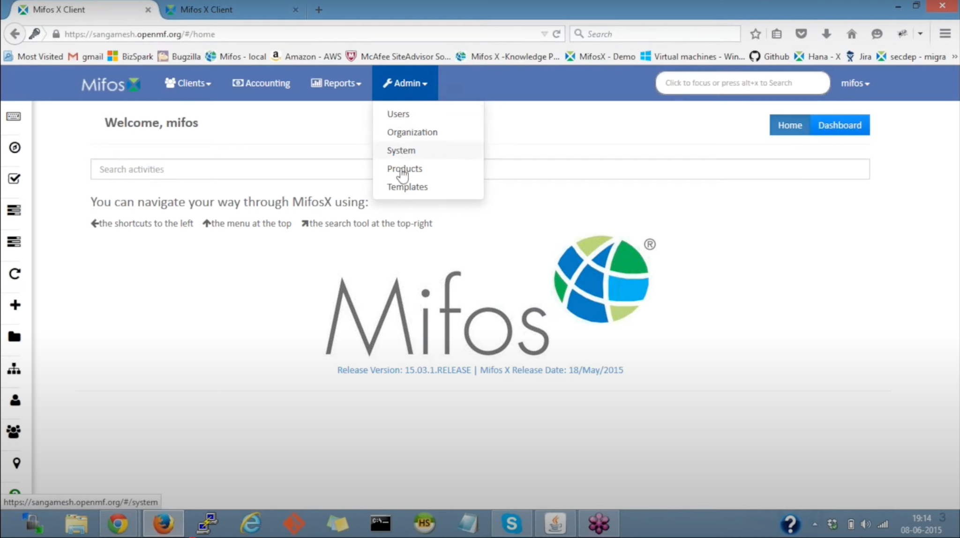

In the Mifos dashboard

* Click on Admin:
* In the dropdown, Click on Products.
* Creart charges by clicking on the charges.sle
* There click on “+create charge”.

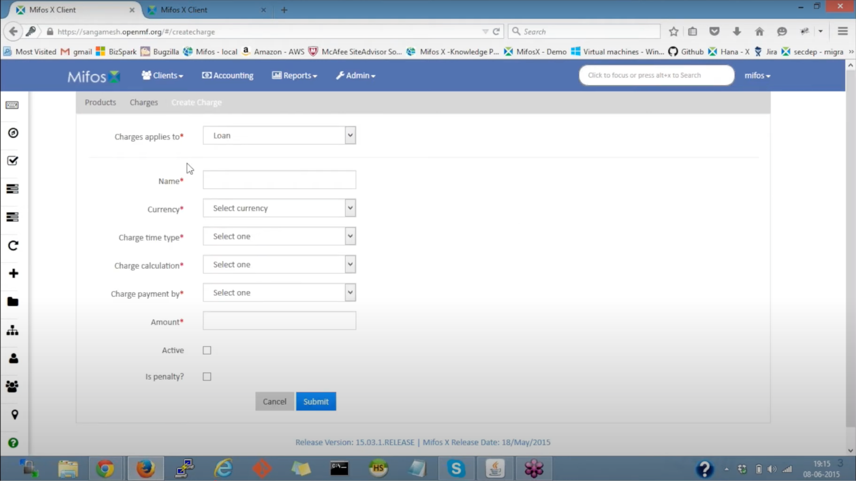

* Select ‘loan applies to’ and Select ‘loan’.
* Provide Name of the loan
* For eg: Loan processing Fee
* Select currency as ‘US dollar’
* Change time type

Now, What is ‘Change time type’?

They are four types:

* Disbursement
* Specific due date
* Installment fee
* Overdue installment

**Disbursement:** The fee is charged at the time of Loan Disbursement. - Ex: If the loan amount is $1,000 and disbursement is on 5th Jan. With the Loan processing fee of

$1 - Flat. Then on the Loan disbursement date as on 5th jan, it would show in the transaction as:

Loan disbursement = $1,000 & Fees = $1.

Specified due date: These fees get collected at the provided date. - Ex: If the specified due date provided is on 10th Jan and the repayment date is on 15 Jan. The

fees get collected as on 10th Jan.

Installment fee: The fee gets collected at every installment. Ex: If the installment fee is defined as $1 and the loan repaid is every week. Then at the every

installment i.e everAy week in this example fee of $1 gets collected.

Overdue installment: This charge gets collected if there is an overdue in the installment. - Ex: If the penalty defined is 1% of the loan amount and if the loan installment was supposed to be paid on 15 Jan and client misses the payment for that particular installment, he will be penalized

1% of the loan amount.

* Select ‘charge time type’ as ‘Disbursement’.
* Now go to ‘Charge calculation’
* There are 4 types:

Flat - Provided amount

% Amount - % of loan amount

% loan amount + Interest

%Interest

* Select ‘%flat’
* Select charge payment by as ‘Regular’

Regular for regular payment

Account transfer is for transferring through an account and link savings account.

* Fill amount as ‘1’ it denotes the %.
* Check the ‘Active’ section.
* Do not check the ‘is penalty’ section.

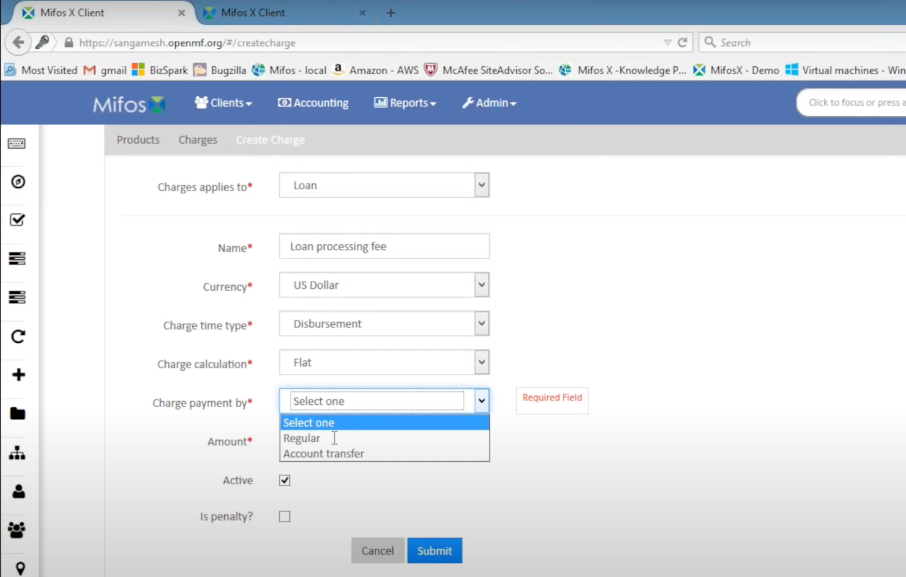

* Then select ‘Submit’.

So now the loan processing fee is defined.

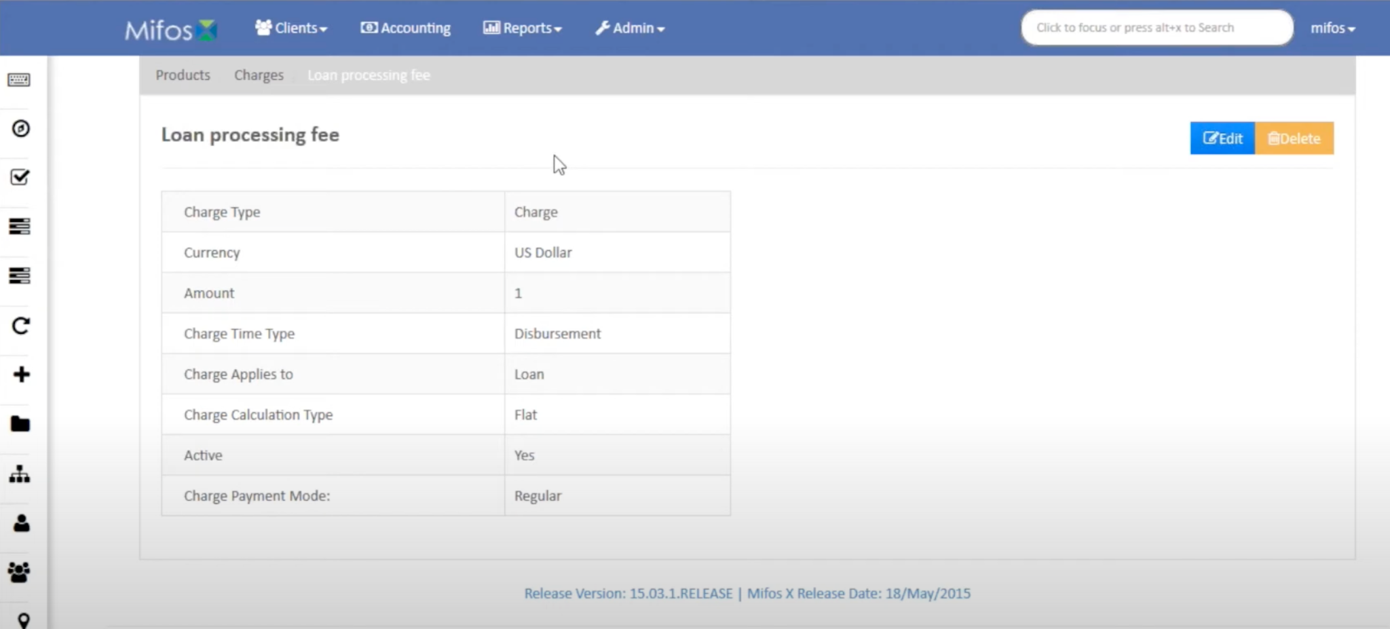

Now, we will go to ‘Charge’ page by clicking on ‘charge’

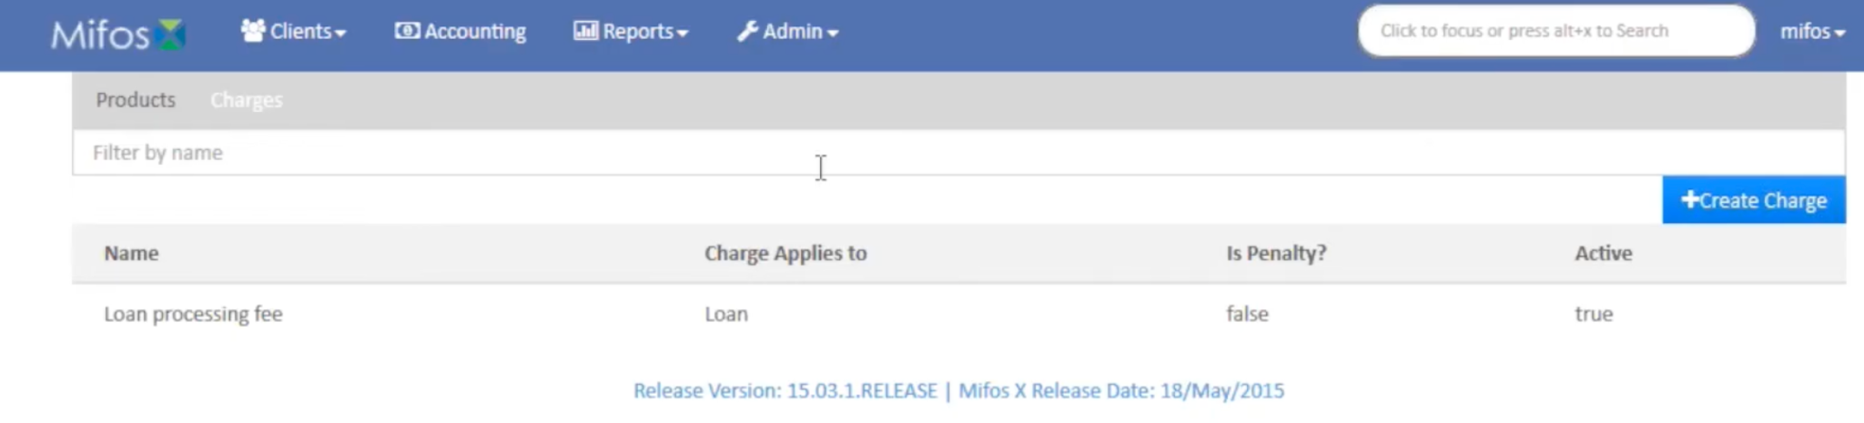

Now, we will create one more charge by clicking on ‘+Create Charge’

* In Charges applies to select ‘Loan’
* Now, enter the name as ‘Late payment fee’.
* Select Currency as ‘US Dollar’
* Select Charge time type as ‘Overdue Fees’ as it means Penalty.
* Select Charge calculation as ‘%Amount’ which means % of loan amount.
* Select Charge payment type as ‘Regular’.
* Select Amount as ‘1’ which is %1 of Loan amount.
* Check the Active check box
* Check the Is penalty? Check box
* Now click on ‘Submit’.

Now if we click on charges, it gives a list of Defined charges. Once these charges are created.

* We go back to the product, then Loan product.
* If there is already a loan product, edit it.
* If not, create new loan product by clicking on ‘+Create Loan Product’.
* Here, inside loan products give all the details required.
* Then in the bottom, select a charge ‘Loan processing fee’ and click on ‘add’ button to add the current loan product.
* We can also add ‘Late payment fee’ and click on ‘add’ button to add the charges which we had created in the beginning.
* Then click on ‘Submit’.

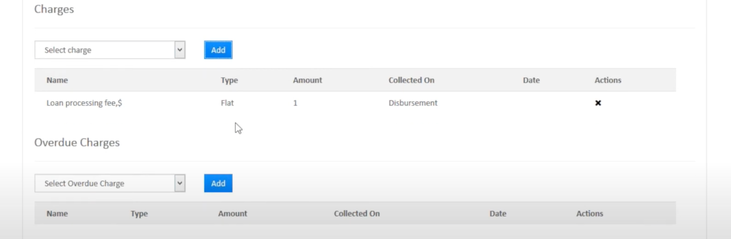

Then if you scroll down and see, both these charges are added to the loan product.

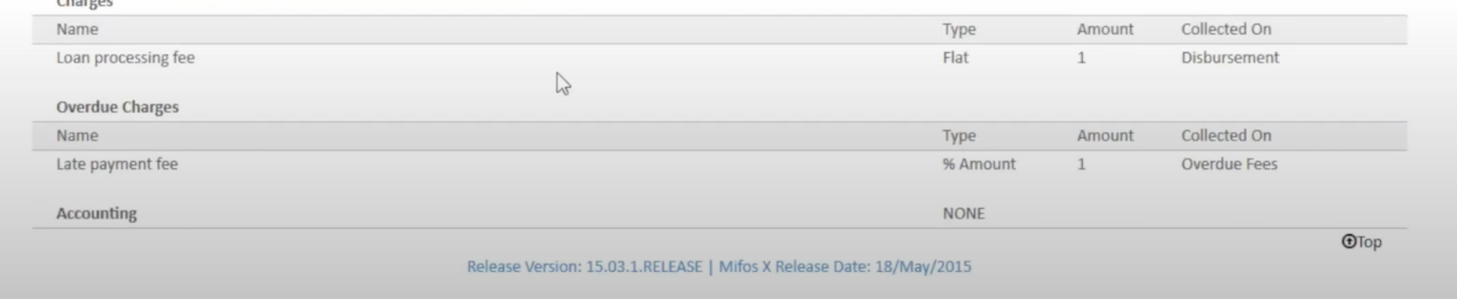

So whenever a client disburses a loan or an overdue the fees get charged.

## Mifos x Savings Products

Savings products define the rules, default settings, and constraints for a financial institution's current/checking and passbook savings accounts. A saving product provides a template for multiple accounts that are or will be held by the financial institution's clients, groups and centers.

The categories of information required to set up a saving product includes:

* Identifying or descriptive information
* Terms
* Settings
* Charges
* Accounting

Beginning at the main screen, select [**Admin**](https://mifosforge.jira.com/wiki/display/docs/Administration), then select **Products** from the drop-down menu. This will launch the **Products** menu.

Select Savings Products. Fixed Deposit Products defines the rules, default settings, and constraints for a financial institution's fixed deposit offerings (also referred to as term deposits). A fixed deposit product provides a template for multiple fixed deposit accounts for the financial institution's clients.

The information required to set up a fixed deposit product includes:

* Identifying descriptive information
* Terms
* Settings
* Charges
* Accounting

On this page:

[Now Select Create Fixed Deposit Product](https://mifosforge.jira.com/wiki/spaces/docs/pages/102629544/Fixed+Deposit+Products#FixedDepositProducts-NowSelectCreateFixedDepositProduct)

* [Details](https://mifosforge.jira.com/wiki/spaces/docs/pages/102629544/Fixed+Deposit+Products#FixedDepositProducts-Details)
* [Currency](https://mifosforge.jira.com/wiki/spaces/docs/pages/102629544/Fixed+Deposit+Products#FixedDepositProducts-Currency)
* [Terms](https://mifosforge.jira.com/wiki/spaces/docs/pages/102629544/Fixed+Deposit+Products#FixedDepositProducts-Terms)
* [Settings](https://mifosforge.jira.com/wiki/spaces/docs/pages/102629544/Fixed+Deposit+Products#FixedDepositProducts-Settings)
* [Interest Rate chart](https://mifosforge.jira.com/wiki/spaces/docs/pages/102629544/Fixed+Deposit+Products#FixedDepositProducts-InterestRatechart)
* [Charges](https://mifosforge.jira.com/wiki/spaces/docs/pages/102629544/Fixed+Deposit+Products#FixedDepositProducts-Charges)
* [Accounting](https://mifosforge.jira.com/wiki/spaces/docs/pages/102629544/Fixed+Deposit+Products#FixedDepositProducts-Accounting)

Beginning at the main screen, select [Admin](https://mifosforge.jira.com/wiki/display/docs/Administration), then Products from the drop-down menu. This will launch the Products menu.

Select Fixed Deposit Products.

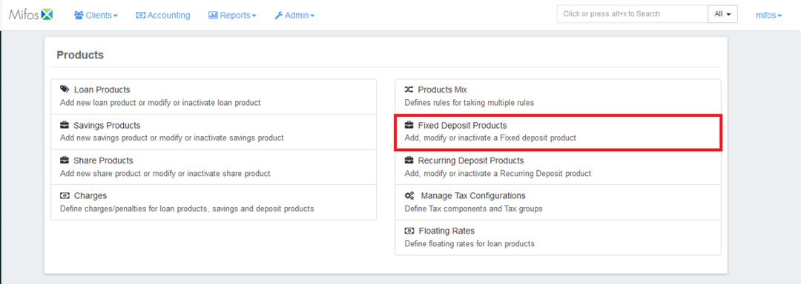

### Now Select Create Fixed Deposit Product :

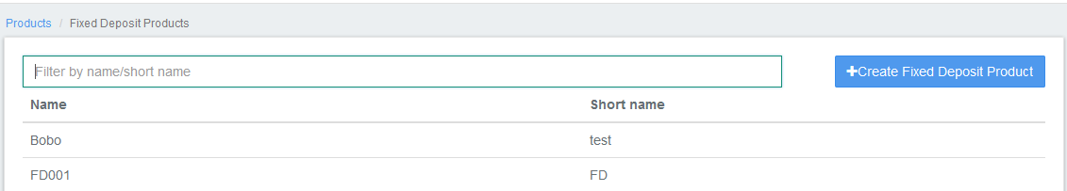

### Details :

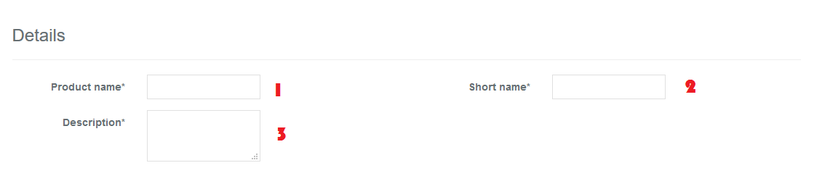

Please refer above Image for details, Details mentioned below are updated with respect to the provided fields number's.

* 1 - Provide Savings Product name .
* 2 - Provide Short name.
* 3 - Provide Description of this product.

### Currency :

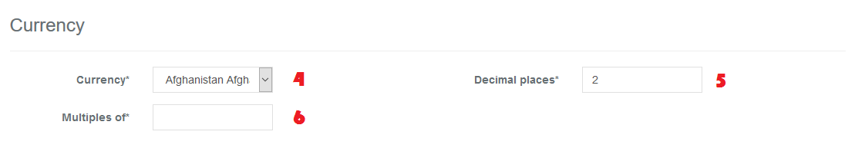

* 4 - Select Currency. You need to have defined required currency: [Currency Configuration](https://mifosforge.jira.com/wiki/display/docs/Currency+Configuration)
* 5 - Provide Decimal places.
* 6 - Provide Currency in multiples of. This is to provide the total rounding off amount. For example: 10, so Total amount gets rounded of to 10's.

### Terms :

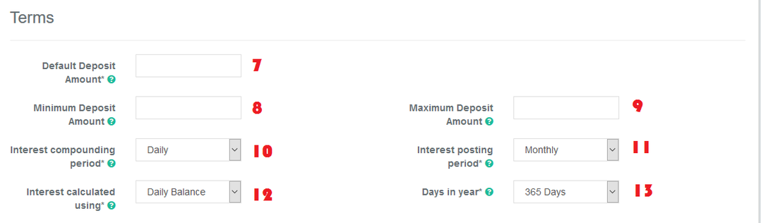

* 7 - Provide Default Deposit Amount

8 - Provide Minimum Deposit Amount

9 - Provide Maximum Deposit Amount

* 10 - Select Interest compounding period. For more information refer: [Savings Interest Calculation and Posting](https://mifosforge.jira.com/wiki/display/MIFOS/Savings+Interest+Calculation+and+Posting) Daily   
   Monthly  
   Quarterly   
   Semi-Annual   
   Annually
* 11 - Select Interest posting period - Interest get posted for the selected frequency period. For more information refer: [Savings Interest Calculation and Posting](https://mifosforge.jira.com/wiki/display/MIFOS/Savings+Interest+Calculation+and+Posting) Monthly   
   Quarterly   
   Semi-Annual   
   Annually
* 12 - Select Interest calculated using. For more information refer: [Savings Interest Calculation and Posting](https://mifosforge.jira.com/wiki/display/MIFOS/Savings+Interest+Calculation+and+Posting) Daily Balance   
   Average daily balance
* 13 - Select Days in year - depending upon your financial days in a year practice.   
   365 Days  
   360 Days

### Settings:

For detailed information on Fields refer: [Fixed Deposit Product Fields](https://mifosforge.jira.com/wiki/spaces/docs/pages/72253549/Fixed+Deposit+Product+Fields)

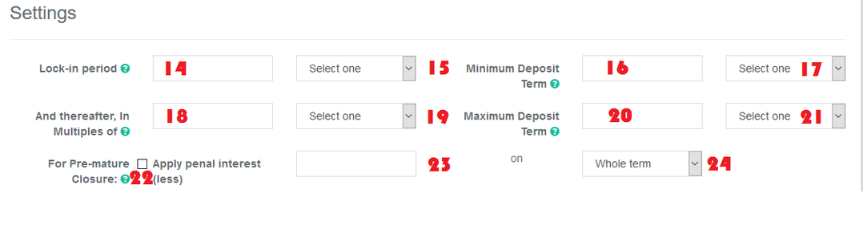

14 - Provide Lock-in period value

Example: 12 Months (*15 - freq) so for the 12 months it doesn't allow withdrawal.

15 - Select frequency

Days

Weeks

Months

Years

16 - Provide Minimum Deposit Term value

Example: 12 months (*17 - Freq), can set a minimum deposit term.

17 - Select frequency

Days

Weeks

Months

Years

18 - Provide thereafter in multiples of value

Example: Let's say the provided deposit term is 12 months and Provide thereafter in multiples of value is 3 months. Then creation of Fixed Deposit account will only be allowed every after 2 months like 14, 16, 18th month.(*19 - freq)

19 - Select frequency

Days

Weeks

Months

Years

20 - Provide Maximum Deposit Term value

Example: 36 months (*21 - Freq), can set maximum deposit term.

21 - Select frequency

Days

Weeks

Months

Years

22 - Check the check box to enable penalty, if there is a premature closure.

23 - Provide the percentage - penalty for premature closure.

Example: 1(%) will be deduced by the selected deduction type(*24).

24 - Select type of deduction

Whole term - As originally defined term.

Till premature withdrawal - Till the date of premature withdrawal.

## Interest Rate chart :

For info on amount range interest rate chart, please refer - [Interest rate chart with amount range](https://mifosforge.jira.com/wiki/spaces/docs/pages/121831466/Interest+rate+chart+with+amount+range)

For detailed information on Fields refer: [Fixed Deposit Product Fields](https://mifosforge.jira.com/wiki/spaces/docs/pages/72253549/Fixed+Deposit+Product+Fields)

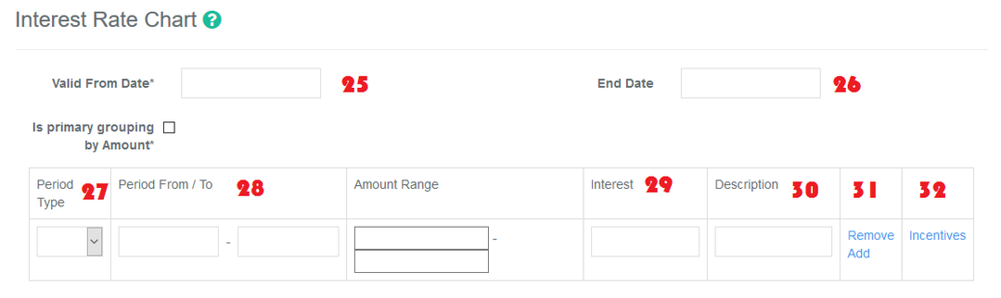

25 - Provide start date for the interest rate chart.

26 - Provide end date, in case if you want to stop the provided interest rates for the chart.

27 - Select period type

Days

Weeks

Months

Years

Example: Months

28 - Provide period value - From / To

Example: a) 1 - 12 months

b) 13 - 18 Months

29 - Provide rate of interest for the period.

Example: a) 8(%)

b) 8.5(%)

30 - Provide description for the table.

Example: a) 1 - 12 mnt - 8%.

b) 13 - 18 mnt - 8.5%.

31 - To add more interest on the interest rate table, click on Add button. To remove, click on remove button.

32 - Incentives - For detailed information on Fields refer: [Fixed Deposit Product Fields](https://mifosforge.jira.com/wiki/spaces/docs/pages/72253549/Fixed+Deposit+Product+Fields)

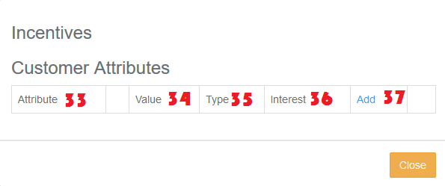

33 - Select Attribute from the drop down.

Example - Gender

34 - Select either one depending upon your needs:- Less then or Equal or Greater then or Not equal.

Example - Female

35 - Select Type:

Fixed - Provided value will be considered as the rate of interest. Example - 9%(*36).

Incentive - Provided value will be added to the interest rate chart. For example in the chart if it is defined as 8% and incentive is provided as 2%(*36) then the final interest value will be 10%.

36 - Provide the rate of interest. Example: 9% as shown in (*35).

37 - Click on Add(+) button to define more.

Example 1) Attribute - Gender, Equal, Value - Female, Type - Fixed, Interest - 9(%) then close the button to save.

Example 2) Attribute - Age, Greater then, Value - 60, Type - Incentive, Interest - 2(%) then close the button to save.

### Charges :

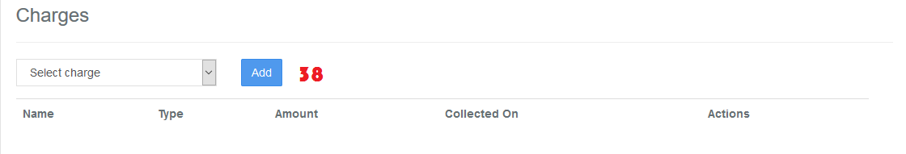

In order to use Add charge, you should have already defined it in charges. For more information on charges refer here: [Charges](https://mifosforge.jira.com/wiki/display/docs/Charges)

### 

### Accounting :

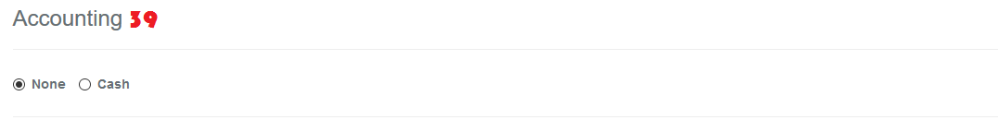

By default, Accounting will be disabled - None:- This means If you are using this product for various transactions like deposits, withdrawals,etc, these transactions are not passed in the journal entry.

Enabling accounting for the savings product:-

>> You should have created chart of accounts, for more information refer: <https://mifosforge.jira.com/wiki/display/docs/Chart+of+Accounts+and+General+Ledger+Setup>.

>> To enable Accounting, you need to select cash accounting. As of now, Mifos x supports only cash accounting for savings product.

* Cash

>> Map accounts with respect to the savings product accounts. For information on these accounts refer: [A Possible accounting Spec](https://mifosforge.jira.com/wiki/display/MIFOSX/A+Possible+accounting+Spec) - Accounting rules for savings.

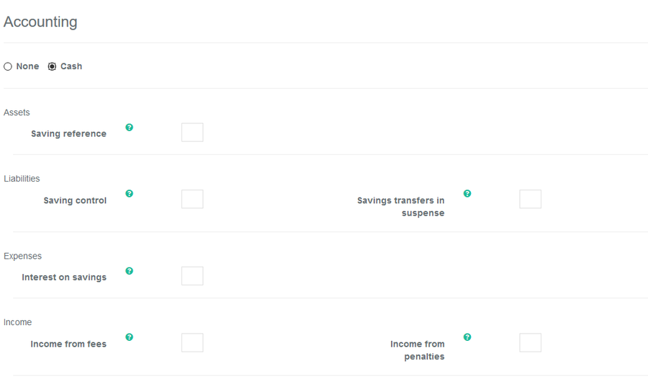

Advanced Accounting Rule

On clicking on the show button it enables the Advanced accounting rule.

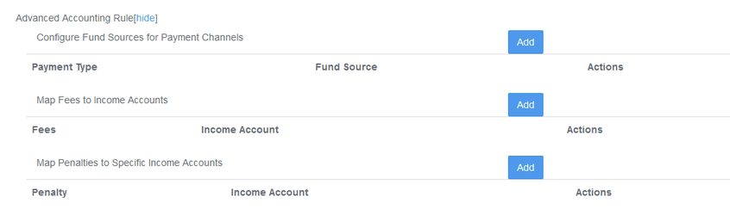

If you click on Add button, it will expand and show up selection drop-downs.

* Configure Fund sources for Payment Channels.   
  Example: In the image shown above, Payment type - Cheque is mapped to Fund source - Bank. So whenever payment type is used for transaction. Journal entry for Account - Bank will be passed.
* Map Fees to Income Accounts.
* Map Penalties to Specific Income Accounts

Click on Submit button to Save/Create savings product.

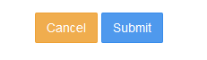

## Mifos X Accounting :

Step 1: Standard Financial Account Principles

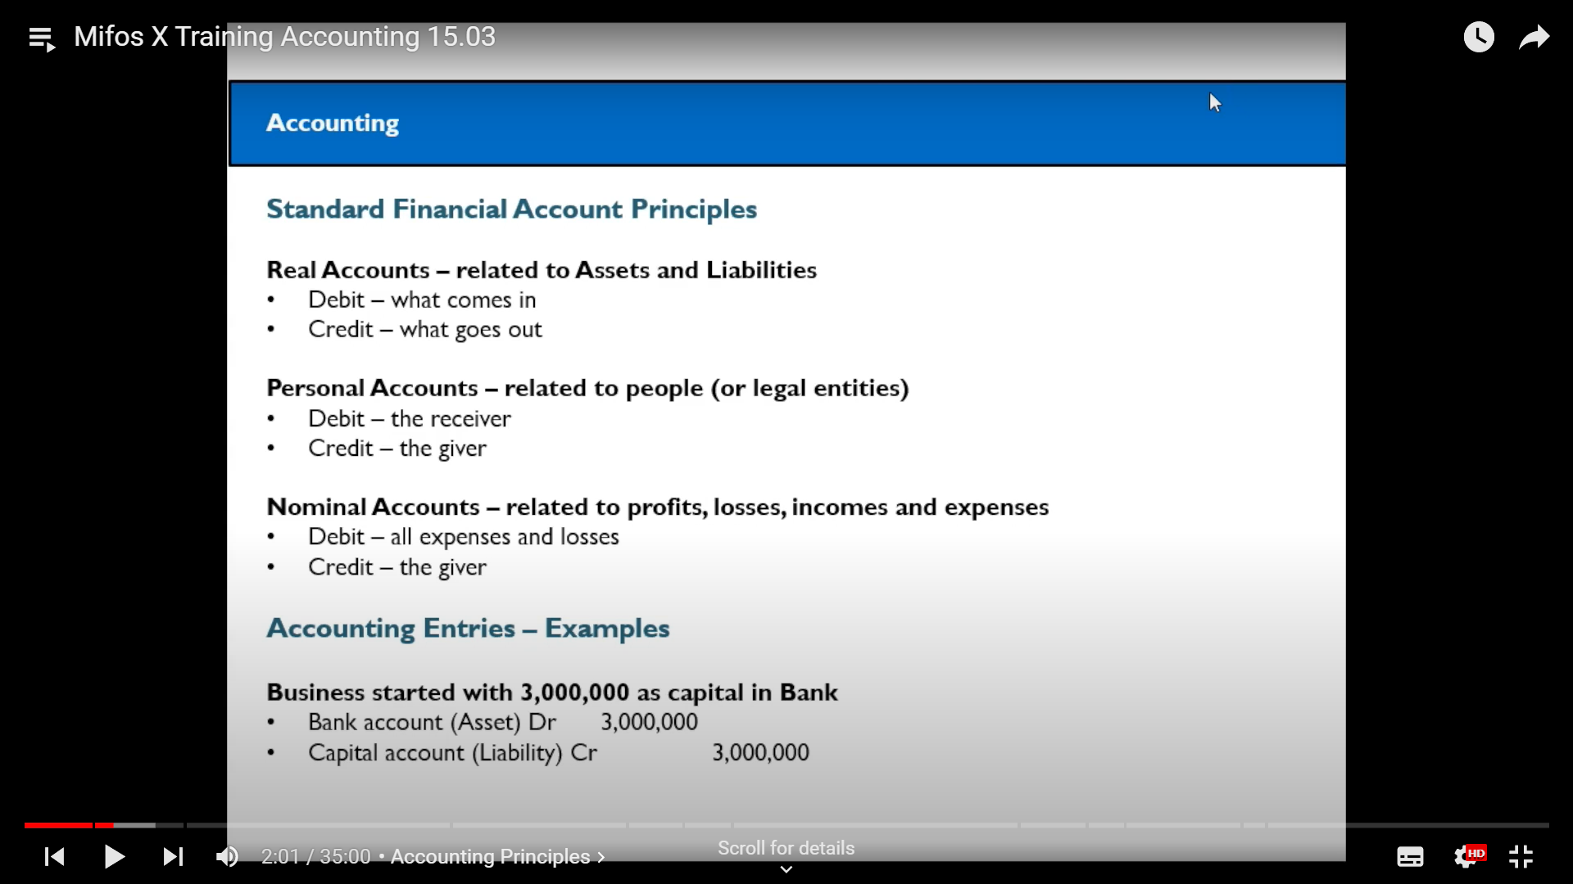

Step 2: Here are some examples

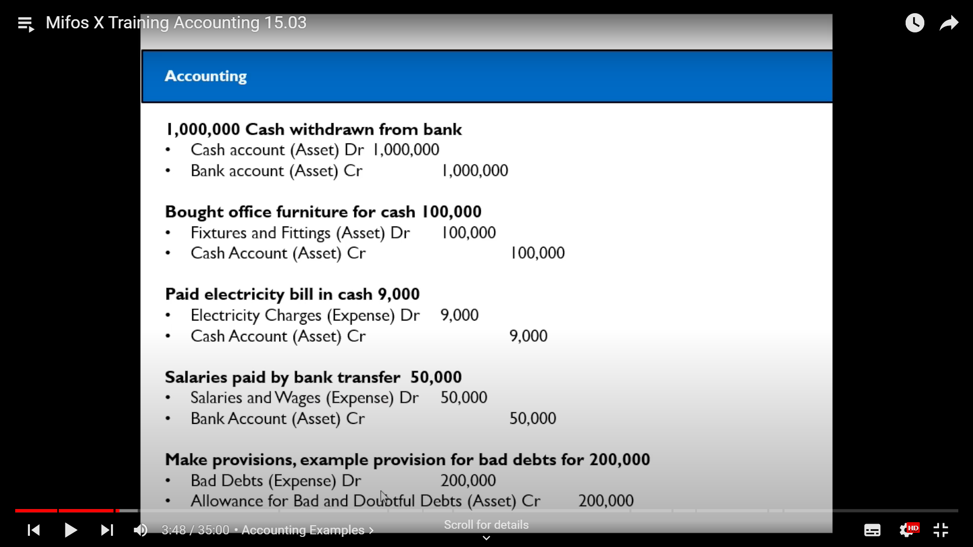

Step 3: Mifos Dashboard page

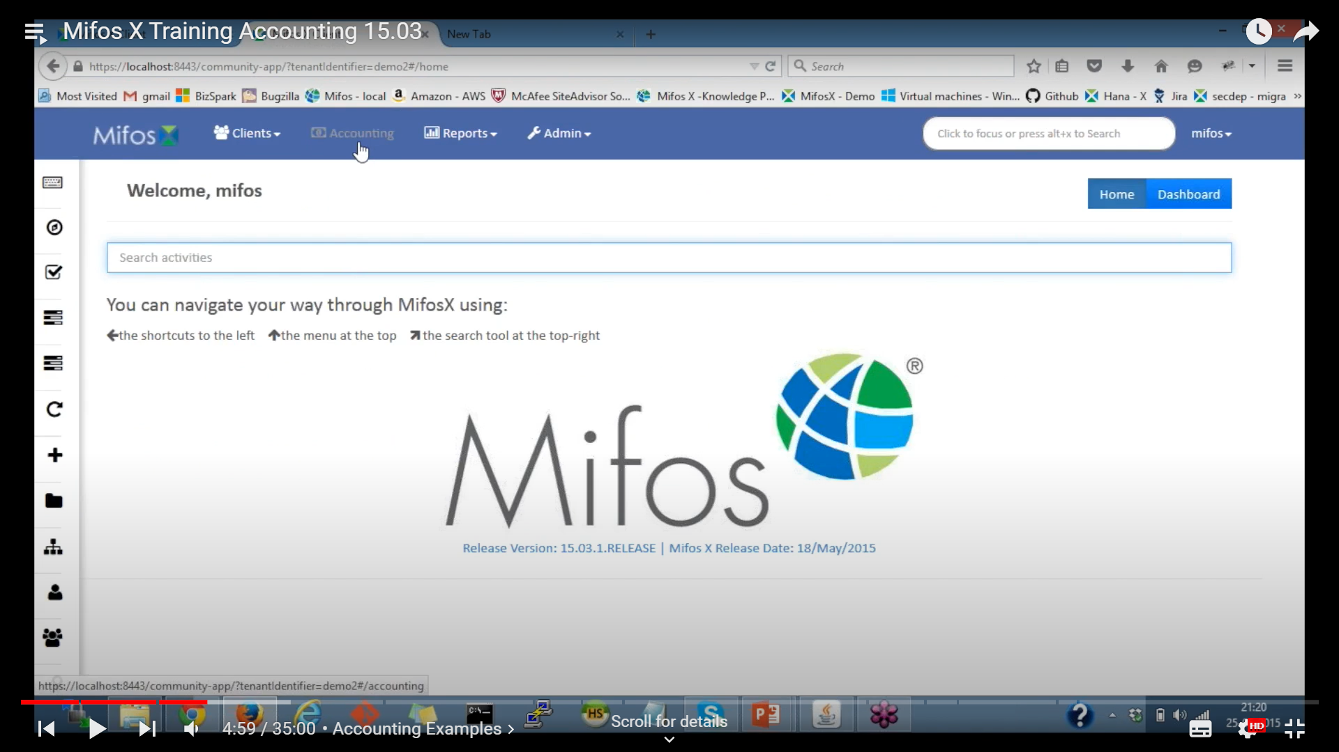

step 4: Click on Accounting Section

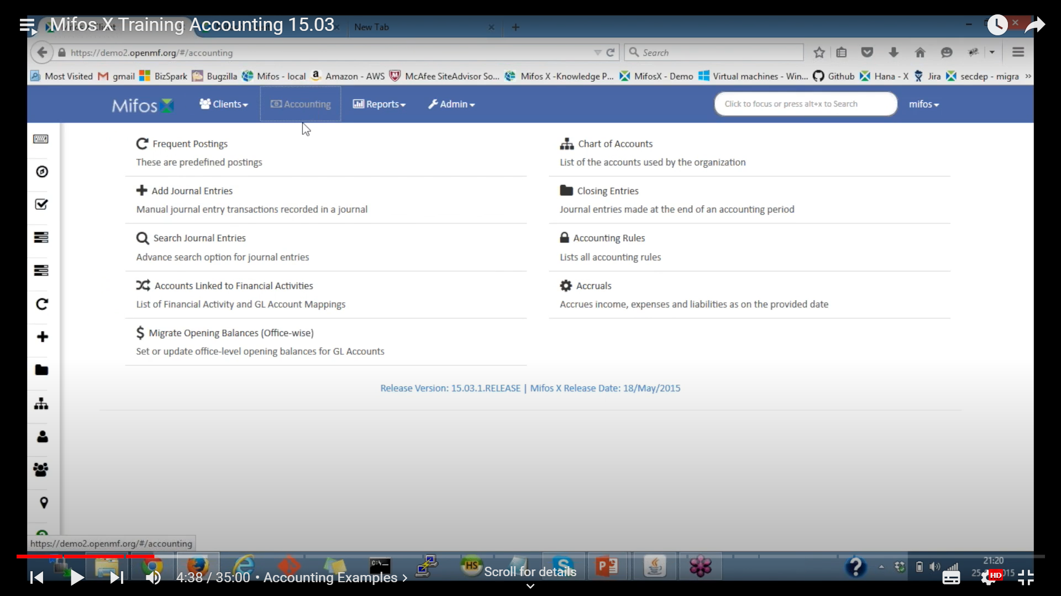

Step 5: Click on Chart of Accounts

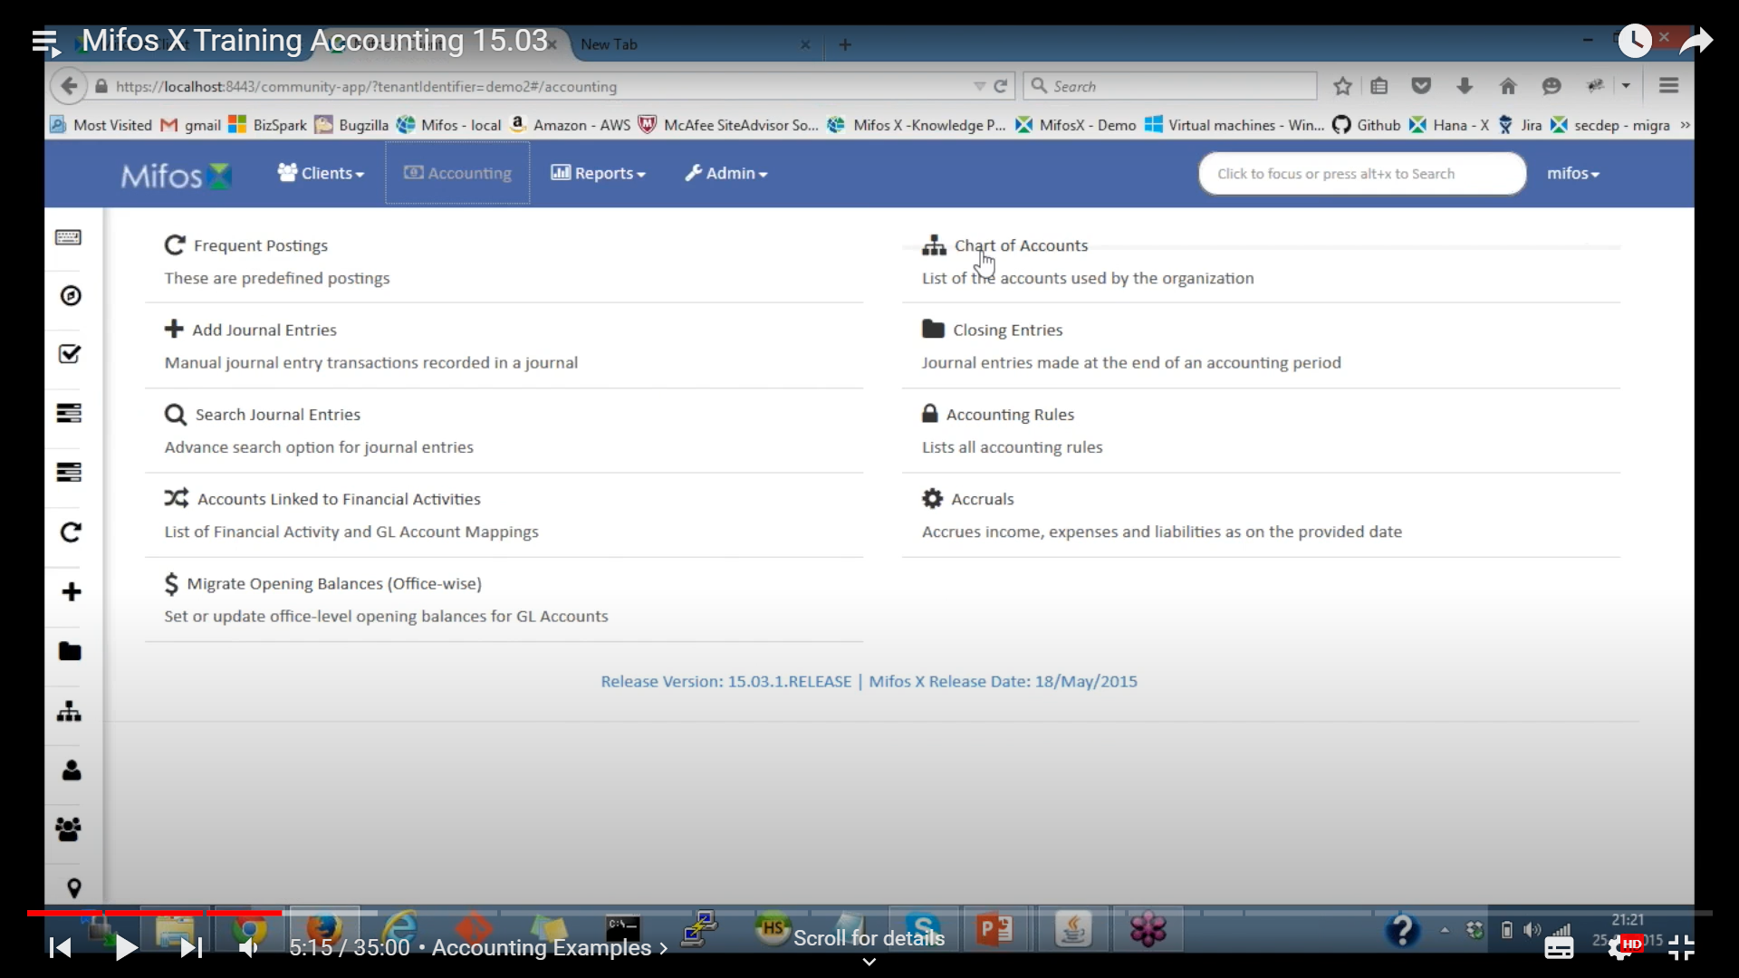

## 

## 

## 

## 

## 

## 

### How to Create GL Account?

1. On the Chart of Accounts page, click the  button at the top-right of the screen:  
     
   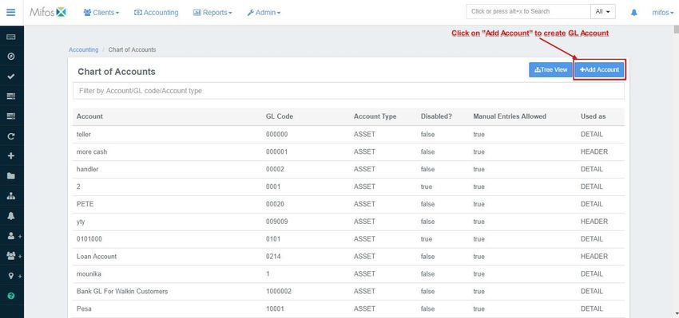
2. Select the **Account Type** from the drop-down menu.  
   Furthermore, fill in the optional information on the right side of the screen if you wish to do so.
3. Type the GL (General ledger) Code.  
   *For example: 10000*
4. Select **Header** from the **Account Usage** drop-down menu.  
     
   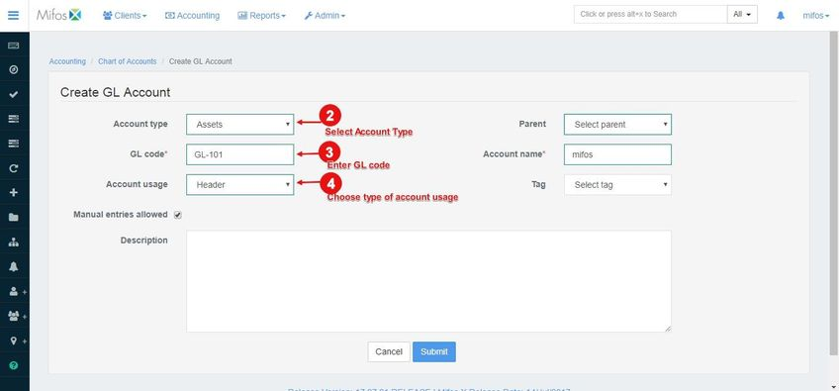
5. Select a **Parent** from the drop-down menu (*if required*).
6. Type the **Account name**.  
   *For example: Cash & Bank*
7. To allow **Manual Entries**, click on the check box next to it to make sure it is checked.
8. Select a **Tag** from the drop-down menu.

### How to Create Tag?

Navigate to **System** >> **Manage Codes**

1. In the Search Bar on the top of the page, type "tags", and a list of tags associated with assets, equity, expenses, income and liability will be displayed:  
    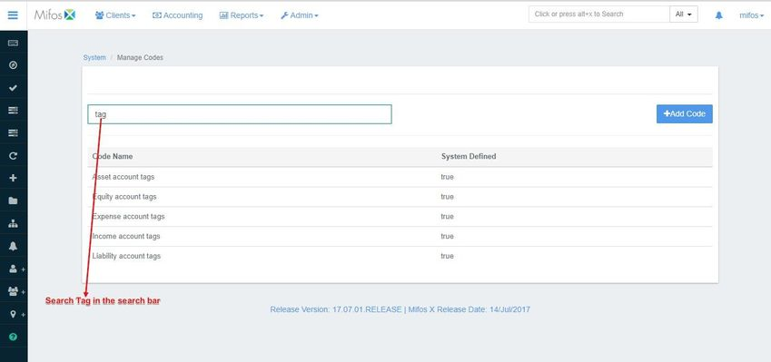
2. Click on the required type of tag. In this example, I'll be selecting "**Asset account tags**" and will create two types of asset tags: "**Bonds**" and "**Jewelry**" *(as shown in the screenshot below)*:  
    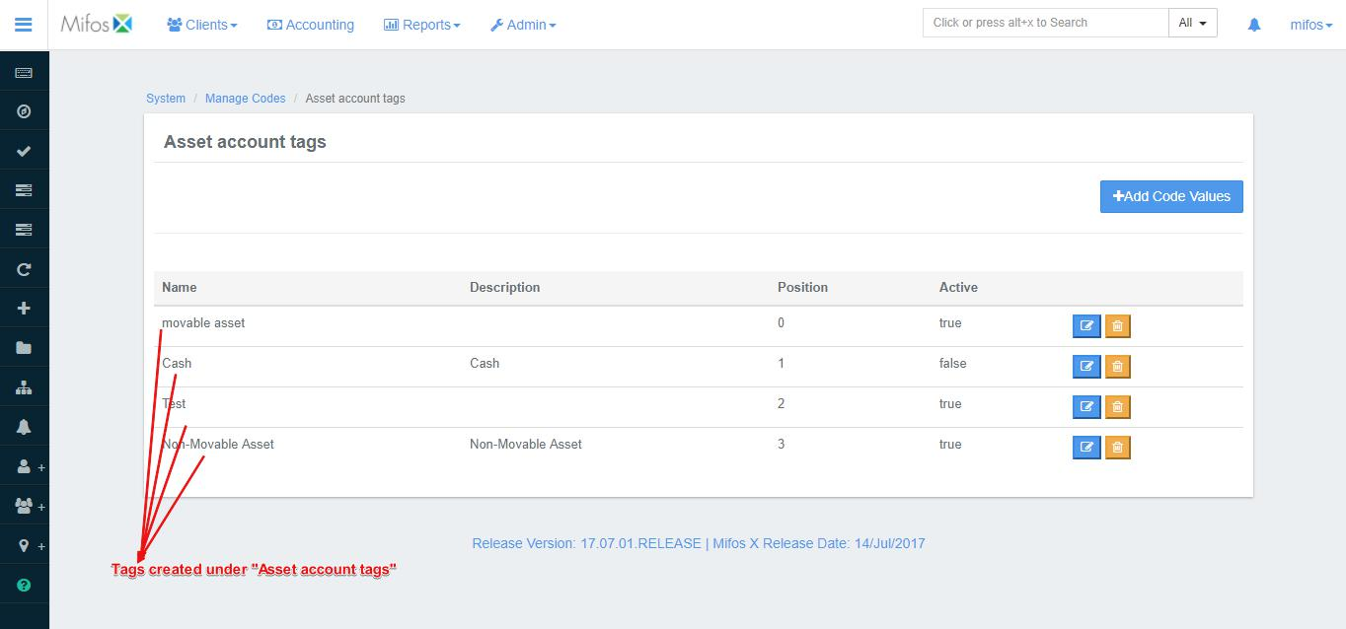
3. Once the tags are defined, go back to the GL Account Creation page and select "Account Type" as **Assets** under the "tags" drop-down menu. This will display the tags associated with **Assets**: 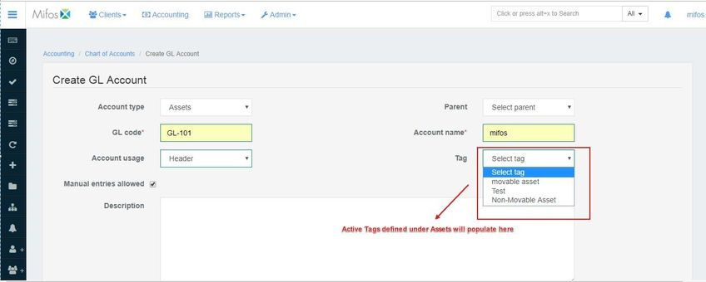
4. Type a **Description** in the text box provided:  
     
   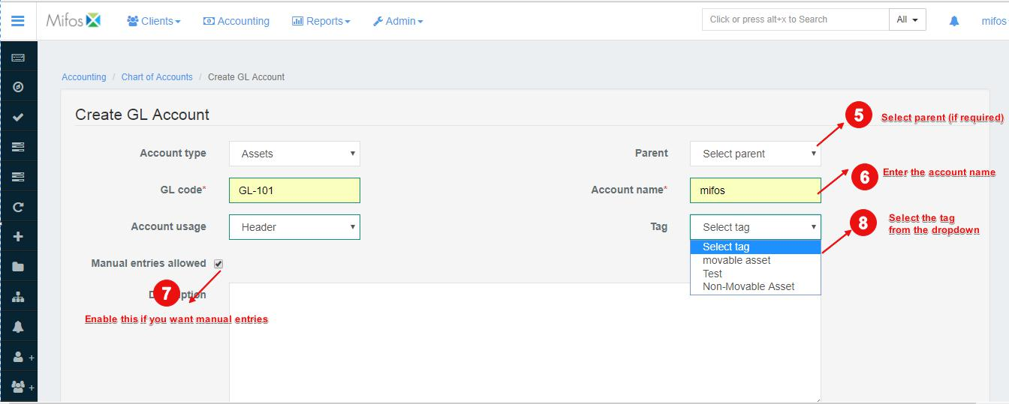
5. When you are done with filling all the fields, click on  .

## 

### How to Create Sub-ledger Account?

1. From the Chart of Accounts page, click on the existing GL Account which has **Account Usage** set as as **Header**. This will redirect you to a new page. Click on :  
     
   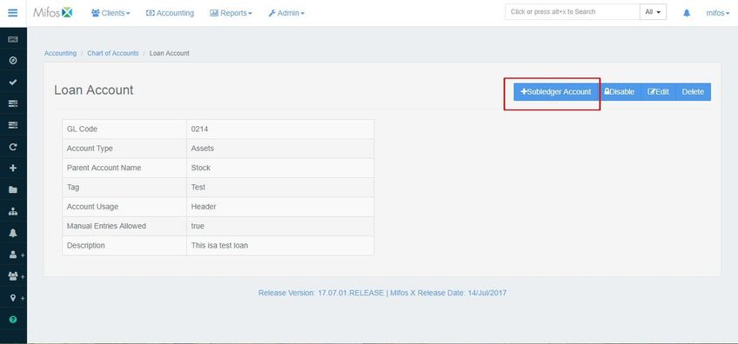
2. Type the **Account name**.
3. Next, fill in the **GL Code**.
4. Select **Detail** from the **Account Usage** drop-down menu.
5. To allow **Manual Entries**, click on the check box next to it to make sure it is checked.  
     
   
6. Next, fill in the optional information on the right side of the screen if you wish to do so.
7. Select the **Account Type** from the drop-down menu.
8. Select a **Tag** from the drop-down menu (which has been further documented in GL account creation).
9. Select a **Parent** from the drop-down menu.
10. Type a **Description** in the text box provided:  
      
    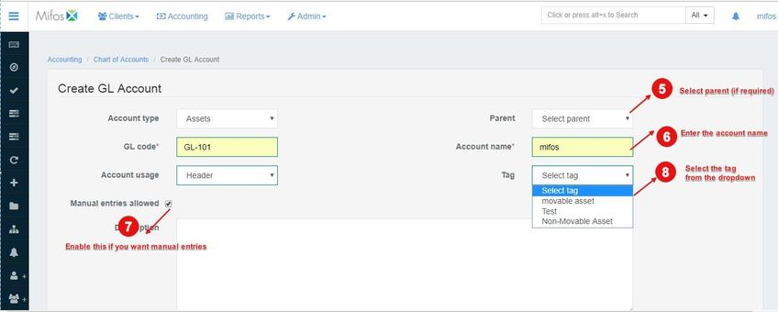
11. Click 

## 

## Overview of General Ledger Accounts :

Once you have navigated to the **Chart of Accounts** page, you will be presented with a chart of all the accounts being used by your organization. You may filter the results by typing any keyword in the **Filter by Account/GL Code/Account type** field. Alternatively, you may view this chart in a **Tree View** - please see the **View Chart of Account (Tree View)** section below to learn about this.

### 

### 

## View Chart of Accounts (Tree View):

There is an alternative way to view your accounts - using the **Tree View**. From the **Chart of Accounts** page, click the the blue **Tree View** button at the top-right of the screen.

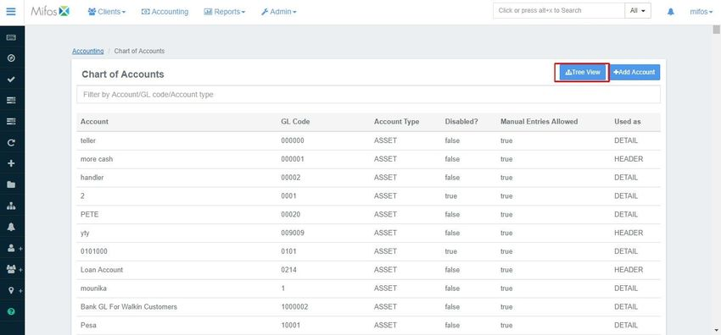

You will be taken to a new screen (with the same title as the previous one) having only one entry, with a small '**+**' sign on the left:

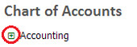

Click on the '**+**' sign to expand the tree. A typical result may look like the one shown in the screenshot below. This is an effective way to examine the structure of your organization's accounts within the Mifos system:

### 

## Edit, Disable or Delete an Existing Account:

You may edit, disable or delete an existing account by navigating to it's **Detail page**. You can do this by clicking on an account on the Chart of Accounts screen. Search for the account you would like to edit and click on it - it will be highlighted in blue when the cursor is hovering over it:

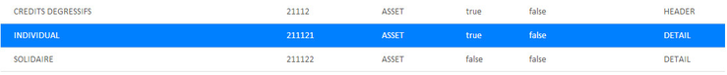

Once you click on the desired account you will be taken to a screen with more details for that account. An example of this has been shown below (*note the three blue buttons to the right of the screen*):

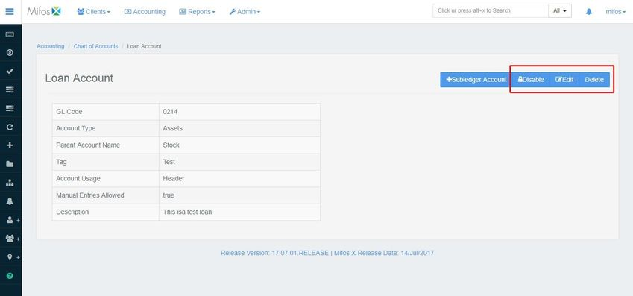

* To **Disable** the selected account, click the blue **Disable** button at the top-right of the screen. To re-enable it, click the button again.
* To **Delete** the selected account, click the blue **Delete** button at the top-right of the screen. This will launch a pop-up window - click the blue **Confirm** button to confirm the deletion of the account.
* To **Edit** the selected account, click the blue **Edit** button at the top-right of the screen. This will launch the **Edit GL Account** page:

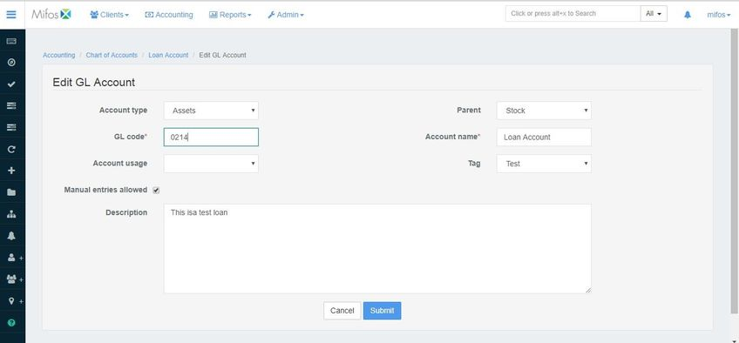

Once you are done making the necessary changes, click on .

## Accounts linked to Financial Activities:

Accounts linked to Financial Activities are mapped accounts which are needed to do system generating accounting transaction.

Below are the accounts which are needed to be mapped respectively

* **Asset transfer** - Should be an Asset - Account type.
* **Liability transfer** - Should be a Liability - Account type.
* **Main cash account or cash at vault** - Should be an Asset - Account type.
* **Cash at Tellers/cashier** - Should be an Asset - Account type, used for "Teller cashier management" feature.
* **Opening Balances transfer contra** - Should be an Equity - Account type, used for "Migrate opening balances" feature.
* **Fund source** - Should be an Asset - Account type.

## [Defining new mapping](https://mifosforge.jira.com/wiki/spaces/docs/pages/106430472/Accounts+linked+to+Financial+Activities#AccountslinkedtoFinancialActivities-Definingnewmapping)

Beginning at the main screen, click on [**Accounting**](https://mifosforge.jira.com/wiki/spaces/docs/pages/101384453/Accounting). This will launch the **Accounting** menu.

Select **Accounts linked to Financial Activities**

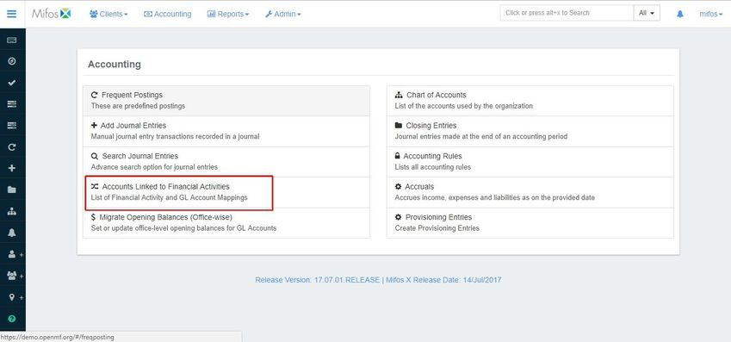

## Defining new mapping

Click on "**+Define New mapping**"



Select and edit the mapping as mentioned in the example below:-

**Financial activity**: Opening Balances Transfer Contra

**Account**: Opening Balances Contra Account(Equity account type)

Then click on **Submit**.

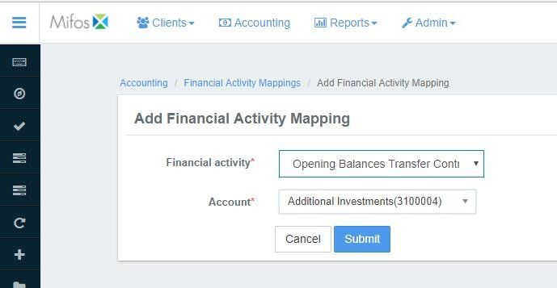

### Migrate opening balances (Office-wise) :

As a Head Accountant, I wish to set the opening balances for GL (General Ledger) accounts for a branch or an entire organization. This makes it easier for an organization wanting to move to Mifos to transfer GL account balances (from their existing accounting application or manual system) to Mifos X Accounting.

Beginning at the main screen, click on [**Accounting**](https://mifosforge.jira.com/wiki/display/docs/Accounting). This will launch the **Accounting** menu.

Select **Migrate Opening Balances**

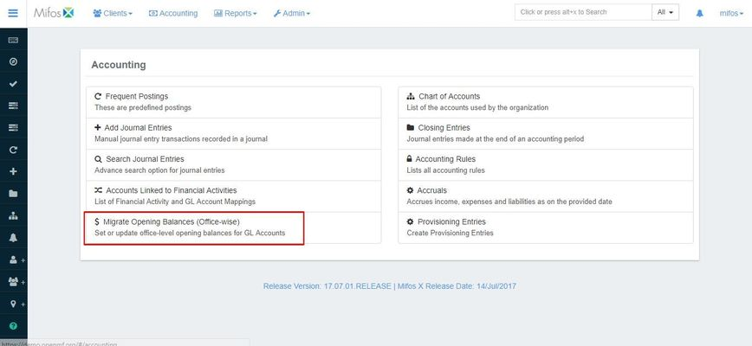

Step 1: Go to "Global configuration" (Admin>>System)

Enable "office-opening-balances-contra-account"



### Step 2: Go to "Chart of accounts" (Admin>>Accounting) .Create a Contra-account (for example. Opening Balances Contra-account, which would be an Equity account

Step 3: Go to "Accounts linked to Financial Activities" (Admin>>Accounting)

a) Click on "Define New mapping"



b) Select and update the mapping as mentioned below:-

**Financial activity**: Opening Balances Transfer Contra

**Account**: Opening Balances Contra -account

Then click on Submit.



Step 4: Go to Migrate opening Balances (Admin>>Accounting)

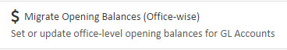

a) Select the desired office from the drop down

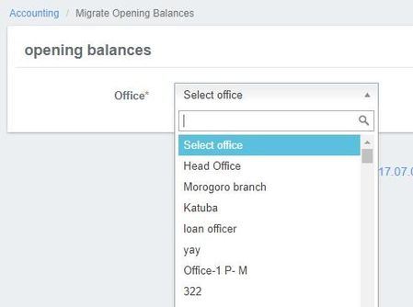

b) Select "Date of Opening Balance"

Select "Currency"

Enter Debit balance - Amount in the field box, with respect to your GL account.

Enter Credit balance - Amount in the field box, with respect to your GL account.

Then click on Submit button to pass the opening balance entries. 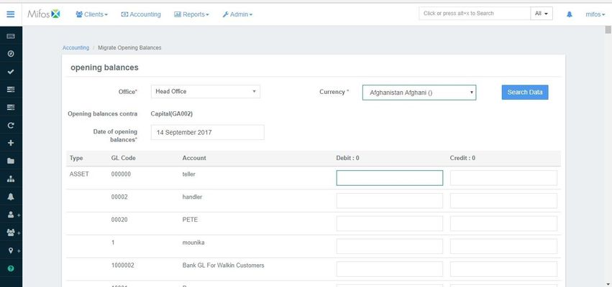

What happens if Opening balances are set after entering any journal entries in accounting system:

Be cautious that **Opening balances** are set before making any journal entry in accounting system. If you fail to do so, you won't be able to set the opening balance. Below are a few scenarios which should not be done before setting opening balance.

**Scenario 1:Don't Define a Loan Product With Accounting Enabled:**

* If you are setting up opening balances, make sure that you don't have any loan product with accounting enabled.

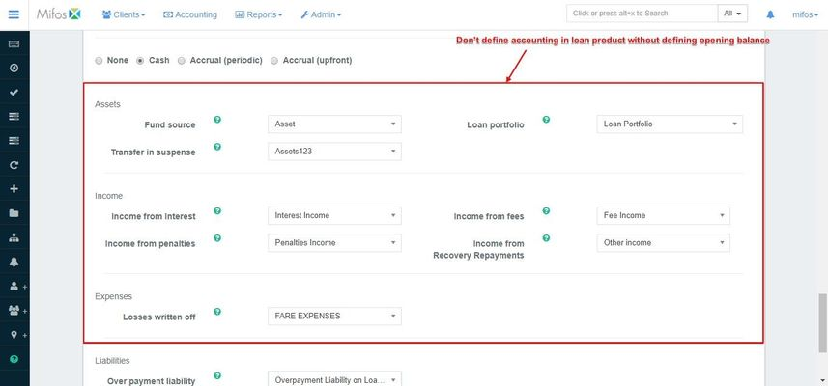

* In case you have loan product with accounting enabled and this loan product is linked with any of the clients, you won't b able to submit opening balances.  
  So make sure that while setting up opening balances you don't have any loan product with accounting enabled.

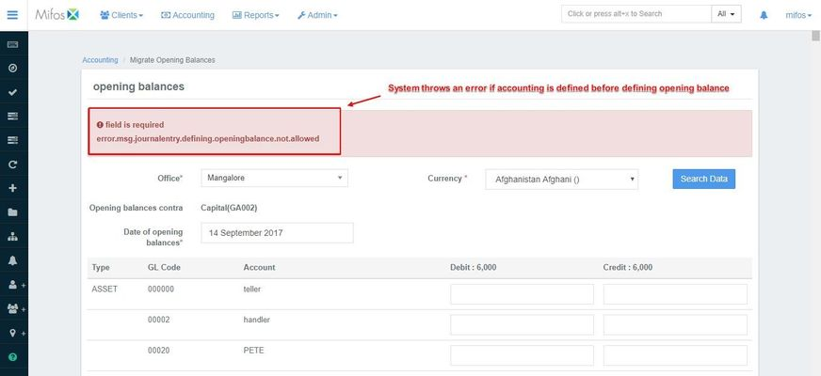

#### **Scenario 2: Don't Define a Savings Product With Accounting Enabled:**

* If you are setting up opening balances make sure that you don't have any savings product with accounting enabled.

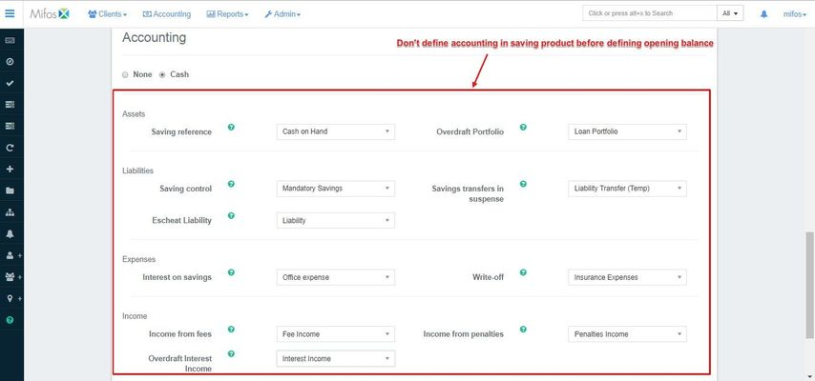

* In case you have savings product with accounting enabled and this savings product is linked with any of the clients, you won't be able to submit opening balances.So make sure that while setting up opening balances you don't have any savings products with accounting enabled.



### 

## Accounting Rules:

Mifos X supports **Accounting Rules** to ease the accountant’s tasks and reduce errors.

Accounting Rules are preconfigured accounting transactions in which debit and credit accounts available for posting are defined.

For example, you can configure an Accounting Rule for a payroll that will display only the expense accounts related to payroll debits and only the asset accounts available for credits.

Later you could use Frequent Postings to add an entry to your journal entry.

Beginning at the main screen, click on [**Accounting**](https://mifosforge.jira.com/wiki/display/docs/Accounting). This will launch the **Accounting** menu.

Select **Accounting Rules**

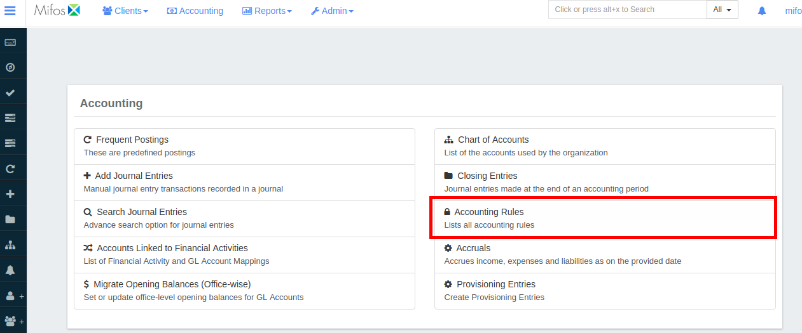

### 

### Create accounting rule :

Click on +Add Rule the page shown below opens.

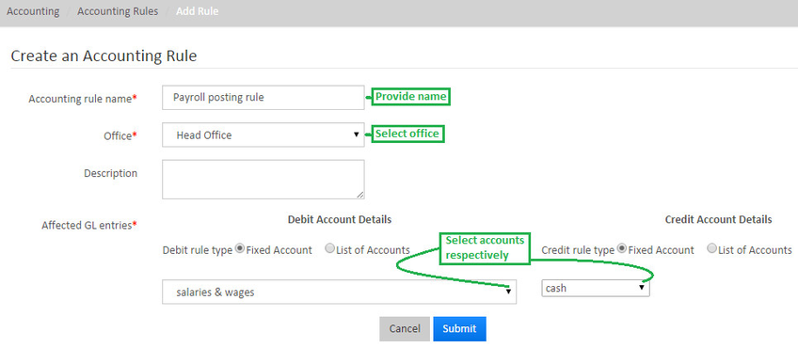

As illustrated in the image above, you need to provide details and click on **Submit** button.

## Multiple entries:

In case, you want to do multiple entries you need to create debit and credit Account Tags, and then assign the tags to expense and asset accounts. The tagged accounts can then be used to create an Accounting Rule.

For example: To create a payroll posting rule, create a debit Account Tag, “Payroll”, and assign it to each Expense Account you want available for payroll debits. Then create a credit Account Tag, “Cash,” and assign it to each Asset Account you want available for credits.

### To tag an account to be debited, do the following:

1. Create a debit Account Tag:
   1. On the Mifos toolbar, click **Admin,** andthen click **System** to open the System menu.  
      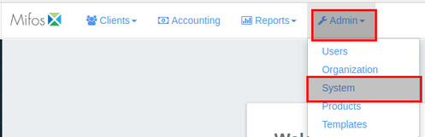
   2. On the System menu, click **Manage Codes** to open the **Manage Codes** dialog.  
      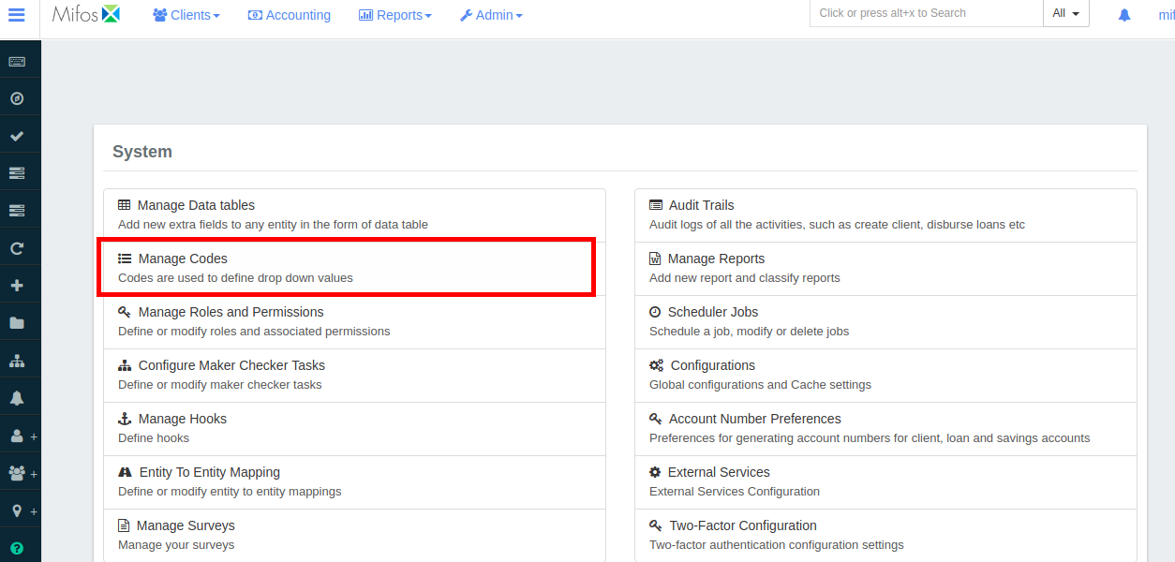
   3. In **Code Name** list, select **Expense Account Tags**.  
      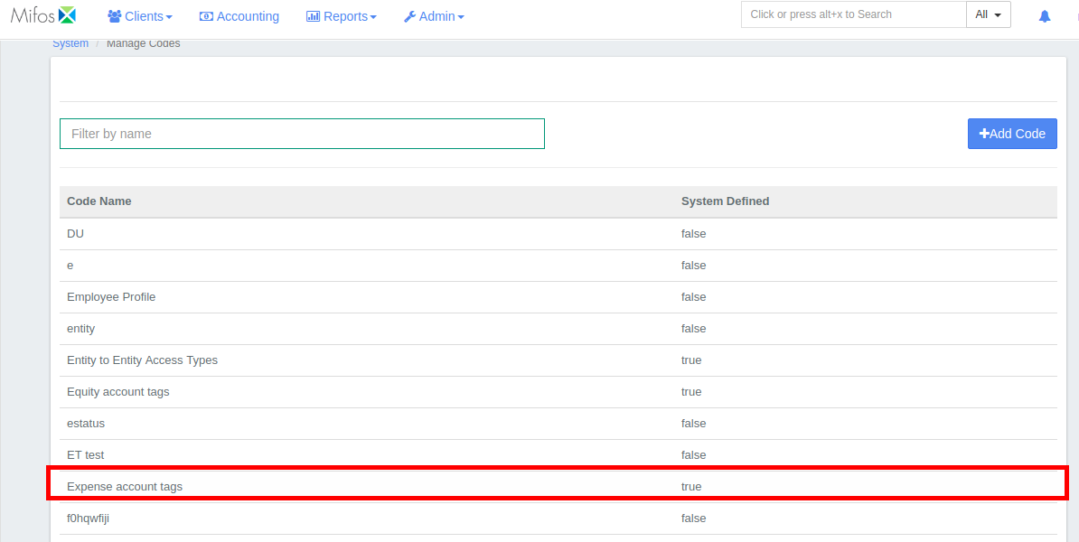
   4. In the **Expense Account Tag** dialog, click **+Add Code Value**.  
      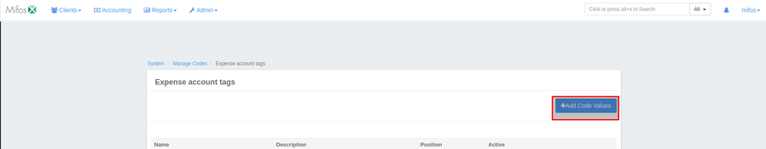
   5. In the **Code value** box, enter a name for your debit Account Tag code value, and then click **+Add** in blue.  
      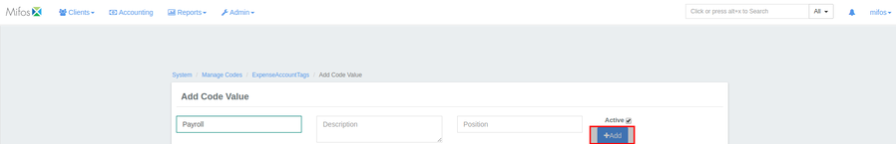  
      **NOTE:** To edit the code value, click the **Edit Code Value** button. To delete the code value, click the **Delete Code Value** button.  
      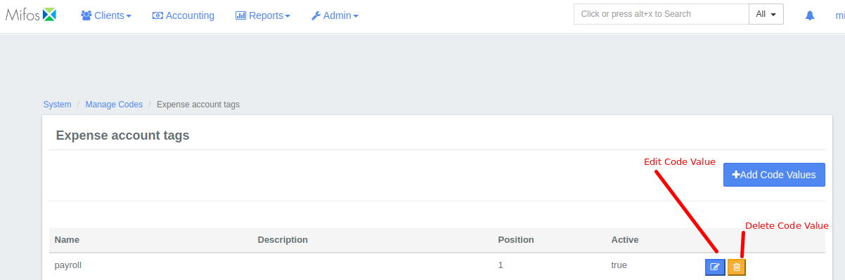
2. Assign Expense Account Tags to accounts you want available for debits using your Accounting Rule.
   1. On the Mifos toolbar, click **Accounting** to open the Accounting menu.  
      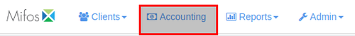
   2. On the Accounting menu, click **Chart of Accounts**.  
      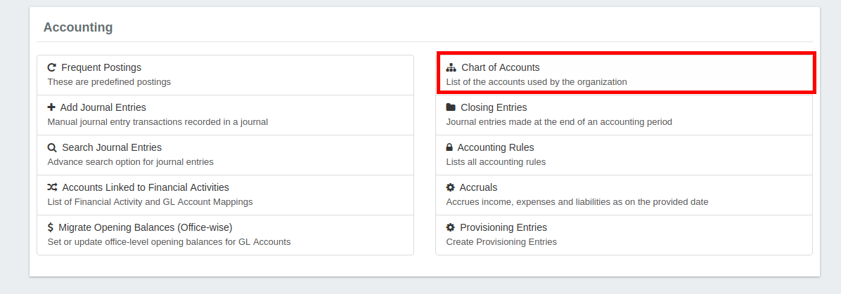
   3. In the **Chart of Accounts** list, click the account you want to tag.  
      **NOTE:** For debits, select from accounts with an Account Type EXPENSE.  
      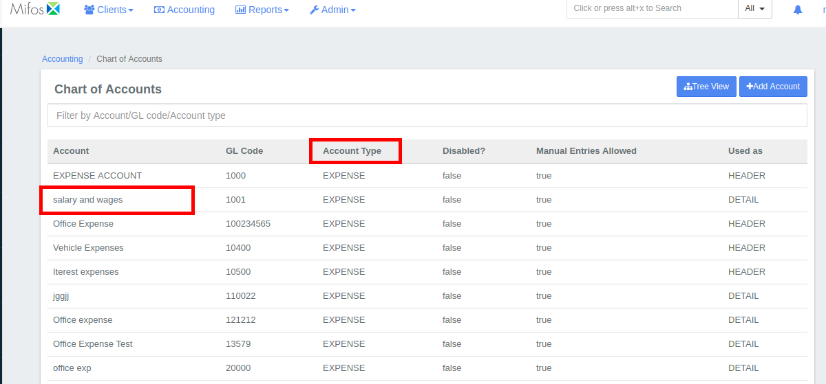
   4. Click **Edit**.  
      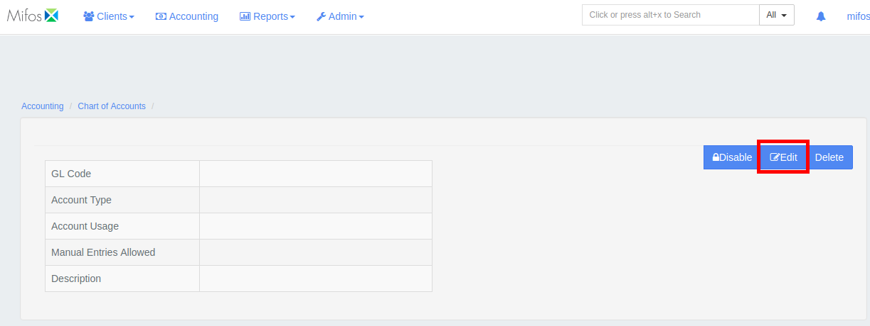
   5. In the **Edit GL Account** dialog, in the **Tag** list, select the expense account tag you want to assign to the account, and then click **Submit.  
      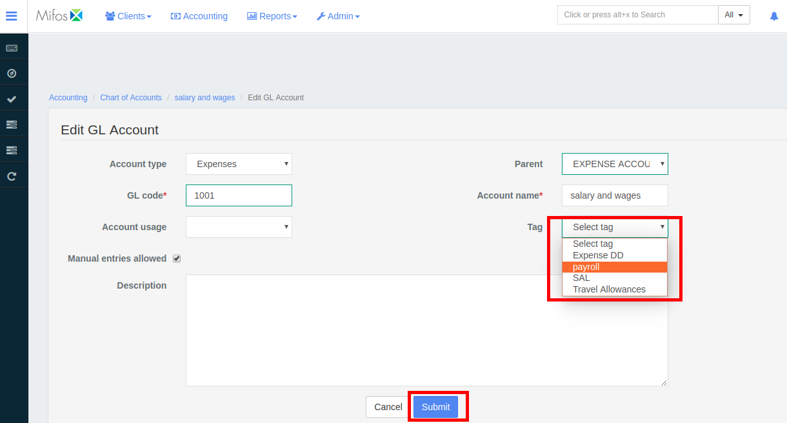**
   6. Repeat for each Expense Account you want your Accounting Rule to make available for debits.

### To tag an account to be credited, do the following:

1. Create a credit Account Tag.
   1. On the Mifos toolbar, click **Admin,** andthen click **System** on the drop down menuto open the System menu.  
      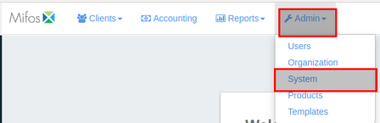
   2. On the System menu, click **Manage Codes** to open the **Manage Codes** dialog.  
      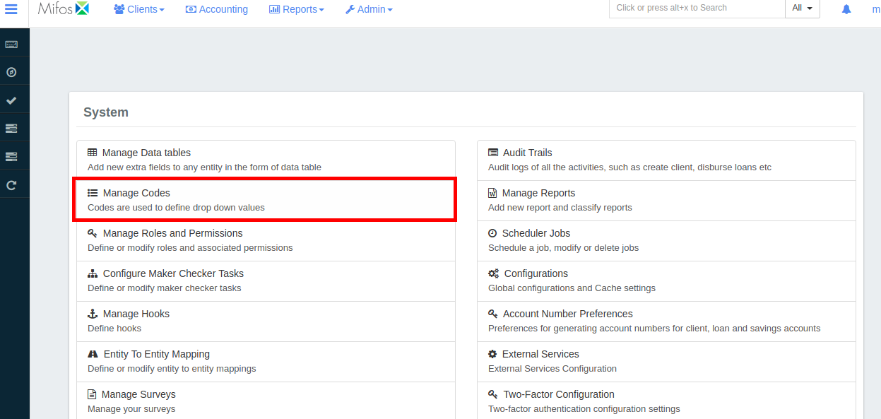
   3. In **Code Name** list, select **Asset Account Tags**.  
      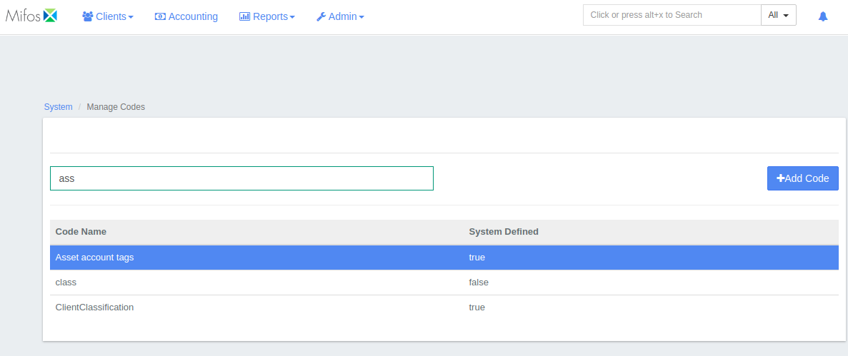
   4. In the **Asset Account Tag** dialog, click +**Add Code Value** at the top right corner of the window  
      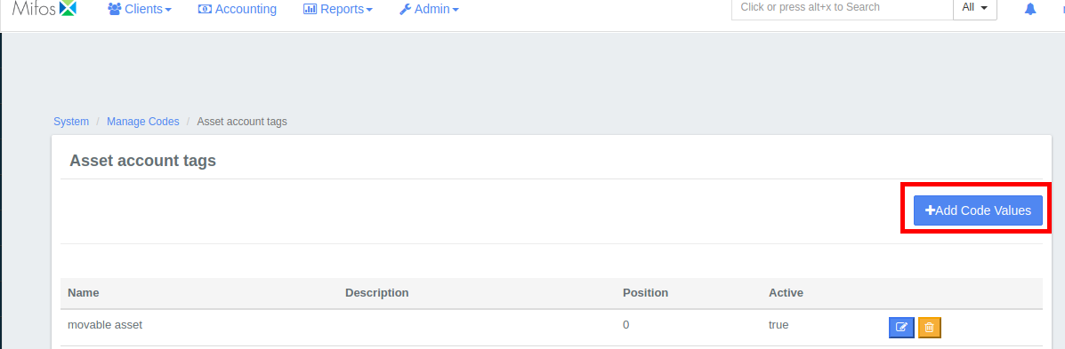
   5. In the **Code value** box, enter a name for your debit account tag code value, and then click **+Add**.
   6. **NOTE:** To edit the code value, click the **Edit Code Value** button. To delete the code value, click the **Delete Code Value** button.   
      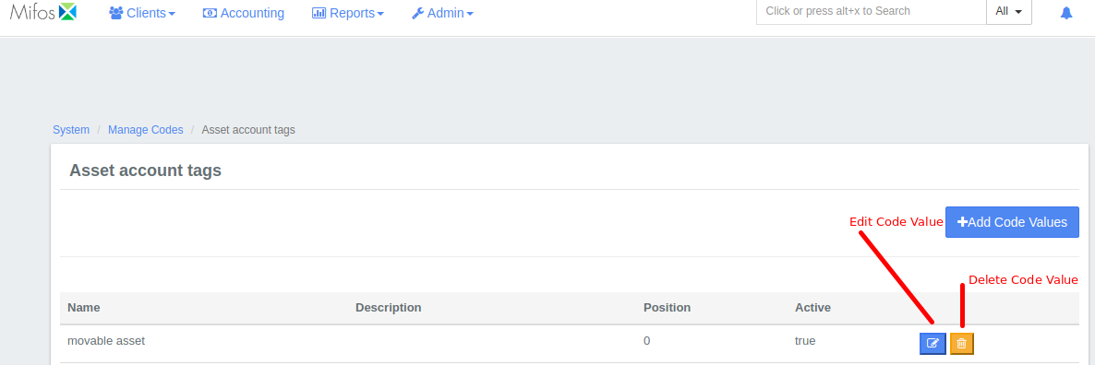
2. Assign Asset Account Tags to accounts you want available for credits using your.

## Accounting Rule

* 1. On the Mifos toolbar, click **Accounting** to open the Accounting menu.  
     
  2. On the Accounting menu, click **Chart of Accounts**.  
     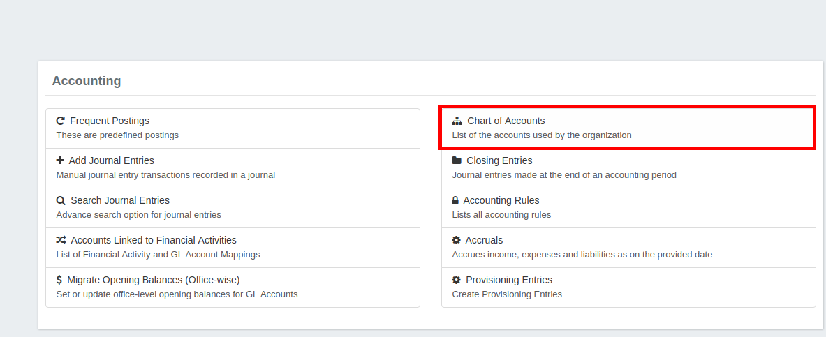
  3. In the **Chart of Accounts** list, click the account you want to tag.  
     **NOTE:** For credits,select from accounts with an Account Type ASSET.  
     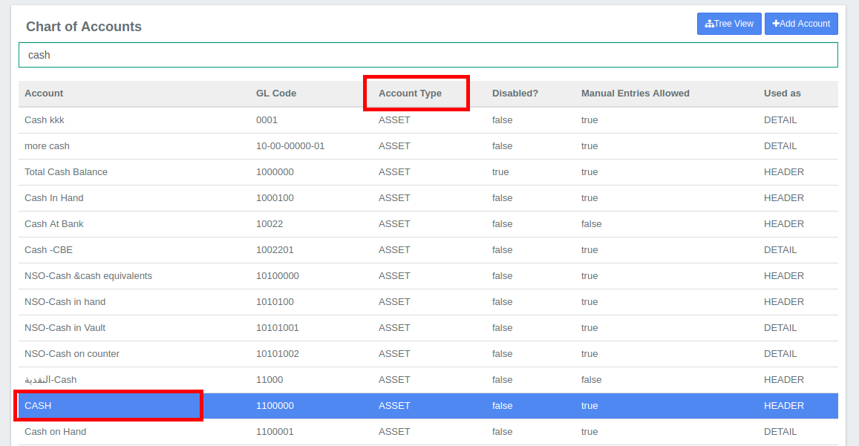
  4. Click **Edit**.  
     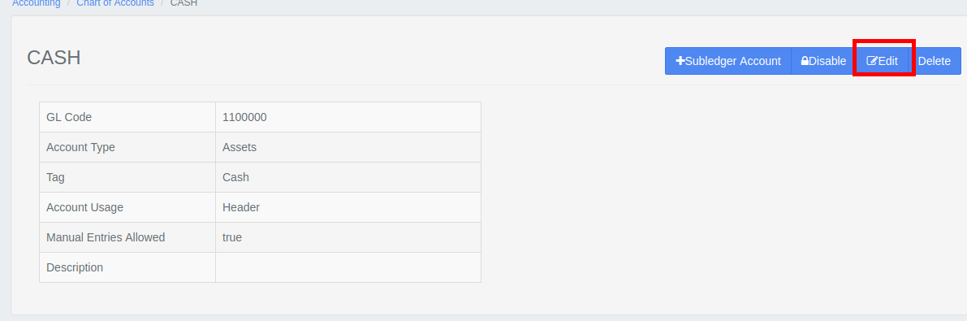
  5. In the **Edit GL Account** dialog, in the **Tag** list, select the asset account tag you want to assign to the account and then click **Submit.  
     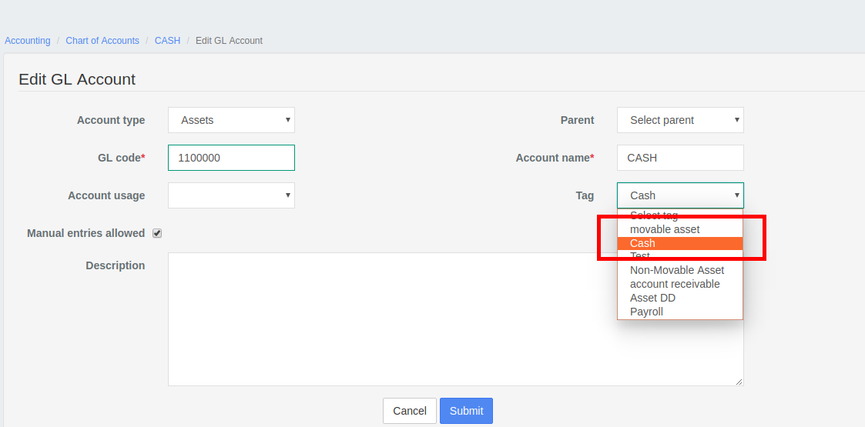**
  6. Repeat for each Asset Account you want your Accounting Rule to make available for credits.

Go to Accounting then go to Accounting rules; by doing the following:

1. On the Mifos toolbar, click **Accounting** to open the Accounting menu.  
   
2. On the Accounting menu, click **Accounting Rules** to open the **Accounting Rules** dialog.  
   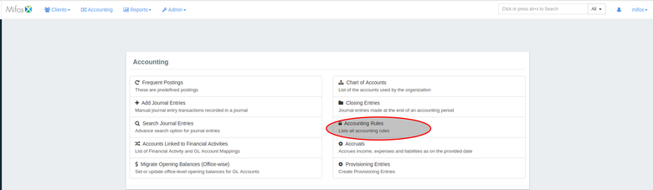
3. Click **+Add Rule** to open the **Add Rule** dialog.  
   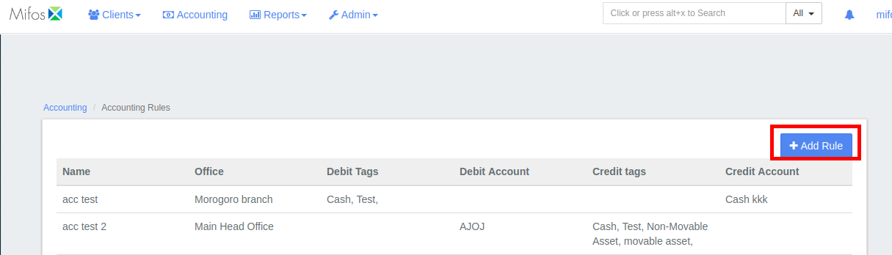
4. In the **Accounting rule name** box, enter a name for your new accounting rule.  
   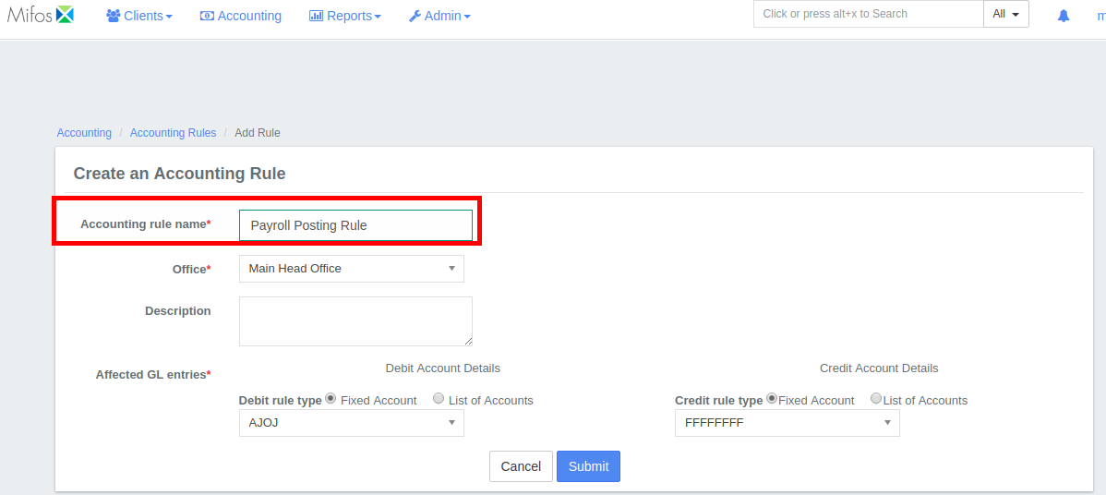
5. In the **Office** list, select an office.  
    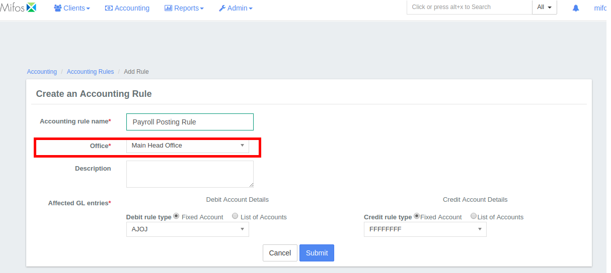
6. In the **Description** box, enter an optional description.  
    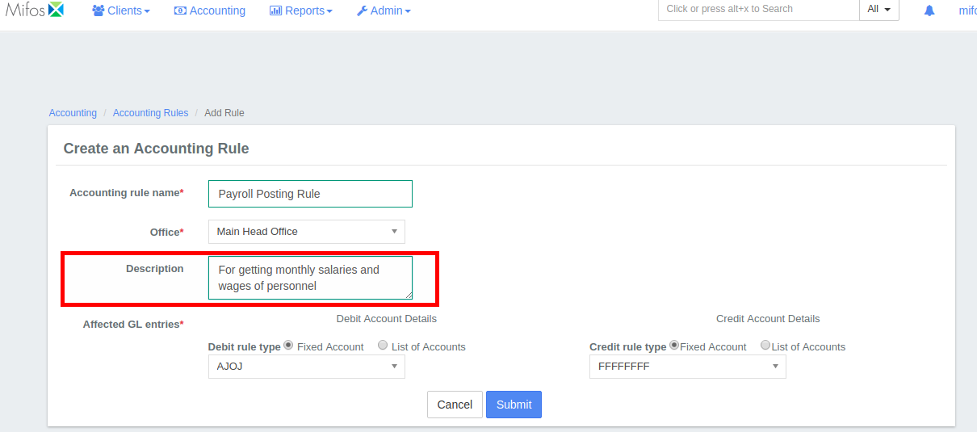
7. Under **Affected GL entries**, set the Credit and Debit rules.

### To set the Debit rules:

* + 1. Under **Debit** **Account Details,** select **List of Accounts.  
       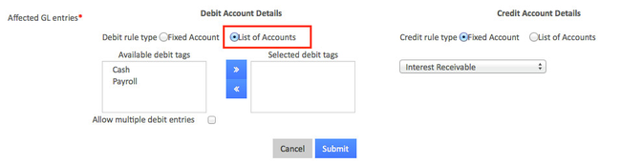**Select an account from the **Available debit tag** list, and then click the right arrow (**>>**) button to add the account to the **Selected debit tag** list.   
       **NOTE:** To allow multiple debit entries select **Allow multiple debit entries.**

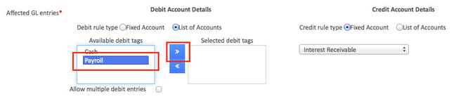

### To set the Credit rules:

* + 1. Under **Credit** **Account Details,** select **List of Accounts.  
       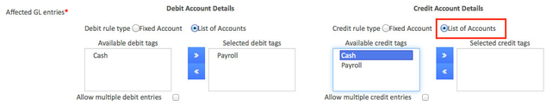**
    2. Select an account from the **Available credit tag** list, and then click the right arrow (**>>**) button to add the account to the **Selected credit tag** list.   
       **NOTE:** To allow multiple debit entries select **Allow multiple credit entries.  
       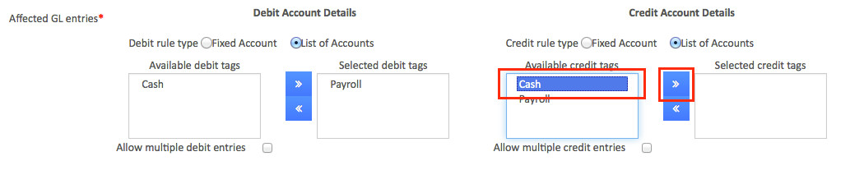**

1. Click **Submit** to post your new accounting rule.

## View Accounting rule:

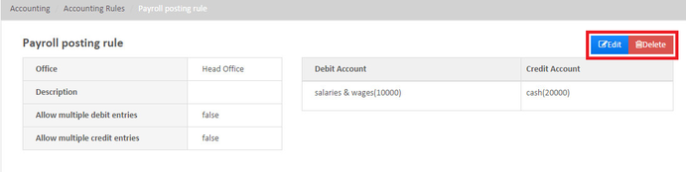

### Edit or Delete Accounting rule:



To **Edit**

Click on **Edit** button in blue, then modify necessary changes and click on Submit.

To **Delete**

Click on **Delete** button in red, then click on confirm.

## Provisioning Entries

#### **From the main screen, click on** [**Accounting**](https://mifosforge.jira.com/wiki/spaces/docs/pages/101384453/Accounting)**. This will launch the** [**Accounting**](https://mifosforge.jira.com/wiki/spaces/docs/pages/101384453/Accounting) **menu as shown below, from the menu Select Provisioning entries.**

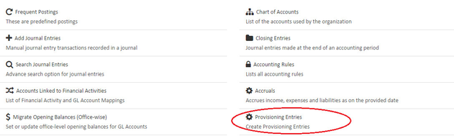

Note: You should have created [provisioning criteria](https://mifosforge.jira.com/wiki/spaces/docs/pages/110690306/Loan+Provisioning+Criteria) and once a loan falls under arrears, provisioning entries will work.

### Create Provisioning Entries :

**System generated** - Once the provisioning criteria is created on the loan areas depending upon the criteria set, then provisioning entries will be created automatically. A scheduler job "Generate loan loss provisioning" will execute this process.

**Creating Manually** - Click on the blue **Create provisioning entries** button at the top-right of the screen.

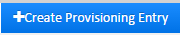 This will launch a new page like the image shown below:

Take note that this field is mandatory as it has an asterisk(*)

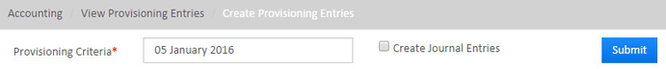

**Complete** the required fields:

* 1. Select **Date**.
  2. Optional field - Check the check box for **Create Journal Entries**.
  3. Click on **Submit** button.

### View provisioning entry :

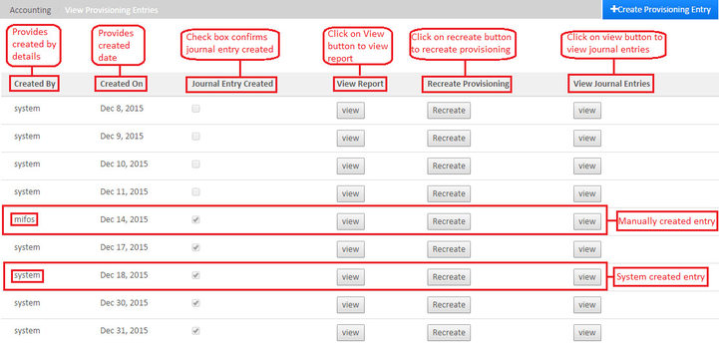

**Complete** the required fields:

* 1. **Created By** - Provide details of created by .
  2. **Created On** - Provide date of creation .
  3. **Journal Entry Created** - Check box confirms journal entry created.
  4. **View Report** - Click on view button to view report.
  5. **Recreate Provisioning** - Click on recreate button to recreate provisioning.
  6. **View Journal Entries** - Click on view button to view journal entries.
  7. Click on **Submit** button.

View **Journal entry**

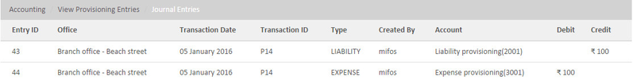

## Print General Ledger Listing:

1. Navigate to **Admin,** select **Systems** and click **Manage Reports,** nowclick on **+Create report** from the menu displayed which looks like the image shown below:

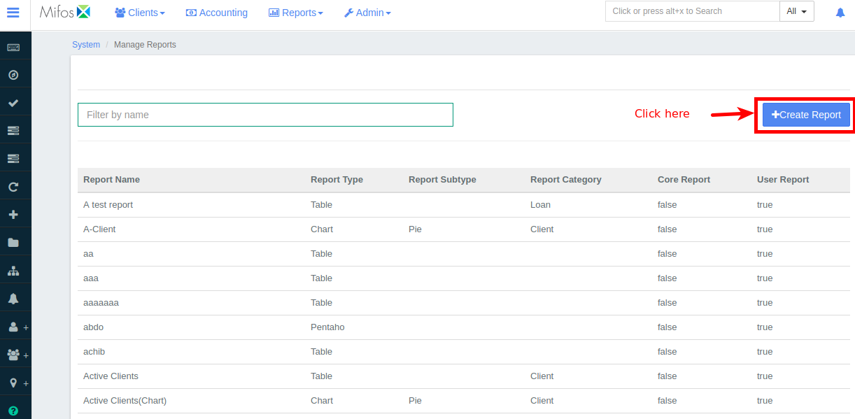

2. Enter the details for '**Report Name','Report Category', 'User Report'** fields.

Report category must be specified as "**Accounting**"

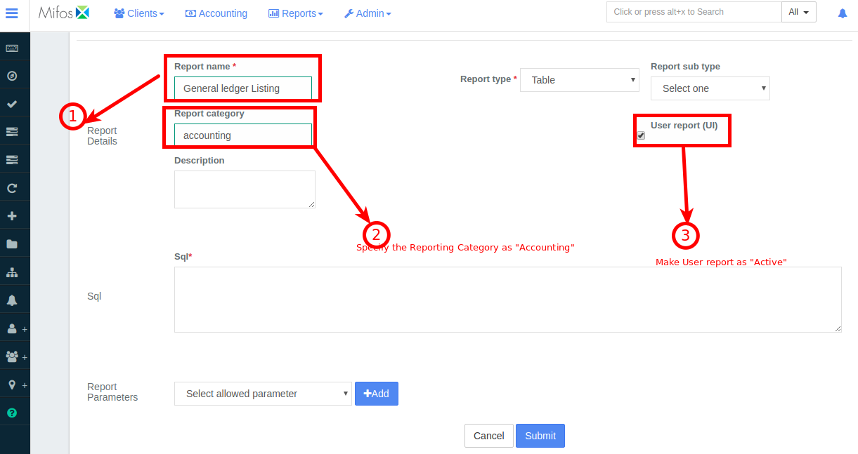

3.Next in the field provided for '**Sql**', paste the below query:

**Query**

select gl_code, name

From

acc_gl_account

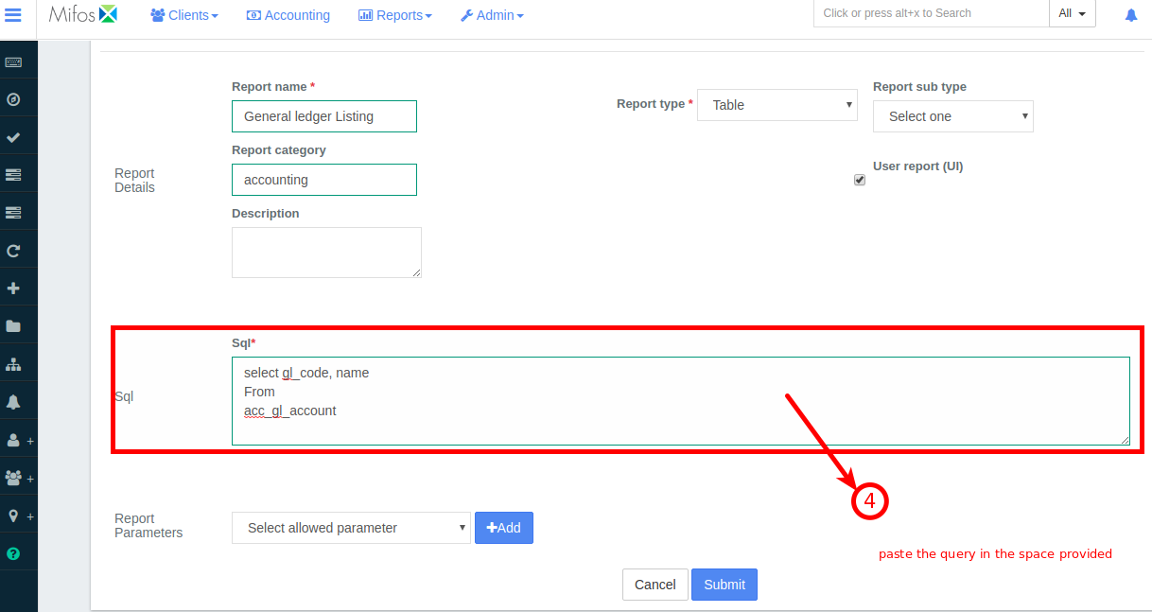

4. Click 

### How to Print?

1. Navigate to **Reports** then select **All** from the drop down menu. In search bar "**Specify the same report name provided at the time of report creation**"

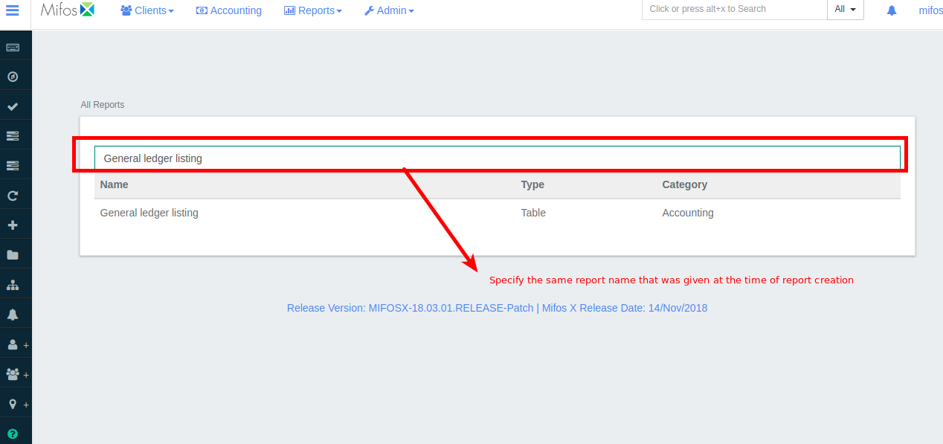

2. Click on the report.

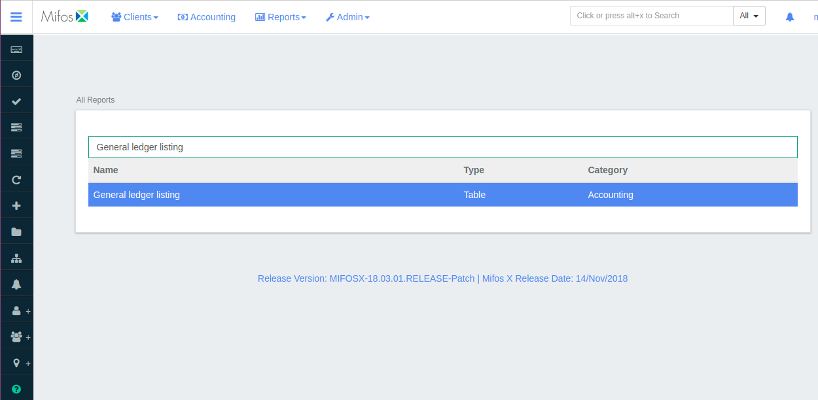

3. Click 

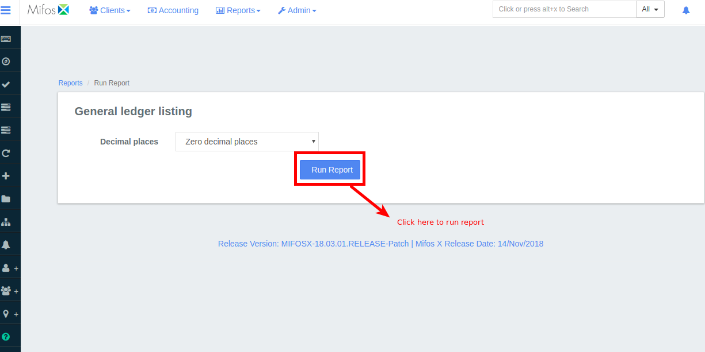

4. Once "**Run Report**" is clicked all the **Chart of Accounts** are displayed.

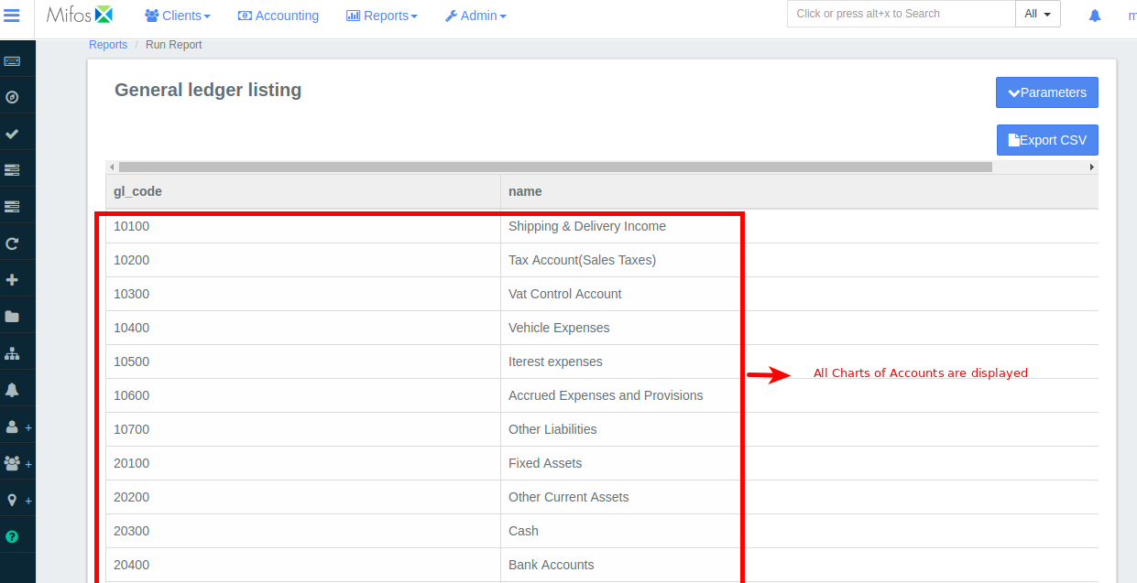

5. To **Print** the general ledger listing click on 

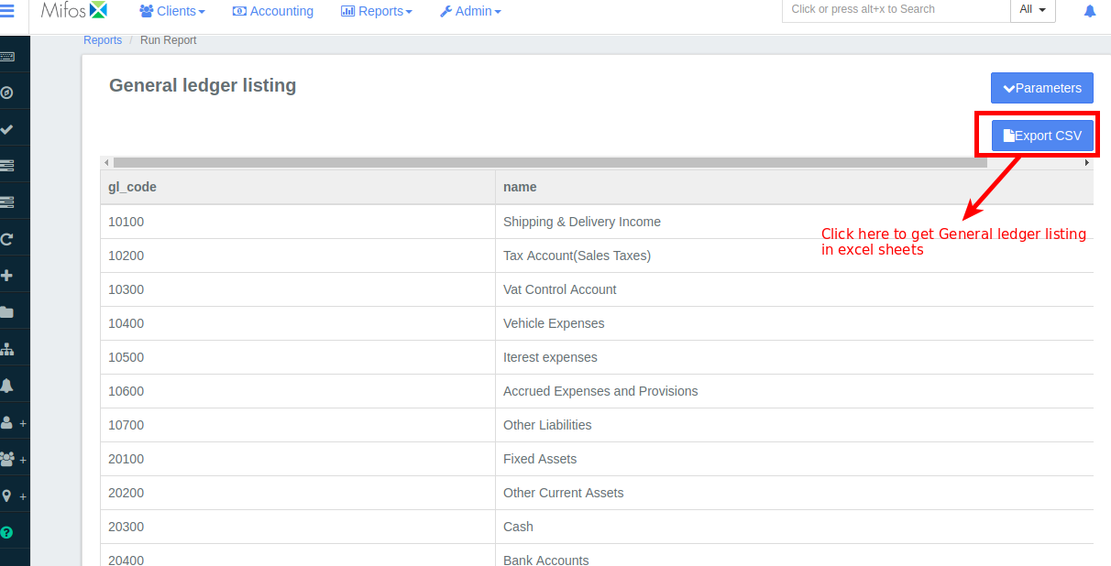

### How To Enter GL Opening Balance

The **opening balance** is the first entry in a firm's accounts, either when they are first starting up or at the start of a new financial year.

The **opening balance** can be found on the credit or debit side of the ledger, depending on whether or not the firm has a positive or negative balance.

**Step 1:** Navigate to **Accounting** then select **Chart of Accounts** from the menu which looks like the one shown below;

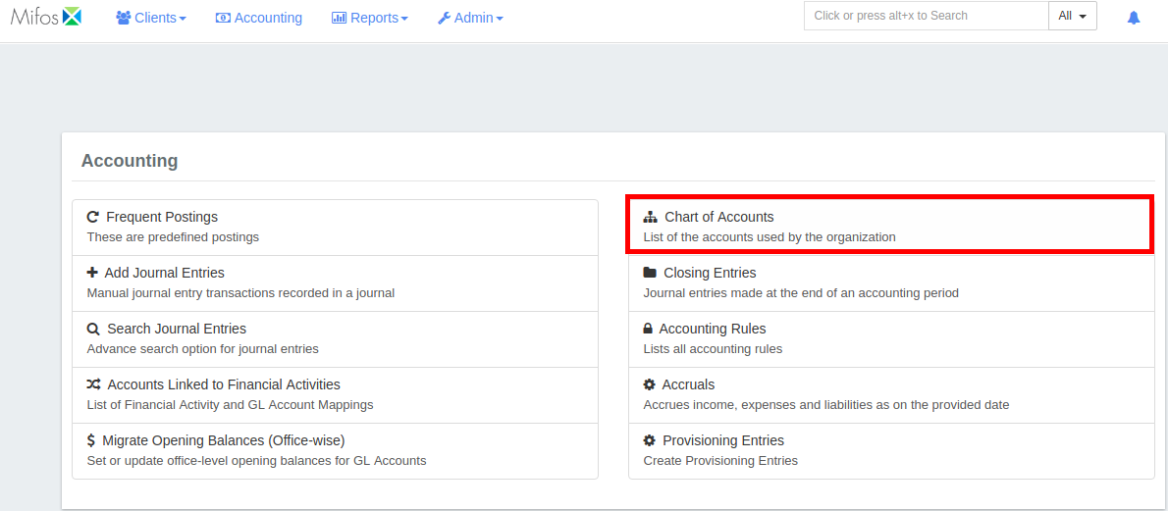

**Step 2:** Click on **+Add account**

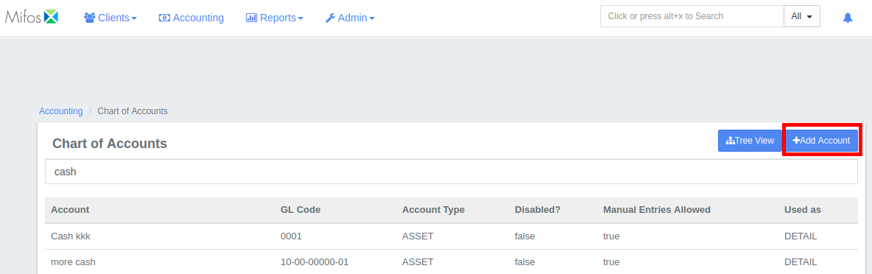

**Step 3:** Create GL accounts for **Assets, Liabilities, Income, Expenses,** Here I am adding it for "**Assets**"

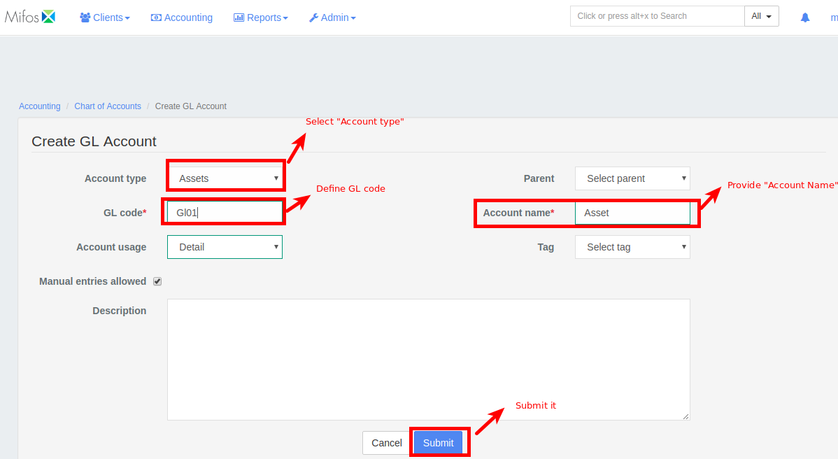

**Step 4:** Similarly create GL accounts for **Liabilities**, **Income**, **Expenses**

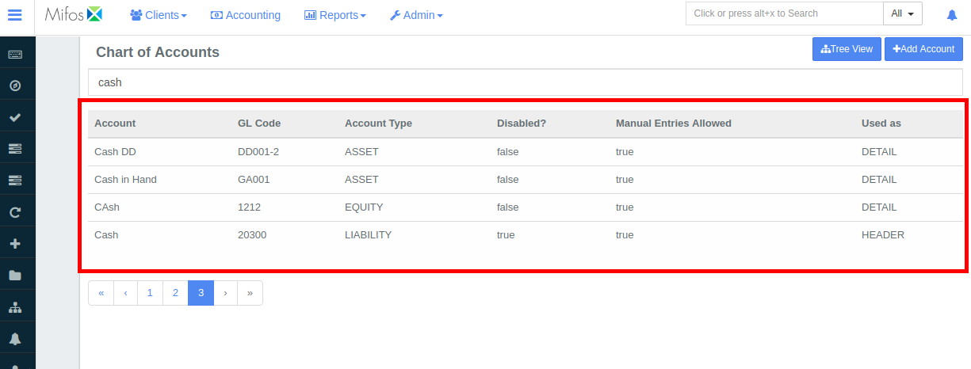

**Step 5:** Create a GL account "**Opening Balances Contra Account"** with account type "**Equity**"

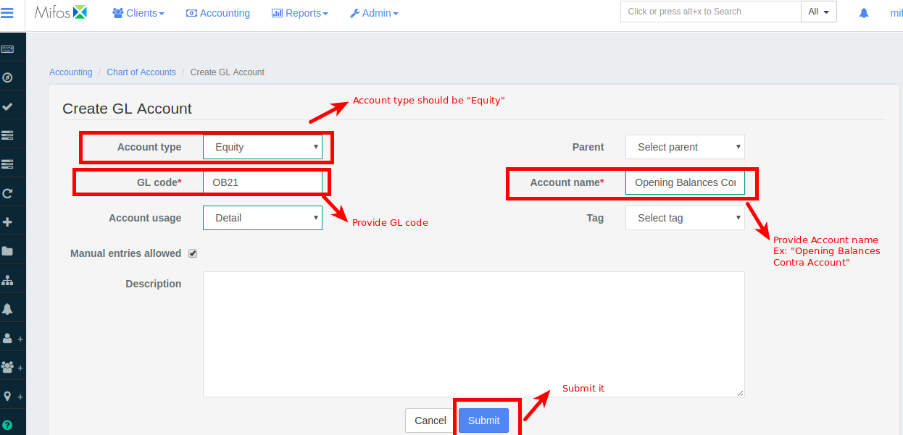

You can see this GL account in chart of accounts like in the image shown below:

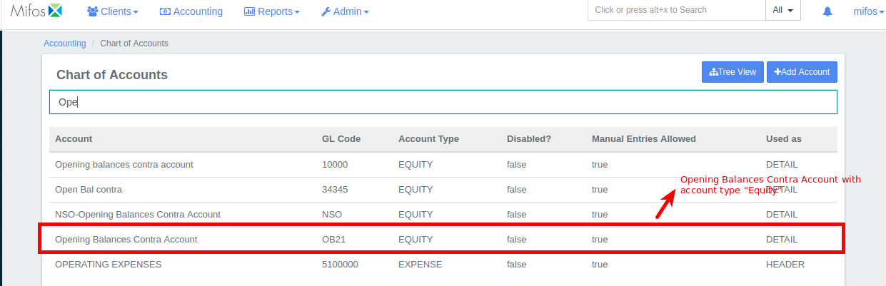

**Step 6:** Next go to **Accounting** then click on **Accounts Linked to Financial Activities** from the menu

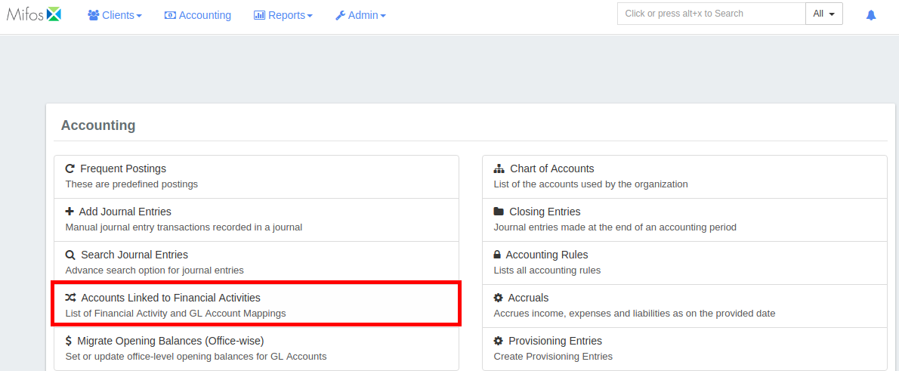

**Step 7:** Click on **+Define New Mapping** to define financial activity

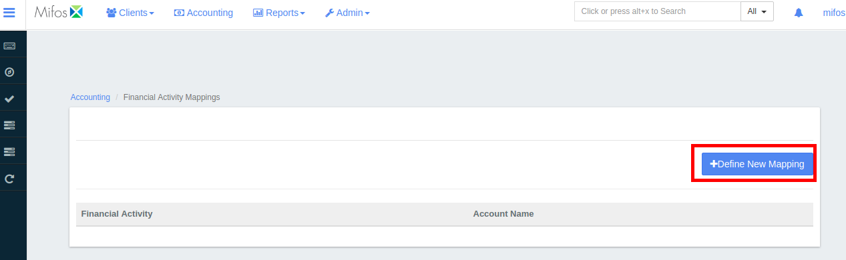

**Step 8:** In **Financial Activity Mapping** set "Financial Activity" drop down as **"Opening Balance Transfer Contra"**  and set "Account" drop down as **"Opening Balances Contra Account (OB21)"**

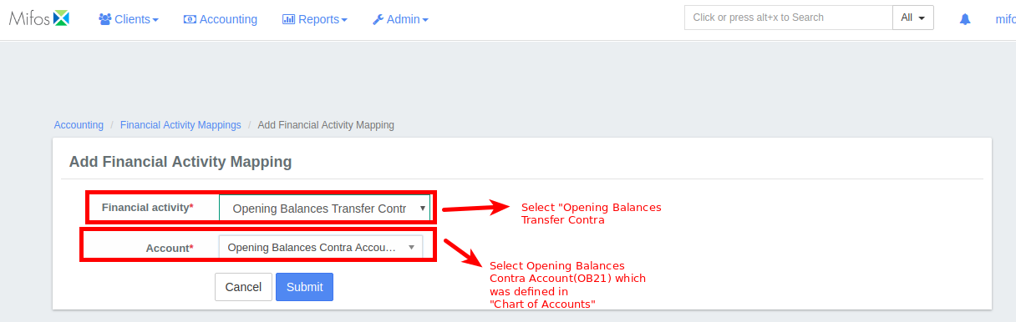

**Step 9:** Next navigate to **Accounting** then click on **Migrate Opening Balances**

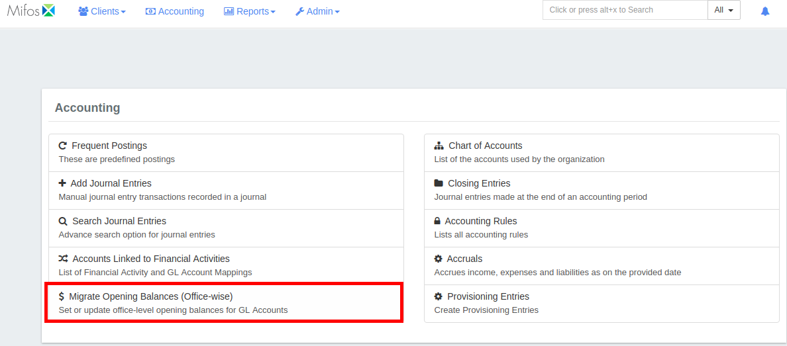

**Step 10:** Select the appropriate **Branch** and **Currency**  from the drop down and click on 

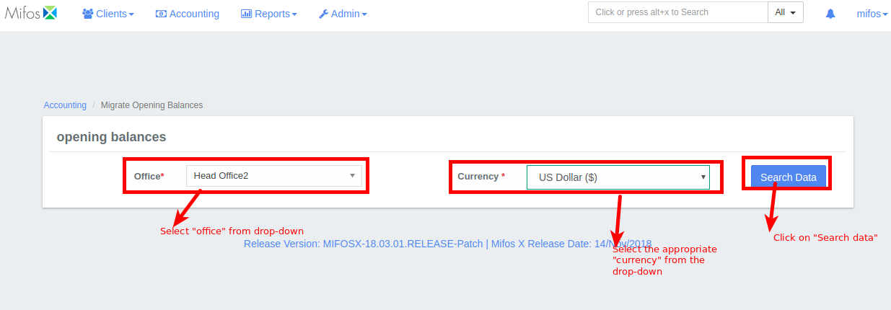

**Step 11:** Next define the **Opening balances**, a sample entry is shown in the screenshot below:

Sum of all the credits must be equal to sum of all debits.

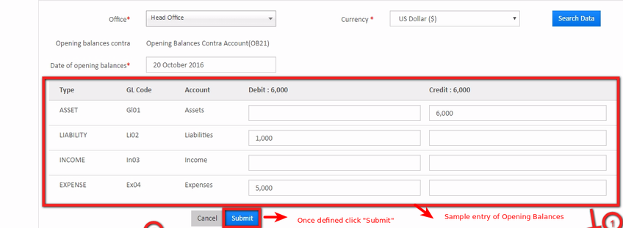

**Step 12:** On clicking submit **Opening Balances** are set.

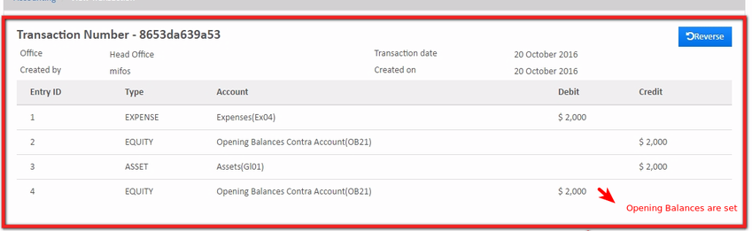

## 

## Configure Notifications:

This documentation provides instructions on how to integrate notifications within a functionality.

For example: We may want to notify a specific set of users about the creation of a new savings account so that those users can act upon those notifications and take specific actions like approve/activate the savings account.

First of all, let's configure notification for the example above, then we can take a few more examples to make you comfortable with configuring notifications.

**Note :-** It is imperative to understand that we need to send notifications only to those users who have some work related to that notification. Otherwise, it is not useful to send a notification to any user who can't do anything with that notification.

|  |  |  |
| --- | --- | --- |
| **Events / Notification generated** | **Permissible actions / Permissions to be checked for the role of a user** | **Status** |
| New client created | ACTIVATE CLIENT, READ CLIENT | Done |
| New loan created | READ LOAN, APPROVE LOAN | Done |
| New loan approved | READ LOAN, DISBURSE LOAN | Done |
| New share account created | APPROVE SHARE ACCOUNT | Done |
| New share account approved | ACTIVATE SHARE ACCOUNT | Done |
| New savings account created | READ SAVINGS ACCOUNT, APPROVE SAVINGS ACCOUNT | Done |
| New savings account approved | READ SAVINGS ACCOUNT, ACTIVATE SAVINGS ACCOUNT | Done |
| New fixed deposit account created | APPROVE FIXED DEPOSIT ACCOUNT | Done |
| New fixed deposit account approved | ACTIVATE FIXED DEPOSIT ACCOUNT | Done |
| New recurring deposit account created | APPROVE RECURRING DEPOSIT ACCOUNT | Done |
| New recurring deposit account approved | ACTIVATE RECURRING DEPOSIT ACCOUNT | Done |
| Dividend posted to account | READ DIVIDEND SHARE PRODUCT | Done |
| Interest posted to account | READ SAVINGS ACCOUNT | Done |
| Repayment made | READ SAVINGS ACCOUNT | Done |
| Deposit made | READ SAVINGS ACCOUNT | Done |
| Savings has gone into dormant | READ SAVINGS ACCOUNT | Done |
| Loan has been closed/paid off | READ LOAN | Done |
| Loan has been rescheduled | READ LOAN | Done |
| New group created | ACTIVATE GROUP, READ GROUP | Done |
| New center created | ACTIVATE CENTER, READ CENTER | Done |
| New loan product created | READ PRODUCT MIX | Done |
| Savings Account gets Overdrawn |  | ? |
| Mobile Payment Received |  | ? |
| Savings has gone into Inactive Status |  | ? |
| Loan Is Overdue by XX days |  | ? |
| New Survey taken |  | ? |
| Collection sheet submitted |  | ? |
| Cashier drawer settled |  | ? |

### Summary :

* For a user to get notification for an event, they will require a role containing the permission required to get that notification. For example: if a user wants to be notified whenever a new client is created, they will need a role having "ACTIVATE CLIENT" or "READ CLIENT" permissions.
* To assign a permission to a role, navigate to **Admin >> System >> Manage Roles and Permission** and then click on the name of the role for which you want to assign the permission to.

To assign a role to a user, navigate to **Admin >> Users** and then click on the name of the user to view his/her details, including roles.Every user in an organization has some role associated with him/her. To see which role is associated with a user, follow these steps:

1. Navigate to **Admin >> Users.  
     
   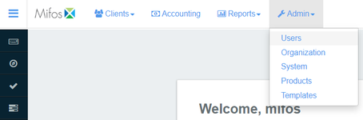**
2. This will display a list of Users. Click on the name of the user whose details you want to view (*NOTE: you can use the search bar on the top of the page to filter users by name*).

Now, if you want a user to receive a notification whenever a new savings account is created (*so that they can activate/approve that account*), you need to make sure that the role of that user contains the permission to either approve/activate the savings account.

You can see what permissions a role contains by navigating to **Admin >> System >> Manage Roles and Permission** and then clicking on the name of the role for which you want to see the permissions.

For our example above, we need the permissions **"ACTIVATE SAVINGS ACCOUNT"** or **"APPROVE SAVINGS ACCOUNT"** to be checked for the role of a user who will receive these notifications. Ensure that the user who will receive the notification should also have the permission to read the savings account because they have to activate/approve that savings account.

With this, our notification is configured and the user will be able to receive a notification whenever a new savings account is created. They can then act upon that notification to perform any permitted actions.

Following is the list of notifications which you can configure, and in front of it are the permissions of a role which need to be checked. Simply pick a notification which you think needs to be generated for a user then check the corresponding permissions in the role of that user.

## Mifos X ,how to create clients,groups and centers:

1.It has 6 child page

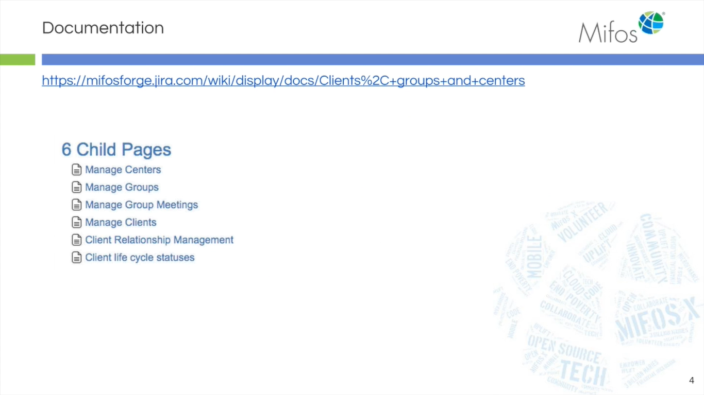

### Create a Client :

1.Click on clients,then clients

2.Create client

1.select the office,give name and other detail.

2.add the number , gender and other details

3.select the client classification

4.select the activation date

5.click on submit

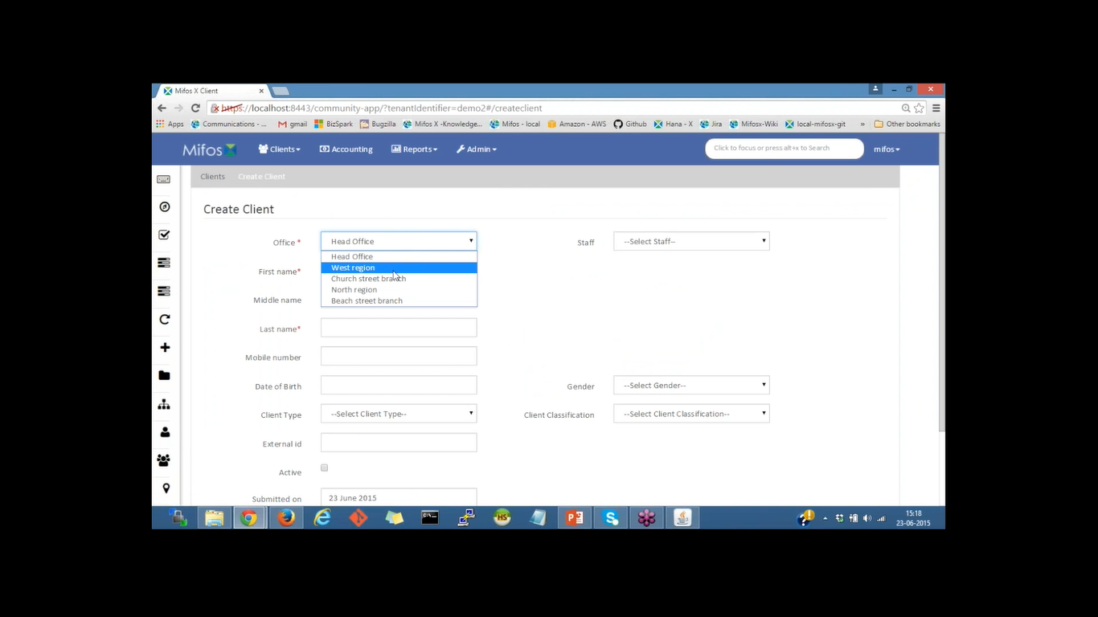

1.Click on clink it would show pending.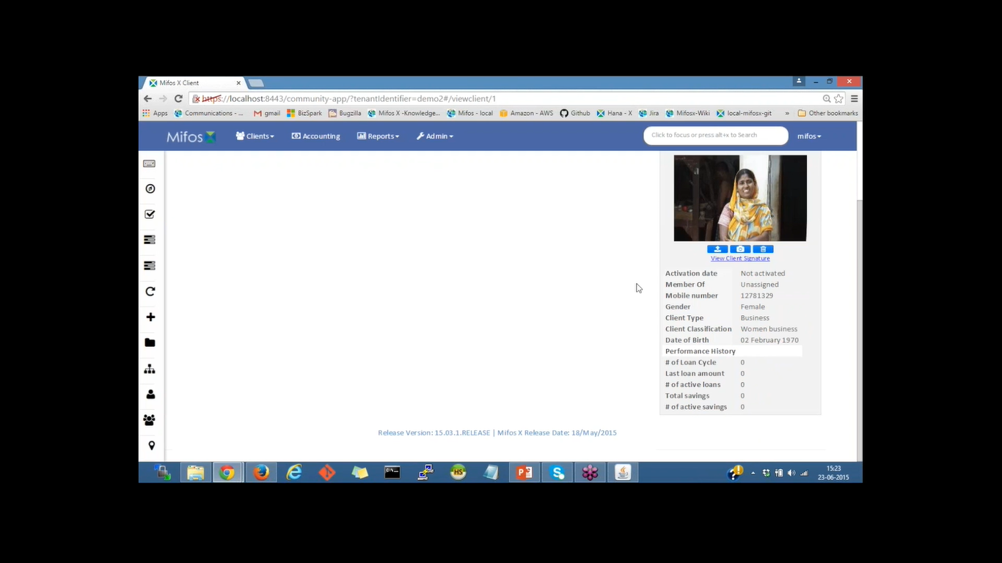

2.To make it active,click on activate button

3.Provide the date

4.Update client image,we can also update the signature

1.Identity-give the document,and give unique ID.

2.We can upload the document for the local system

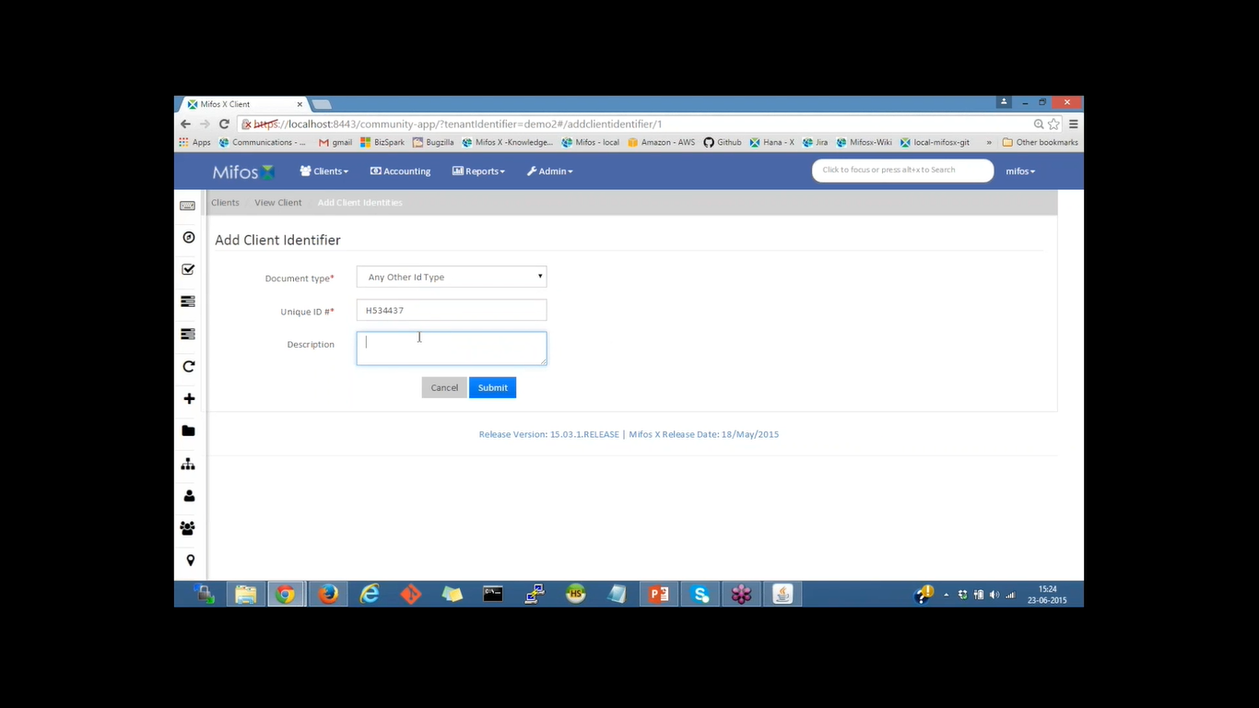

1.When we go back to identity,we can download the scan copy of it

2.There is a document section,where we can upload the other document

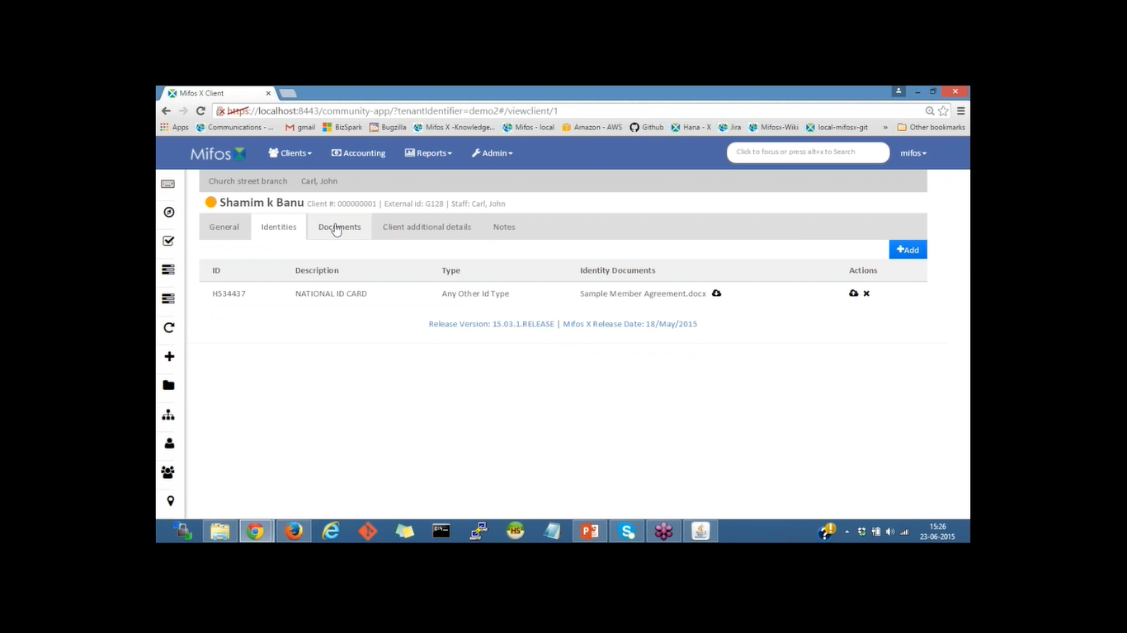

3.When we go back to identity ,we can download scan copy

4.Client extra Detail and click on add,provide the address and click on submit

5.There is a note section where we can add note to the document

6.Go back to general tab and verify all the document provided and on activation,selected data and submit

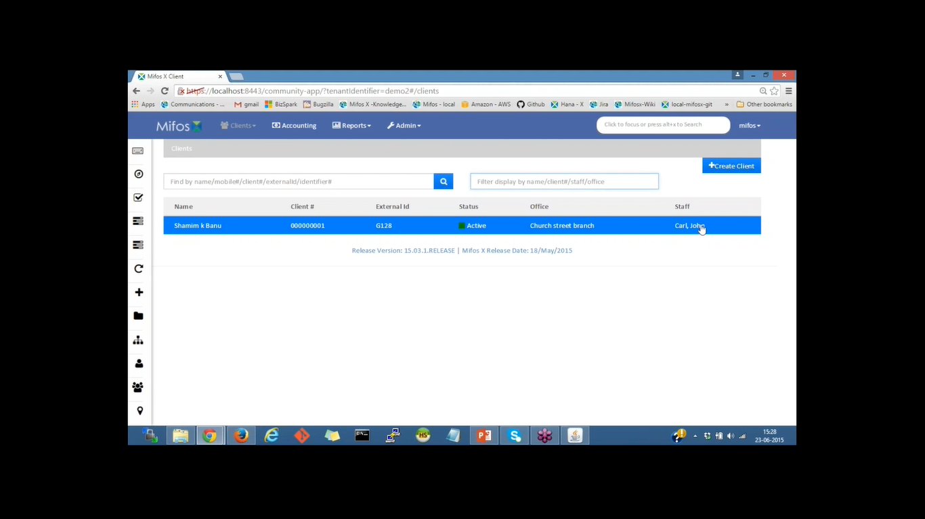

1.Click on client again and provide the following detail and submit the detail

2.Upload the client the image

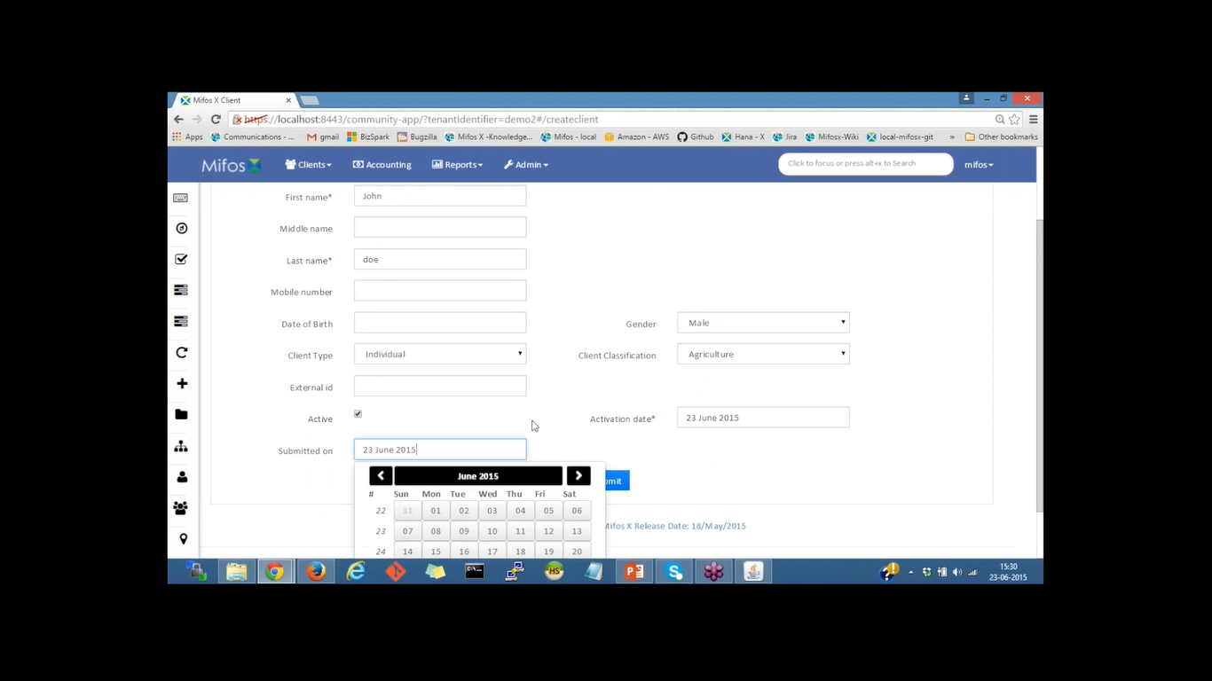

1.Click on client and create image

2.give the office detail,name,stuff,gender and other vital detail and submit

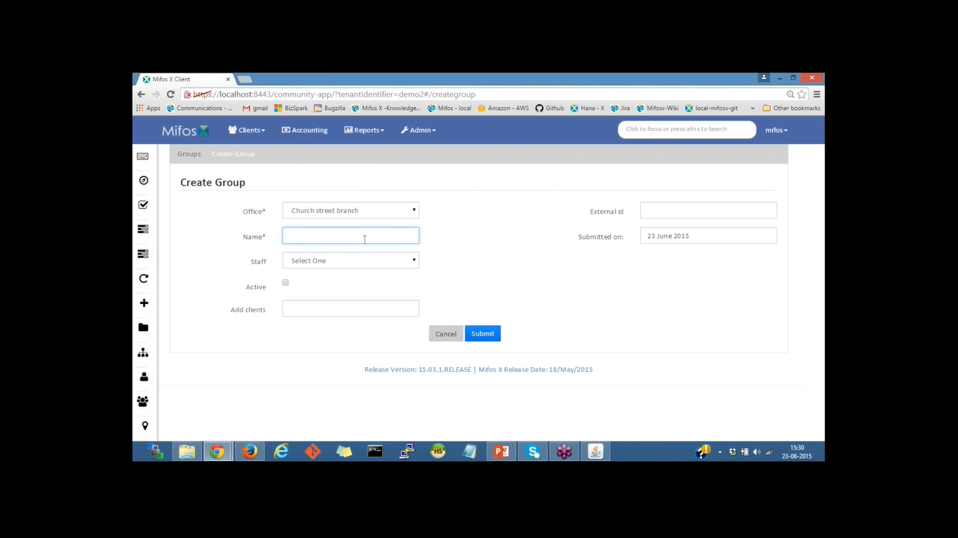

### To create group :

1.click on client ,create group ,it would show pending

2.To make it active,click on activate button

3.Provide the date and click on submit

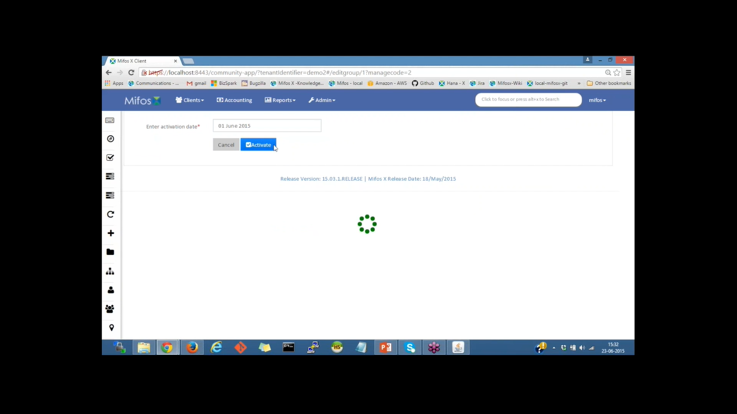

1.We can see the group name and office name and other detail

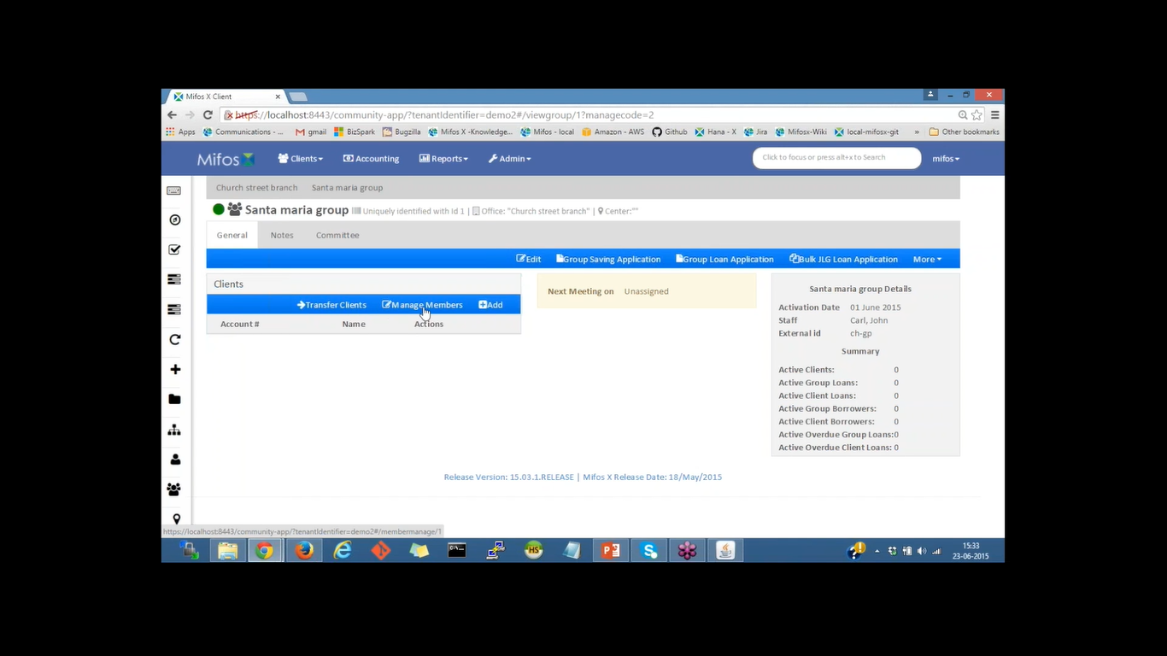

1.We can also add member for the group-group-manage members,and type their name and enter

2.We can also create new client by adding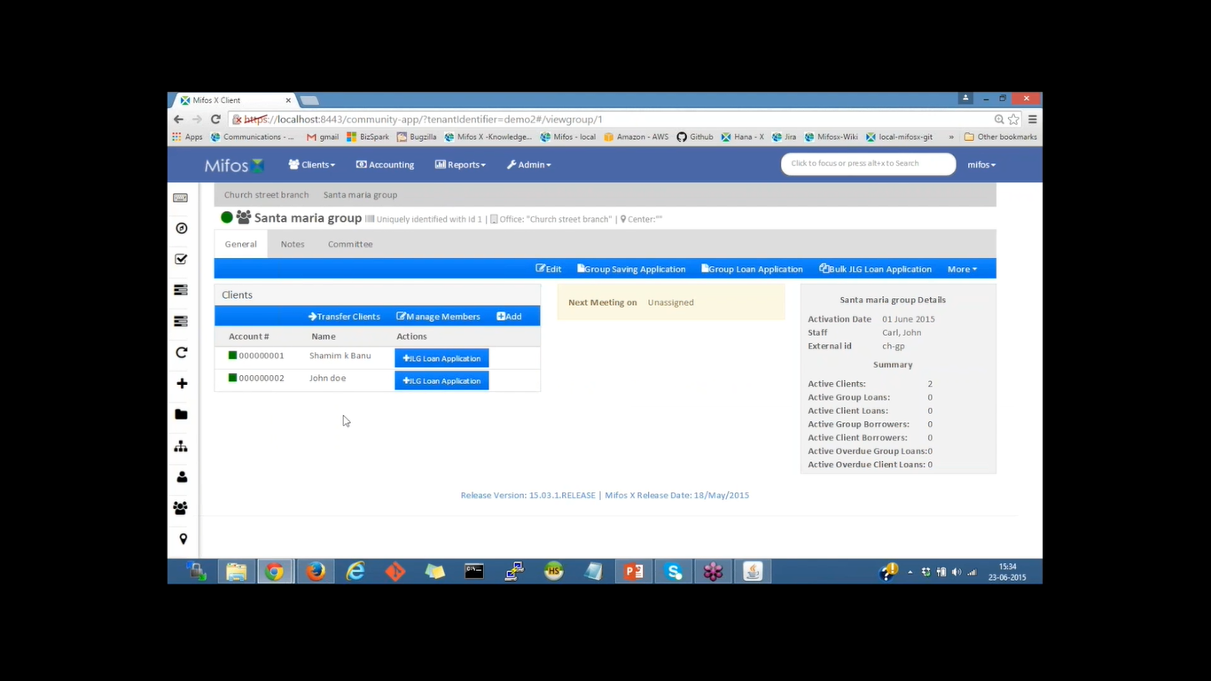

1.click on more ,attach meeting and give the date and repeatibility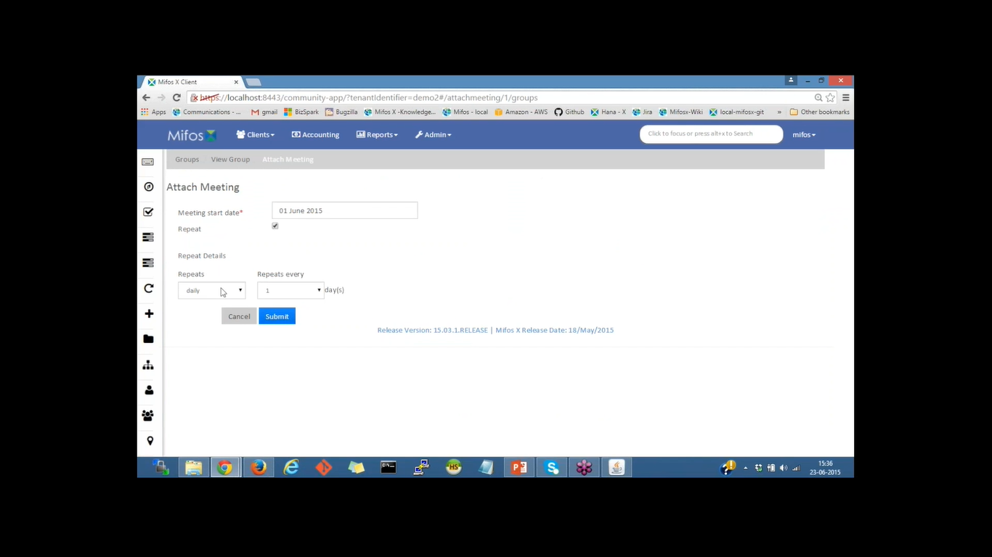

### To create center:

1.click on client

2.create center

3.Give the following detail like name,office ,stuff and other detail required and press submit.

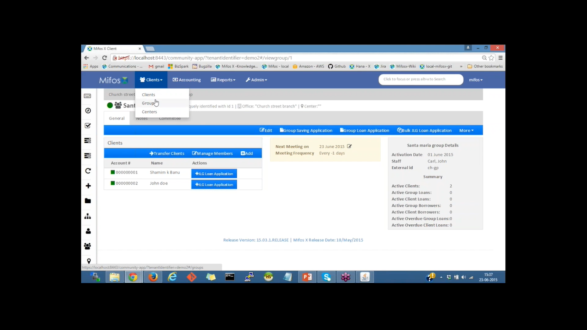

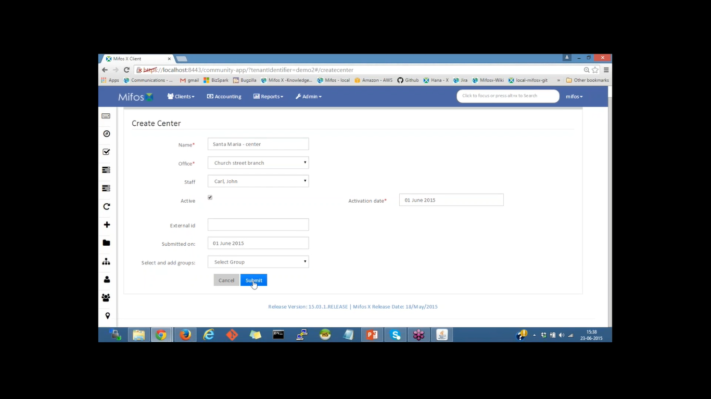

1.Click on client,center,it would provide the detail,we can edit add and manage the group

2.All the detail of the center would be display

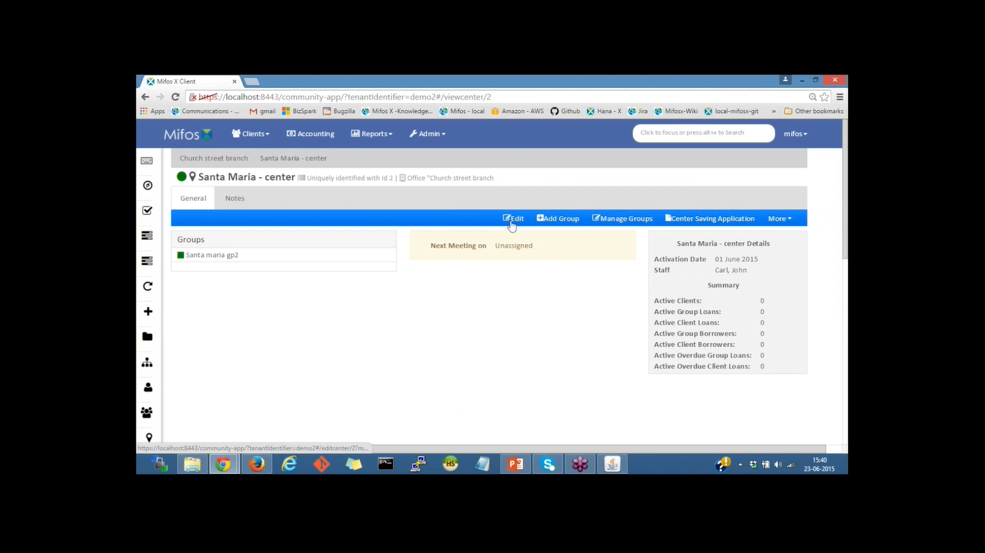

1.if you type the name in the search box it would show you the detail like the entity and office name

2.And once you click it would take you that page

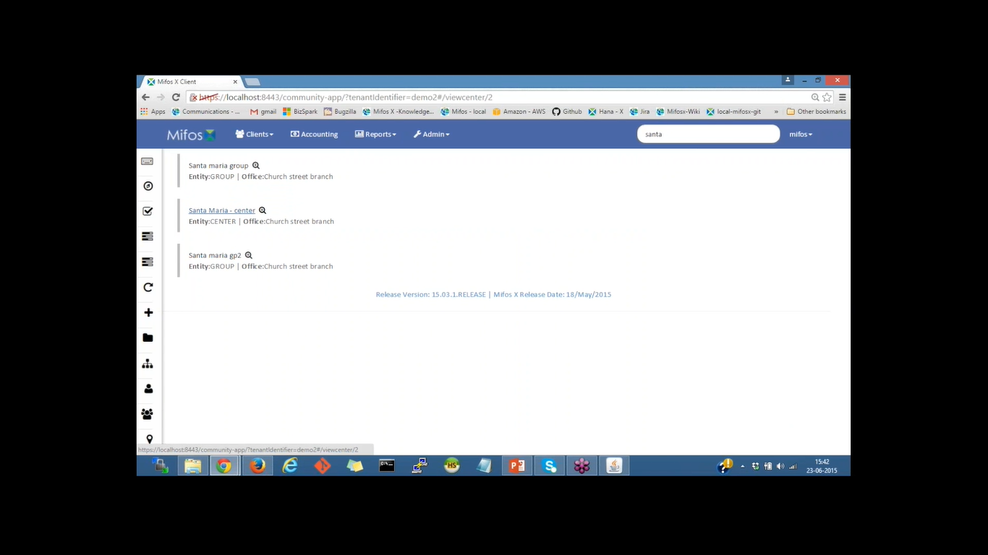

1.loans and saving account overview would be display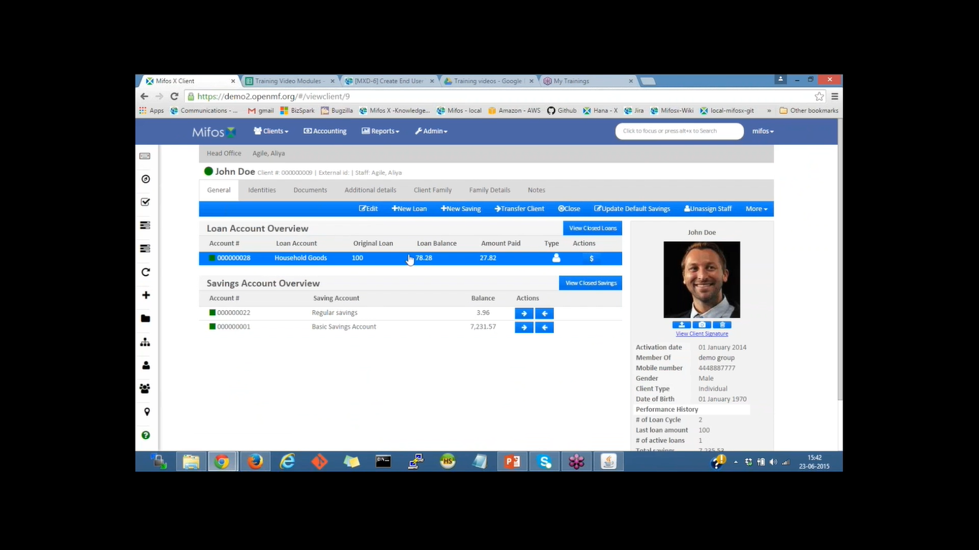

## Mifos x manage data tables:

Mifos X data-tables allow the user to add custom fields in addition to the built-in fields to a client profile, loan/saving account, group, center or an office.For example, you may want to collect additional client details such as education and poverty level. You can do this in Mifos X by creating a data-table, choosing the client application table name and adding custom fields: education and poverty level... To manage tables in Mifos X, you can use the data management feature in the platform. This allows you to create, edit, and delete tables and the data they contain. Here are the steps to manage tables in Mifos X:

* Log in to the Mifos X platform as an administrator.
* 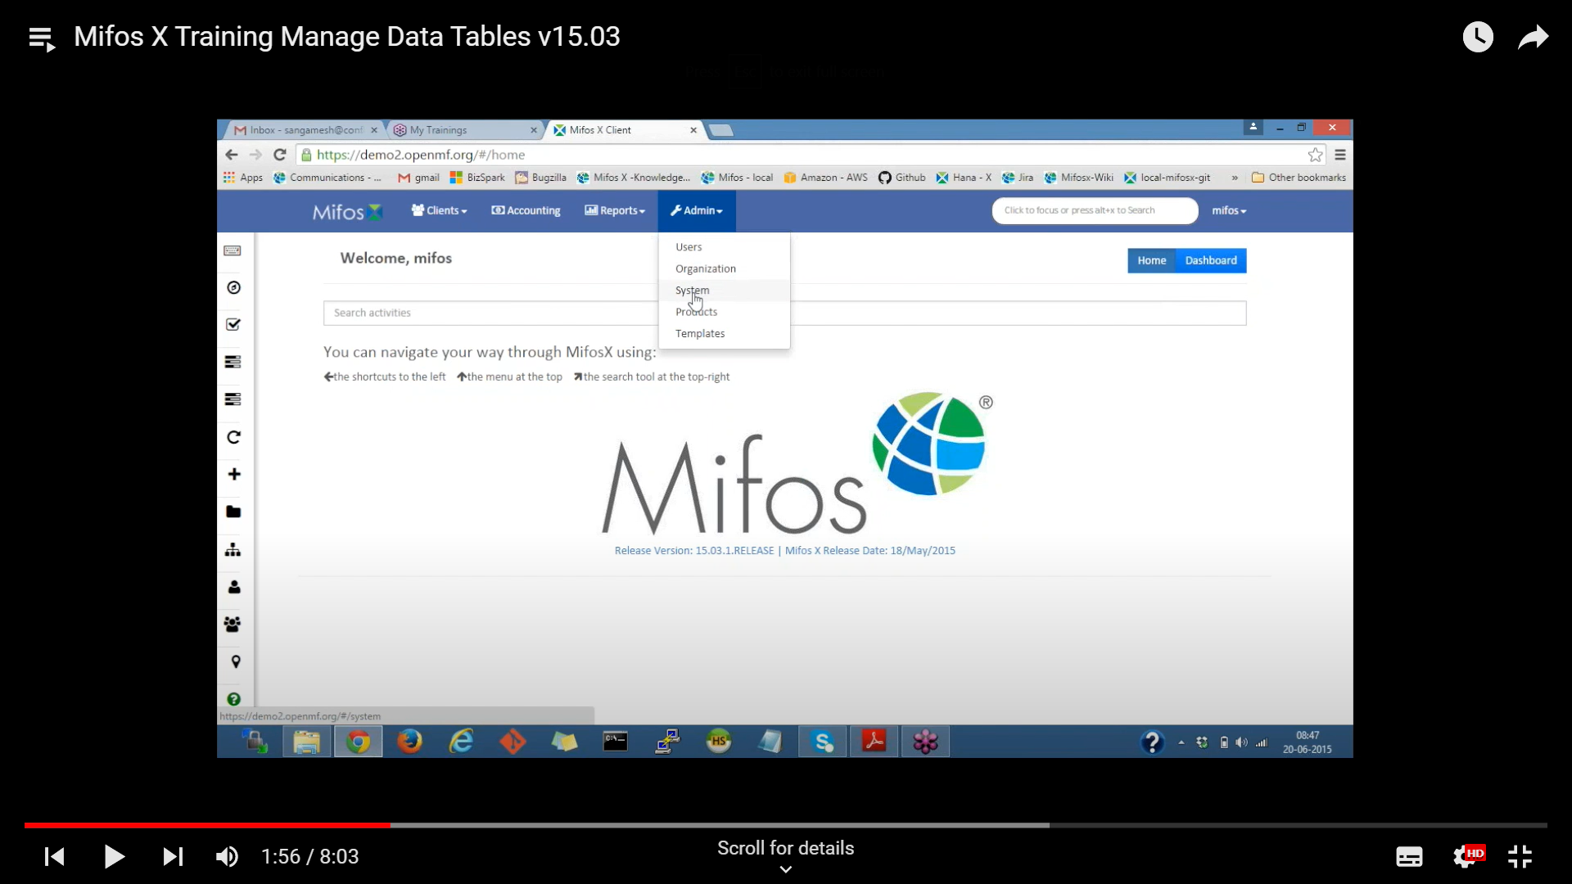
* Navigate to the "Data Management" section in the main menu.
* Select “**Manage Data Tables**" option to view a list of available tables.

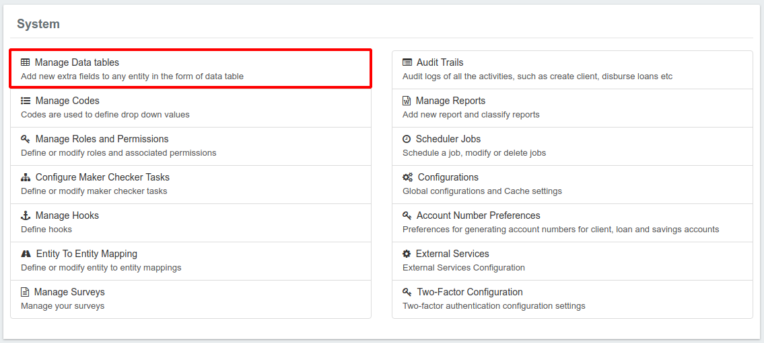

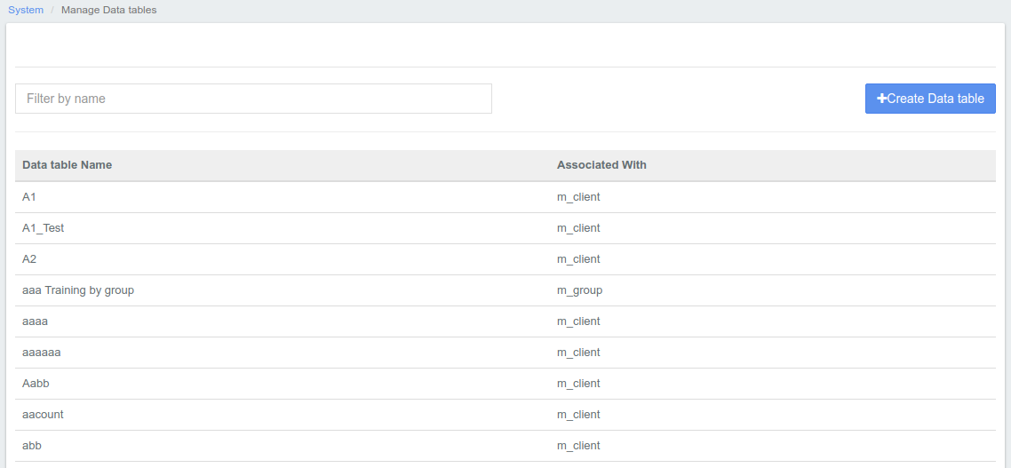

* To edit an existing table, select the table and click the "Edit" button. Make your changes and click "Save".To delete a table, select the table and click the "Delete" button. Confirm the deletion when prompted.

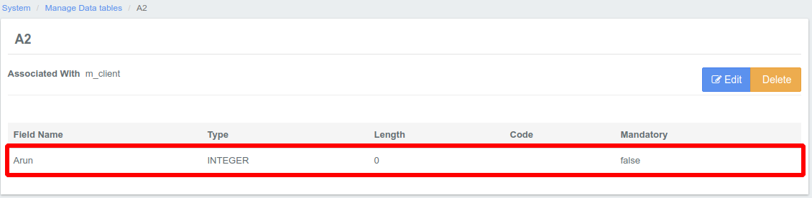

Note: Be careful when making changes to tables as this can affect the data stored in the platform.

* To create a new table, click the "Create Table" button and enter the necessary information such as table name, description, and columns.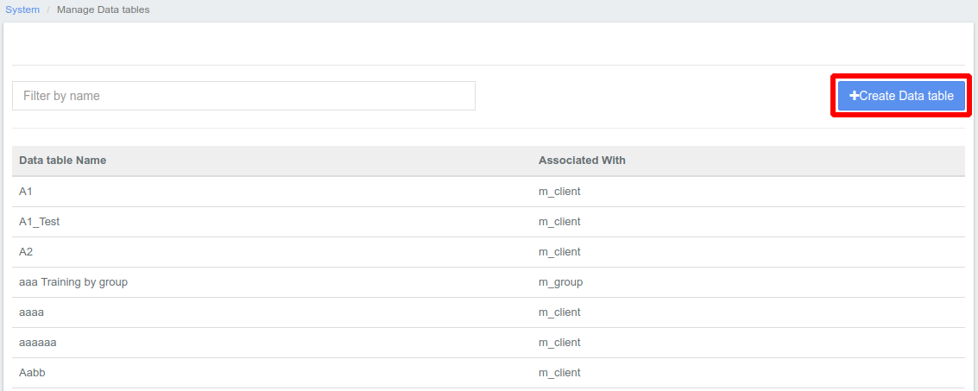

This will launch a page that will allow you to create a new data table as shown below

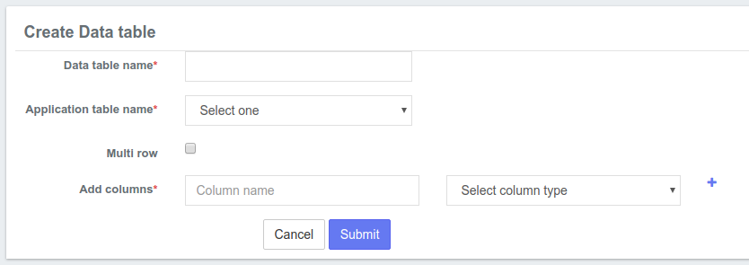

Give the Data Table an appropriate name of your choice.

* The **Application table name** field will provide a drop down of system functions the data table will affect. For example, if you are adding fields that will impact the Client level, click on **Client.**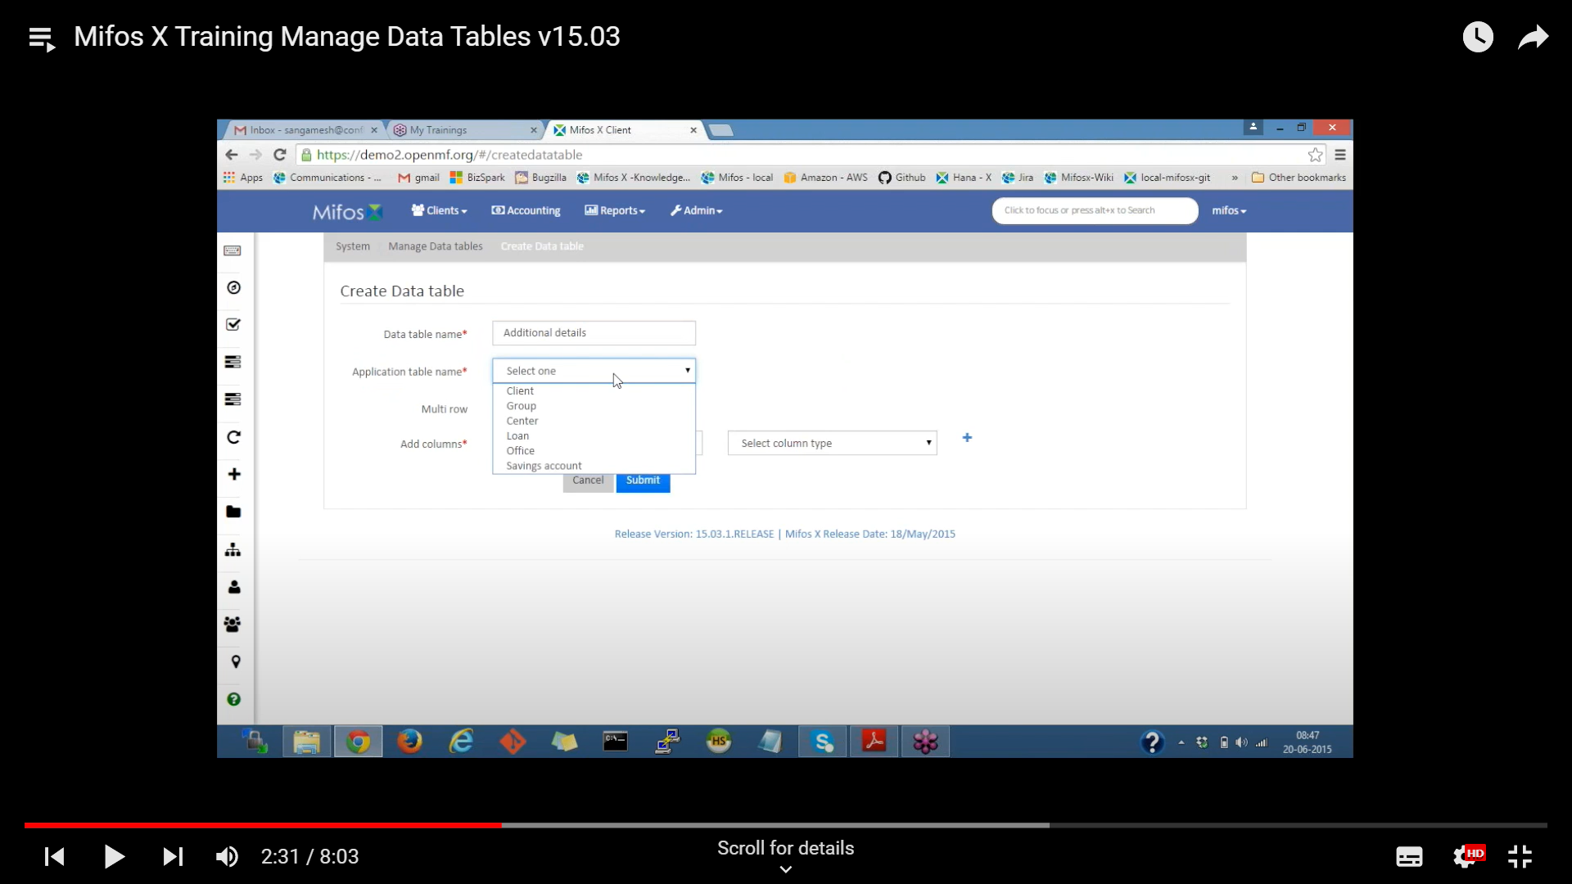
* Under Add Columns, enter an appropriate name of your choice for the field in the **Column name** box. Then select a column type from the **column type** drop-down menu. Some options include Date, Number, String, Decimal. Click the plus (**+**) button to add your custom field. 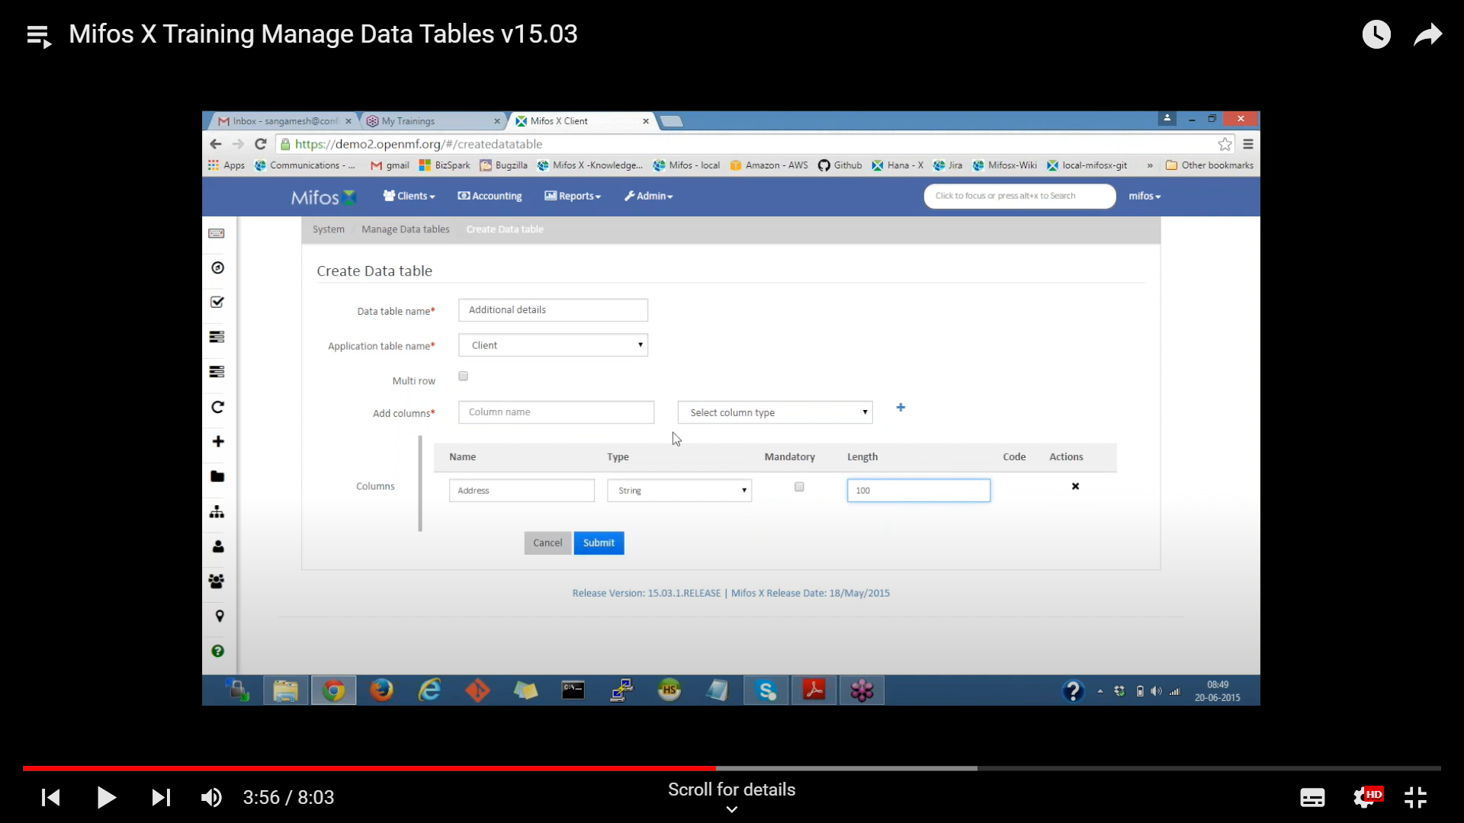

From the screenshot above, you can make a field required by clicking the **Mandatory** checkbox next to the type. If you selected a **String** column type for any field**,** enter a maximum number of characters for the field in the **Length box.** For **Drop-down** column type, select a system defined code from the drop-down list.Column Types are listed below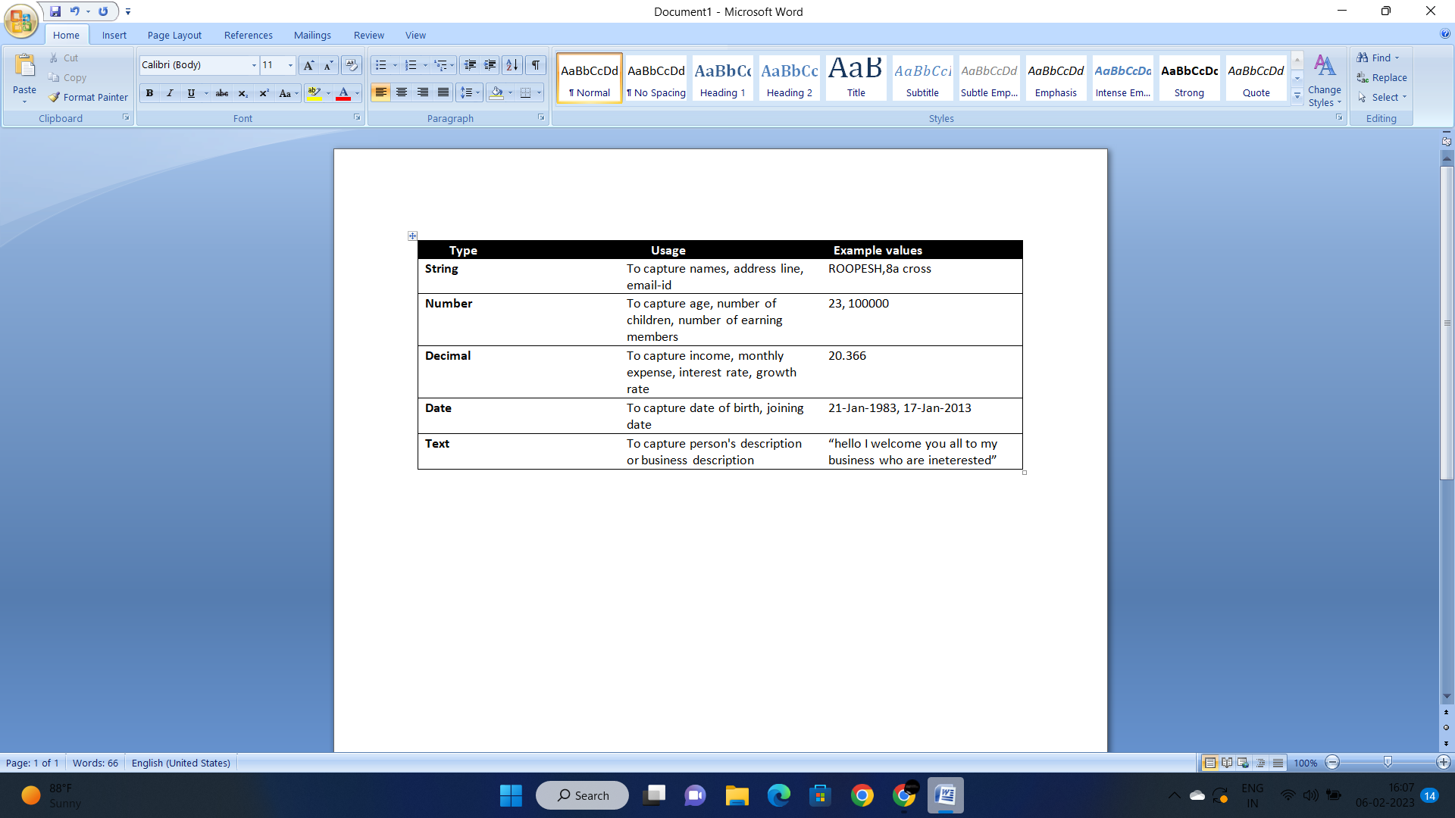

Check your inputs and then click the **Submit** button.

Go to the **clients** or the field you have selected and you can see the new table which you created then enter the details then go to checker inbox & tasks and approve the request for changes.

## Mifos x currency configuration :

In order to change or select currency type goto the Admin-click on Organisation and select Currency configuration . It will search available currency.

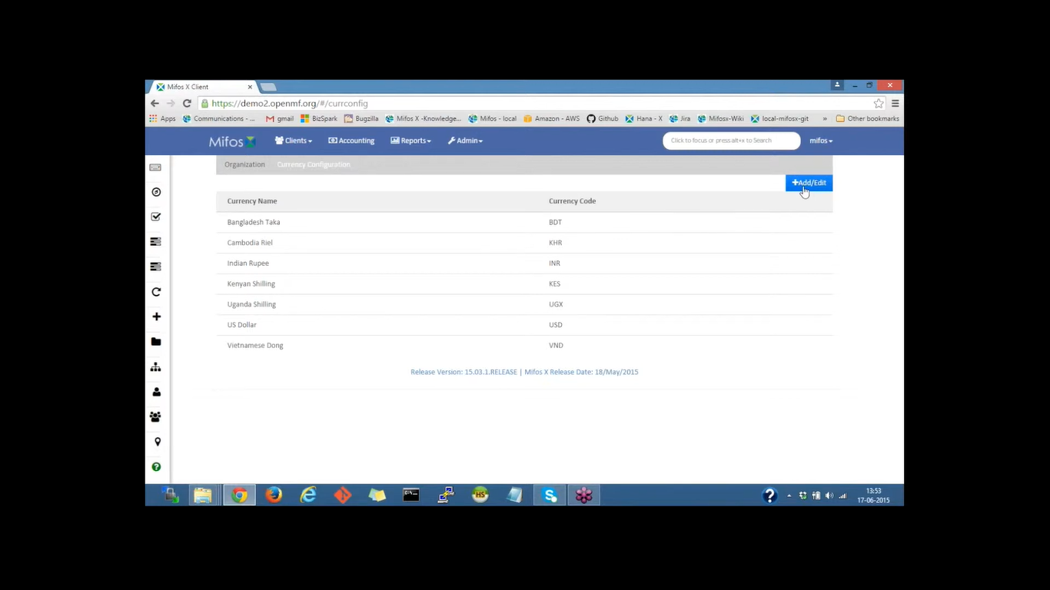

Click on Add/Edit then next page will open.

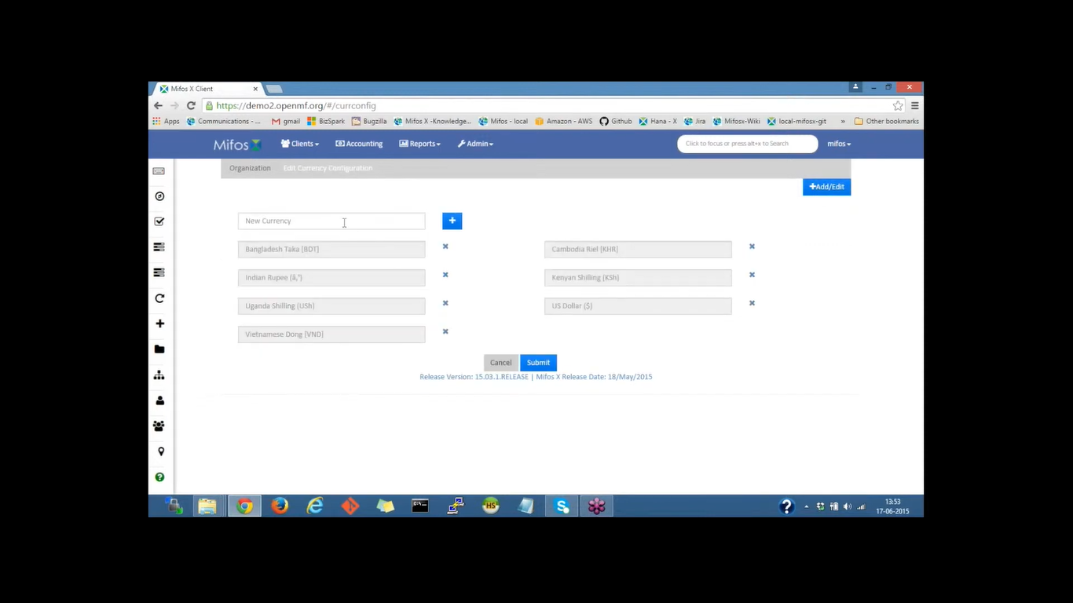

Add the currency type and it will give available currency click on submit.

## Mifos x Manage Office :

Enter Mifos Credentials

* Login using ID and password.
* Go to Admin, then go to the ‘Orginantion’ .
* Click on the ‘Manage offices ’ to create a new office..
* There on the right side of the page we have ‘create office’, click on the ‘create office’ button.
* Then Provide the office name. For eg: West region.
* In the parent office column select ‘Head Office’.
* In the ‘Opening on’ column select a date.
* Next we have is the external ID, Give any ID or leave it as blank.
* Now click on the ‘Submit’ button.

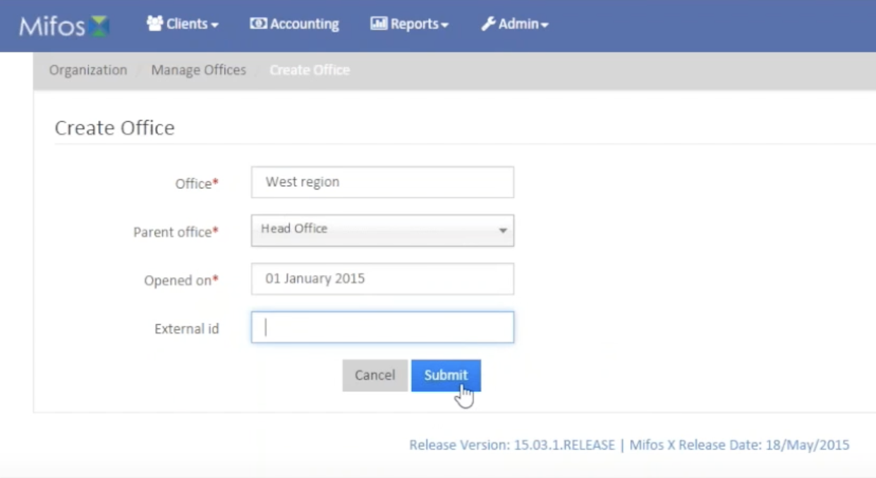

Now the ‘West Region Office’ has been created under the ‘Head Office’.

* Let us go back to the ‘Manage Offices’ and click on the ‘Create Office’ button again.
* Now we will create a Sub-Office under the ‘West region Office’.
* In the Office Column fill the name of the sub-office. For eg: Church Street Branch.
* For the ‘Parent office Column’ select the ‘west region’.
* Fill in the desired date for the ‘Opened on’ column.
* Click on the ‘Submit’ button.

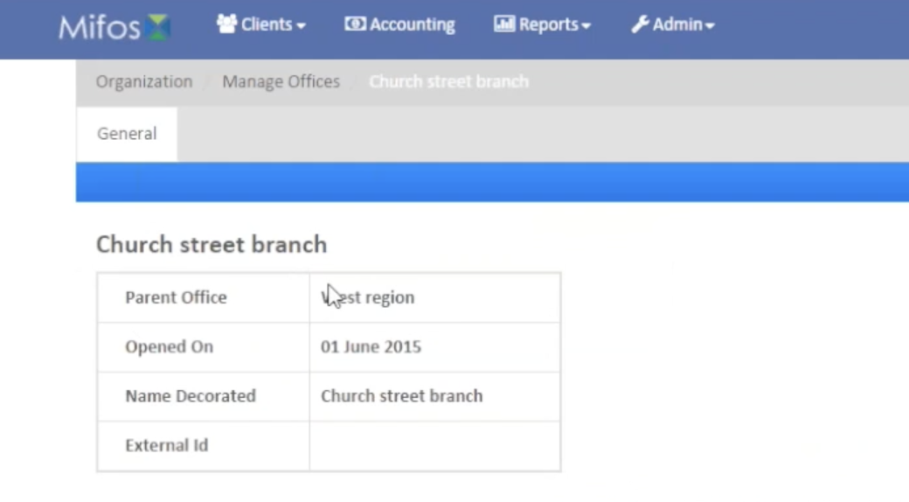

Now the sub-office ‘Church Street Branch’ is created under the parent office ‘West region’.

* Go back to the ‘Manage office’ again and click on the ‘Tree view’ as it is a List view.
* Inside there will be another Tree view. Click on the ‘+’ button on the Head Office it will provide the list of sub-offices under the Head office.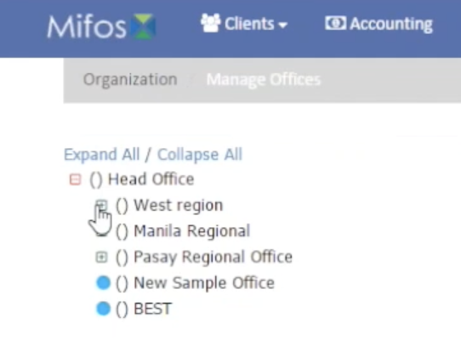

## Mifos x Charges(savings and deposit fees) :

Mifos supports two types of charges—fees and penalties. Fees are charged for services—for example, membership fees, loan disbursement fees, withdrawal fees. Penalties are charged to discourage clients from deviating from the terms of a product—for example, late payment penalty for a loan account, early withdrawal penalty for a fixed deposit account.

It supports Loan charges, Savings & deposits charges and Client charges.

Charges may be associated with a product. When an account is opened based on a product that charges have been associated with, the account will include (inherit) all charges that are associated with the product. In addition, charges that are not defined for a product may be associated with individual client accounts.

On this page:

[Creating a Charge](https://mifosforge.jira.com/wiki/spaces/docs/pages/72908813/Charges#Charges-CreatingaCharge)

* [Loan charge](https://mifosforge.jira.com/wiki/spaces/docs/pages/72908813/Charges#Charges-Loancharge)
* [Savings & deposit charge](https://mifosforge.jira.com/wiki/spaces/docs/pages/72908813/Charges#Charges-Savings%26depositcharge)
* [Client charge](https://mifosforge.jira.com/wiki/spaces/docs/pages/72908813/Charges#Charges-Clientcharge)
* [Share charge](https://mifosforge.jira.com/wiki/spaces/docs/pages/72908813/Charges#Charges-Sharecharge)
* [Charge Fields](https://mifosforge.jira.com/wiki/spaces/docs/pages/72908813/Charges#Charges-ChargeFields)

Beginning at the main screen, select [Admin](https://mifosforge.jira.com/wiki/display/docs/Administration), Products from the drop-down menu. This will launch the Products menu.

### Select Charges:

### 

### Creating a Charge :

Click on +Create Charge.

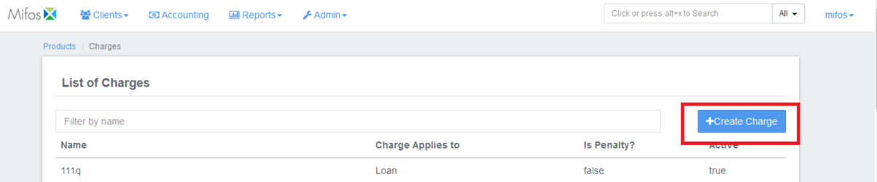

### Loan charge :

1. Select Charges apply to as Loan. 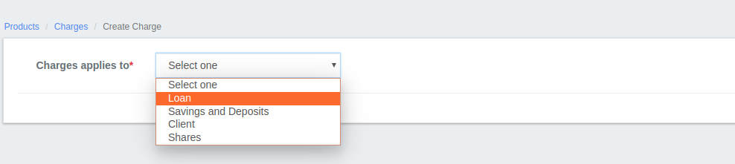
2. Fill in the charge fields described in the Charge Fields table below.
3. Select Charge time type   
   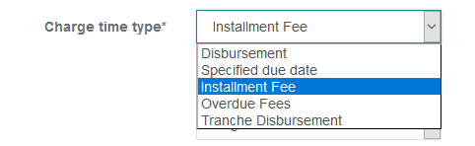  
   Disbursement: Gets charged at the time of loan disbursement, provide amount gets collected separately (Not from the loan amount).   
   Specified due date: Gets charged on the provided date.   
   Installment Fee: Gets charged on every loan installment.   
   Overdue Fees: Gets charged if there is an overdue, this is a penalty charge.   
   Tranche Disbursement: Gets charged for Tranche loan disbursement.
4. Click Submit.

### 

### Savings & deposit charge :

1. Select Charges apply to as Savings & deposit.
2. Fill in the charge fields described in the Charge Fields table below.
3. Select Charge time type  
   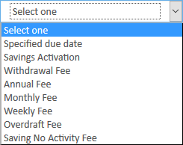  
   Specified due date: Gets charged on the provided date.   
   Savings Activation: Gets charged at the time of Savings activation.   
   Withdrawal Fee: Gets charged at the withdrawal of savings amount.   
   Annual Fee: Gets charged every annually.   
   Monthly Fee: Gets charged every monthly.   
   Weekly Fee: Gets charged every weekly.   
   Overdraft Fee: Gets charged on Overdraft account.  
   Saving no activity fee: Get charged on no savings account activity.
4. Click Submit.

### Client charge :

1. Select Charges apply to as Client charge.
2. Fill in the charge fields described in the Charge Fields table below.
3. Select Charge time type
4. 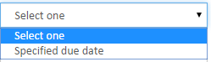
5. Specified due date: Gets charged on the provided date.
6. Click Submit.

### 

### Share charge :

1. Select Charges apply to as Share charge.
2. Fill in the charge fields described in the Charge Fields table below.

#### Select Charge time type

#### 

Share Account Activate: Gets charged at the time of Share activation, charge calculation can be only be flat not % of amount.

Share Purchase: Gets charged at the time of share purchase.

Share Redeem: Gets charged at the time of redeeming of shares.

3. Click Submit.

### Editing charge:

Select charge from the available charge list >> Click on Edit button

### 

Then click on Submit button.

### Viewing charges :

Click on Admin>>Products>>Charges

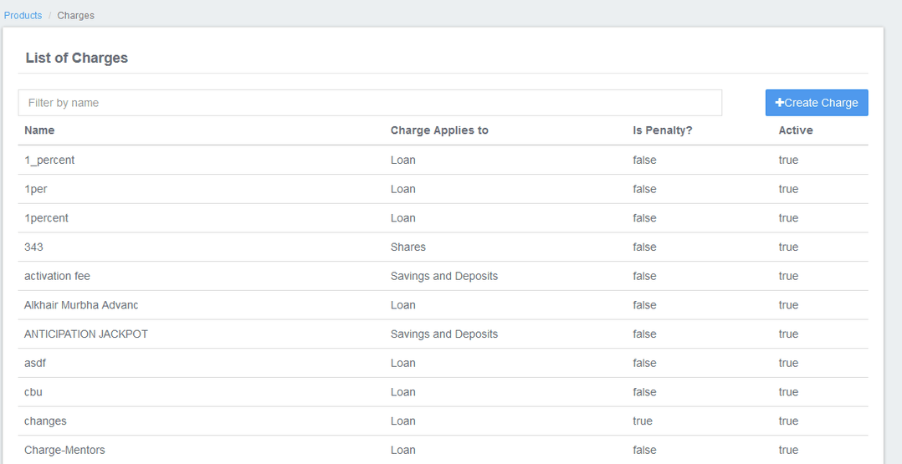

### 

### Charge Fields :

|  |  |  |  |
| --- | --- | --- | --- |
| Field Name (attribute) | Description | Example | Validations (if applicable) |
| Name | A descriptive name for the charge. The name provided in this field will populate charge selection lists on applicable product and account forms. | Service Fee | Required field  Alphanumeric |
| Currency | Select the currency to be used when the charge is applied. The product and charge currency must be the same to be valid. Set up multiple charges if the same charge is required for products set up in different currencies.  (Note: If you don't find the currency type you need from drop-down menu, you need to define it. [Click Here](https://mifosforge.jira.com/wiki/display/docs/Currency+Configuration) to see How to define the currency) | Indian Rupee | Required field  Select from list |
| Charge time type | Select the desired charge time type from the list. There will be different charge time types in the list depending on the product type select in Charges applies to. | Specified due date | Required field  Select from list |
| Charge calculation | Select the desired charge calculation from the list. There will be different charge calculation options in the list depending on the product type selected in Charges applies to. | Flat | Required field  Select from list |
| Charge payment by | This field will display for loan product charges only. Select the desired charge payment method from the list. | Account Transfer | Required field for loan product charges  Select from list |
| Add Fee Frequency (loan charges only)  Charge Frequency  Frequency Interval | This option will display for loan product charges only. To add a fee frequency, check Add Fee Frequency.  If Add Fee Frequency is checked the Charge Frequency and Frequency Interval fields will appear and must be filled in. | Checked  monthly  1 | Check Add Fee Frequency to add a fee frequency; uncheck to remove a fee frequency  Select Charge Frequency from list  Numeric |
| Amount | The value in this field is used with Charge calculation to calculate the amount to be charged to the client.  Example:  Apply a service fee of 25 rupees (flat calculation) monthly by transferring the funds from another account. | 25 | Required  Numeric |
| Active | If checked, this charge is available to associate with products and accounts. If unchecked, this charge is not available to associate with products and accounts. | Checked | Checked indicates an Active charge |
| Is penalty? | If checked, this charge is marked as a penalty, rather than a fee. | Unchecked | Checked indicates that the charge is a penalty. Unchecked indicates that the charge is a fee. |

## Mifos x Windows Installation :

|  |
| --- |
| **Prerequisite Software**   * JAVA DEVELOPMENT KIT >> VERSION 1.8.0_231 & above * MYSQL SERVER >> Version 5.5 or 5.6 only - Any version above or below is not recommended in a live production environment unless you have tested it your self * TOMCAT >> Version 7.0.109.0 & above (version 7.0.xx.xx) |

|  |  |
| --- | --- |
| **Install Java** | |
| 1) Before beginning, uninstall any existing versions of Java currently on your computer. |  |

2) In your web browser, go to <http://www.oracle.com/technetwork/java/javase/downloads/jdk8-downloads-2133151.html>, to download JAVA 1.8.

3) Oracle requires that you read the license agreement, then click the button labeled *Accept License Agreement*.

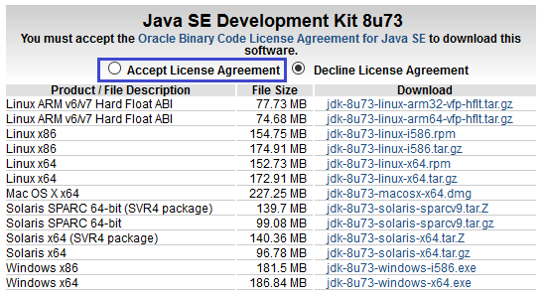

4) Click the link to download the version for your system architecture i.e. Windows x86 for 32bit or Windows x64 for 64bit.

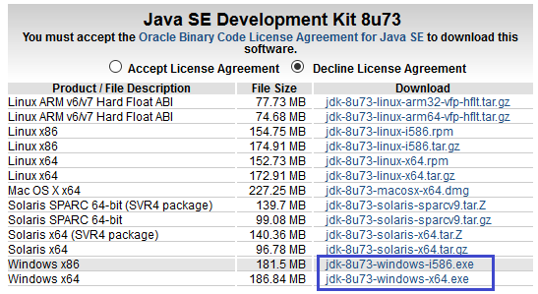

5) Save the Java installation file to your computer

6) Run and install the Java file.

|  |  |
| --- | --- |
| **Install Tomcat** | |
| 1) In your web browser, go to <http://archive.apache.org/dist/tomcat/tomcat-7/v7.0.109/bin/apache-tomcat-7.0.109.zip> to download Tomcat 7.0.109. This is downloaded as a folder  >> Under the section *Binary Distributions>>Core*, click on the link *32-bit windows zip* or *64-bit windows zip* (depending on your system architecture) to download.    2) Extract the apache-tomcat-7.0.68.zip. |  |

3) This is the folder once apache-tomcat-7.0.109 gets extracted:

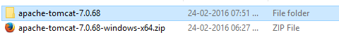

4) Copy and paste the apache-tomcat-7.0.68 folder to the c:\ drive, then rename it tomcat.

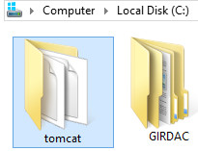

|  |  |
| --- | --- |
| **Create Environment Variables** | |
| 1) Open your Environment Variables:  *Start Menu > Control Panel > System and Security > System > Advanced System Settings > Environment Variables*.    2) **Create the JAVA_HOME variable:**  Click on the *New* button, under the *User Variables* section.  For *Variable Name*, enter *JAVA_HOME*  For *Variable Value*, provide the Java path (for example: C:\Program Files\Java\jdk1.8.0_66). Note  If you are running 32-bit Windows, then the path is: C:\Program Files (x86)\Java\jdk1.8.0_66  Java jdk path "jdk1.8.0_66" may be different on your system as it is dependent on the version you have installed.      Click the *OK* button.  3**) Edit the PATH variable:**  In the *System Variables* section, scroll down to and select the Path variable.  Click the *Edit* button at the bottom of the window.  Use your mouse cursor and click inside the Variable Value box.  Using your keyboard's right-arrow or End key, move all the way to the far right of the current text in *Variable Value*.  Add the following text onto the end of the existing *Variable Value* text:  - For Java path example:- *;C:\Program Files\Java\jdk1.8.0_66\bin* - For Mysql server path example:- *;C:\Program Files\MySQL\MySQL Server 5.5\bin* Note  There must be exactly one semi-colon between whatever is already in your PATH variable, and the new C:\Program Files\Java\jdk1.8.0_66\bin – don't add a semi-colon if your previous PATH already ended with a semi-colon.  Java jdk path "jdk1.8.0_66" may be different on your system as it is dependent on the version you have installed.      Click the *OK* button  4) **Create the JAVA_OPTS variable:**  a. Under the User Variables section, click the *New...* button again.  b. For *Variable Name*, enter *JAVA_OPTS*  c. For *Variable Value*, enter the system's memory size, for example: -Xms512m -Xmx1024m |  |

|  |  |
| --- | --- |
| **Download Mifos** | |
| **1)** Go to <http://mifos.org/> from your web browser and navigate to Take Action >> Get Mifos    **2)** Click on the "DOWNLOAD IT ON YOUR OWN" link    3) Click on "Download MifosX Now"    4) Fill out the *Mifos Download Form with your information*, then click the *Next Page* button. The download will start automatically.  **Note** :You can skip the form by scrolling to the bottom of the page and clicking on:  *No thanks. I would just like to download Mifos without providing additional information.*  However, we are able to understand and serve you better if you provide details of your organization.    5) You will automatically be redirected to a download page for Mifos on the Sourceforge website. Here you will be prompted to download a ZIP file containing the Mifos application.  **Note**: Or You can also download other versions directly from: <https://sourceforge.net/projects/mifos/files/Mifos%20X/> |  |

6) Once you have download the Mifos ZIP file, extract it to a new folder on your computer. Remember this location, as you will need to refer to it later.

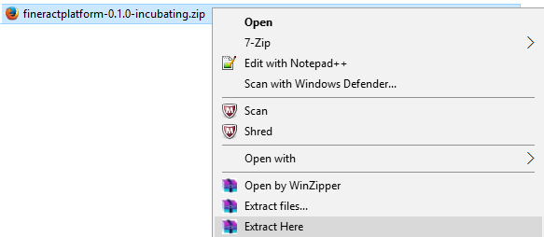

|  |  |
| --- | --- |
| **Initialize MySQL data** | |
| 1) Download HEIDISQL from <http://www.heidisql.com/download.php> and save the installation file to your computer. |  |

2) Run the Heidisql installation file and setup Heidisql:

i) Click on local and enter the MySQL password (**mysql**) in the Password field.

ii) Click on the Save button.

iii) Click on the Open button.

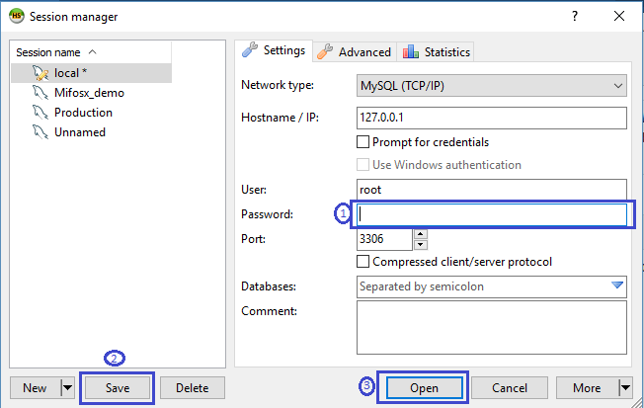

3) Copy the following database command and paste it into the large white box titled *Query*

***create database `mifosplatform-tenants`; create database `mifostenant-default`; use `mifosplatform-tenants`;***

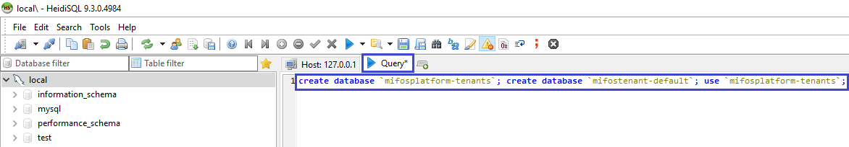

4) Click on the Run button to execute the query.

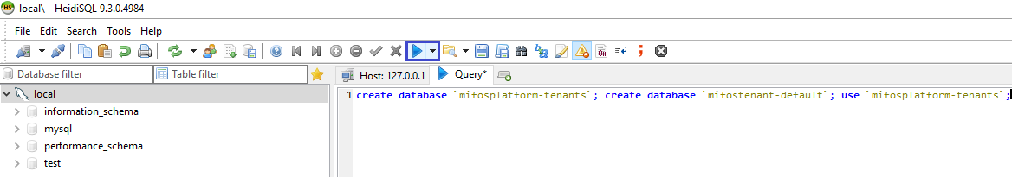

5) In the heidisql menu bar, click on File>>Load SQL file...

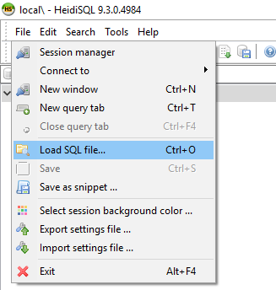

6) In the Load SQL file window:

Navigate to the location where you extracted the Mifos application files.

Navigate to the database folder inside that location.

Select the file mifospltaform-tenants-first-time-install.sql and click Open.

Run the first-time-install script, by clicking Run Query button. Once it's successful close the heidisql application.

|  |  |
| --- | --- |
| **Drop Mifos into Tomcat folder** | |
| 1) fineract-provider.war to tomcat>>webapps folder  1-a) Copy "fineract-provider.war" file from downloaded *fineract-platform* folder    1-b) Paste it to tomcat\webapps folder    2) Community-app to tomcat>>webapps folder  2-a) Copy "community-app" folder from downloaded *Mifos-platform>>apps* folder:    2-b) Paste it to tomcat\webapps  2-c) Rename existing ROOT folder to OLDROOT under tomcat\webapps\  2-d) Rename community-app folder to ROOT  3) **api-docs to tomcat>>webapps>>ROOT folder**  3-a) Copy "api-docs" folder from downloaded *Mifos-platform>>api-docs* folder:  **3**-b) Paste it to tomcat\webapps\ROOT folder |  |

|  |  |
| --- | --- |
| **Create .mifosx folder** | |
| 1) Create .mifosx folder in home directory & paste Pentaho folder into it  Use command prompt for creating .Mifos folder(make directory) i.e md .mifosx    2) Copy **PentahoReports** folder from downloaded **Mifos-platform** folder    3) Paste it to .mifosx folder |  |

|  |  |
| --- | --- |
| **Start Mifos** | |
| 1) Go to "C:\tomcat\bin" folder, Run "startup.bat" by clicking it.    Note: You can create a shortcut of "startup.bat" on your desktop and rename it as start mifosx.  2) Application gets started    3) Once server starts, will display as "Server startup in xxxxx ms"    4) You could access through any internet browser:-  **@** [**https://localhost**](https://localhost/)  **and if you are using server port number as 8443 then you could access it @** [**https://localhost**](https://localhost/)**:8443**  5) For the first time access it will display as shown below, please click on proceed:-    6) Login into Mifos, Provide user name: **mifos** and password as: **password** |  |

## Mifos x Low Bandwidth cloud access

### Mifos x installation on cloud:

We strive to make Mifos X as readily available and deployable in any environment as possible. We have a number of cloud images and packages available for instant deployment and are looking for volunteers to assist in making available additional images.

# 

Once Mifos platform is downloaded ,extract the folder .Go to Mifos platform >> release >>apps >>community-app >> index.htm.

Provide login credential.

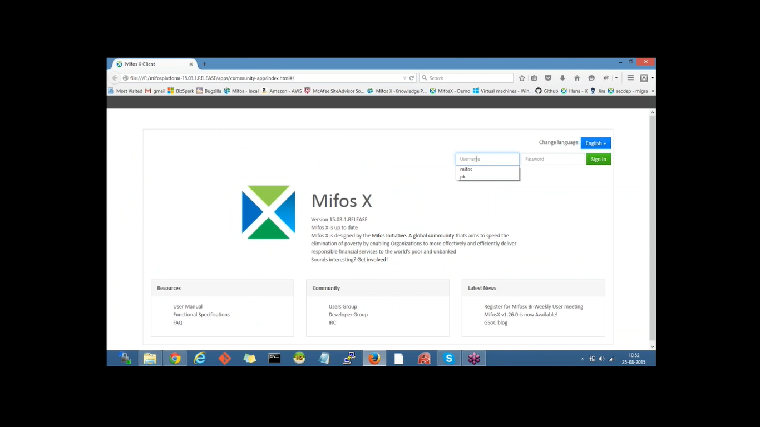

To access demo 2 instance,you need to update url by adding this index html

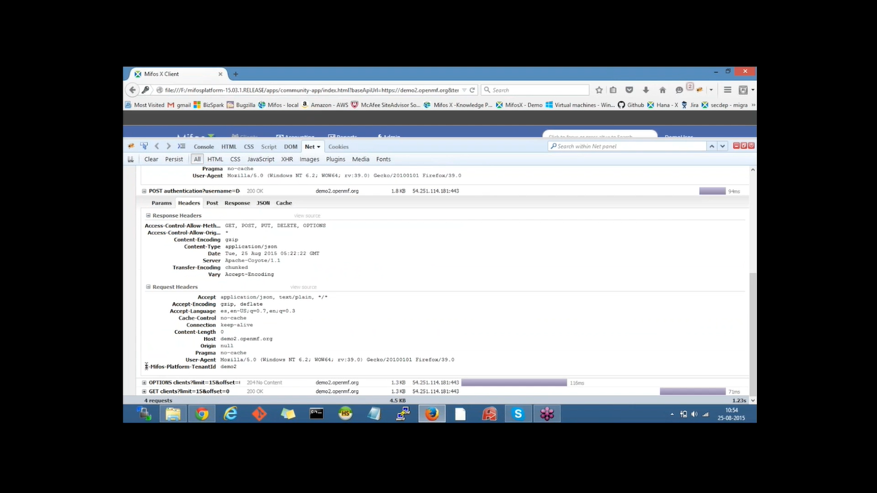

## Mifos X Training Request Feature & Report Bug :

To report bug or to request for a new feature go to browser and search <https://mifosforge.jira.com> and the page will be displayed as shown in below figure.Go to login option and give the credentials and press login

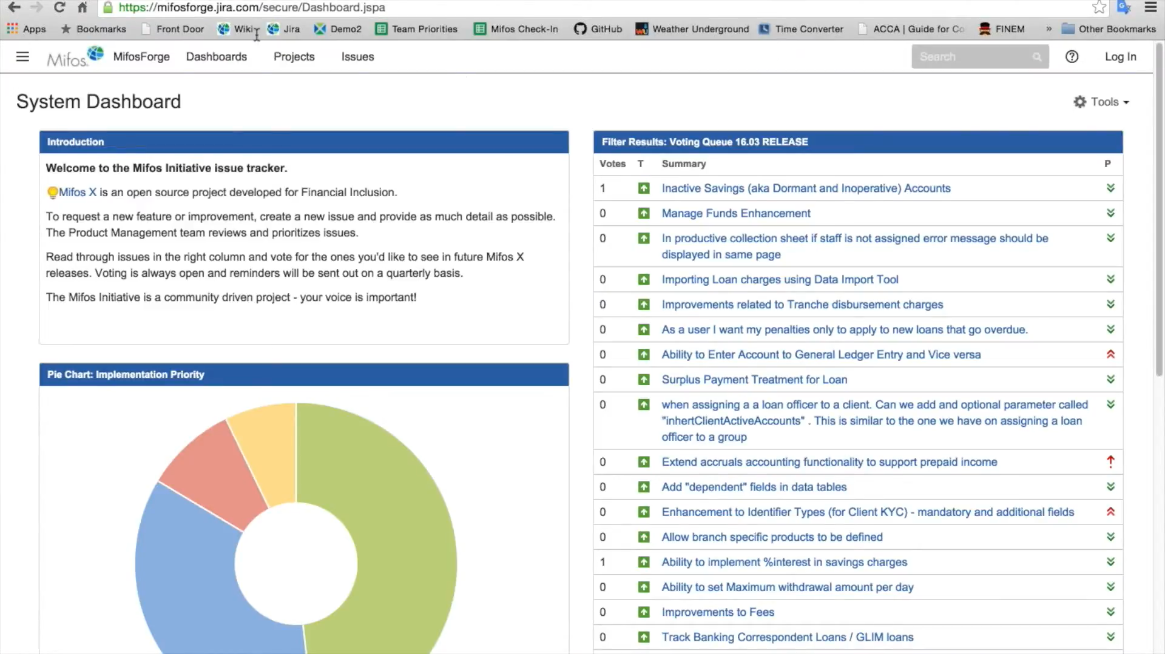

Then press on create button as shown below

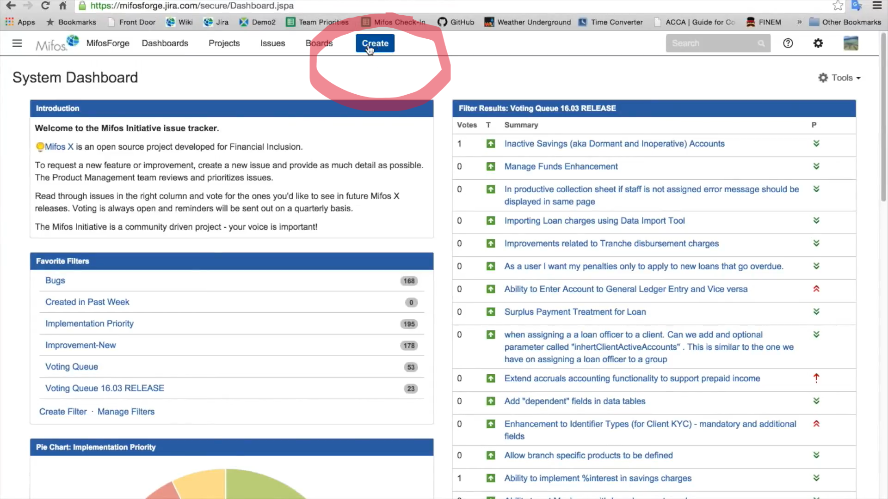

Once clicking on that it will take you to a page as shown below and fill out all the details that has asked and press on create which is displayed on bottom of the page

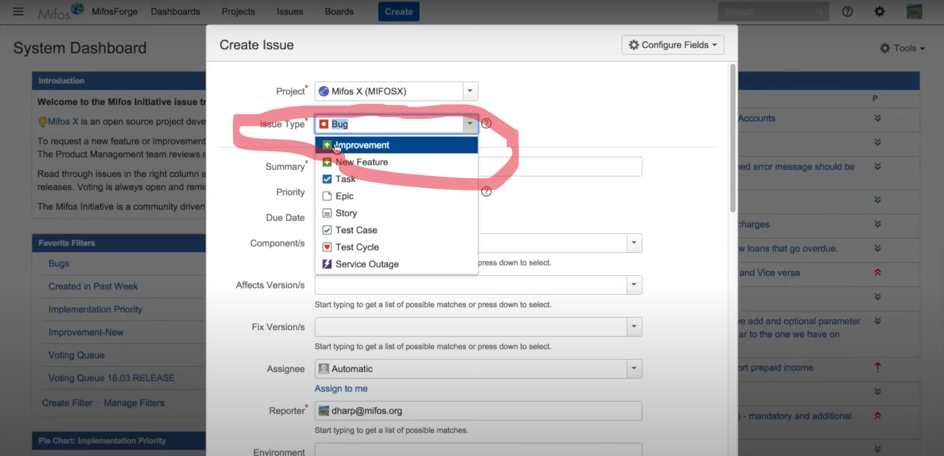

# 

# 

# 

# 

## Mifos x data Import tool:

### Installing Data Import Tool:

note: Data Import Tool will work with Mifos X - version from 1.26 to 15.03.

1 - Required Software

1.1 - Download & Install Git hub

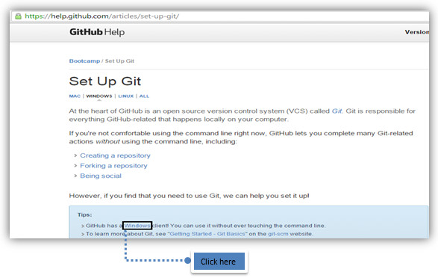

1.2 - Download & Install Git Bash from: <http://git-scm.com/downloads>

#### 

1.3 - Downloading Gradle (Compatible version is 2.6)

From <http://gradle.org/downloads>

#### 

1.4 - Extracting downloaded Gradle to C:/

#### 

### 2 - Setting up environment variables for gradle.

#### 

### 3 - Cloning URL

#### **from** [**https://github.com/openMF/dataimporttool**](https://github.com/openMF/dataimporttool)

3.1 - **Open git bash:**

git clone https://github.com/openMF/DataImportTool.git

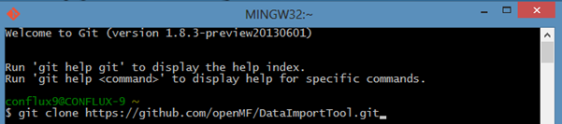

4 - Create dataimport.properties file in home directory

>> Right click and open new text file then paste 4.1 content below in it, now click on save button>>Rename .txt file to dataimport.properties

Tip: In folders and settings, make sure to enable folder extension.

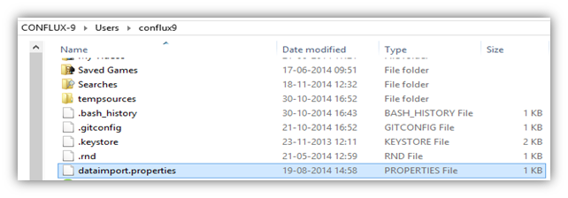

4.1 - Update below provided details in the dataimport.properties file:

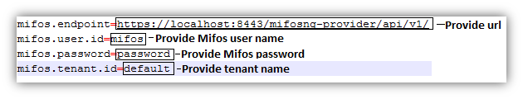

mifos.endpoint=<https://localhost:8443/mifosng-provider/api/v1/>

[mifos.user.id](http://mifos.user.id/)=mifos

mifos.password=password

[mifos.tenant.id](http://mifos.tenant.id/)=default

**Note:** If you are using Multi-tenant, then endpoint should be the same but [tenant.id](http://tenant.id/) and respective credentials should be changed respectively.

**Note:** If the you are connecting to the demo server and want to use your tenant, for importing the data then it will be like this:-

For example:- Tenant name is - xyzmfi, then

mifos.endpoint=<https://demo.openmf.org/mifosng-provider/api/v1/>

[mifos.user.id](http://mifos.user.id/)=<your username>

mifos.password=<your password>

[mifos.tenant.id](http://mifos.tenant.id/)=xyzmfi

### 5 - Starting Data import tool:

5.1 - Open Gitbash>> Go to:

cd DataImportTool

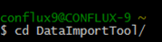

5.2 - Run:

gradle clean tomcatRunWar

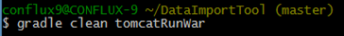

5.3 - Once the server is started:

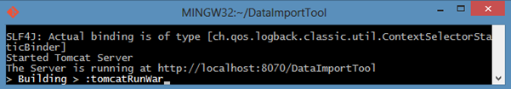

### 6 - Start Using - Data Import tool from web browser, by going to:

<http://localhost:8070/DataImportTool>

Note: Make sure Mifos X is running.

Also refer compatible software details:- [Compatible Software](https://mifosforge.jira.com/wiki/spaces/docs/pages/98598928/Compatible+Software)

### Get started with data import tool

### **Getting started**

Starting Data Import tool, Using Git bash >> Go to:

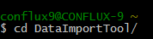

Run:

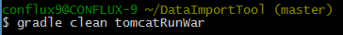

Once the server is started:

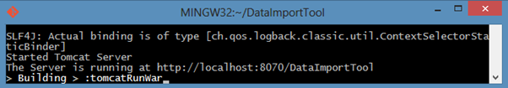

Using Data Import tool, from web browser - Go to:

http://localhost:8070/DataImportTool

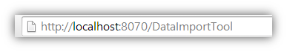

### Using Data Import Tool :

Setting up from Front end

In order to start importing data, you should have created office & staff from front-end:

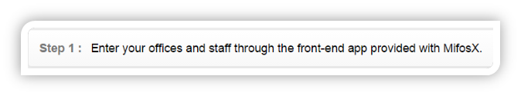

### 

**Importing Clients**

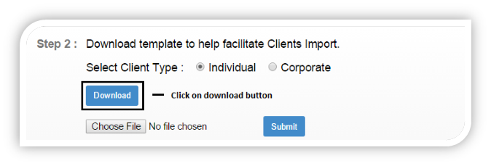

**Updating details in the downloaded sheet:**

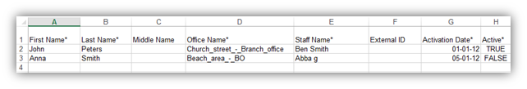

Note: All fields marked with an asterisk(*) are compulsory.

Drop down values should be selected, i.e. for: Office Name, Staff Name and Active.

Date format should be: DD-MM-YYYY

**Uploading the sheet:**

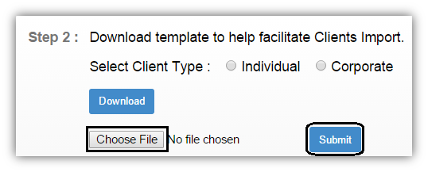

Choose file and select the file >> then click on submit button to upload.

### **Re-Uploading unsuccessful import sheet**

If the import was not completely successful, then Re-Upload.xls sheet will be generated automatically:

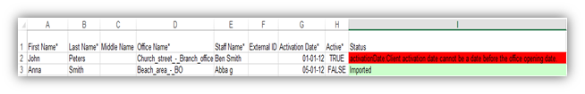

Open the sheet and check for status

**In the shown example:**

a) For 2nd row for client – “John”, Import was failed and the status is “activationDate : Client activation date cannot be a date before the office opening date” (Shown in red).

b) For 3rd row for client - “Anna”, Import was Successful and the status is “Imported (Shown in green)”.

After making the necessary changes, upload the same sheet again.

**For this example, I am only updating for failed import i.e.:**

a) For 2nd row for client – “John”, updating the “Activation date” to the Office opening date or later date.

**Import Successful**

On successfully completing the import, it will show the message as:

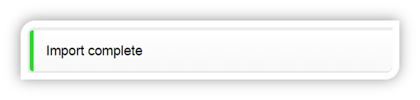

**In the same way Data can be imported**

### Import Centers:

### Import Groups:

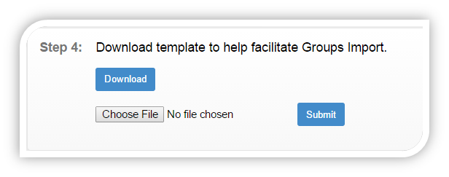

### Import Loans:

To start importing Loans, you should have defined from front end:

Currency configuration, Loan products & Charges. (Administration => Organisation/ Products)

Payment Types (Administration -> System -> View Code -> Add/Edit Code Value)

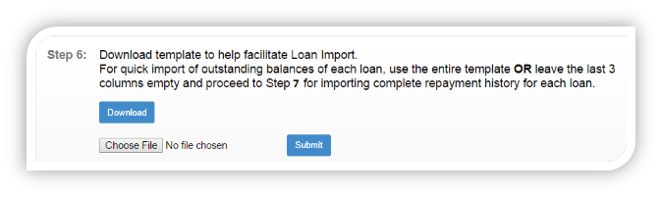

### Import Loan repayments:

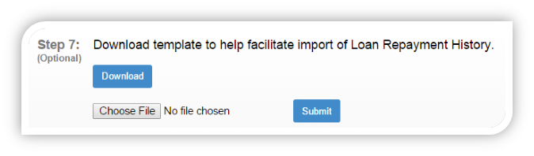

### Import Savings:

To start importing Savings, you should have defined from front end:

Currency configuration, Savings products & Charges. (Administration => Organisation/ Products)

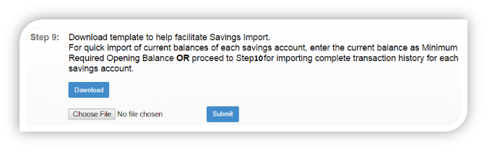

### 

### Import fixed deposit:

To start importing fixed deposit, you should have defined from front end:

Currency configuration, fixed deposit products and Charges. (Administration => Organisation/ Products)

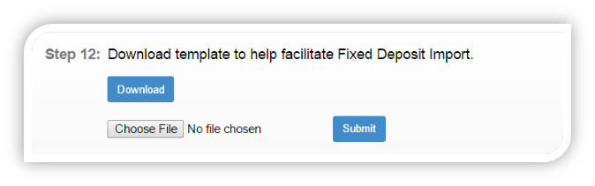

### Import recurring deposit:

To start importing recurring deposit, you should have defined from front end:

Currency configuration, recurring deposit products and Charges. (Administration => Organisation/ Products)

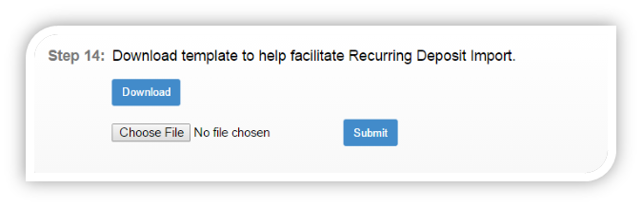

### Importing RD account transaction’s:

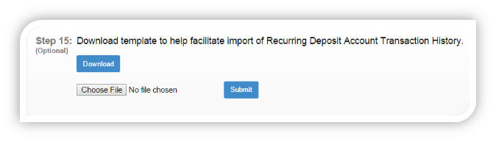

### Importing closing of savings account:

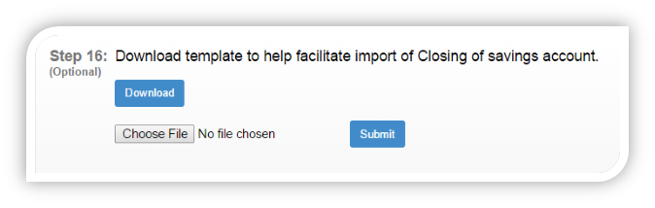

### Importing/Adding – Journal entries:

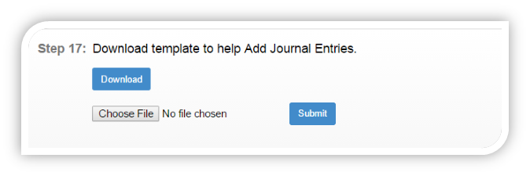

## Mifos x Building Custom Reports:

* First go to ‘System’, then ‘Manage Report’.
* In Manage Report click on Create Report.
* In the Create Report, give the ‘Report name’.
* And select the ‘report type’. Eg:Tree.
* Select Report Sub type.
* Then enter the report catagory.
* In Description enter a brief description of the report.
* Then If you want to enter any parameters select in ‘Export Parameters’.
* Click on ‘Submit’ button for the report to be created.

### METADATA TABLES:

* ﻿﻿There are three metadata tables that record report details.
* ﻿﻿stretchy_report
* ﻿﻿stretchy_report_parameter
* ﻿﻿stretchy_parameter
* ﻿﻿These tables are installed as part of the Mifos X database installation.
* ﻿﻿They also contain the sql associated with the reports a parameters.

In Mifos X, apart from using standard reports which are already shipped, you can create your own **Custom Reports**based on your required parameters.

Mifos X currently supports two types of Custom Reports:

### 1) Stretchy Reports

### 2) Pentaho Reports

LIMITATIONS OF STRETCHY REPORTS

* ﻿﻿The reports can only be exported in spreadsheet formats.
* ﻿﻿The reports can't be saved in other formats like PDF.
* ﻿﻿They lack formatting options for the reports to be created.
* ﻿﻿Not suitable for big or complex reports which can user experience.

PENTAHO REPORTING

* ﻿Pentaho Reporting is a suite of tools for creating pixel perfect reports.
* ﻿﻿With Pentaho Reporting you are able to transform data into meaningful information tailored to your audience.
* ﻿﻿You can create HTML, Excel, PDF, Text or printed reports.
* ﻿﻿It's open-source reporting tool.

### Creating Stretchy Reports:

Go To **Admin** >> **System** >> **Manage Reports** and Click on **'+ Create Report'** tab to see the following window:

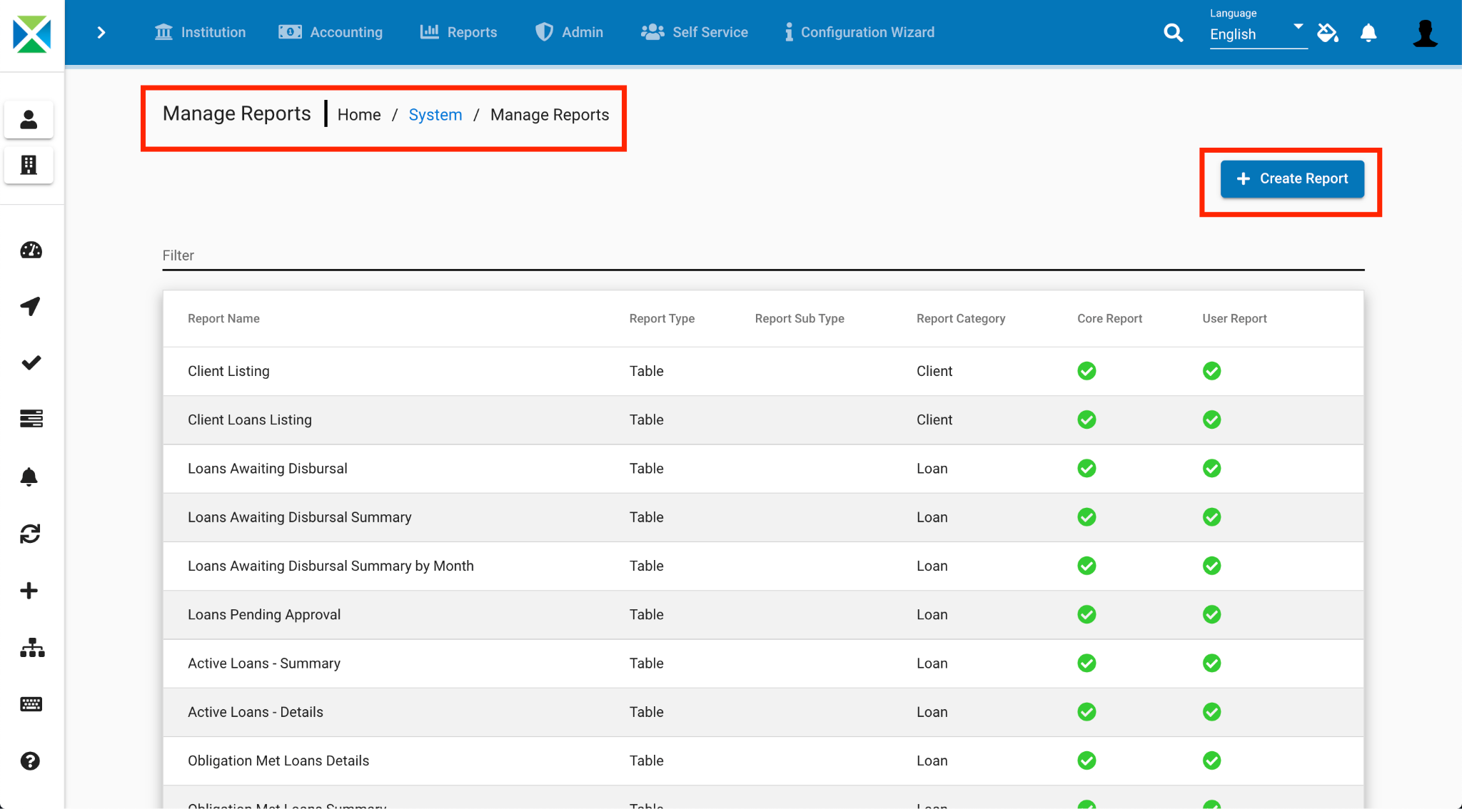

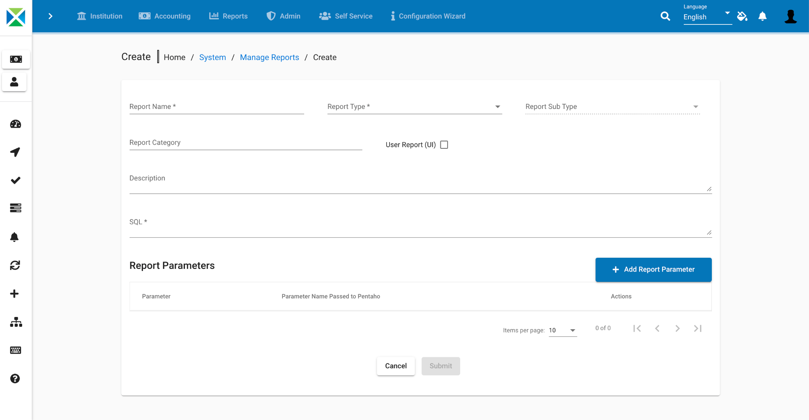

The following SQL Query is used as an example:

**Example** :Select c.id clientId, CONCAT("\"",c.display_name,"\"") clientName, ounder.name officeName from m_office o join m_office ounder on ounder.hierarchy like concat(o.hierarchy, '%') join m_client c on c.office_id = ounder.id where o.id = ${officeId}

Parameter: Select office

The Stretchy Report requires you to fill the following fields before it gets generated:

|  |  |  |
| --- | --- | --- |
| **Field Name** | **Drop-Down Parameters** | **Description** |
| Report Name | None | Provide the name for the report, so that users can search for it using this name. |
| Report Type | * Table * Pentaho * Chart * SMS | If you're creating a Stretchy Report, select 'Table'.  If you're creating a Pentaho Report, select 'Pentaho'.  If you're creating a 'Chart' Report (like Bar, Pie, etc.), select 'Chart'. |
| Report sub type | * Bar * Pie | If you have selected the Report Type as 'Chart' , you need to select Report sub type as either Bar or Chart. |
| Report Category | None | Provide the Report Category *(for example: Clients, Loans, Savings, Accounts, etc.)* to which the Report belong to. |
| Description | None | Give a small description about the report being generated. |
| Use Report | None | If you check it, the report is ready to be used once it's created.  If you leave it unchecked , the report name won't be shown in the list of Reports, even though it will be created. This option is used when the report creation is still under process. |
| Sql | None | Here, you need to write the SQL Query to generate the required report. In order to write SQL queries, you need to have a basic understanding of the following:   * MySQL * Database Structure of Mifos X * Knowledge of most of the important tables which are present in the database (for example: 'Mifostenant-default') |
| Report Parameters | * Start Date * End Date * Select Officer * Select Loan Officer * Select Currency etc. | Select the available parameter from drop-down list and click on '+Add' button. You can select more than one parameter as per the requirement of your project. |

After filling in the required parameters, click on the '**Submit**' button to generate the report.

To view the Report, click on '**Reports**' tab and either search for it by Report Name, or go to the specific category to which the report belongs to and select the report.

### Modify existing Stretchy Reports:

Go to Admin >> System >> Manage Reports to see the list of Stretchy as well as Pentaho Reports.

Click on the specific report you want to modify. It will show the highlights of the Stretchy Report as shown in the screenshot below:

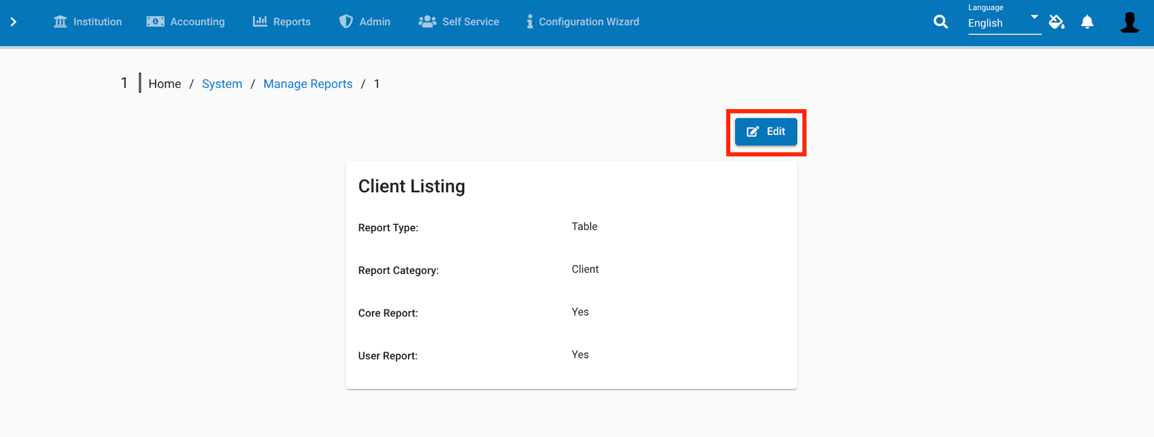

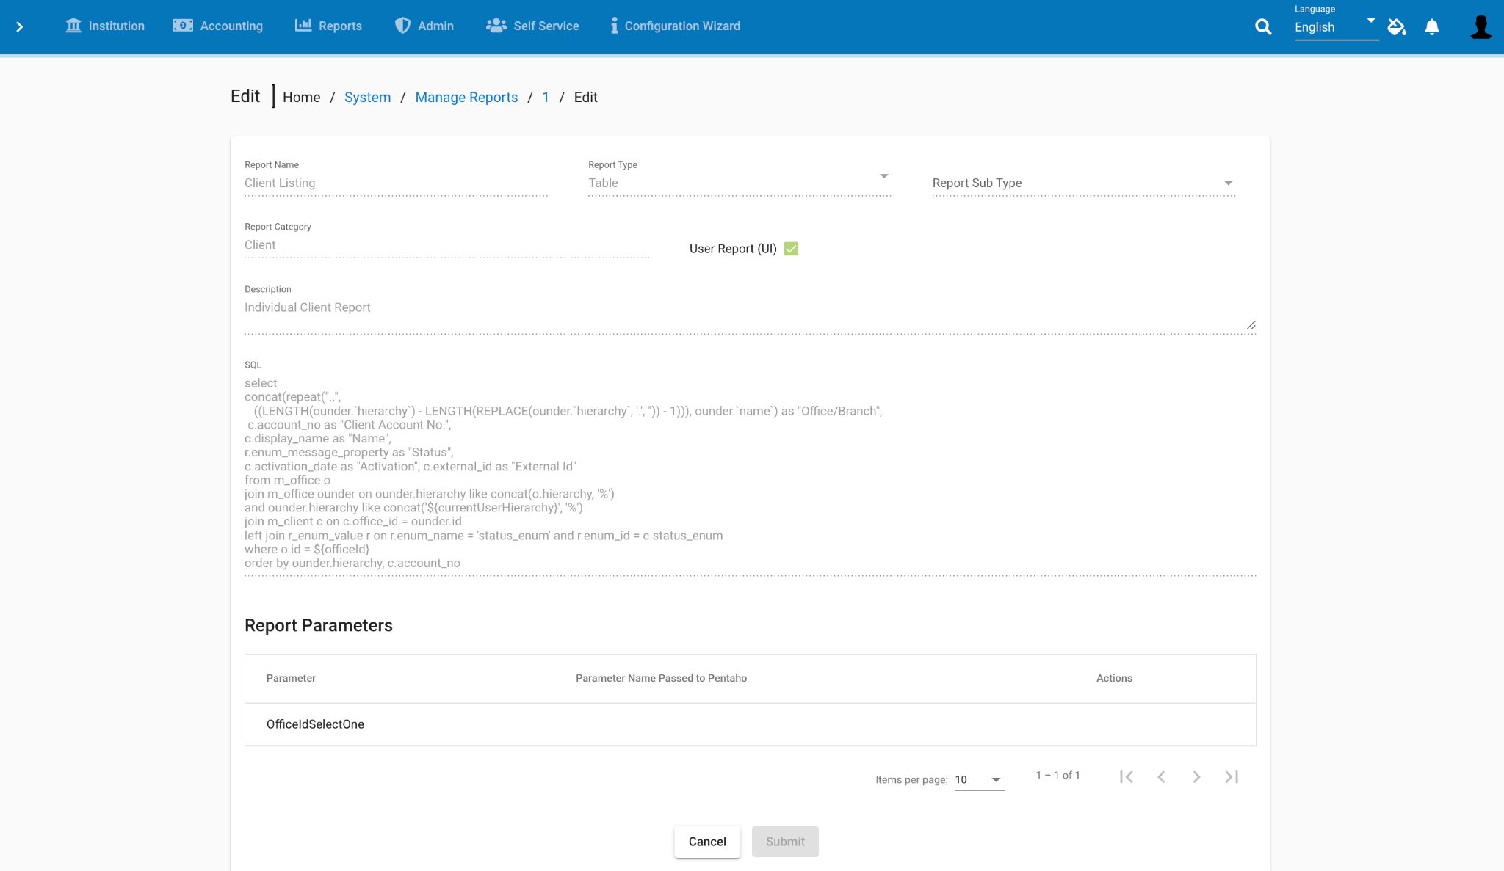

Click on the 'Edit' button to modify the Report.

Once you modify the report, click on the 'Submit' button.

## Create and Upload Custom Pentaho Reports:

**P**entaho Reporting is a suite of tools for creating pixel-perfect reports. With Pentaho Reporting, you are able to transform data into meaningful information tailored to your audience. You can create HTML, Excel, PDF, Text or printed reports. It’s an open-source reporting tool.

Stretchy Reports vs Pentaho Report

|  |  |  |
| --- | --- | --- |
| **Stretchy Reports** | **Pentaho Reports** |  |
| 1 | They lack formatting options for reports to be created. | You can format texts, column headings and tables. |
| 2 | Not suitable for big and complex reports. | Pixel-perfect reports can be created irrespective of their size and complexity. |
| 3 | Can only be exported to spreadsheets. | Can be exported to HTML, Excel, PDF, Text, etc. |
| 4 | Very simple to create and can be created using the community-app front-end for Mifos X. | It needs a separate tool ("Pentaho Report Designer"), which allows us to create Pentaho reports and later embed those reports in Mifos X. |
| 5 | Better suited for simple reports having less or no formatting options | Better suited for complex reports having a lot of formatting options |

### Creating Simple Pentaho Report and Embedding it to Mifos X :

Downloading and Installing Pentaho Report Designer

To download Pentaho Report Designer Tool please click on the following link,

<https://sourceforge.net/projects/jfreereport/files/latest/download>

Note: The current version of Pentaho Report Designer is 5.0.1

It will be the zipped file with size around 268 MB.

Download it and unzip it in the required directory.

Copy mysql connector jdbc into lib folder. <http://dev.mysql.com/downloads/file.php?id=457911>

**Starting Pentaho Report Designer:**

Go into the unzipped 'Pentaho Report Designer' folder and double click on 'report-designer.bat' file(for Windows).

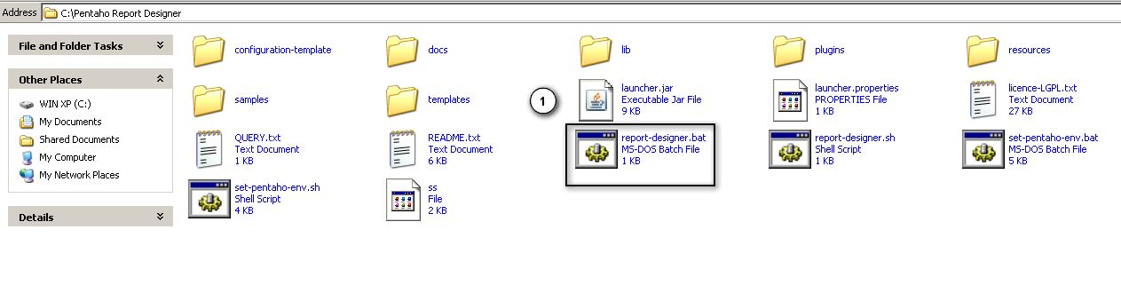

Once Pentaho Report Designer tool starts, you will be welcomed with the following window.

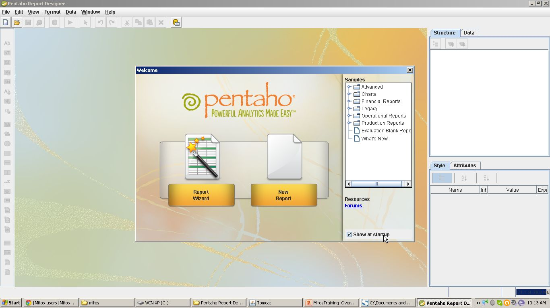

**Creating Your First Pentaho Report**

* Go to the 'File' Menu and click on 'New' button.
* Go to the 'Data' tab, click on 'Add Data Source' and then click on JDBC.

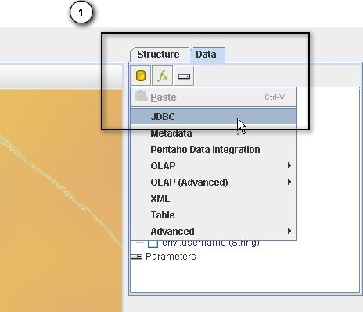

* Once you click on JDBC, the following window will open, where you need to click on '+' (Create New Connection) button.

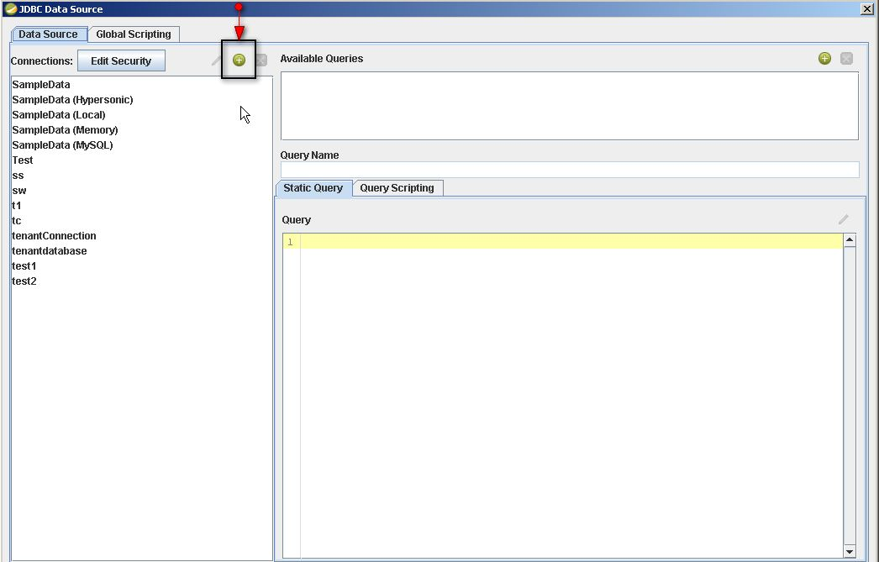

* Once you click on 'Create New Connection', the following window will appear. Here, you have to provide all the setting information as given in the following table and then click on 'Test' button to generate the Message Box where it shows the confirmation of connection. Once Connection is established click on 'OK' button.

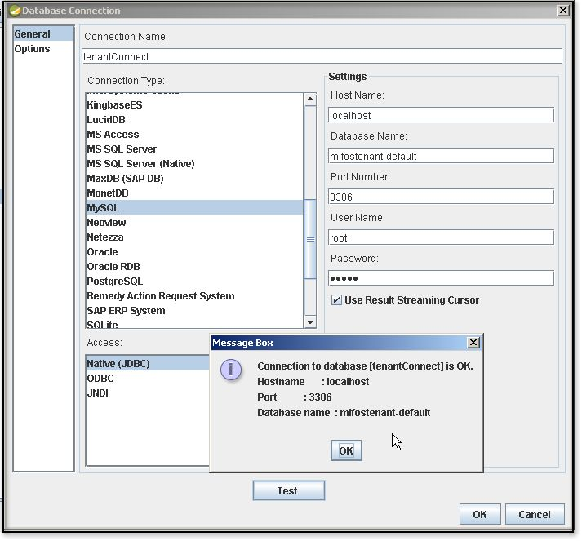

|  |  |  |
| --- | --- | --- |
| **Sl.No** | **Field Name** | **Description** |
| 1 | Connection Name | Provide the appropriate connection name |
| 2 | Host Name | This is the name of server to which designer tool connects to. In this case, we are connecting to 'localhost'. |
| 3 | Database Name | Provide the database name to which designer tool needs to connect. In MifosX, we generally connect to the database 'mifostenant-default' |
| 4 | Connection Type | In the left column, please select the appropriate connection type(in this case, mysql) . Once you select 'mysql' the Port Number automatically selected as 3306. |
| 5 | User Name | Provide the mysql username( in this case it is 'root') |
| 6 | Password | Provide the mysql password. |

* As shown in the following window, click on '+' button to add the sql query.

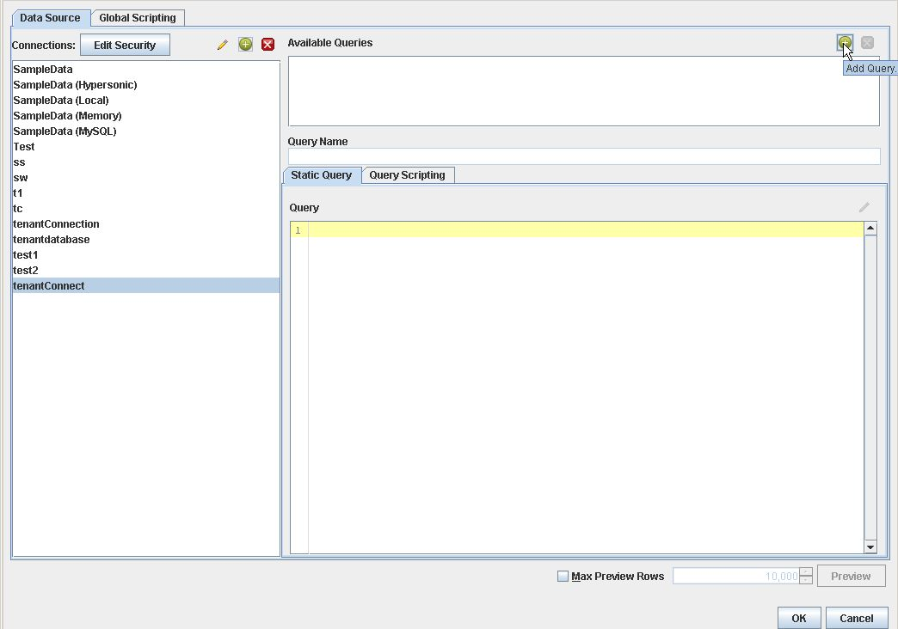

* Here, Provide the Sql Query Name and write the appropriate Sql Query and then click on the 'Preview' button to confirm that, the Sql query executed successfully. Then click on the 'OK' button.

Query example:

**select mc.firstname,mc.lastname,mc.account_no from m_client mc**

**where mc.activation_date between ${startdate} and ${enddate}**

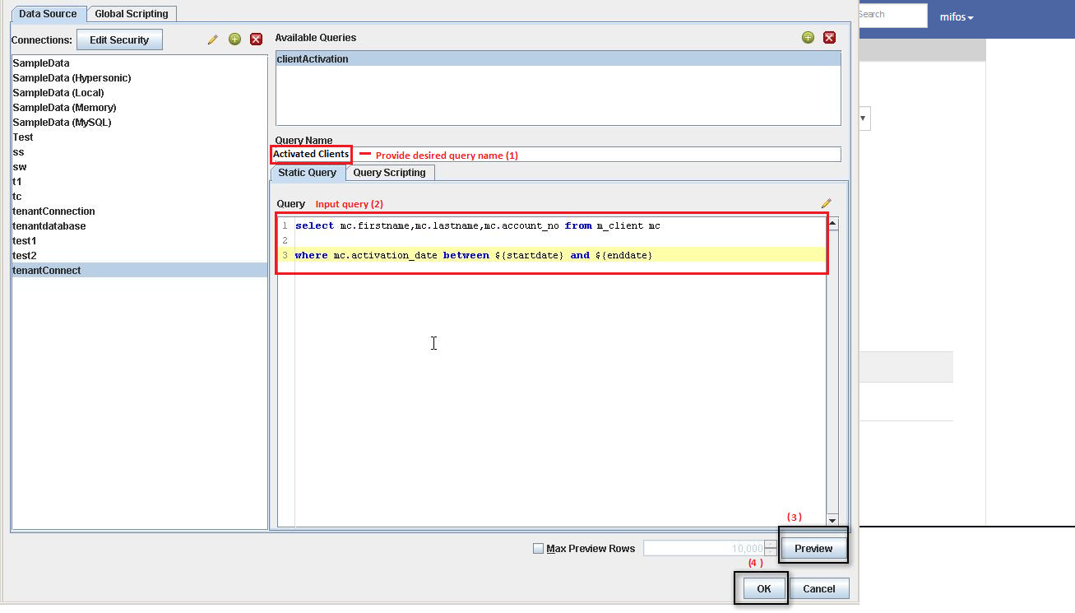

* Once you create an executable Sql Query, you may have to add parameters if required. In order to embed Pentaho Report to MifosX, At least you have to create 3 parameters which are passed to MifosX, namely:
* tenantUrl
* username
* password.

To add parameters, under the 'Data' tab, scroll down to see 'parameters' and then right click on 'parameters' and then click on '**Add parameter**' to see the following window.

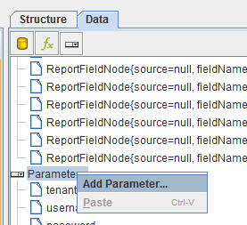

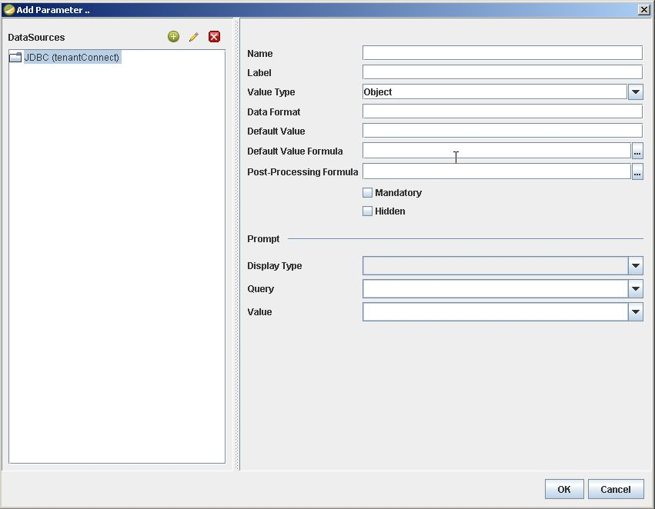

|  |  |  |
| --- | --- | --- |
| **SI.NO** | **Parameter Name** | **Parameter Fields** |
| 1 | tenantUrl | Name:tenantUrl  Label:Tenant Db  Value type: String  Default Value: jdbc:mysql://localhost:3306/mifostenant-default  Check mandatory |
| 2 | username | Name:username Label:User Name Value Type: String  Default Value: root |
| 3 | password | Name:password Label:Password Value Type: String  Default Value: mysql  Check Mandatory Field |
| 4 | startdate (For this example) | Name:startdate Label:Start date Value Type: Date (SQL)  Display Type: Date Picker |
| 5 | enddate (For this example) | Name:enddate Label:End date Value Type: Date (SQL)  Display Type: Date Picker |

Basically, these three parameters are required to embed Pentaho Report in MifosX. Similarly, you can define more parameters as per requirement of the report.

* Once you add the parameters, you need to check whether the report is working fine in the pentaho environment. First, You need to add the Report fields into 'Details' section of the pentaho environment. In our example, the fields 'firstname', 'lastname' and 'account_no' of the clients are added. In order to add them you need to drag each field in 'Details' section of the pentaho environment as shown in following two screenshots.

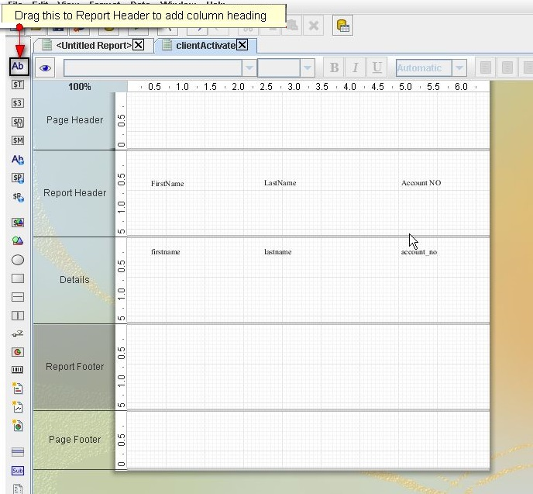

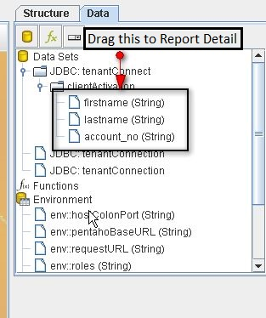

* Next you need to click on the 'Run' button and choose appropriate format for the report.

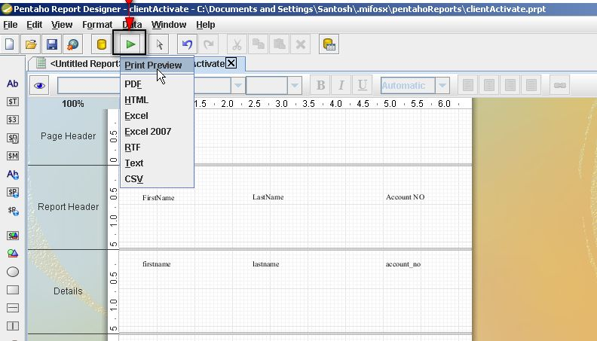

* Once you 'Run' the report by choosing appropriate format, the following window will open where you enter the parameters and generate the report. (In this case, PDF is selected).

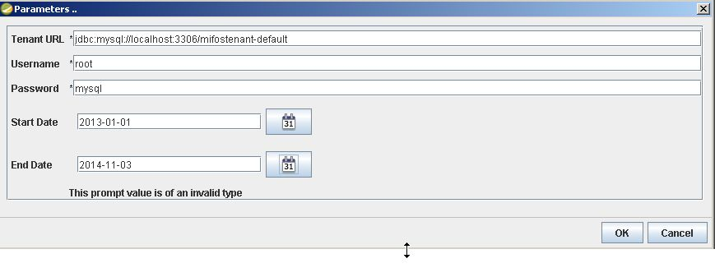

* If you click on the 'OK' button and a PDF is generated, it means Pentaho Report was created successfully.
* Add Global scripting once you are done with all the design and testing. Before you save the report you need to add global scripting.

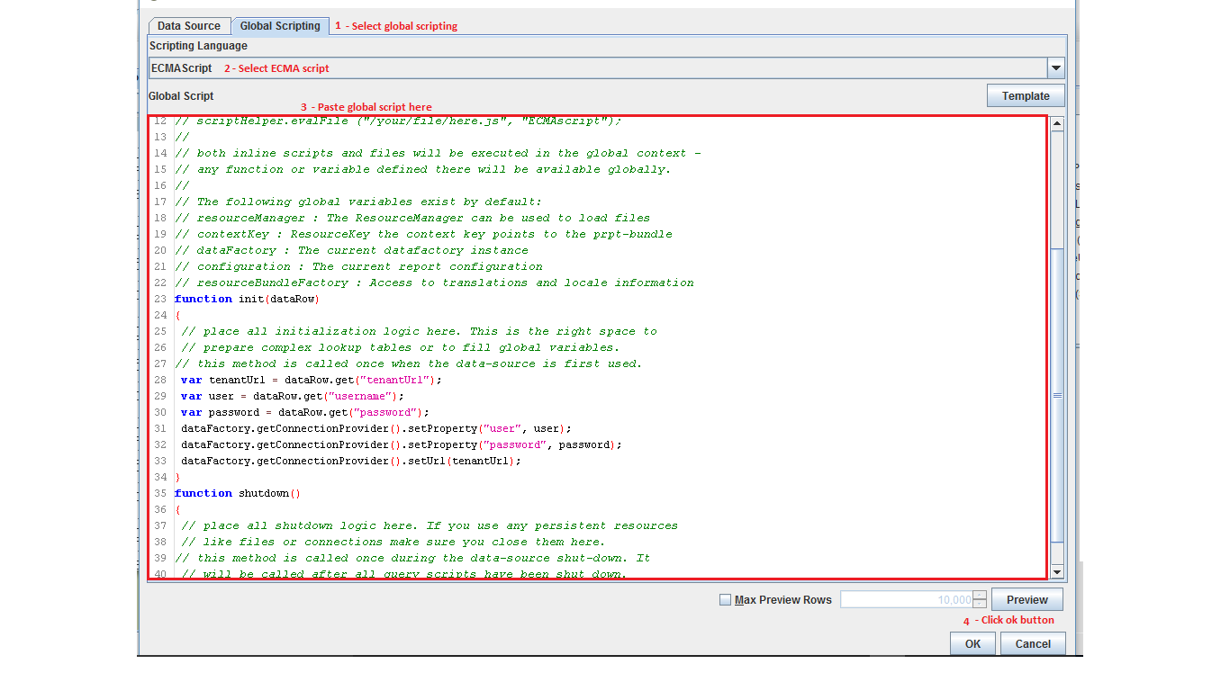

Copy this content into it

// This is a template to demonstrate the existing functions

// you can use in a global data-source script. All functions and

// global variables you define here will be available for the

// all query scripts.

//

// Feel free to delete any function you don't use.

//

// you can process scripts via

// scriptHelper.eval("println ('Hello World');", "ECMAscript");

//

// or your can load your own ECMA/JavaScript files and execute them via

// scriptHelper.evalFile ("/your/file/here.js", "ECMAscript");

//

// both inline scripts and files will be executed in the global context -

// any function or variable defined there will be available globally.

//

// The following global variables exist by default:

// resourceManager : The ResourceManager can be used to load files

// contextKey : ResourceKey the context key points to the prpt-bundle

// dataFactory : The current datafactory instance

// configuration : The current report configuration

// resourceBundleFactory : Access to translations and locale information

function init(dataRow)

{

// place all initialization logic here. This is the right space to

// prepare complex lookup tables or to fill global variables.

// this method is called once when the data-source is first used.

var tenantUrl = dataRow.get("tenantUrl");

var user = dataRow.get("username");

var password = dataRow.get("password");

dataFactory.getConnectionProvider().setProperty("user", user);

dataFactory.getConnectionProvider().setProperty("password", password);

dataFactory.getConnectionProvider().setUrl(tenantUrl);

}

function shutdown()

{

// place all shutdown logic here. If you use any persistent resources

// like files or connections make sure you close them here.

// this method is called once during the data-source shut-down. It

// will be called after all query scripts have been shut down.

}

* You need to save the report with '.prpt' extension. In order to do it, Just go to the 'File' menu and click on 'Save' button.

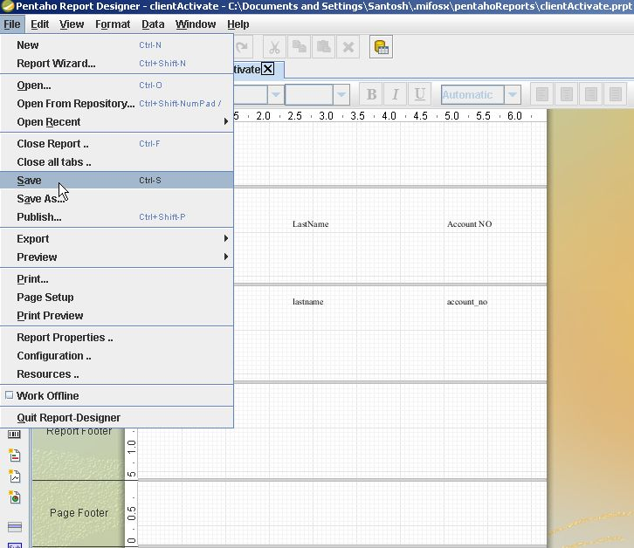

### Embedding Pentaho Report in MifosX:

* Create a '.mifosx' folder (use DOS to create the folder) in your home directory and then create a sub folder 'pentahoReports' in '.mifosx' folder.
* Please copy the pentaho report file( with *.prpt file extension) which you have created earlier using 'Penntaho Report Designer Tool' in "home/.mifosx/pentahoReports" folder.
* Go to Community-app and then go to Admin >> System >> Manage Reports and click '+Create Report' to see the following window.

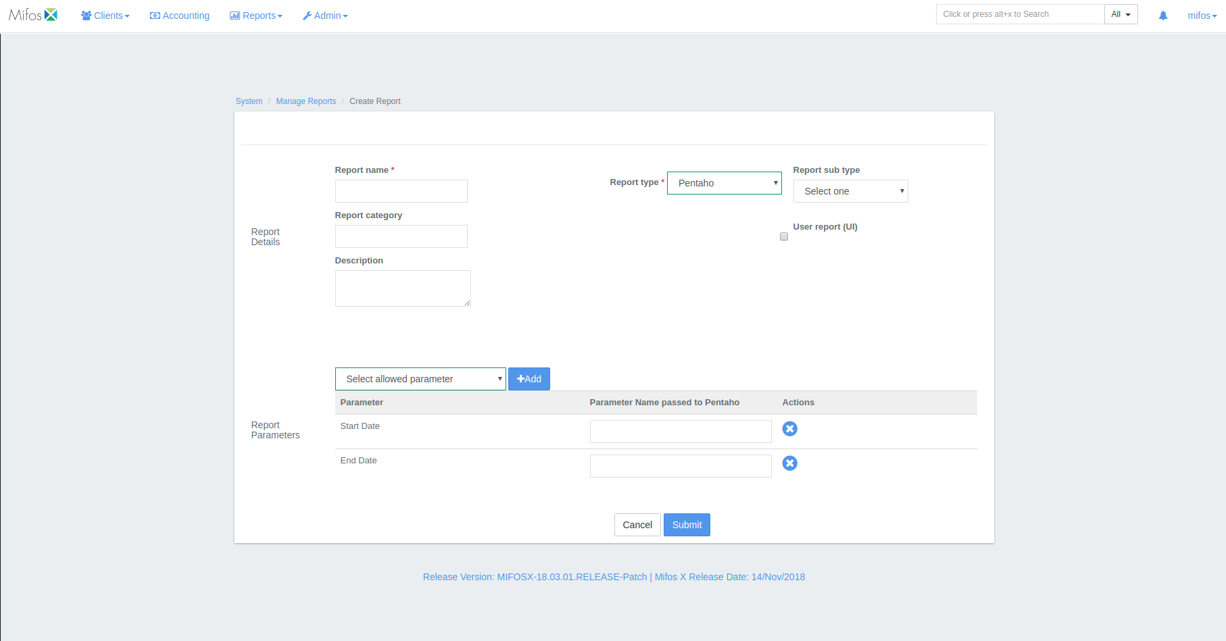

* Ensure **'Report Name' should be the same as the pentaho report file name** (that is in this example, "**Activated Clients**.prpt").
* Select Report Type as 'Pentaho' from drop-down list.
* Ensure to check the box for "Use report(UI)".
* Select the required parameters which are passed to pentaho. (in this case, startDate, endDate).
* Click on the 'Submit' button to create the report.

### Generating created Pentaho Report :

Go to Community-app and then go to 'Reports' tab and then by selecting the report section>>then the required report you could generate the report.

In this example: Reports>>clients>>Activated clients.

# 

# 

# 

# 

# 

# 

# 

# 

# 

# 

## Mifoxs x Payment type

For all kinds of payments, you can specify what forms of payment you will accept.

**On this page:**

### [Adding a Payment Type](https://mifosforge.jira.com/wiki/spaces/docs/pages/90243216/Payment+type#Paymenttype-AddingaPaymentType) :

* [Edit Payment Type](https://mifosforge.jira.com/wiki/spaces/docs/pages/90243216/Payment+type#Paymenttype-EditPaymentType)
* [Delete Payment Type](https://mifosforge.jira.com/wiki/spaces/docs/pages/90243216/Payment+type#Paymenttype-DeletePaymentType)

Beginning at the main screen, select **Admin,** then **Organization** from the drop down menu. This will launch the [**Organization**](https://mifosforge.jira.com/wiki/display/docs/Organization)menu.

Select **Payment type** to specify types of payment you will accept.

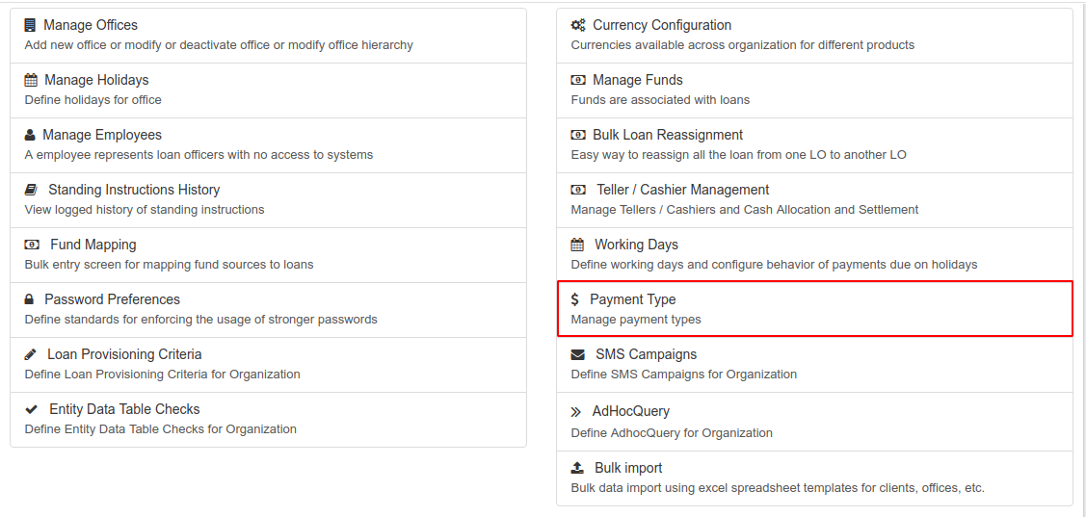

This will launch the **Payment Type** page that displays a list of types of payments, their description, position and whether the payment is a cash payment or not.

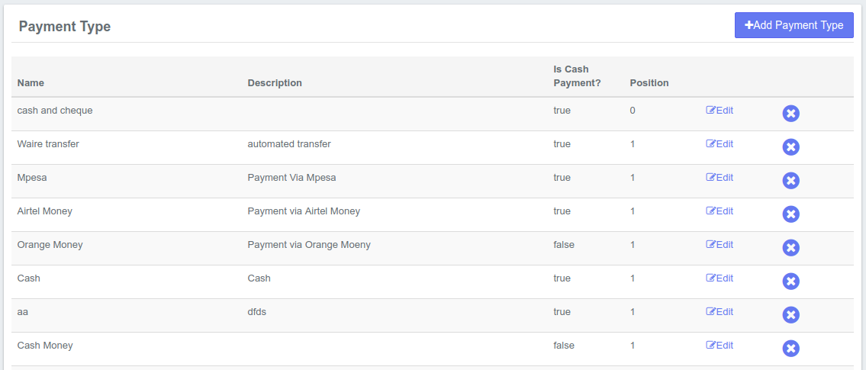

### **Adding a Payment Type**

Click the 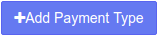 button at the top-right of the page. This will launch the **Create Payment Type** page:

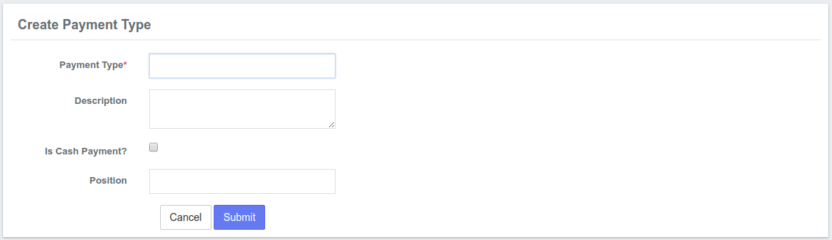

To create a payment type, follow these steps:

1. **Payment type** - Fill in an appropriate name of your choice. In the example below, Payment type is Mobile Money.
2. **Description** - Input the description of the mentioned payment type.
3. **Is Cash payment?**- Check the check box if the payment type is a Cash payment. In the example below, the box is left un-checked since the payment is not in cash.
4. **Position** - Provide the position number to list in the provided drop down menu.
5. Check your input and if complete, click the **Submit** button.

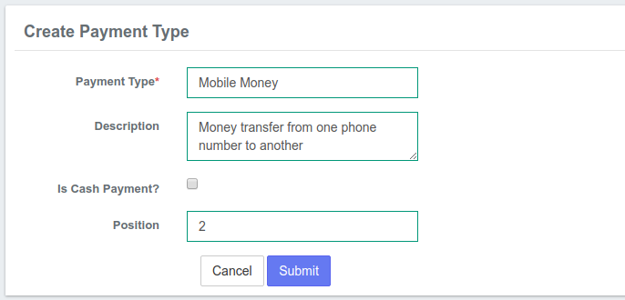

### Edit Payment Type :

Click the **Edit** button at the right of the payment type you want to modify.

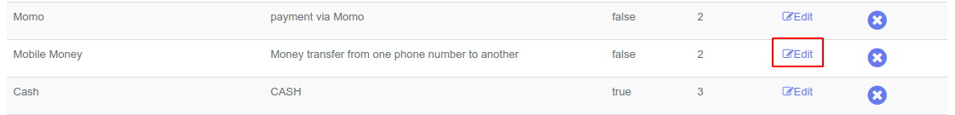

This will launch the Edit Payment type page in which you can modify the details of the type of payment.

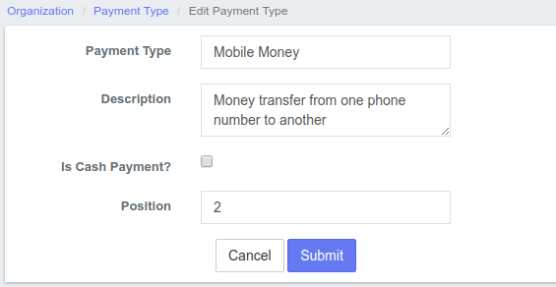

When you are done modifying the payment type, click the **Submit** button.

### Delete Payment Type:

To delete a payment type, Click the  button at the extreme right of the payment type.

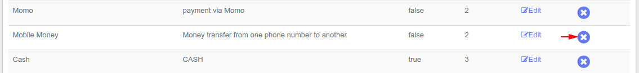

## Mifos x Account number Preferences:

Account number preferences are used to describe custom formats for account numbers associated with Client, Loan and Savings accounts. This enables an organization to easily categorize or differentiate just by account number with respect to the prefixed Office name, Type or by product short name respectively.

### Step 1: Beginning at the main screen, select [Admin](https://mifosforge.jira.com/wiki/spaces/docs/pages/52592736/Administration), then System from the drop-down menu. This will launch the [System](https://mifosforge.jira.com/wiki/spaces/docs/pages/72909302/System) menu**.**

Select Account Number Preferences.

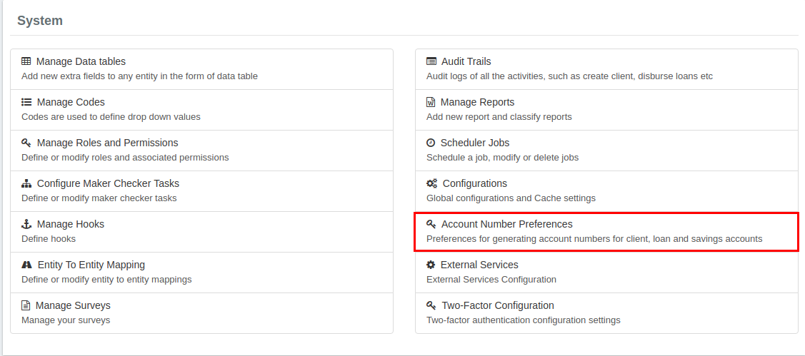

**This will launch the Account Number Preferences page as shown below:**

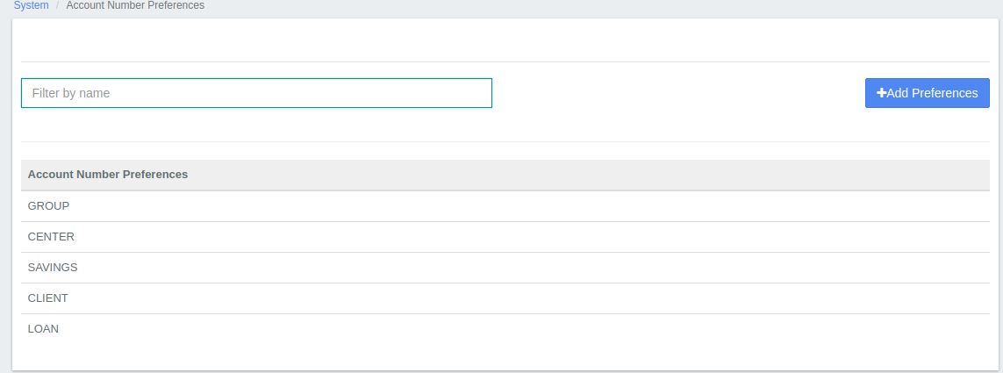

Step 2:

To start adding preferences, Click on 

Creating Preferences for Client Account Number

For Client (Select Account Type), Prefix can be added for: "Client Type" & "Office Name" (Select Prefix Field) then click on submit.

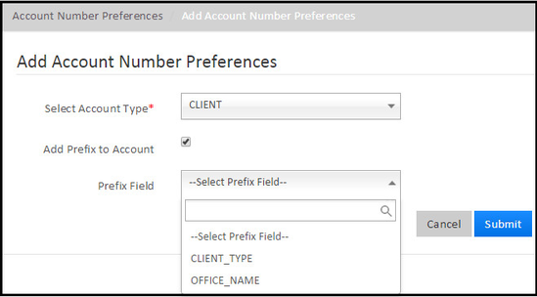

Prefix Field as "CLIENT_TYPE" - Depending upon the organization needs, client can be categorized using Client type in Mifos.

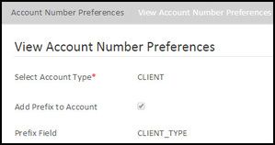

**Step 3:** To define the Client type's :

Go to Admin>>System>>Manage Codes>>ClientType>> then Add Code Values.

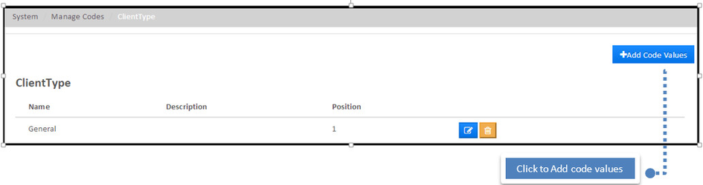

### **Step 4:**

While creating a client, defined Client types will be available for selection.

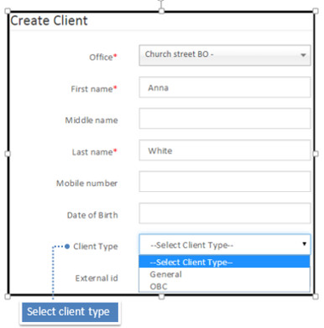

Here for example,

Client: Anna White's client type is "General" The client account number is generated as "General0000000010" instead of "0000000010"

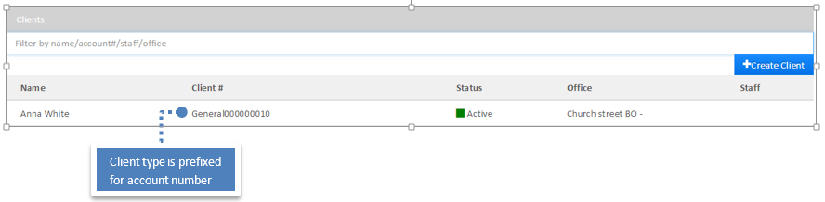

Prefix Field as "Office Name" - Office name will be prefixed for Loan account number

For Example -

Client a): Daniel Fernandes associated office is "Church street BO -" The client account number will be generated as "Church street BO -0000000009" instead of "0000000009"

Client b): John Smith associated office is "11th street BO -" The client account number will be generated as "11th street BO -0000000008" instead of "0000000008"

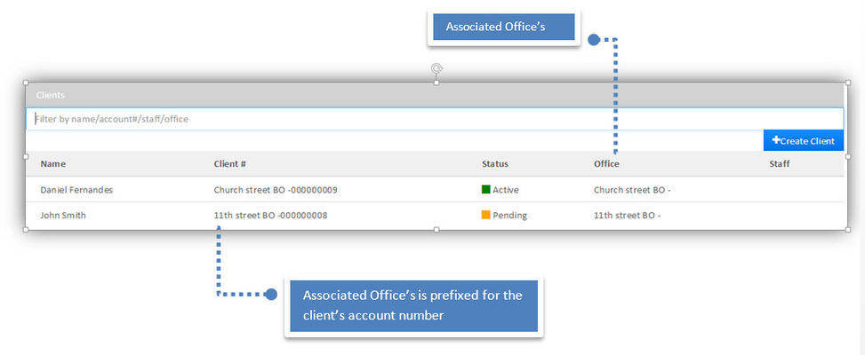

### Creating Preferences for Loan Account Number

In the same way, Prefix can be added

For Loan (Select Account Type), :

"Loan Product Short Name" - Loan product short name will be prefixed for Loan account number.

& "Office Name" - Office name will be prefixed for Loan account number (Select Prefix Field) then click on submit.

### Creating Preferences for Savings Account Number

In the same way, Prefix can be added

For Savings (Select Account Type), :

"Savings Product Short Name" - Savings product short name will be prefixed for savings account number.

& "Office Name" - Office name will be prefixed for Savings account number (Select Prefix Field) then click on submit.

## Mifos x Training manage funds :

This section describes the Manage Funds section under the [Organization Menu](https://mifosforge.jira.com/wiki/spaces/docs/pages/67141724/Organization) that allows you to manage funds associated with loans.

From the [Welcome Page](https://mifosforge.jira.com/wiki/spaces/docs/pages/81166353/Welcome+Page), click on the [Admin](https://mifosforge.jira.com/wiki/spaces/docs/pages/52592736/Administration) button on the top menu bar, then click on Organization from the drop down list. This will launch the [Organization](https://mifosforge.jira.com/wiki/spaces/docs/pages/67141724/Organization) menu.

Select Manage Funds.

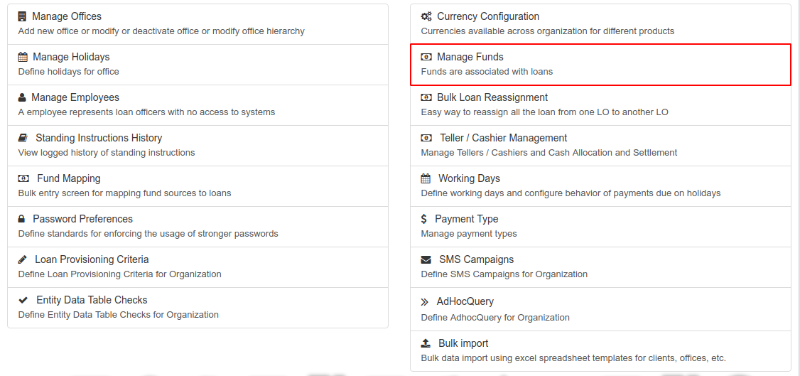

### Add Funds

This section provides an option for adding funds that will be used for lending. Any fund that requires tracking can be set up under a fund name. Add funds by following these steps:

1. Type the name of the new fund in the New Fund field.
2. Click the blue '+' sign to the right of the field to create a New Fund.



### View Funds

Once you have selected Manage Funds, a chart of all currently tracked funds will be displayed. Additionally, a blank field will be displayed on top of the page that allows you to create new funds *(see the Add Funds section of this page to learn more)*.

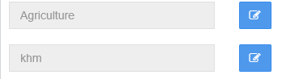

### Edit Funds

Click on Edit button  to modify the Fund Name.

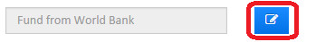

**This will allow you to edit the Fund Name. Click on the Save button to save changes.**

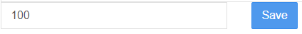

For more details on this process and the way funds are distributed, please see the [Products](https://mifosforge.jira.com/wiki/spaces/docs/pages/70910295/Products) section of this manual.

**Related articles**

* Page:[Manage Funds](https://mifosforge.jira.com/wiki/spaces/docs/pages/67141736/Manage+Funds)
* Page:[Bulk Loan Reassignment](https://mifosforge.jira.com/wiki/spaces/docs/pages/67141738/Bulk+Loan+Reassignment)
* Page:[Manage Employees](https://mifosforge.jira.com/wiki/spaces/docs/pages/67141732/Manage+Employees)
* Page:[Manage Reports](https://mifosforge.jira.com/wiki/spaces/docs/pages/67895354/Manage+Reports)
* Page:[Manage Holidays](https://mifosforge.jira.com/wiki/spaces/docs/pages/67141730/Manage+Holidays)

## Training Audit Trail

Audit Trails allows you to keep track of your organization`s activities in the Mifos system. By selecting different criteria or searching by user, you can gain a better understanding of how your organization is using the Mifos X platform.

**On this page:**

* [Advanced Search for a User](https://mifosforge.jira.com/wiki/spaces/docs/pages/67895352/Audit+Trails#AuditTrails-AdvancedSearchforaUser)
* [How to view an Audit Entry](https://mifosforge.jira.com/wiki/spaces/docs/pages/67895352/Audit+Trails#AuditTrails-HowtoviewanAuditEntry)
* [How to Export CSV](https://mifosforge.jira.com/wiki/spaces/docs/pages/67895352/Audit+Trails#AuditTrails-HowtoExportCSV)

From the welcome page, select [Admin](https://mifosforge.jira.com/wiki/spaces/docs/pages/52592736/Administration), then System from the drop-down menu. This will launch the [System](https://mifosforge.jira.com/wiki/spaces/docs/pages/72909302/System) menu.

Select Audit Trails.

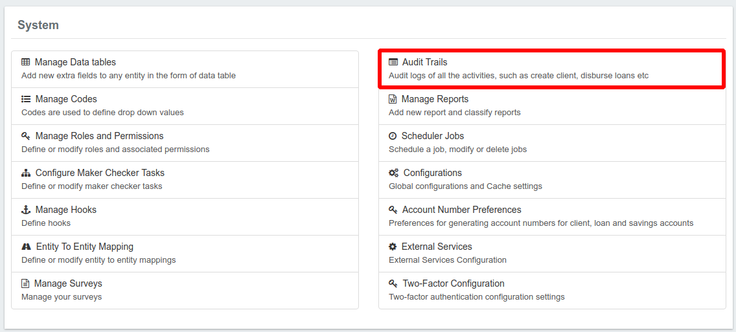

This will launch the Audit Trails page as seen in the screenshot below:

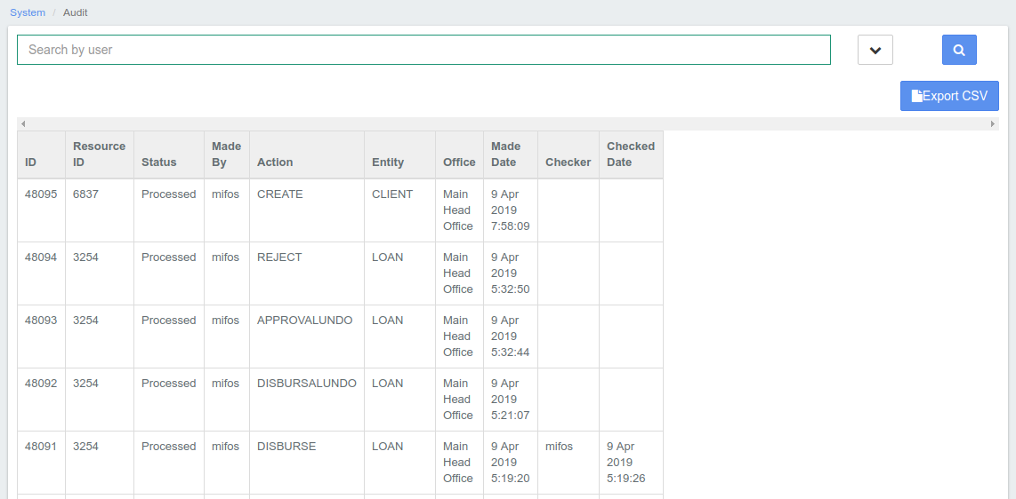

### Advanced Search for a User

You can search for a user via the "Search by User" field at the top or you can have an advanced search by clicking the ^ button at the side of the search bar.



This will activate additional search filters to ease your search;

* Search by user
* Resource ID
* From Date
* To Date
* Checked from
* Checked to
* Select status - drop-down menu
* Select Entity - drop-down menu
* Select Action - drop-down menu
* Select checker - drop-down menu

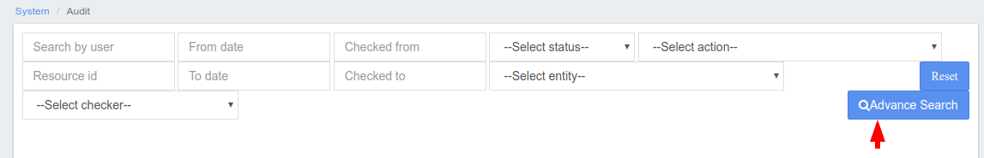

After adding the filters of your choice, click the Advanced Search button as indicated in the screenshot above. Mifos X will display records according to the filters selected. Should you wish to reset your filters, select the Reset Button just above the Advanced Search button. This will clear all entries in the filter fields.

### How to view an Audit Entry :

On the Audit Trails page, select the Audit Entry you would like to view (*it will be highlighted in blue when the cursor is over it*.)

A page detailing the Audit Entry will be displayed as seen in the example below:

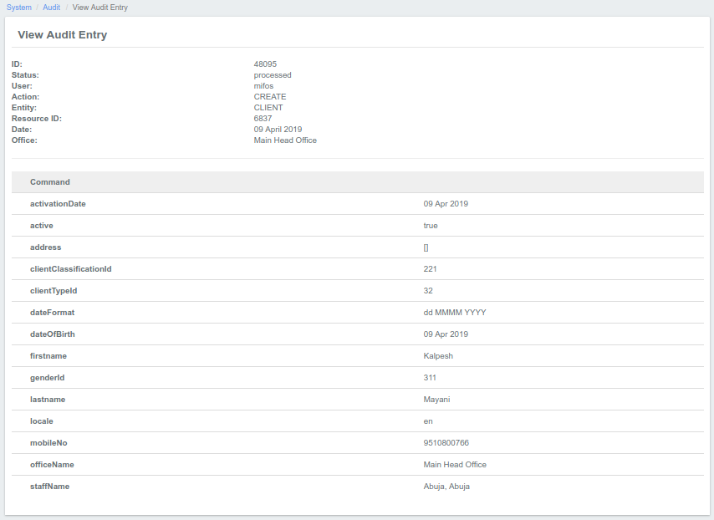

### How to Export CSV :

At the top-right of the report is a blue button labeled Export CSV. A CSV (or Comma-separated values) is a type of file that stores tabular data in plain text form. This allows the data to be easily transferred between programs that are not normally compatible.

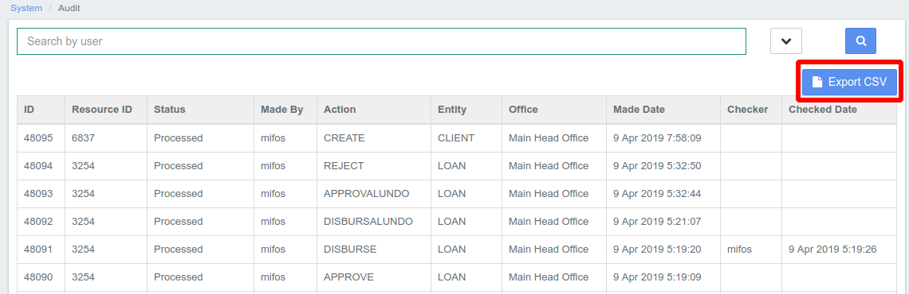

To create a CSV file of your selected data, click on the blue Export CSV button. This will download a CSV file:

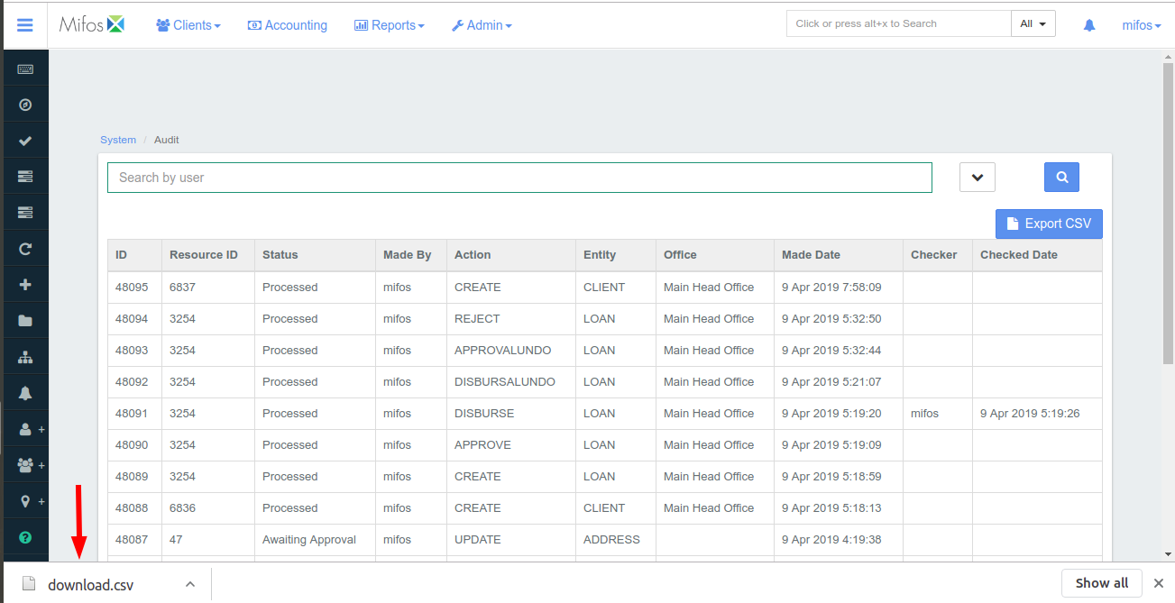

Open the CSV file with an appropriate program of your choice, for example Microsoft Excel or Libre Office Calc. Only the Audit Entries of that page will be exported.

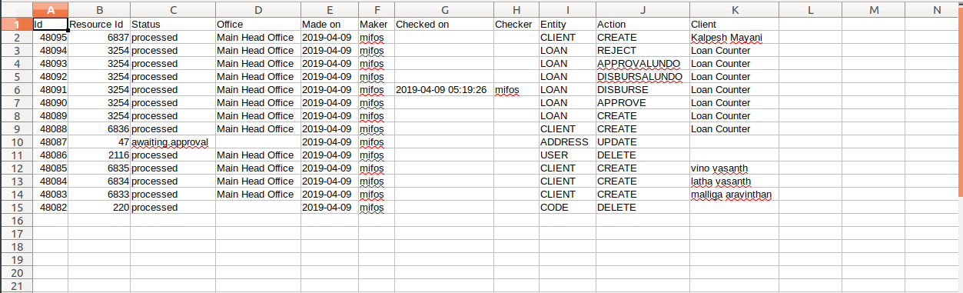

## MIFOS X CONFIGURATIONS :

Configurations provides to set up some global settings.

Go to **ADMIN > SYSTEM> CONFIGURATION**  there are several settings available and you can enable and disable those according to youneed r as shown below.

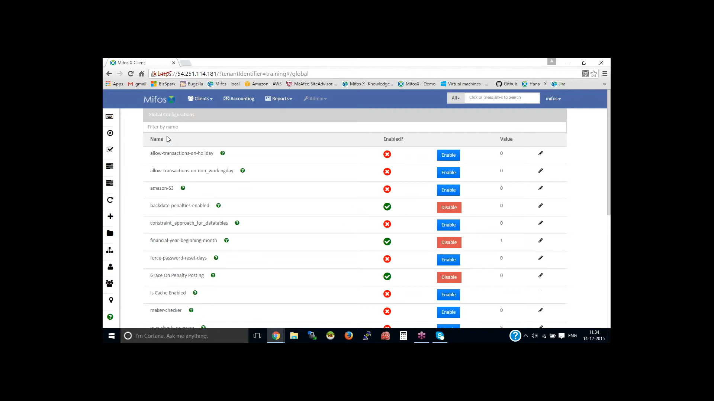

## Mifox creating Templates

Templates are the user defined reports of an any entity.to create an template.go to the Admin and click on Template and inside the template give the Entity,Template name(client name and Account) and inside the body type”hello,client Name,Account number).and submit

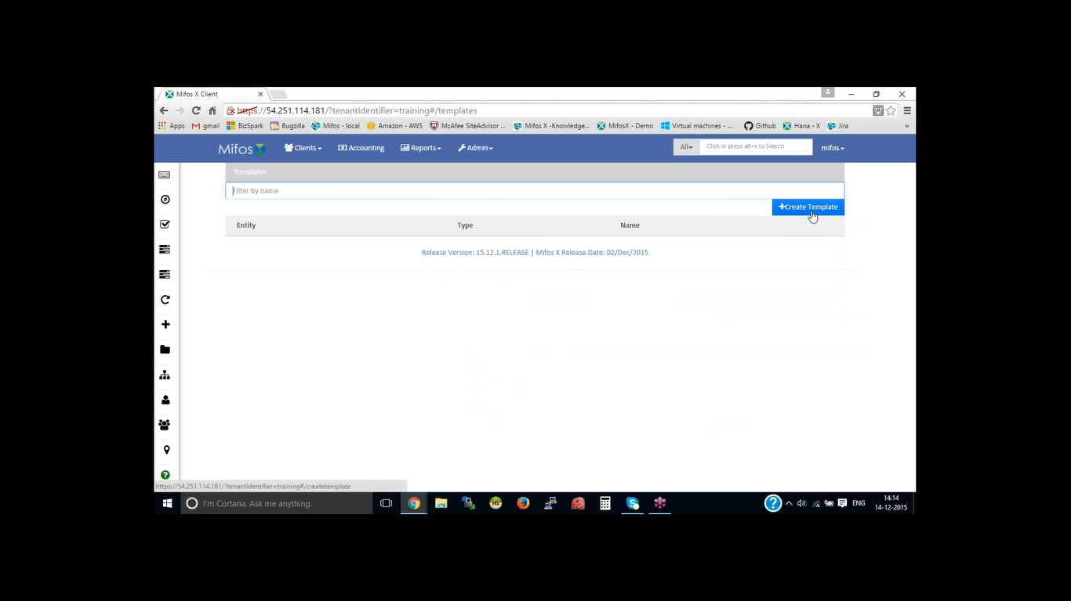

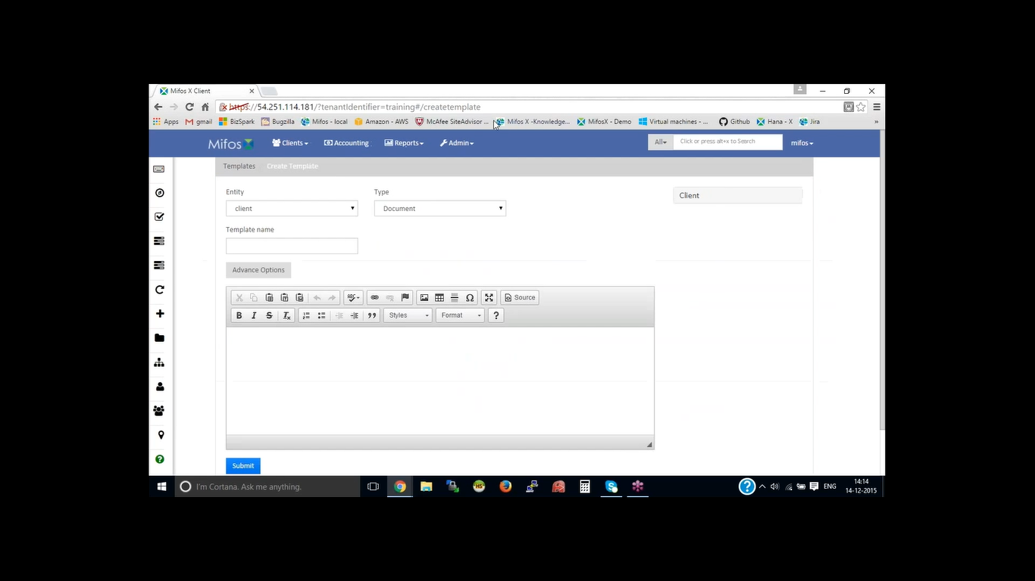

Goto the client and select the client then click on client screen reports check Account.a template is printed.

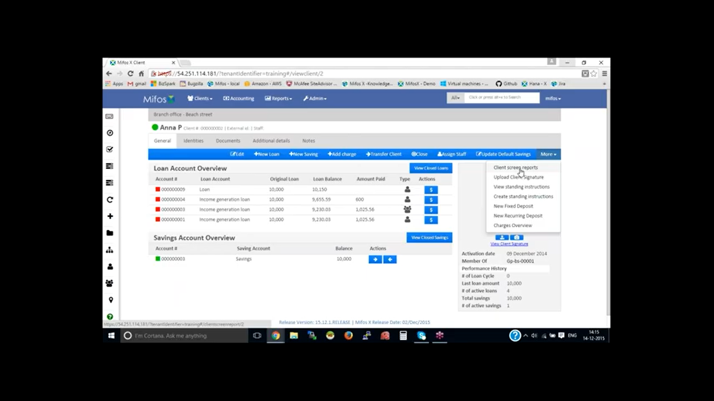

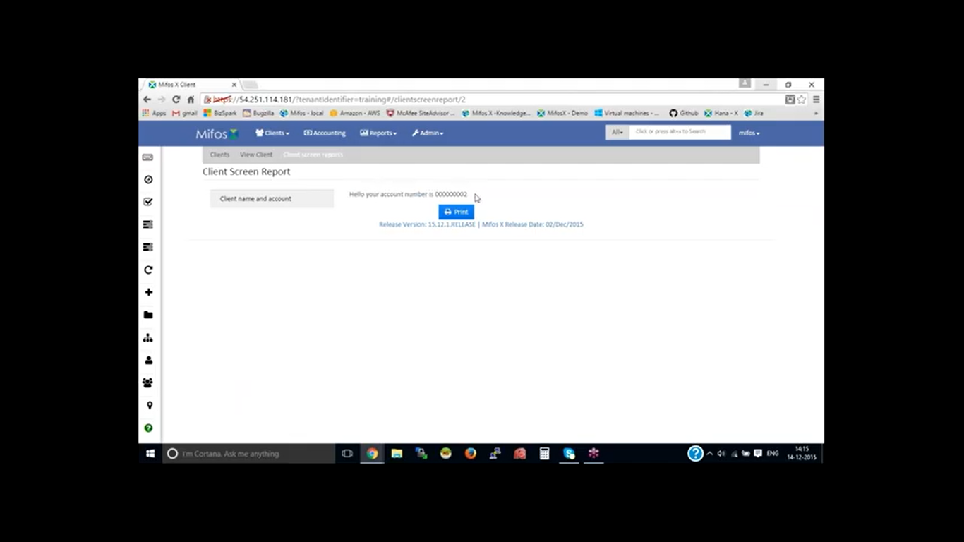

## Mifos x Teller Cash Management

* Login as Super user with ID and password.
* Go to ‘Admin’, Then ‘Organization’ and select ‘Teller Cashier Management’.
* There in the right corner click on ‘New Teller’.
* Then Provide the name of the teller.
* Select the ‘Office’.
* Provide the description.
* Enter start date and end date.
* Set the status as ‘Active’. 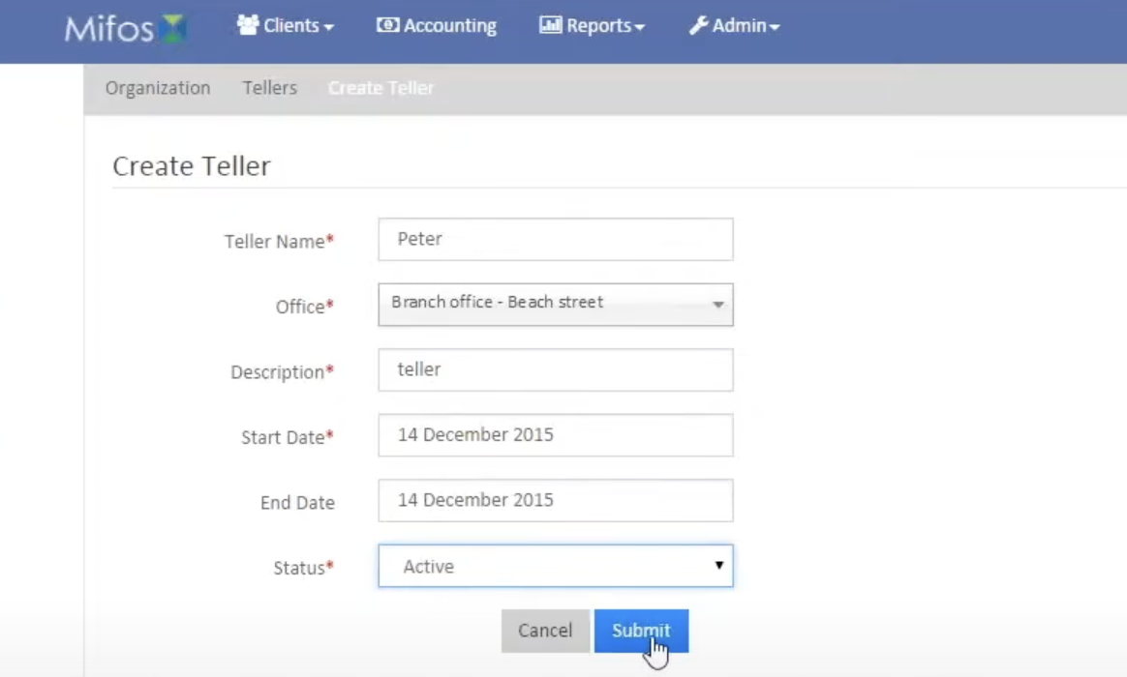

* Then you need to go back to the tellers.
* We can see the available teller, then we need to click on the teller.
* Then we need to click on the ‘+New Casher for teller’.
* Then select the staff, teller name is already assigned.
* Give the description.
* Enter From and to date.
* Then click on ‘Submit’.
* It will direct you to the cashier space where we can allocate cash.
* From the given date and provide the amount.
* Enter Notes/Comments to Allocate cash.
* Before that we need to set the financial activity.
* To allocate the financial activity, we need to go back to the accounting and select ‘Accounts link to financial Activity’.
* Click on ‘+Define New Mapping’.
* There select Financial Activity as ‘Cash at Tellers/Cashiers’.
* And to select the account we need to go back to the ‘accounting’, then ‘Chart of Accounts, There create ‘GL Account’.
* Give in the details and go back to ‘Add financial activity mapping’ .
* Select the account and click on submit.
* Then we should go back to the organization, click on ‘teller/cashier management’.
* Click on ‘allocate cash’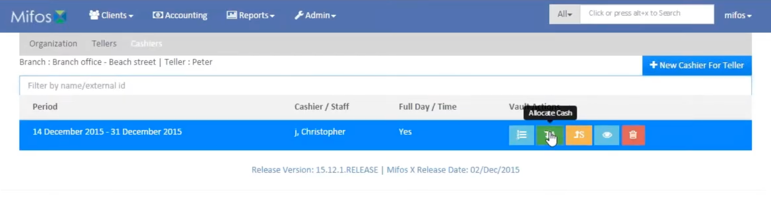
* Enter ‘amount’ and ‘Notel and Comments’
* Click on the ‘Allocate cash’ button.

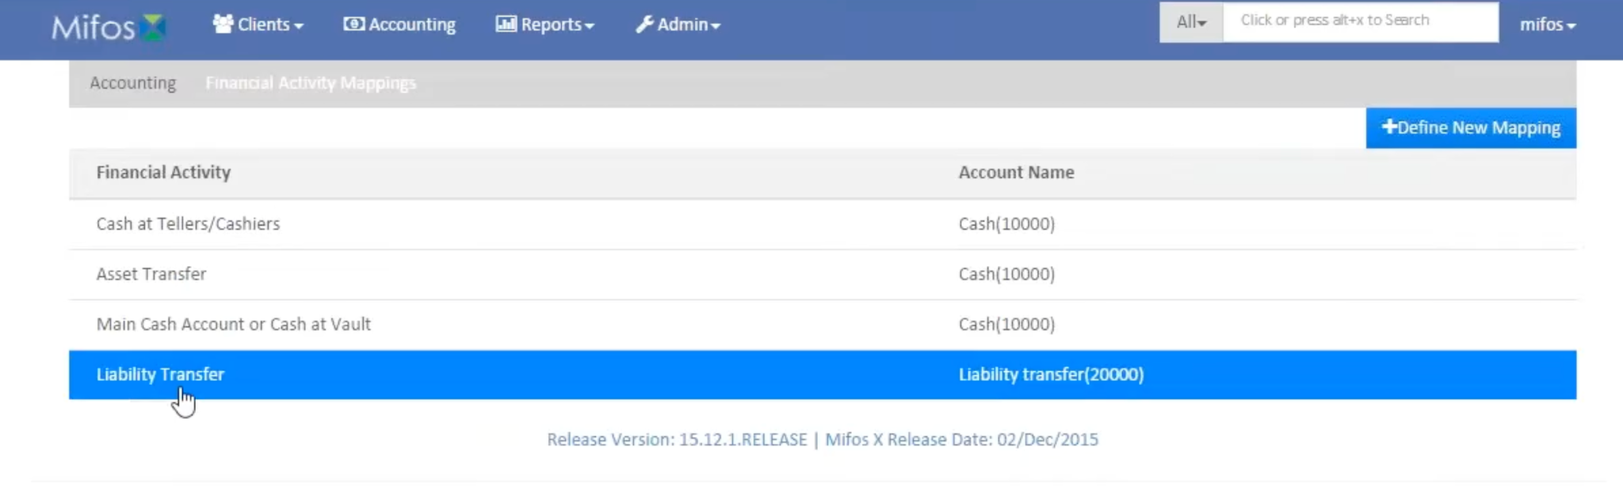

## Mifos x Password preferences

This enables us to set password preferences by just selecting one of the available two preferences. Once the preference is set depending upon the set preference, it allows us to create password as per the mentioned conditions. The two preferences are: one is simple but weak and the other is a second preference which is strong.

**On this page:**

* [Setting Up the Password Preferences](https://mifosforge.jira.com/wiki/spaces/docs/pages/90243214/Password+preferences#Passwordpreferences-SettingUpthePasswordPreferences)

Beginning at the main screen, select **Admin,** then **Organization** from the drop down menu. This will launch the [**Organization**](https://mifosforge.jira.com/wiki/display/docs/Organization)menu.

Select **Password Preferences** to set the preferences.

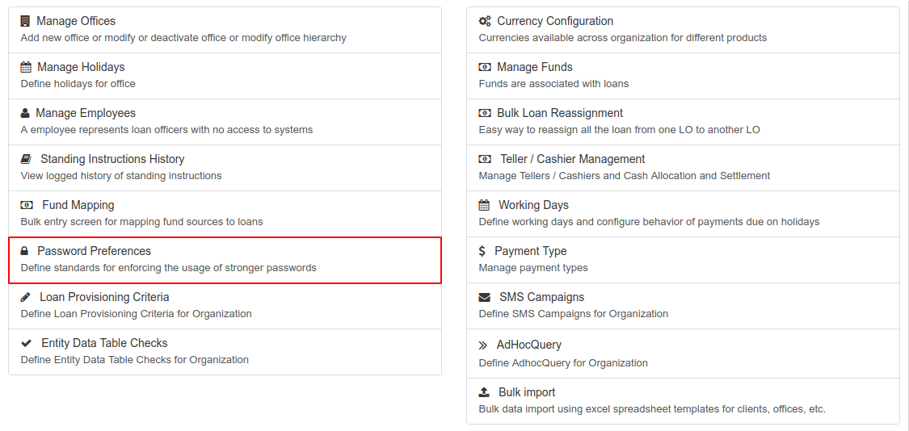

This will launch the **Password Preferences** page:

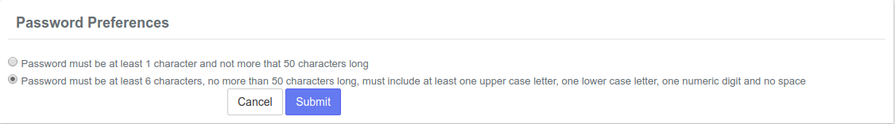

### Setting Up the Password Preferences

On this page, there are two preferences;

1. Password must be at least 1 character and not more than 50 characters long. This means that the provided password should satisfy these conditions;

Must have a **minimum** of 1 character

If you decide to use more than one character, then the password must not contain more than 50 characters

The characters can be of any kind (letters, numbers and symbols) but **Not** the '**&**' symbol.

2. Password must be at least 6 characters, no more than 50 characters long, must include at least one upper case, one lower case letter, one numeric digit & no space. This means that the provided password must satisfy these conditions;

Must have a **minimum** of 6 characters

If you decide to use more than 6 characters, then the password must not contain more than 50 characters

Must include at least one upper case letter.

Must include at least one lower case letter.

Must include at least one numeric digit (number).

Must not have space. There must not be any space between the characters.

The characters can be of any kind (letters, numbers and symbols) but **Not** the '**&**' symbol.

Select your preference and then click the **Submit** button.

## Mifos x Standing Instructions :

### About Standing Instructions

Standing instructions can be set up to automatically transfer funds from one account to another on a periodic basis. For example a standing instruction can be set up to:

* transfer a loan repayment from a saving account to a loan account on the dates that the loan repayment is due
* transfer funds from a current account to a saving account on a monthly basis
* transfer funds from an account owned by one client to an account owned by a different client on a weekly basis

**Step 1:** Go to Admin.Click Organization.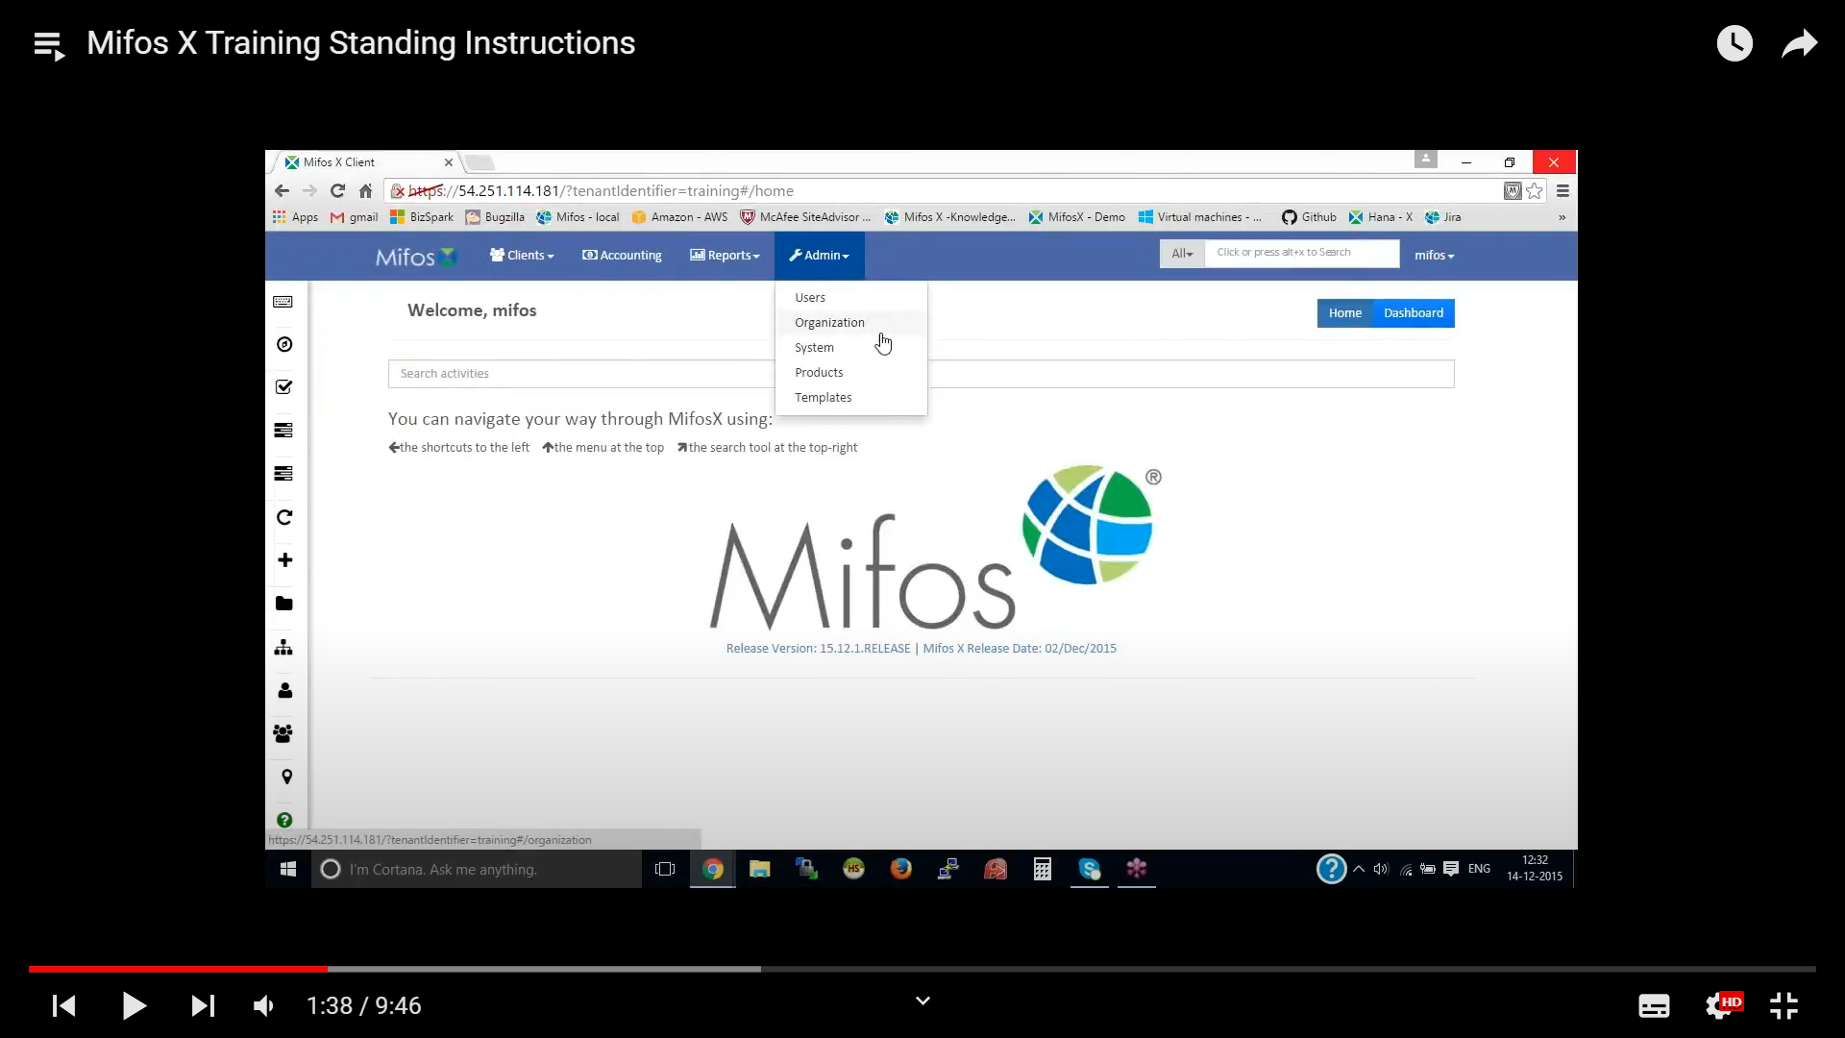

**Step 2:** Then click on Standing Instructions History.

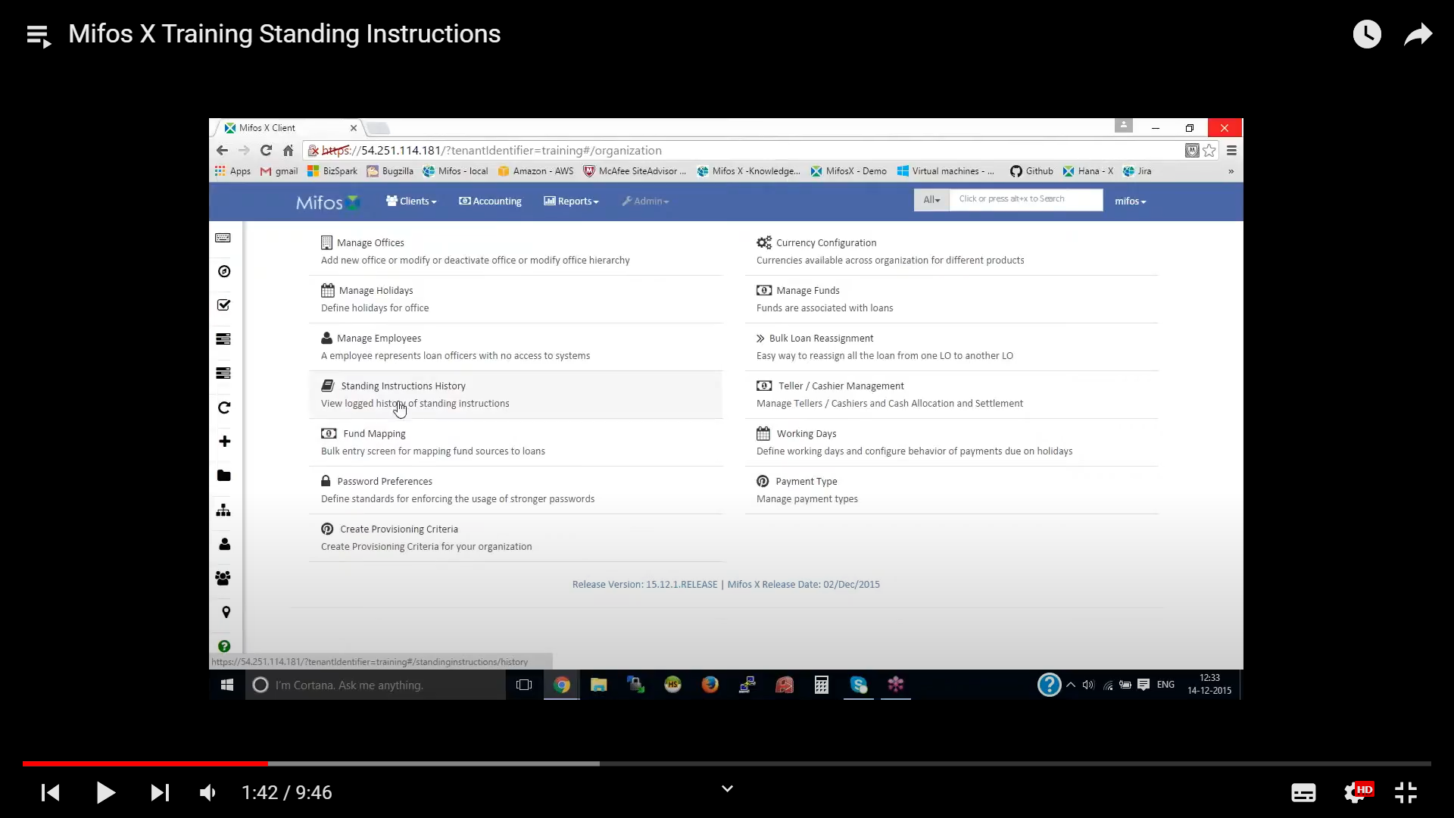

**Step 3:** In order to create Standing instruction we need to have savings account which should be in Active status.

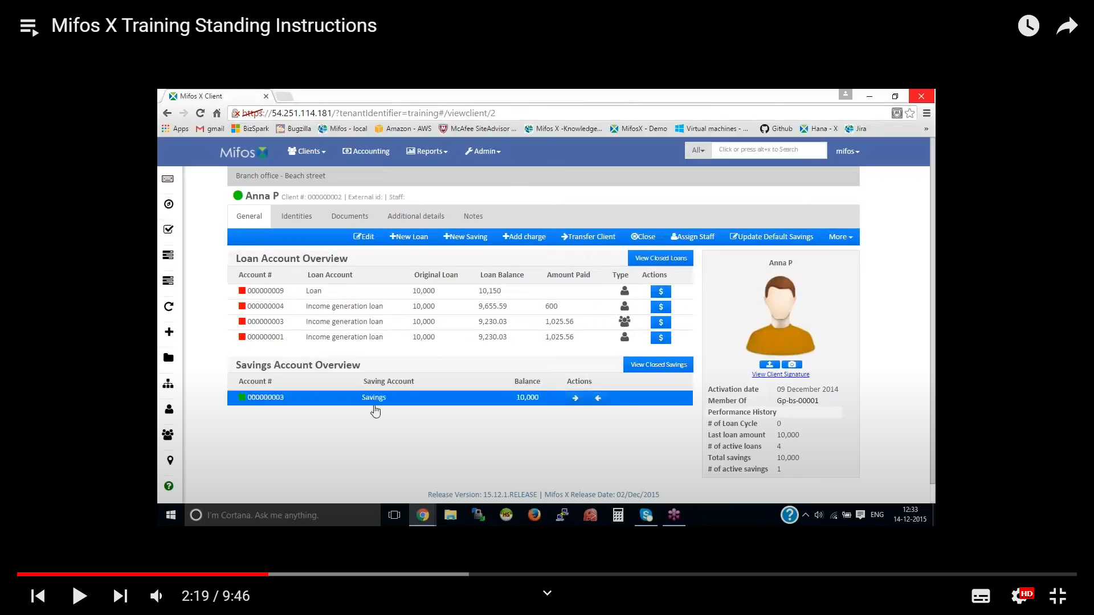

**Step 4:** click on more option there select Create standing Instructions

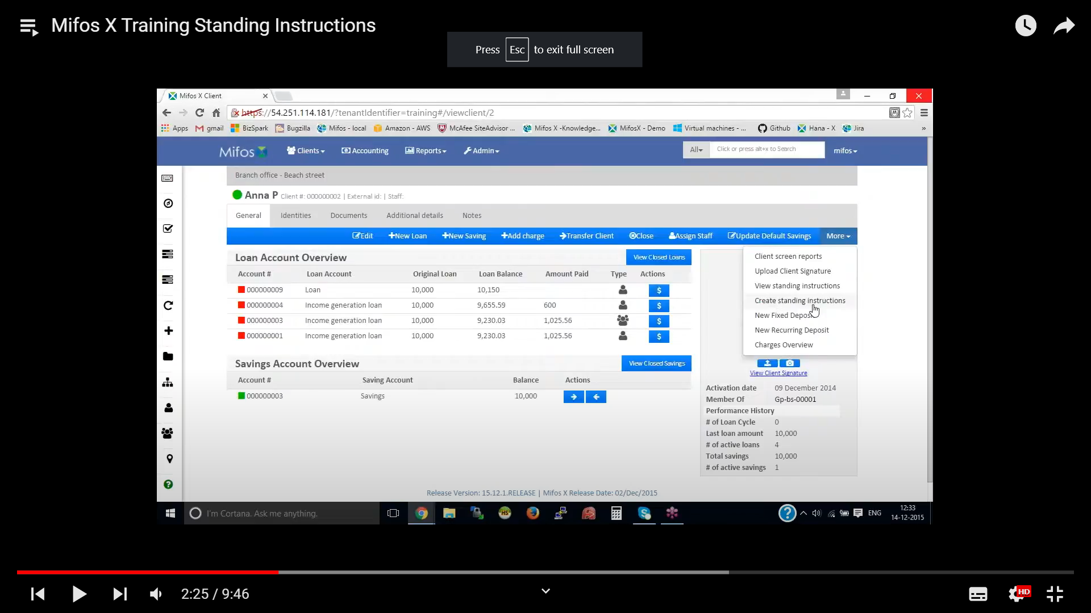

**Step 5:** Provide the name as standing instruction for loan.

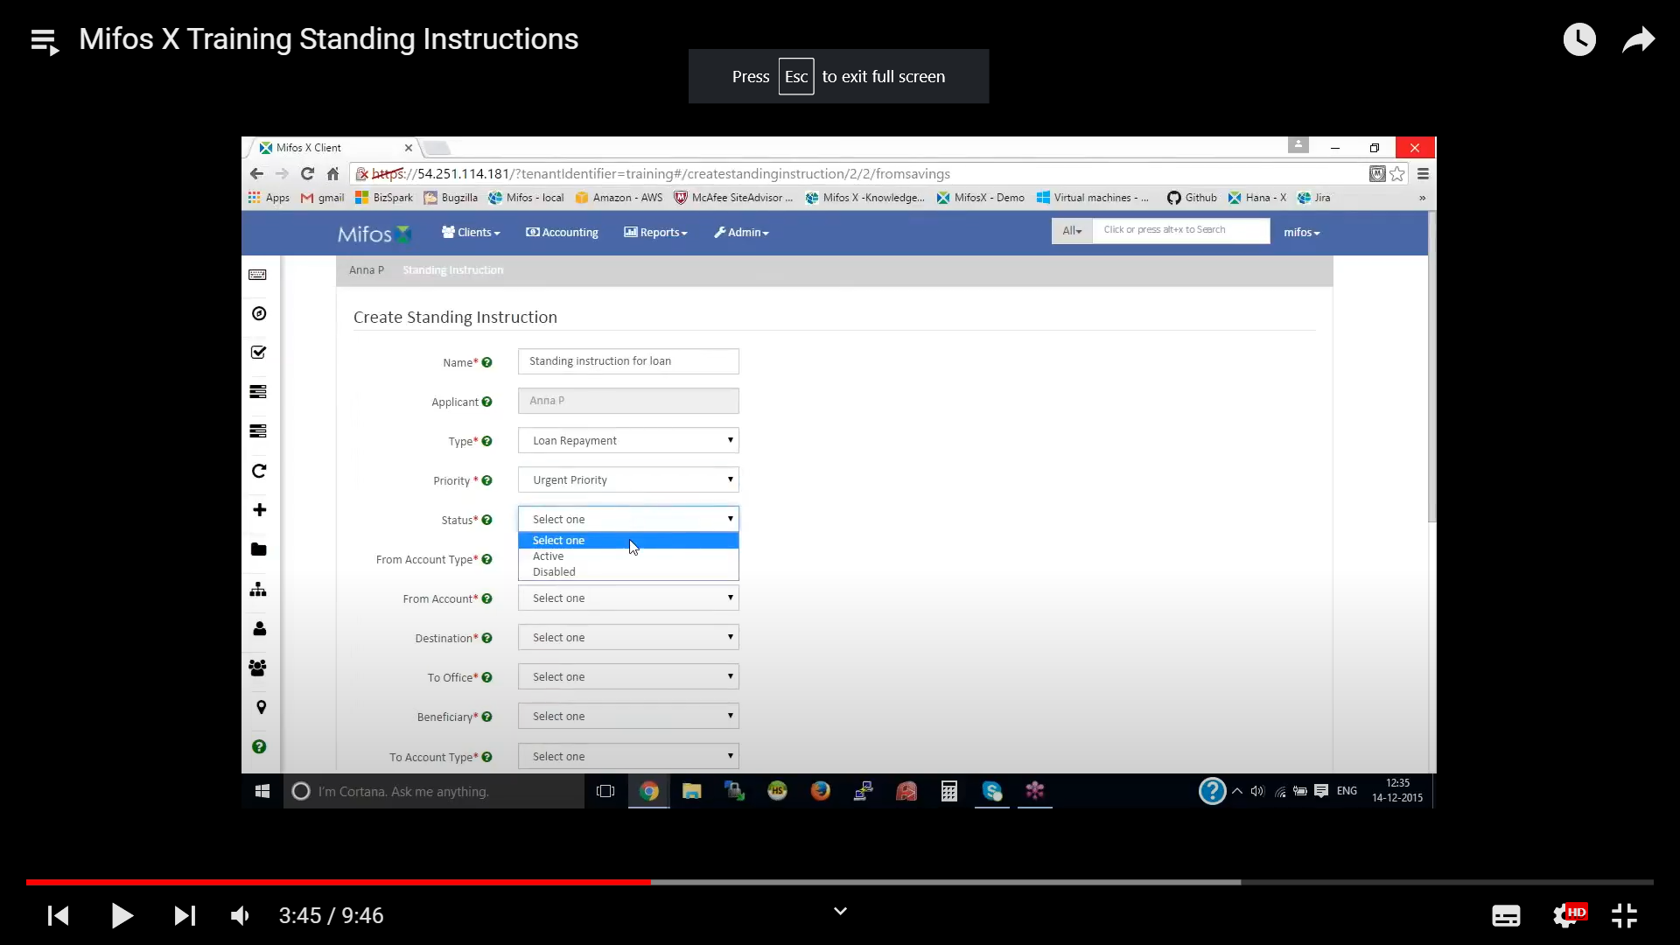

**Step 6 :** Display loan With ID Number

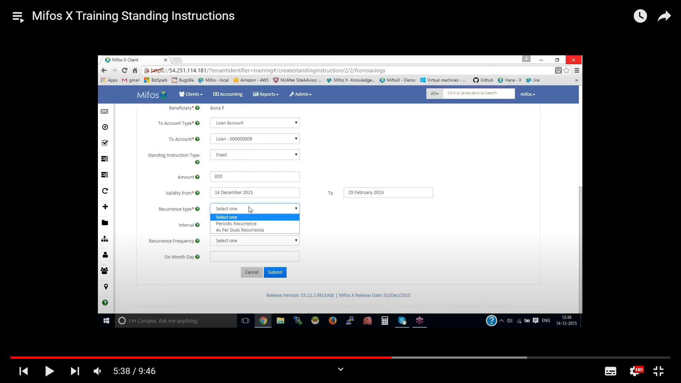

**Step 7:** loan Display details

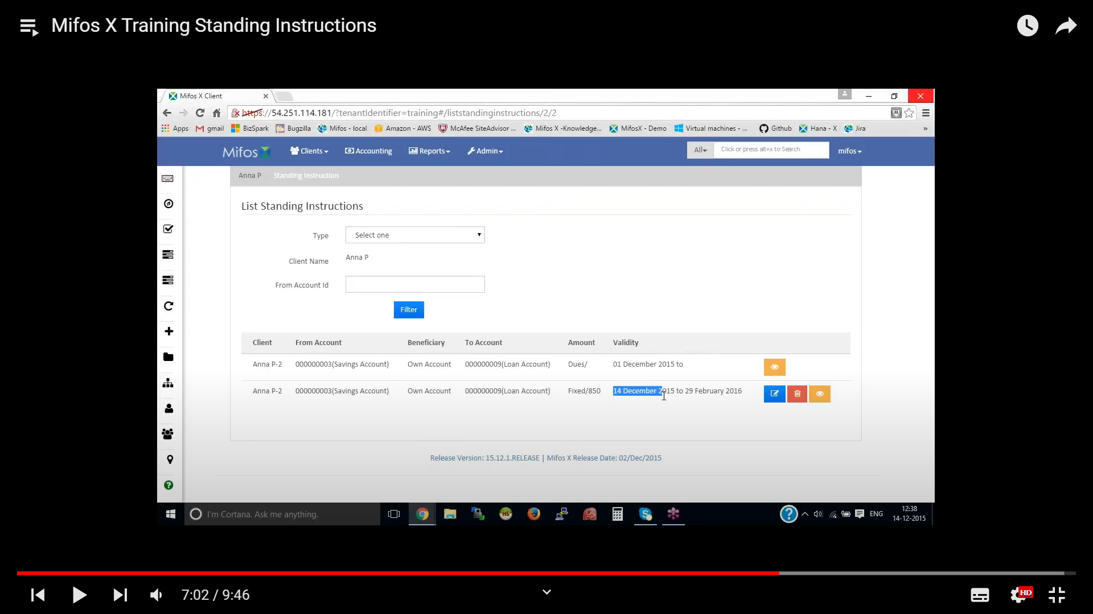

**Step 8:** It shows the history from Standing Instruction

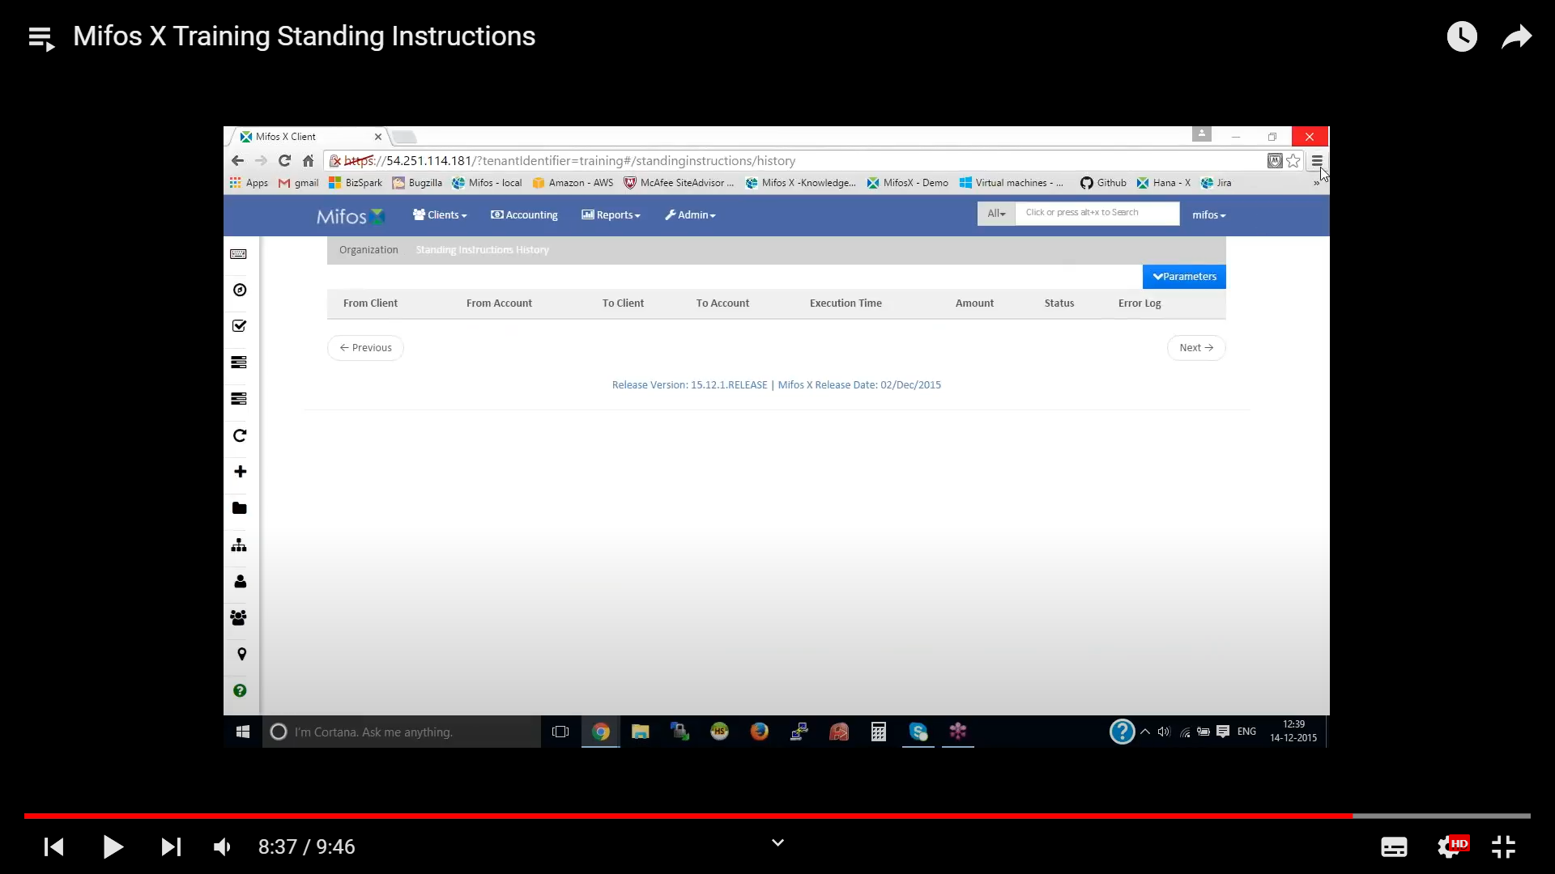

## MIFOS X REPORTS :

The Standard Reports in MifosX are generally categorized into six groups:

1. Clients
2. Loans
3. Savings
4. Funds
5. Accounting
6. XBRL

Go to **ADMIN > SYSTEM > MANAGE REPORTS**

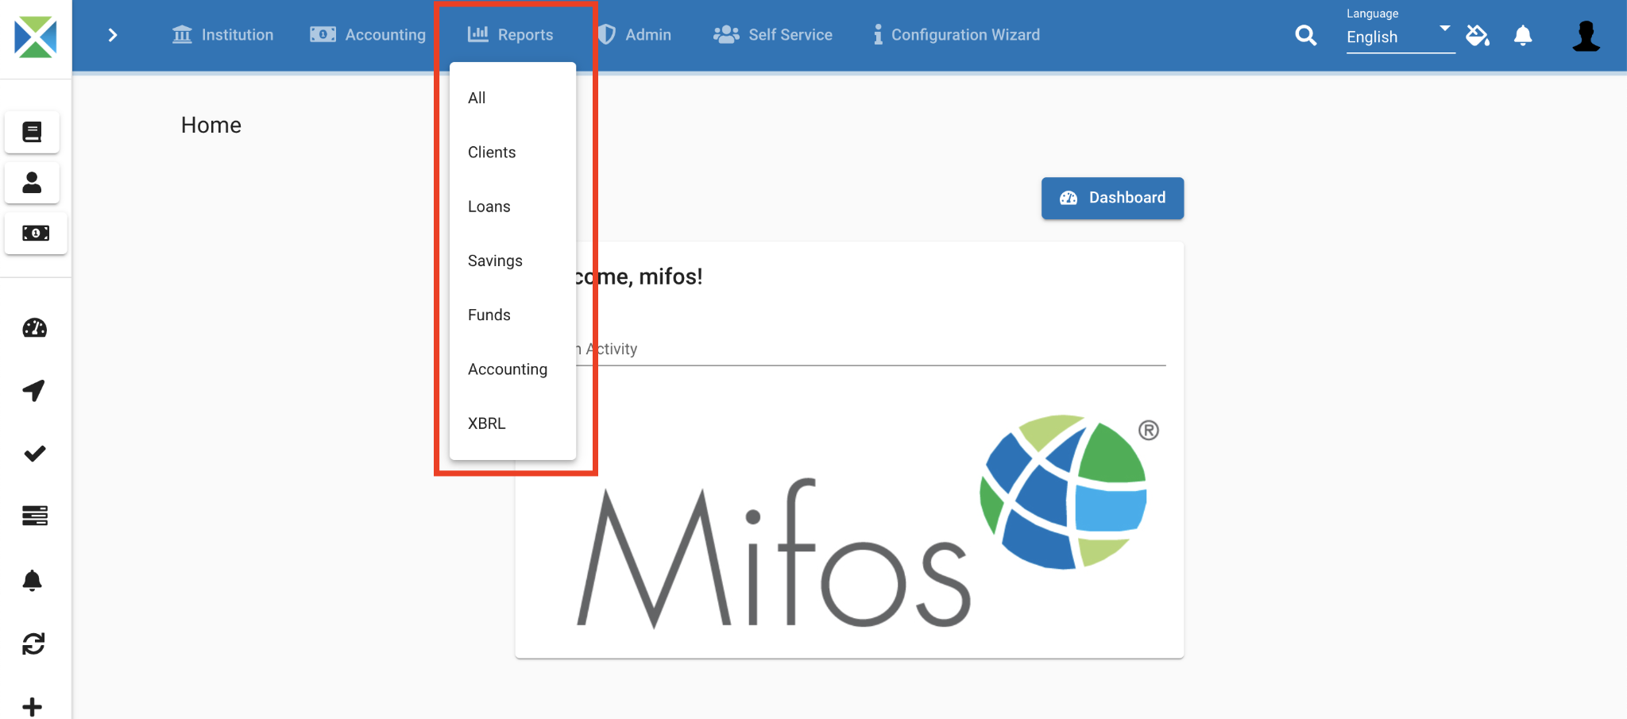

* Choose the type of report, the next window shows all the reports under that category (in this example, the *Clients type*  is selected):

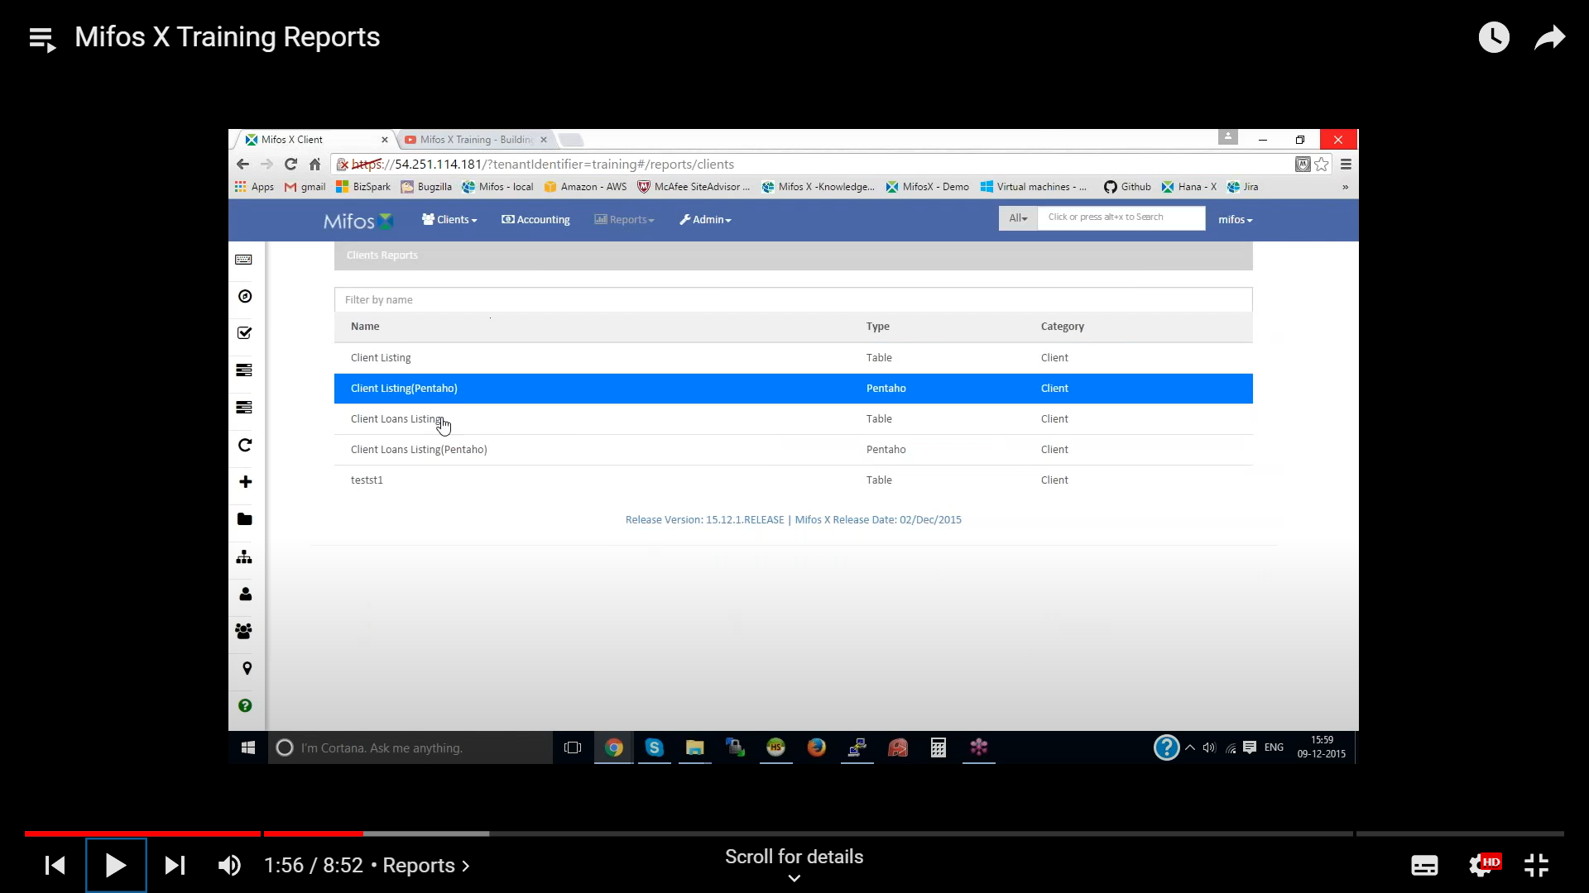

* Select the report you want to generate

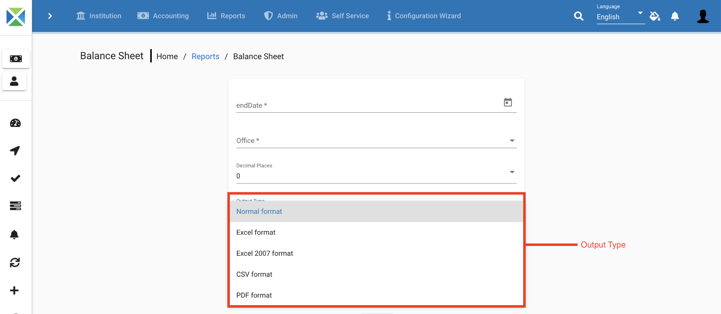

* As shown in the image above, the output type of reports can be selected from a drop-down menu. You can generate Reports in any one of the three formats, namely: *i. Excel* *ii. PDF* *iii. CSV*
* *Click on 'Run Report' to generate the report for viewing in the specified format.*

**CREATING CUSTOM REPORT :**

In Mifos X, apart from using standard reports which are already shipped, you can create your own **Custom Reports** based on your required parameters.

Go To **Admin** >> **System** >> **Manage Reports** and Click on **'+ Create Report'** tab to see the following window:

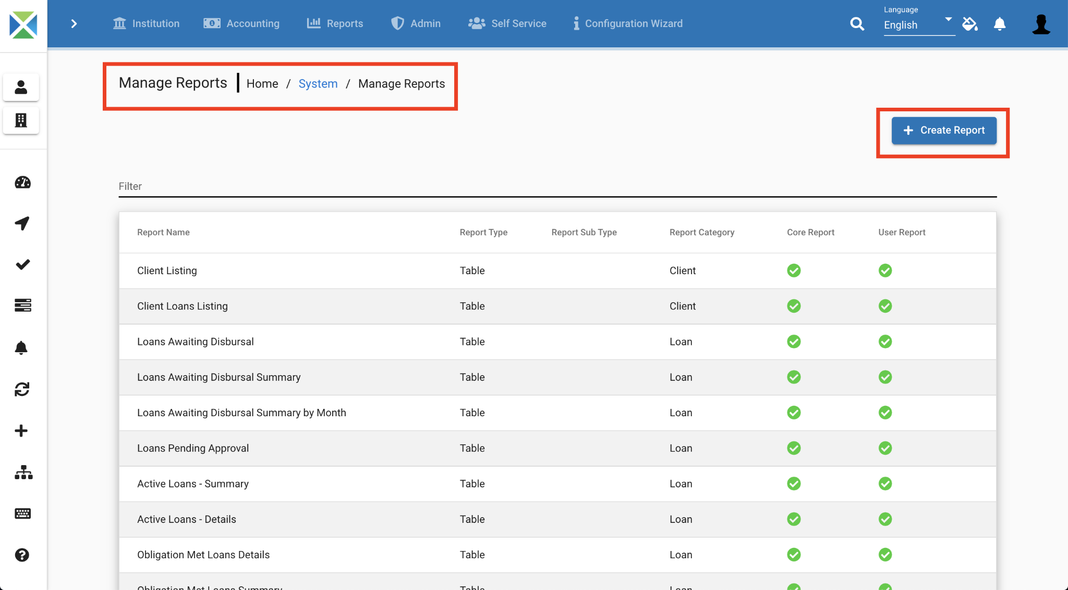

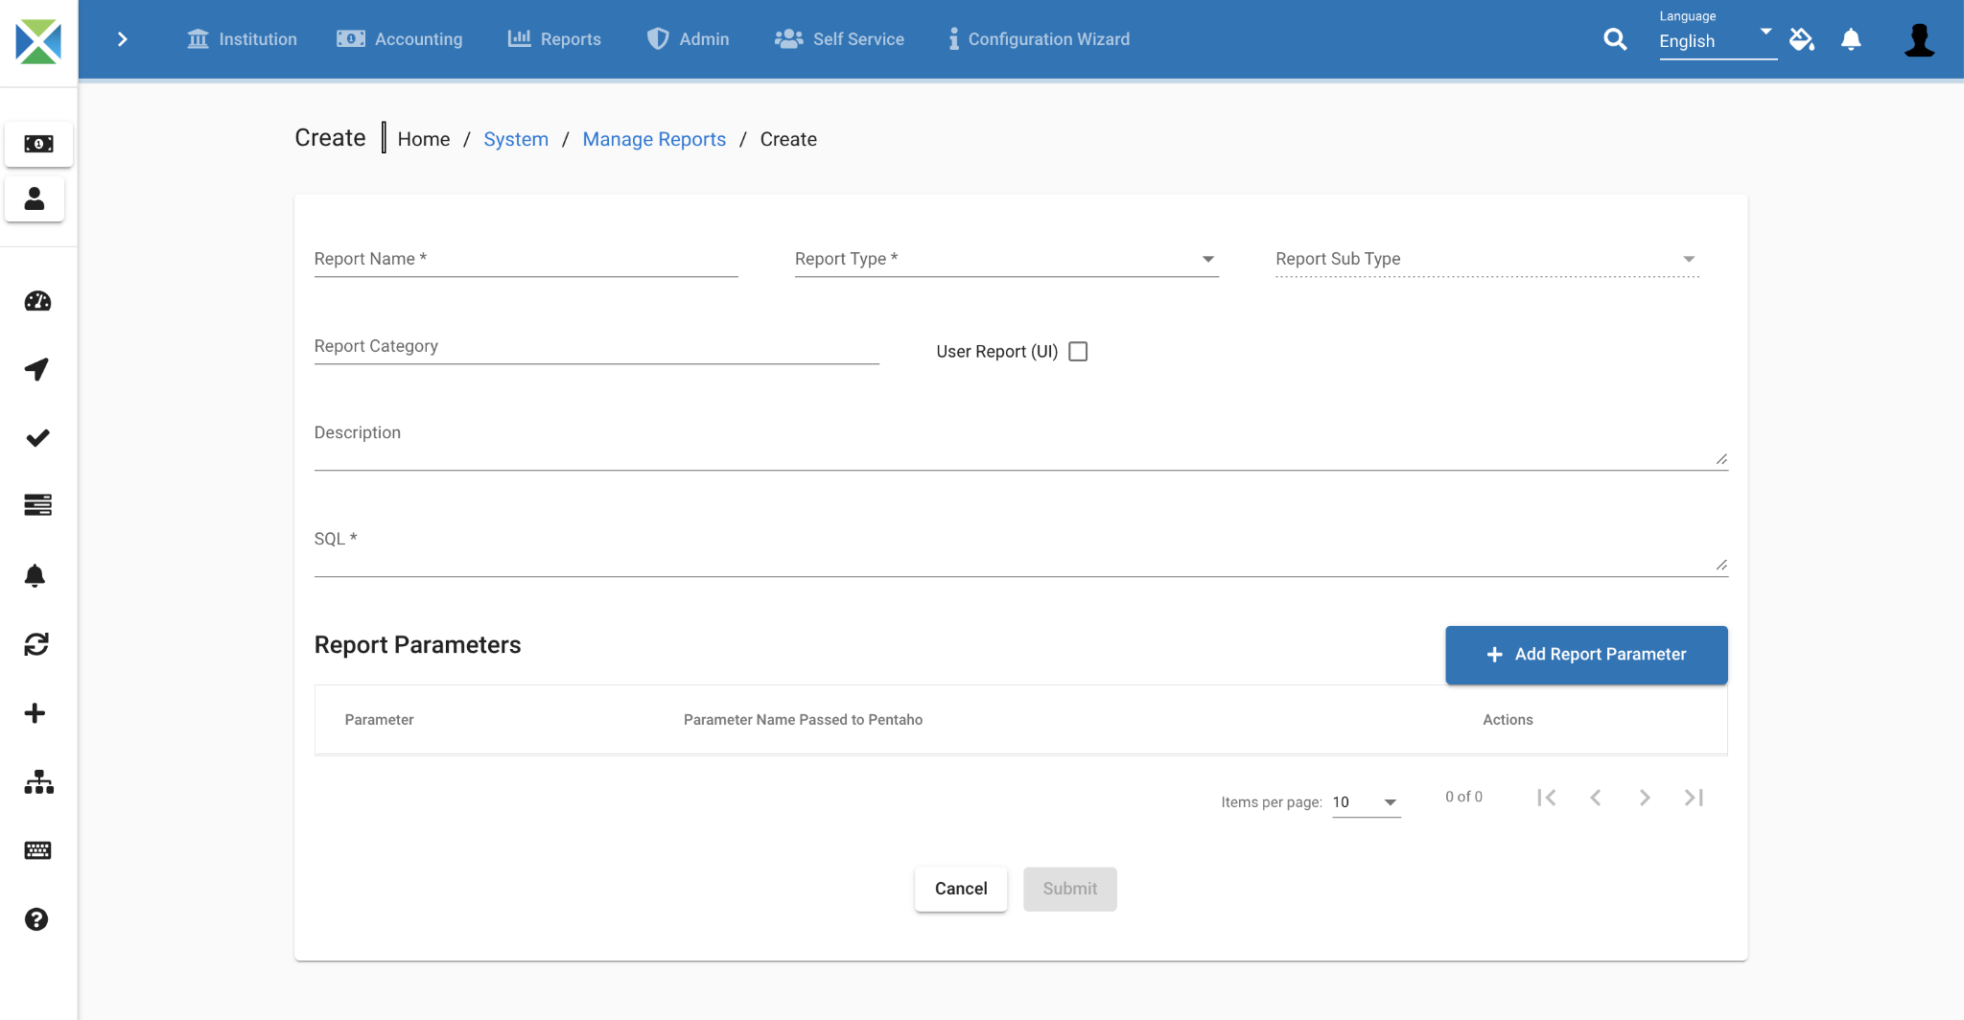

* To make report one needs to have knowledge on data tables and sql after filling all the details click on the '**Submit**' button to generate the report.
* To view the Report, click on '**Reports**' tab and either search for it by Report Name, or go to the specific category to which the report belongs to and select the report.

## Mifos x loan process :

If you want to dispatch or create an loan application for individual,groups and centers the goto clients for individual loads and for group loan go to groups.

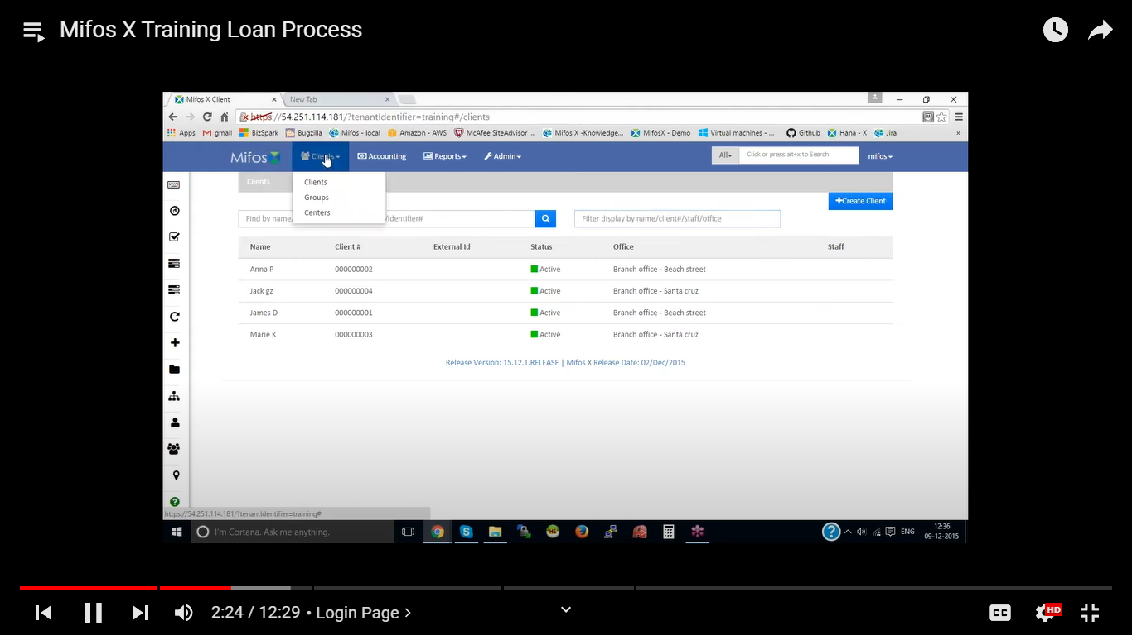

For individual loan goto clients. Select **+New Loan** and in products select income generation loan

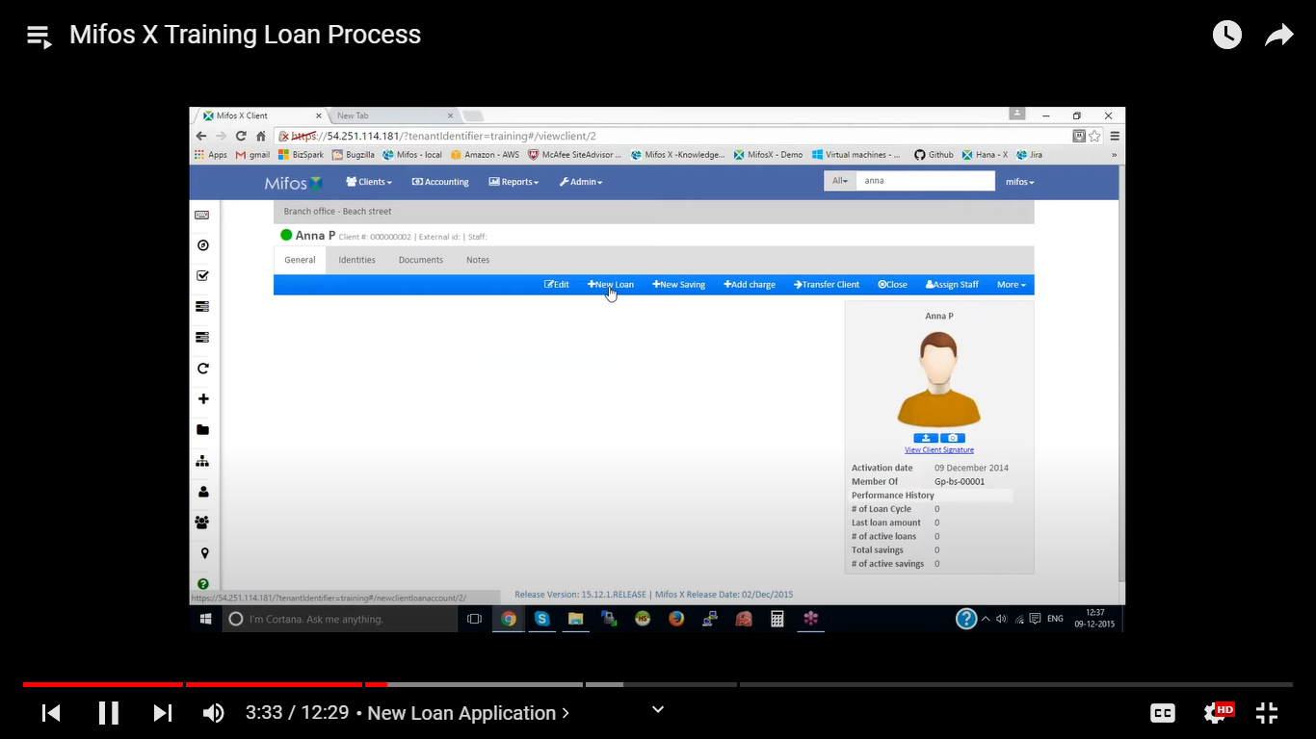

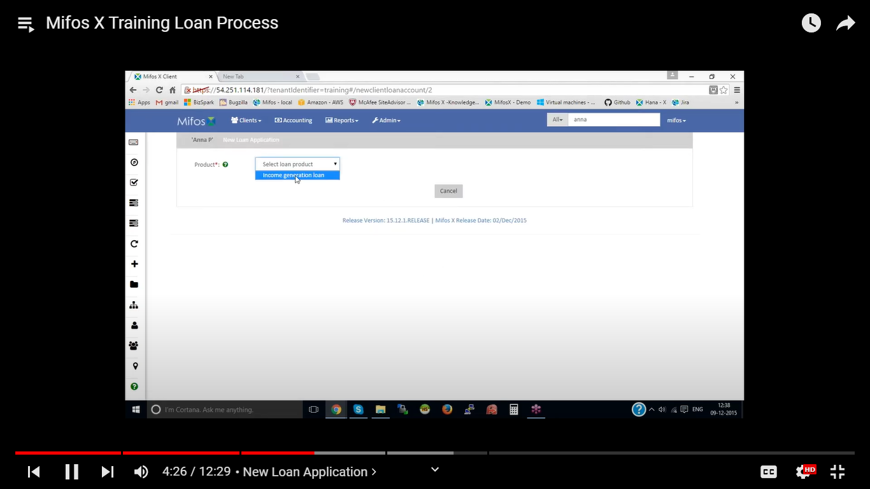

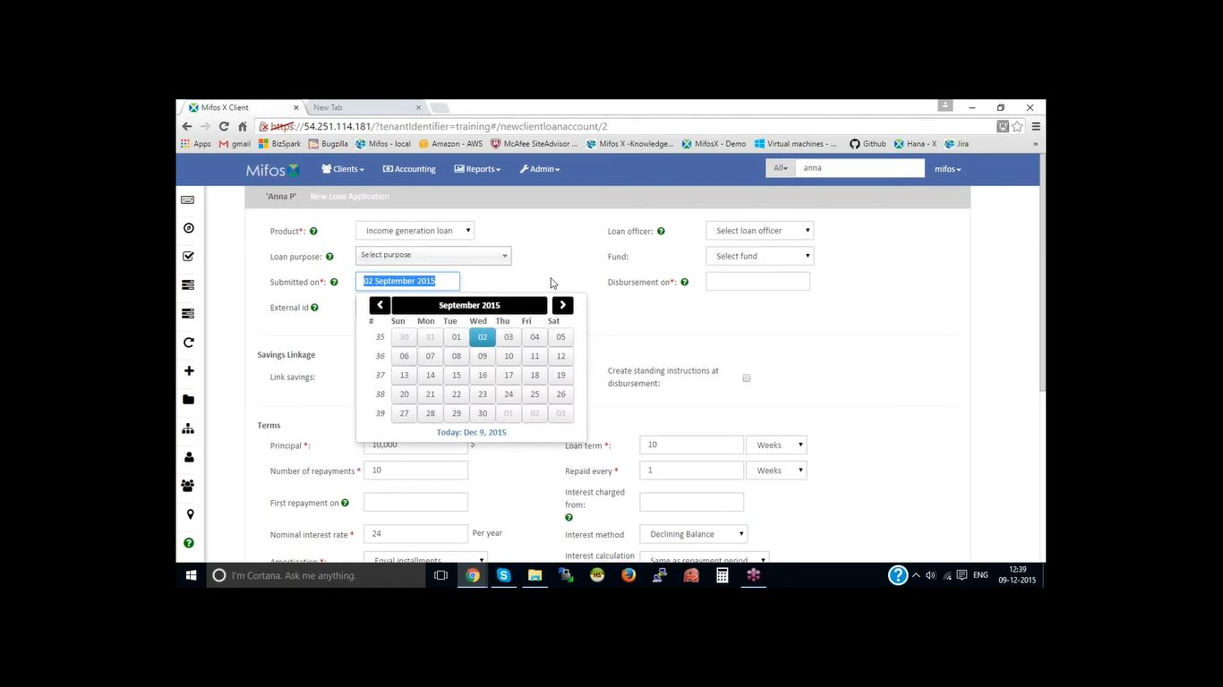

Fill the loan application details and enter the loan submission date and disbursement date and mandatory fields.and submit to bank manager to look out all details and check the detail approval or rejection. After approval from bank manager and its pending to disbursement

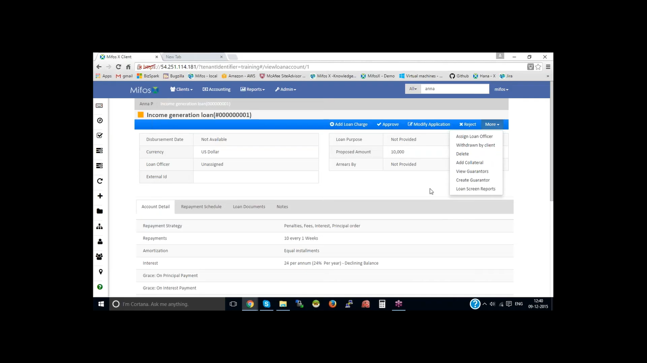

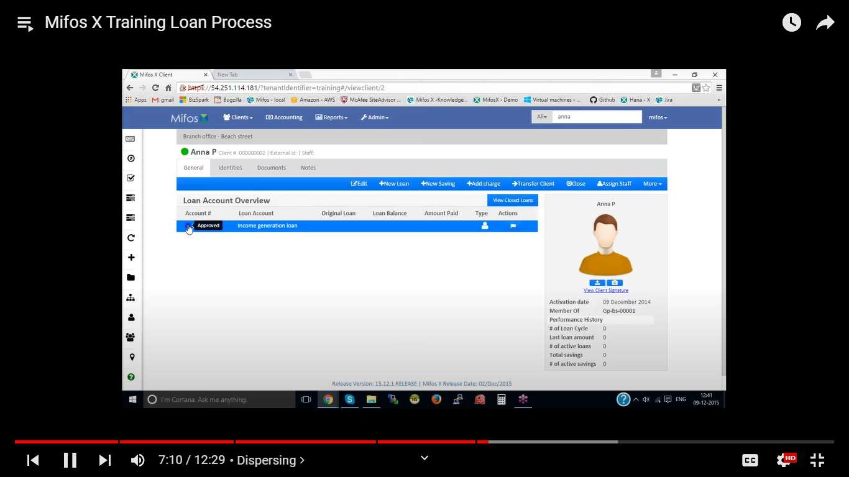

After loan disbursement and loan repayments begins.

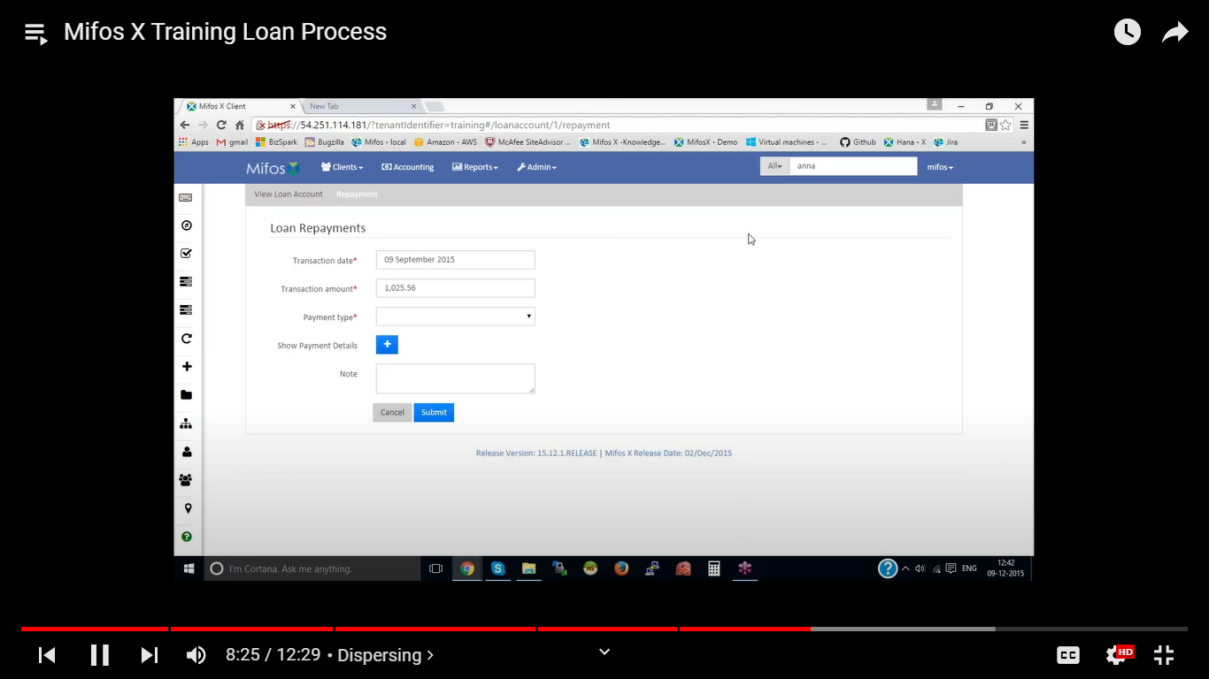

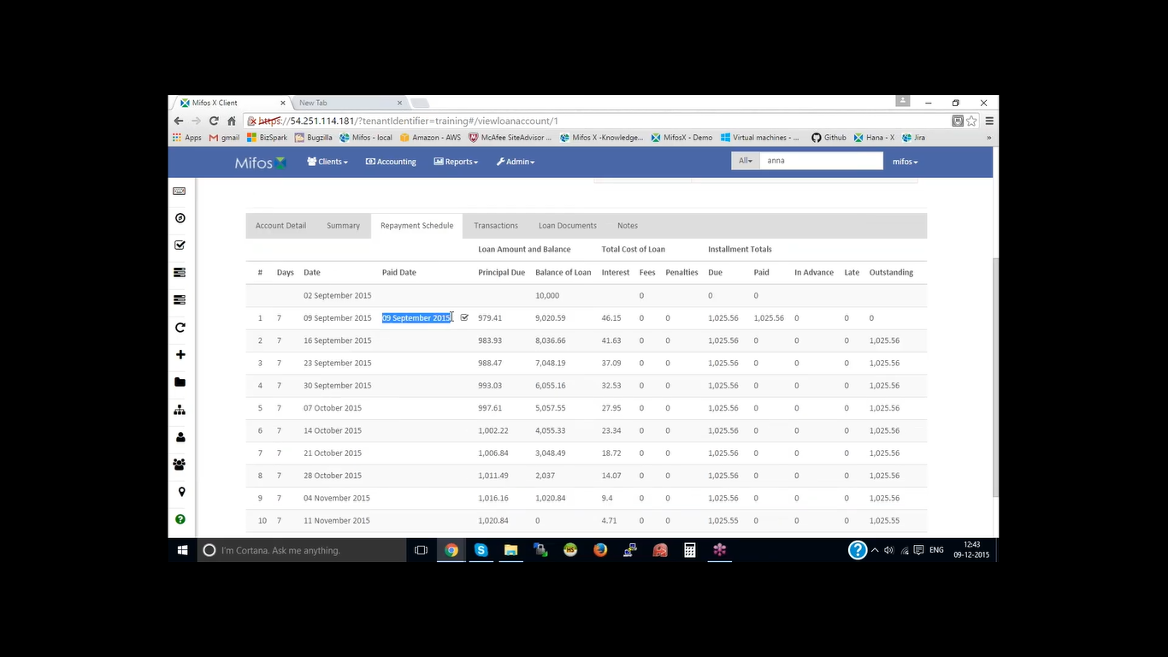

Click on prepay loan of all loan amount gets collected and loan gets closed with black icon

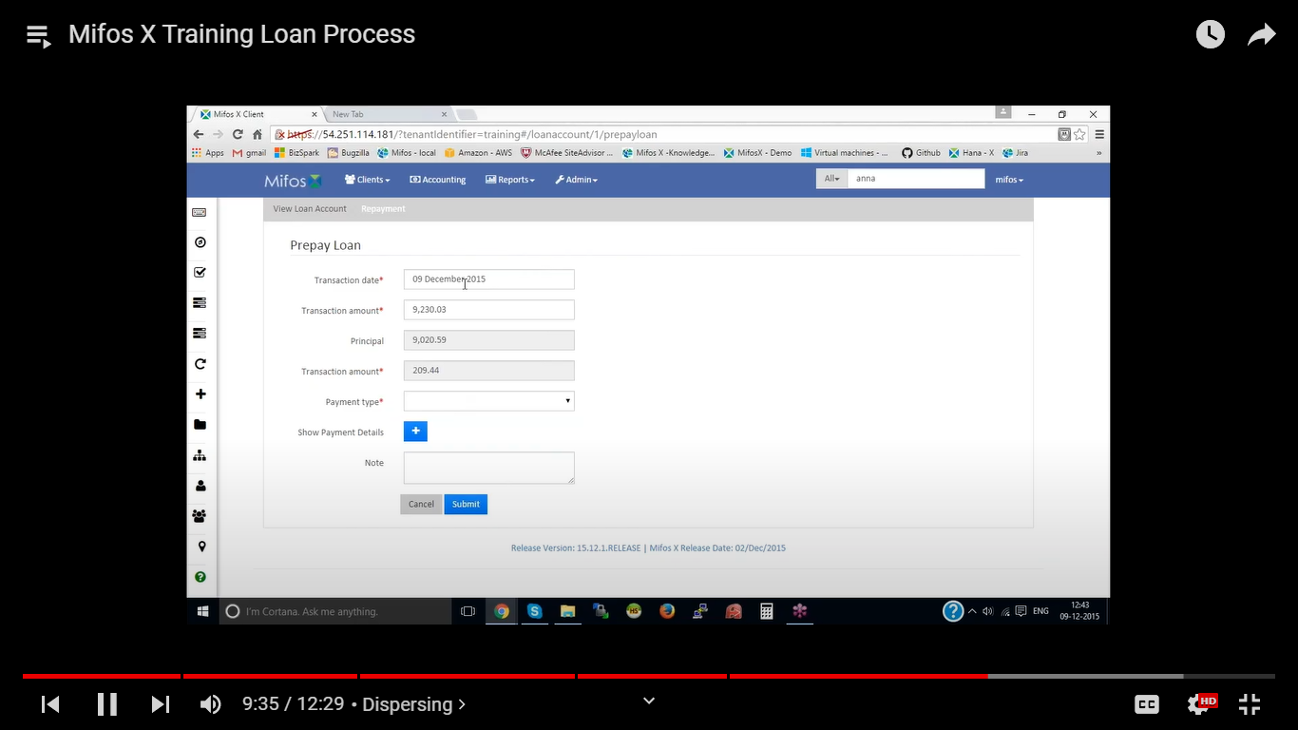

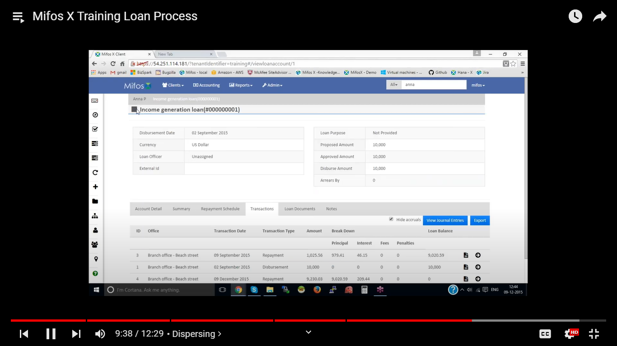

## Mifos x Loan Loss Provisioning :

* Login to Mifos platform.
* Go to Admin, then organization.
* In organization select ‘Create Provisioning Criteria’.
* There click on ‘+Create Provisioning Criteria’.
* But before creating a provisioning certificate.
* Go to the Chart of Accounts, then click on ‘+Add accounts’.
* Fill in the details.

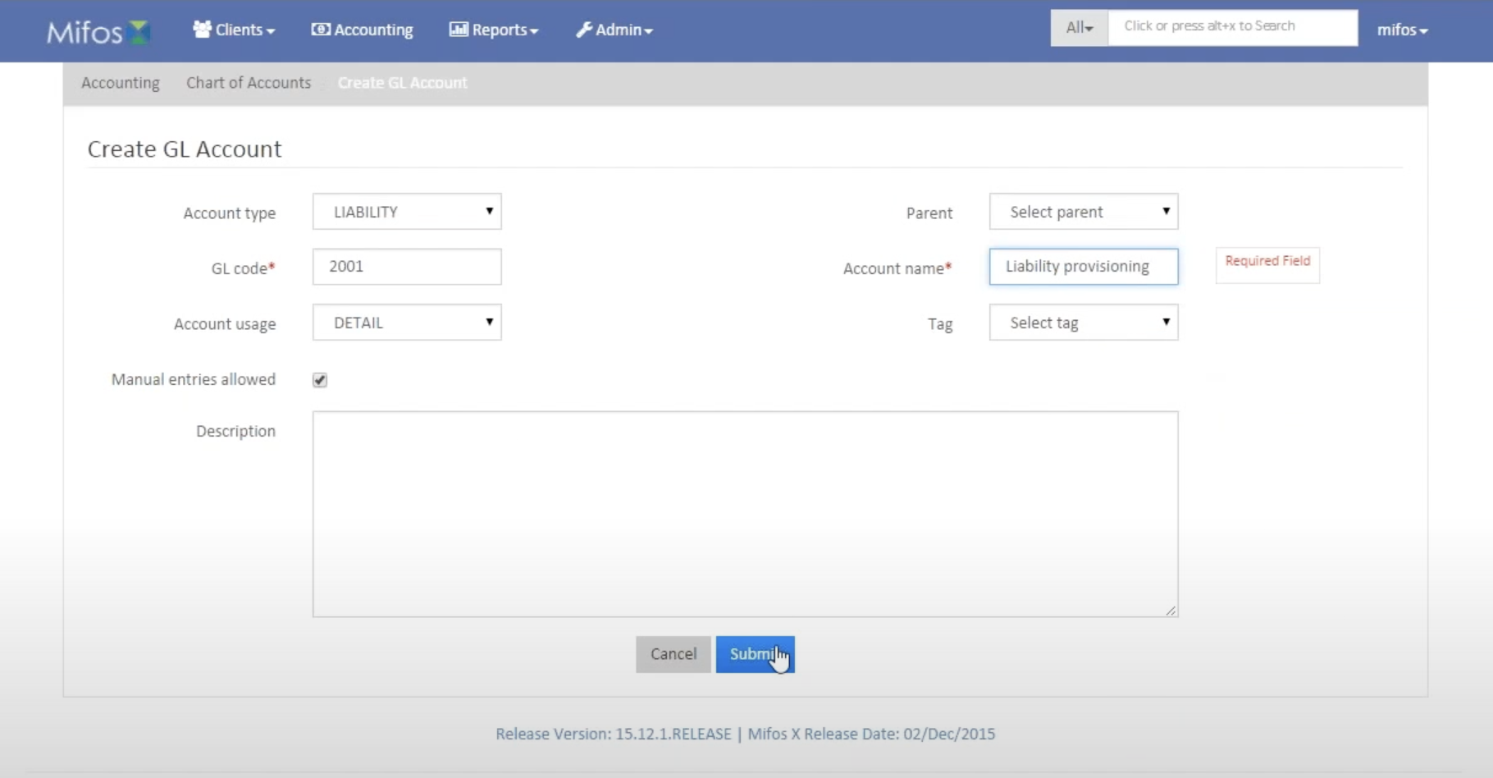

* Click on submit.
* Create another ‘Chart of account’.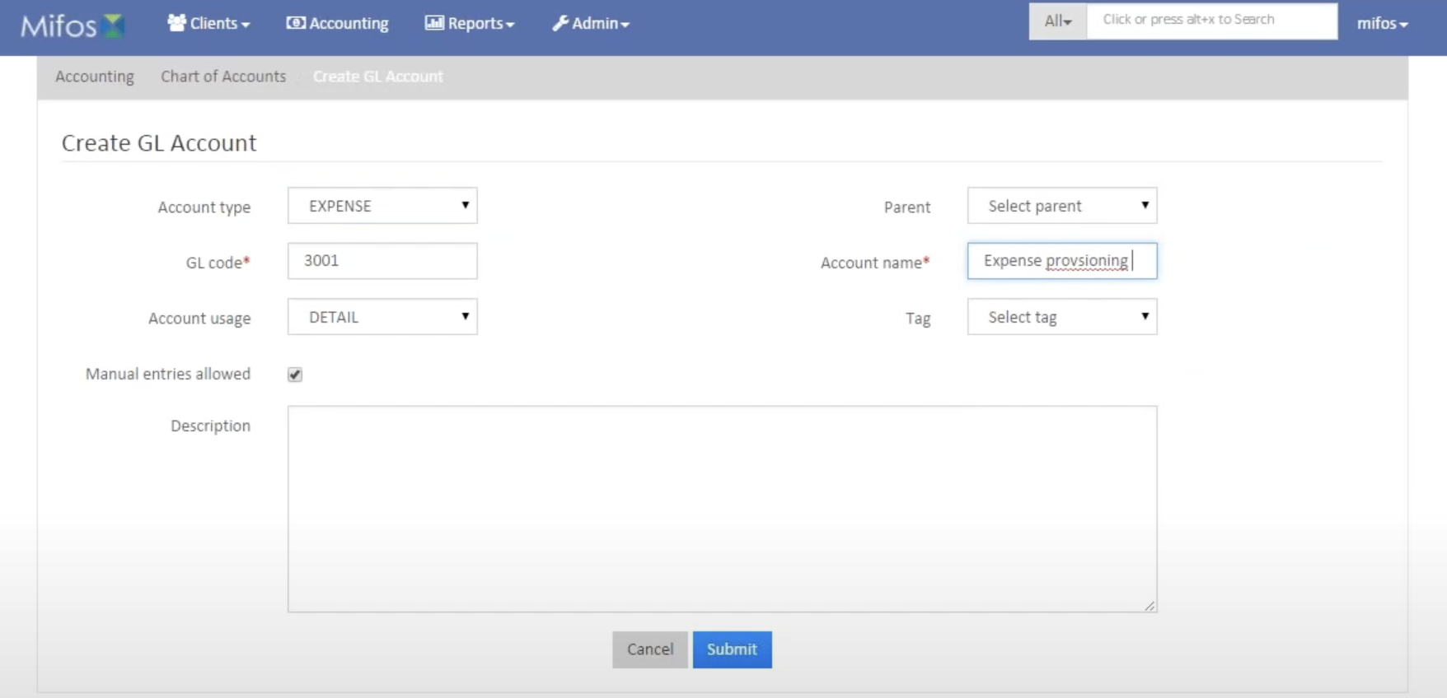
* Then go back to ‘Create provisioning criteria’.

## Mifos x Manage Holidays :

The ability to manage holidays for individual offices is a very useful tool for an organization spanning multiple locations. Use this option to customize holidays for each office of your organization.

**On this page:**

* [Add Holidays](https://mifosforge.jira.com/wiki/spaces/docs/pages/67141730/Manage+Holidays#ManageHolidays-AddHolidays)
* [View Holidays](https://mifosforge.jira.com/wiki/spaces/docs/pages/67141730/Manage+Holidays#ManageHolidays-ViewHolidays)
* [Edit/Delete Holiday](https://mifosforge.jira.com/wiki/spaces/docs/pages/67141730/Manage+Holidays#ManageHolidays-Edit%2FDeleteHoliday)

From the [Welcome Page](https://mifosforge.jira.com/wiki/spaces/docs/pages/81166353/Welcome+Page), click on [**Admin**](https://mifosforge.jira.com/wiki/spaces/docs/pages/52592736/Administration)**,** and click on [**Organization**](https://mifosforge.jira.com/wiki/spaces/docs/pages/67141724/Organization) from the drop-down list that pops up. This will launch the [**Organization**](https://mifosforge.jira.com/wiki/spaces/docs/pages/67141724/Organization) menu (*as shown in the screenshot below*).

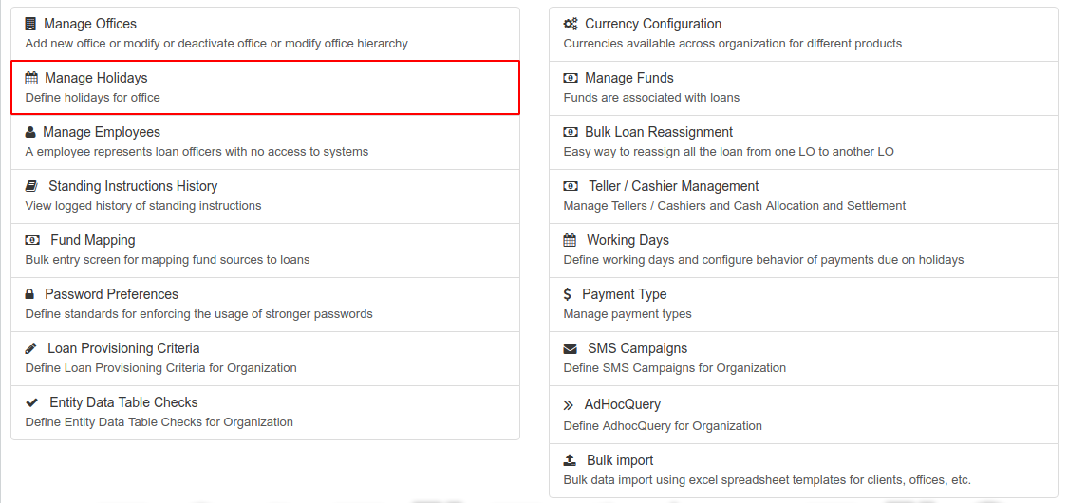

From this menu, select **Manage Holidays**. This will display the following:

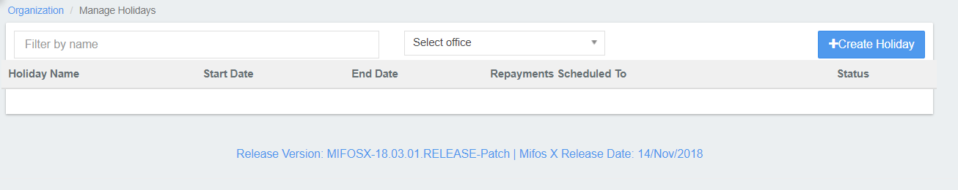

### Add Holidays

This option allows you to create new holidays for each office in your organization.

Click the blue **Create Holiday** button at the top-right of the screen: .This will launch a new page:   
  
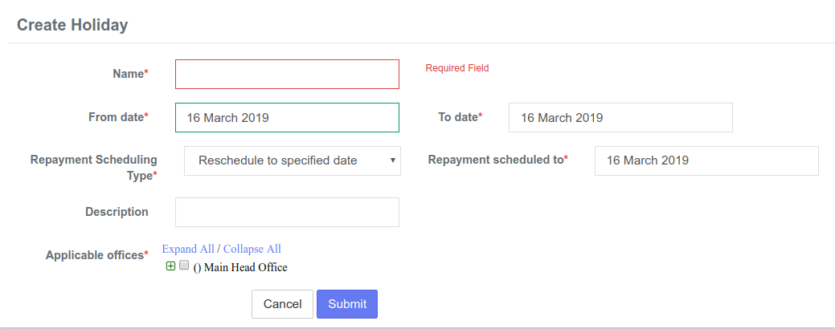

1. **Fill** the required fields:
   1. Name
   2. From Date
   3. To Date
   4. Repayment Scheduling Type
   5. Repayment scheduled to
   6. Description (this is not a required field, but is still available. You may also **Edit** this holiday at another time to add a description or edit the current description).
2. **Select** the office(s) the holiday applies to by clicking on the small '**+**' icon beside **Applicable Offices**. This will open a list of offices for you to choose from. Check the boxes to mark the office(s) you would like to include.  
     
   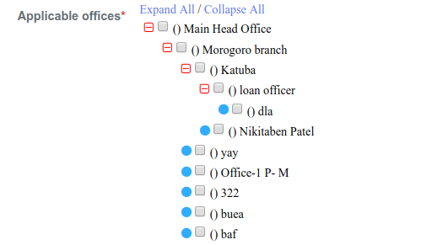
3. Click **Submit**

### View Holidays

Once you have selected **Manage Holidays,** a chart of all holidays will be displayed. The following fields will be displayed:

* Holiday Name
* Start Date
* End Date
* Alternate working day
* Status - Active or Deleted  
    
  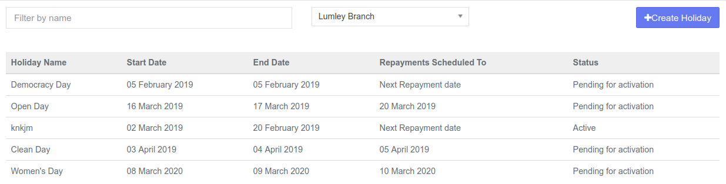

**Tip:** Use the **Filter by Name** field to locate the holiday you are searching for. Begin typing the holiday name and Mifos X will automatically filter the results.

You may also filter holiday results by using the drop-down menu at the center of the **Manage Holidays** screen to select an office:

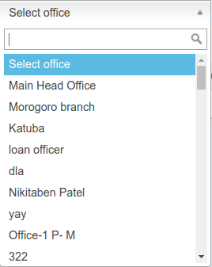

### Edit/Delete Holiday :

To **Edit** this holiday:

1. Click on a holiday in the list to view more details:  
      
   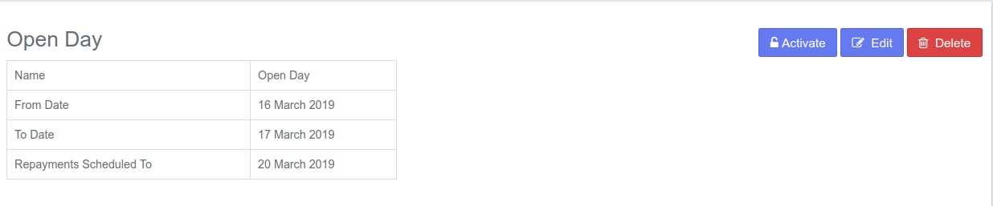
2. Click on the blue **Edit** button at the top-right of the page. This will launch a page where you can change the name of the selected holiday. You may also add or change a description of the chosen holiday.

To **Delete** this holiday:

1.Click the red **Delete** button at the top-right of the screen.

2.Click **Confirm**.

## Loan Overview

Use the following procedures as a guideline to develop your own organization's lending procedures

YOUR ORGANIZATION’S NAME has established these guidelines to advocate fair lending practices, assessing not only the applicant's ability and willingness to pay but the potential risks and benefits to the ORGANIZATION as a whole.

All clients who that have saved with the Organization for at least six months may borrow a maximum of three times his or her savings. The rate of interest for the loan shall be XX% per annum at a reducing balance basis.

## Loan Products :

No matter why the client needs to borrow, YOUR ORGANIZATION’S NAME makes it easy. We offer a range of lending products to fit their needs. Our competitive interest rates and convenient application process make YOUR ORGANIZATION’S NAME the right choice for the clients’ borrowing needs.

### Personal Loans:

Qualifying clients can apply for a Personal Loan. Personal Loans allow the clients to use their good credit to borrow a specific amount over a pre-determined term. Personal loans include:

* Emergency Expenses
* School Fees
* Loan consolidation

### Business Loans:

YOUR ORGANIZATION’S NAME offers a variety of lending solutions for our business owners. We are here to help our clients further develop their businesses through effective funding options and training programs.

* Purchase or refinance of machinery, equipment, or other capital assets
* Permanent working capital, business acquisition, debt consolidation
* Amortizations up to 7 years
* Flexible terms

## Equal Credit Opportunity

YOUR ORGANIZATION’S NAME promotes a lending policy that prohibits discrimination against any applicant on the basis of race, religion, sex, and ethnic background, source of income, marital status or age.

## 

## Definition of Applicant

An "applicant" is any person who directly applies for an extension, renewal or continuation of credit.

If the ORGANIZATION, after using objective nondiscriminatory standards, determines the applicant requesting individual credit cannot support the credit, the ORGANIZATION may request the applicant obtain a co-signer or guarantor.

## Truth-in-Lending

* Maintain loan documents that comply with Regulatory requirements.
* Promptly notify the borrower of any change in terms, which requires notice.
* Resolve all error inquiries within established time limits.
* Maintain the use of periodic statements, which meets all disclosure requirements.
* Notify borrower of "right to rescind" where applicable.

## Cross-Collateralization Clause

The ORGANIZATION reserves the right to include a "Cross-Collateralization" clause on its loan agreement that states the subject loan stands as collateral for all other loans previously or subsequently extended to the borrower, as long as this disclosure is contained in all loans in question. It will also allow for the collateral securing a previous loan to serve as collateral for the new loan. It is understood that the security exists only for the life of the subject loan.

## Notification of Adverse Action

YOUR ORGANIZATION’S NAME will notify an applicant of a credit denial in writing within:

* Thirty (30) days after receiving a completed application and denying or taking adverse action
* Thirty (30) days after receiving an incomplete application, offering a "reasonable" time period to complete the application. Applicant must be informed of the specific information required to complete application. Applicant must also be notified that the application will not receive further consideration if the information is not submitted as required.
* Thirty (30) days after taking adverse action on an existing account.
* Thirty (30) days after a conditional approval have been given and applicant has been offered reasonable time period to comply with loan contingency.
* Ninety (90) days after making a counter-offer, if the applicant has not expressly accepted or used the credit granted.

An adverse action has been taken when:

* A loan has been turned down.

Credit in the terms or amount applied for, is refused (i.e. a counter-offer is made) and the applicant does not accept the counter-offer.

Note: if the applicant accepts the counter-offer, no adverse action has occurred. If the applicant does not accept the counter-offer within ninety (90) days from the time it is made, the adverse action notice must be sent.

* Refusal to increase the limits of an open-end loan account or a reduction or closing of the credit line, if a similar adjustment is not made to all holders of an open-end account.
* A conditional approval has been granted yet applicant has failed to provide information required or meet the terms of contingency agreement.

When adverse action is taken, the applicant will be provided with a notification containing the following:

* A statement of the action taken using the Loan Adverse Action Notice form.
* The specific reasons why adverse action was taken or the applicant's rights to those reasons within thirty (30) days after they are requested.
* The name, address and phone number of credit reporting agency used in credit decision.

Note: When a co-signer or co-applicant is rejected, they must also be sent an adverse action notice indicating the reasons for denial.

## Loan Application Process

Loans will be reviewed for clients and non-clients of legal age of (18) years within the ORGANIZATION's field of membership. Non-clients must establish membership before a loan can be disbursed.

### **Loan Application**

Clients may apply for loans in person, by mail, fax or phone.

**Statement of Purpose**: Applicant must provide a legal purpose for the loan.

**Payroll Deduction**: Applicant must disclose whether voluntary payroll deductions will be made to the ORGANIZATION for loan repayment.

**Personal Information**: Applicant must provide information regarding place of residence, place of employment, income and assets. Applicant is asked to provide information regarding nearest relative. This information may be useful to the ORGANIZATION should collection efforts be necessary.

**Credit Information**: Applicant must provide information regarding all outstanding debts, including but not limited to mortgage (plus taxes and insurance), rent, auto loans, credit cards, lines of credit, etc. Applicant must also disclose information regarding pending applications, bankruptcy filings, outstanding judgments, lawsuits or garnishments, credit denials, child support payments, alimony payments and separate maintenance payments.

**Signature**: Applicant must sign and date the application.

The loan review process may begin when the above information has been obtained.

The application must be completed in full, and approved, before loan funds are disbursed.

## 

### Proof of Income

Verification of income (VOI) and Verification of Employment (VOE) will be completed for every loan applicant.

|  |  |
| --- | --- |
| **Source** | **Required Documentation** |
| Wages/Salary | Current pay stub or a current tax return. |
| Rental Property Income | Copy of tax return, including all schedules. (Rental receipts will not be accepted). |
| Alimony/Child Support | Copy of divorce decree, separation agreement, court order. (The ORGANIZATION may require copies of canceled checks or a written statement from either the attorney or the court as deemed necessary. Alimony may also be verified through tax returns). |
| Self-Employment | Completed and signed copies of tax returns for last three years, most recent financial statement and operating statement of the business. Applicants who have been self-employed for less than three years will be considered on a case-by-case basis. Permission to receive periodic verification of income may be required. |

### Photo Identification

Applicant is required to provide identification in compliance with “Know Your Customer” guidelines.

### Guarantor

If an applicant does not have enough income to qualify for a loan, he/she may provide a guarantor. This person must complete the “Other Applicant Information” section of the loan application and sign the loan agreement. The co-applicant must be a client of the ORGANIZATION.

### Loan Guidelines

Total debt to the ORGANIZATION may not exceed five (5) percent of the Organization’s total share capital and reserves per client. Financing of debt may be granted for a maximum term of 36 months.

DEBT CONSOLIDATION: Customer must provide copies of all bills to be consolidated. Checks will be made payable to the creditor(s) and the account will be closed at the discretion of the loan officer or credit committee.

## 

### Credit Builder Loans

This Program is meant to serve clients or potential clients who have been denied credit or had account problems at other banks or ORGANIZATIONs, and are working to improve their credit history.

YOUR ORGANIZATION’S NAME offers individuals the following services.

A savings account – This is the first step in rebuilding credit. This account must be successfully managed for a period of six months before a loan is considered.

* Financial management training provided by the ORGANIZATION.
* A “Credit Builder” Loan - The maximum loan amount is ______ . The funds from this loan are deposited into a 12 month fixed account. The fixed account is collateral for the loan. The client will make monthly payments on the loan. At the 12 month maturity of the fixed account funds will be available for withdrawal, providing the “Credit Builder” loan is paid in full.
* After the successful repayment of the Credit Builder loan, clients are eligible to apply for an additional loan.

## Mifos x Training Product Mix

### Product Mix

The **Product Mix** function allows a financial institution to define rules that restrict the loan accounts that may be held by a client at once. Mifos X checks a client's active loan accounts when a new loan is being disbursed. If there is a conflict between the client's active loan accounts and the loan account to be disbursed, it will result in an error and the new loan account will not be disbursed.

By default, the system does not restrict any product combinations.

### **Navigation**

### From the [Welcome Page](https://mifosforge.jira.com/wiki/spaces/docs/pages/81166353/Welcome+Page), select [**Admin**](https://mifosforge.jira.com/wiki/display/docs/Administration), then [**Products**](https://mifosforge.jira.com/wiki/spaces/docs/pages/70910295/Products)from the drop-down menu.

This will launch the **Products** menu.

Select **Product Mix.**

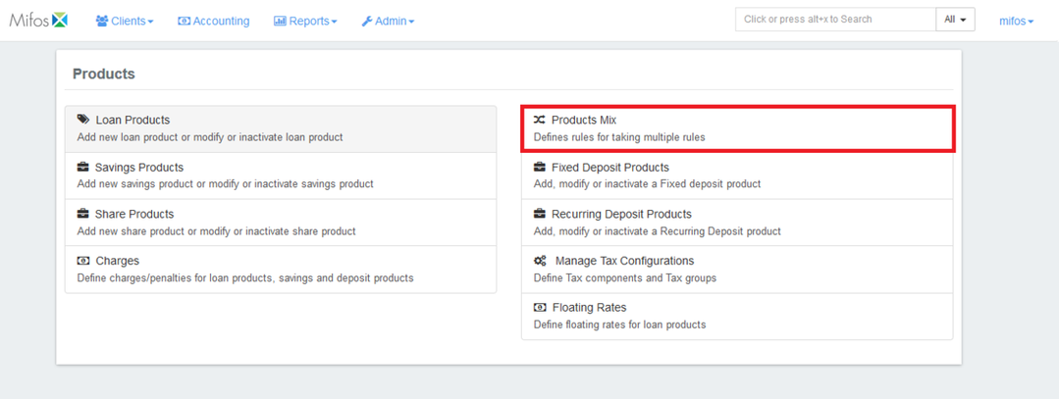

**NOTE:** Before you can define a product mix, you must be logged in to Mifos X with a username that has permission to define product mixes.

If you have the appropriate permissions, you can decide which types of products a given client or group can mix. In this way, you can restrict clients from having active loans or savings accounts of different products at the same time.

For example: if you have three different loan products (A, B, and C), you can make a rule that if a client has taken loan A, then the client can have loan B but not C.

### Creating a new Product Mix

1. Navigate to **Admin** >> **Products** and click on '**Product Mix**' to see the following window:  
      
   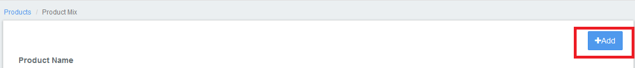
2. Click on '**+Add**'  button, and the following window will be displayed:  
     
   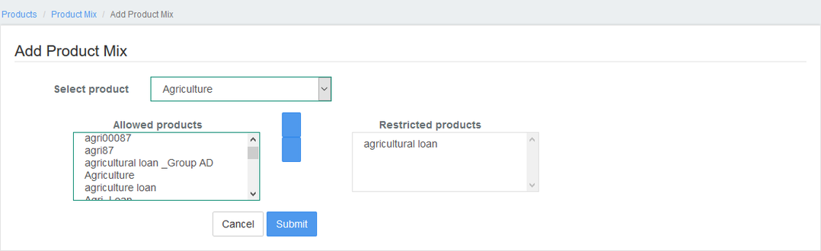
3. Select the loan product from the drop-down menu (*for instance: Agriculture*). After choosing the loan product, you can decide which loan products a client can get (*Allowed Products*) and which loan products are prohibited for the client (*Restricted Products*).   
   * Move loan products from the **Allowed Products** list to the **Restricted Products** list by clicking on the product name and clicking on **>>**.
   * Move loan products from the **Restricted Products** list to the **Allowed Products** list by clicking on the product name and clicking on **<<**.
4. Once you're done, click on the '**Submit**' button  to create a product mix.

### Edit or Delete Product Mix

1. To edit or delete a Product Mix, navigate to **Admin** >> **Products** >> **Product Mix.** The following window will be displayed:   
     
   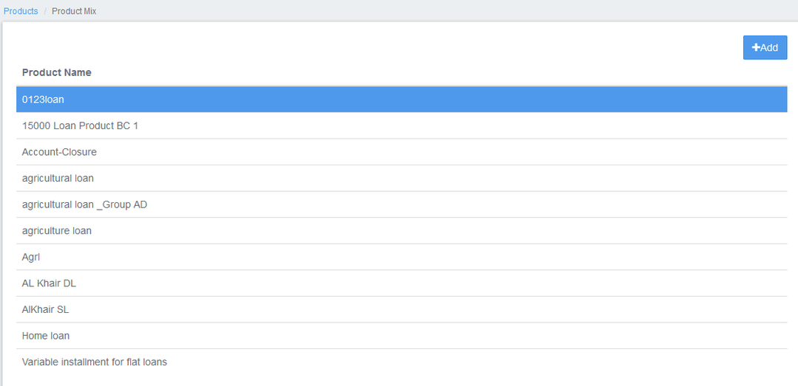
2. Click on the loan product on which the Product Mix is defined (*in this example, 'Agricultural Loan'*) to view the Product Mix:

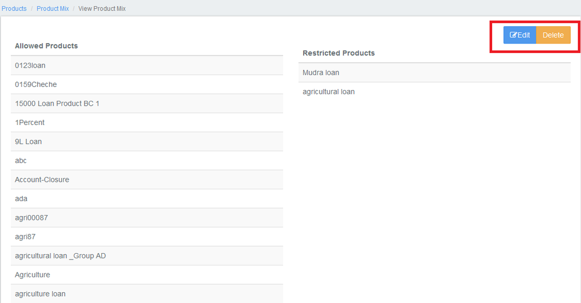

1. Either click on '**Edit**' or the '**Delete**' button to modify or delete the product mix respectively.

## Mifos x Training funding mapping

The Fund Mapping page enables you to map the sources of funds to loans in bulk.

On this page:

* [Approval/Creation/Disbursement - Date](https://mifosforge.jira.com/wiki/spaces/docs/pages/90243210/Fund+Mapping#FundMapping-Approval%2FCreation%2FDisbursement-Date)
* [Loan outstanding percentage](https://mifosforge.jira.com/wiki/spaces/docs/pages/90243210/Fund+Mapping#FundMapping-Loanoutstandingpercentage)
* [Loan outstanding amount](https://mifosforge.jira.com/wiki/spaces/docs/pages/90243210/Fund+Mapping#FundMapping-Loanoutstandingamount)
* [Searching by Loan Status](https://mifosforge.jira.com/wiki/spaces/docs/pages/90243210/Fund+Mapping#FundMapping-SearchingbyLoanStatus)
* [Searching by Product](https://mifosforge.jira.com/wiki/spaces/docs/pages/90243210/Fund+Mapping#FundMapping-SearchingbyProduct)
* [Searching by Approval/Creation/Disbursement-Date](https://mifosforge.jira.com/wiki/spaces/docs/pages/90243210/Fund+Mapping#FundMapping-SearchingbyApproval%2FCreation%2FDisbursement-Date)
* [Searching by Loan Outstanding Percentage](https://mifosforge.jira.com/wiki/spaces/docs/pages/90243210/Fund+Mapping#FundMapping-SearchingbyLoanOutstandingPercentage)
* [Searching by Loan Outstanding Amount](https://mifosforge.jira.com/wiki/spaces/docs/pages/90243210/Fund+Mapping#FundMapping-SearchingbyLoanOutstandingAmount)

Beginning at the main screen, select Admin, then Organization from the drop down menu. This will launch the Organization menu.

Select Fund Mapping to set the preferences.

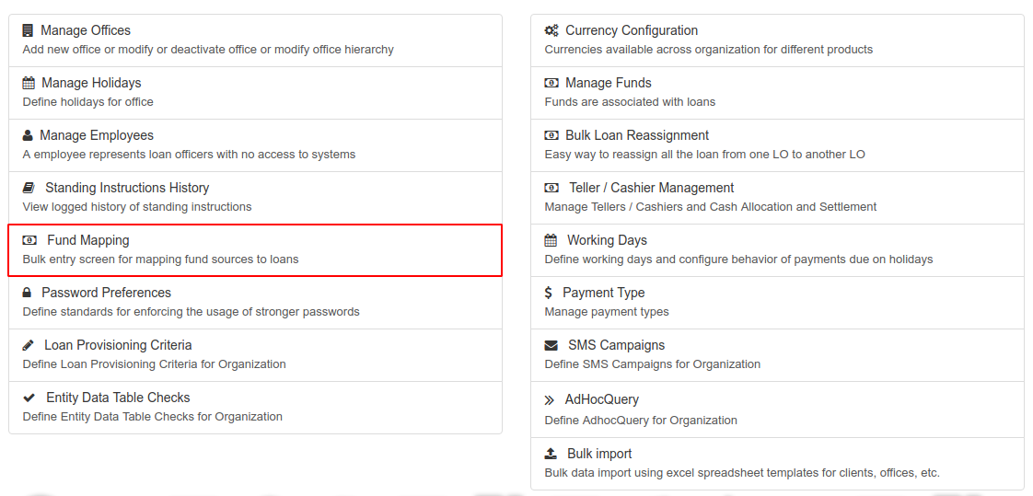

This will launch an Advance search page.

Using Ad Hoc query search, one can search for loans with different aspects. You can search by;

* Loan Status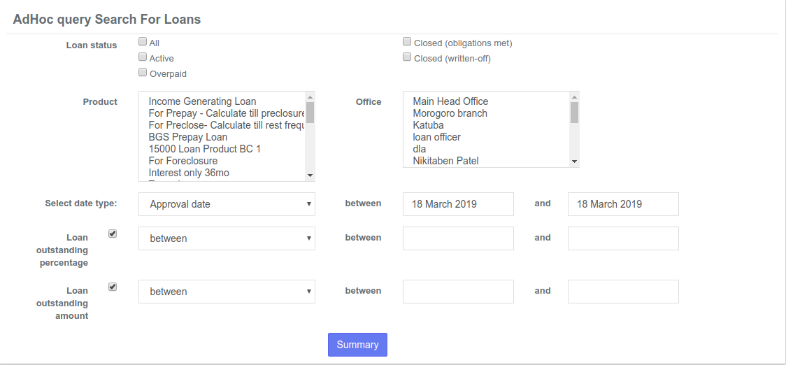
* Product
* Office
* Approval/Creation/Disbursement - Date
* Loan outstanding percentage
* Loan outstanding amount

### Searching by Loan Status

|  |
| --- |
|  |

The options include;

* All - Searches loan with all status.
* Active - Searches only loans with Active status.
* Overpaid - Searches only loans with Overpaid status.
* Closed (obligations met) - Searches loan Closed (obligations met).
* Closed (written-off) - Searches loan Closed (written-off).

### Searching by Product

This is a filtered search based on Products. That is clicking on a particular product or by holding the control button and selecting two or more products and then search.

|  |
| --- |
|  |

### Searching by Office

This is a filter search based on the Office.

|  |
| --- |
|  |

You can click on a particular office or many by holding the control button and selecting the offices.

### Searching by Approval/Creation/Disbursement-Date

This is a filter search based on the type of date. This can be Approval date, Creation date, and Disbursement date.

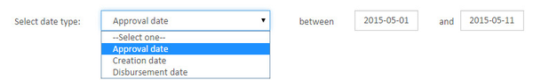

You can be provided a range of dates within which you want your results to be based.

### Searching by Loan Outstanding Percentage :

By default, it will have the check box checked for Loan outstanding percentage. If you don't want to use this filter, un-check the box and then search.

By default, it will be between searches. However, you may select another option from the drop-down and then select the range of dates.

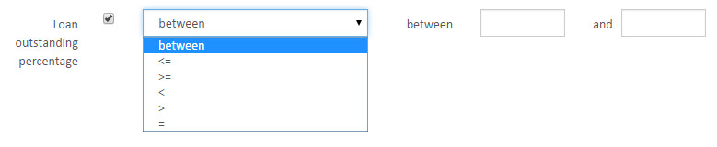

### Searching by Loan Outstanding Amount :

By default, this section will have the check box checked for Loan outstanding amount. If you don't want to use this filter, un-check the box and then search.

By default, it will be between searches. However, you may select another option from the drop-down and then select the range of dates.

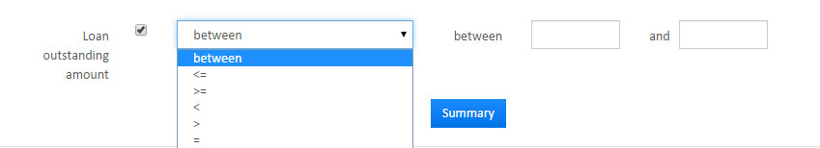

Click the  button to execute your filtered search.

Key Error Messages

## Mifos X Entity to entity mapping

Entity to entity mapping is to restrict access in products with respect to offices. Go to the Admin and click on system and then click on Entity to entity mapping .select offices- ->loan products and give office and loan products then click on filter.start date& end is not manditory

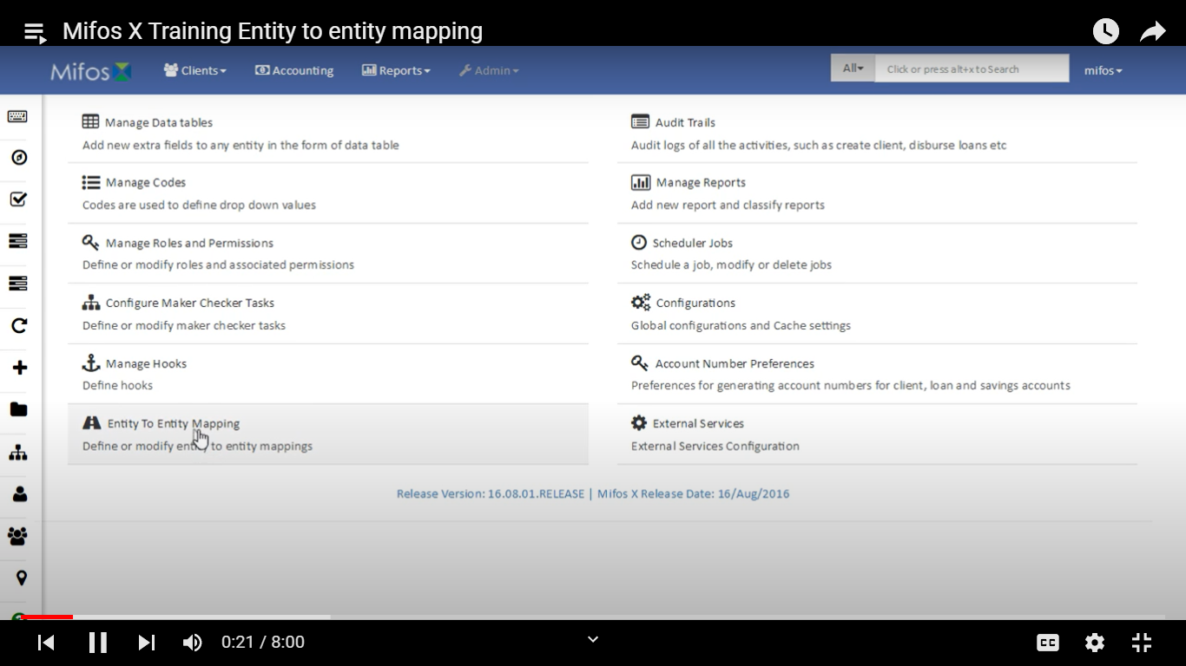

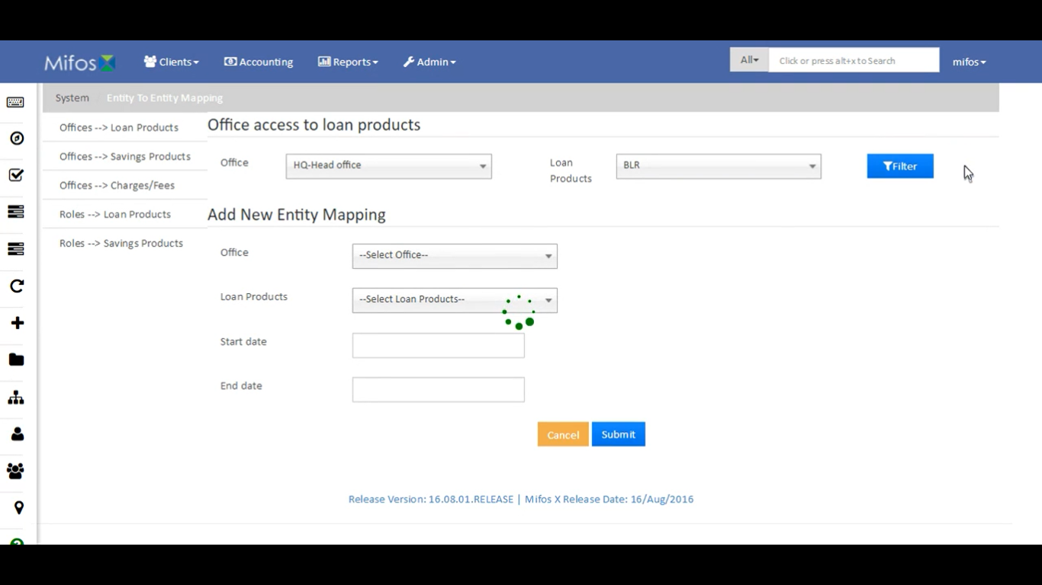

In the sameway select offices- -savings products and the same steps is applicable savings products.select start date and end date.then submit And remaining offices- ->charges/fees,Roles- ->loan products and Roles - ->savings products.